The Numerical Simulations And Mathematical Analysis On A Model Predicting And Preventing The Measles Epidemic

Ashana Evans and Dr. Liping Liu

*Department of Mathematics*

*North Carolina A&T State University*

*1601 E. Market St, Greensboro, NC 27411*

*Submitted: Sunday, March 13, 2016*

*Math 692*

**Table of Contents**

**Abstract**

1. **Introduction**
2. **Parameters & Model equations**
3. Parameters
4. Compartmental Analysis
5. Model Equations: Four and Eight-Age Class Groups
6. Next Generation Matrix: Reproductive Number
7. **Numerical Simulations**
8. Matlab Overview
9. Initial Conditions
10. **Results & Discussions**
11. Reproductive Numbers
12. **Conclusions & Future topics**

**References**

## **Abstract**

Mathematical models of epidemics have a long history of contributing to the understanding of the impact of vaccination strategies. Simple, one-line models can predict target vaccination coverage that will eradicate an infectious virus, while other questions require complex numerical simulations. This research introduces some simple ordinary differential equation models of mass vaccination strategies that can be used to address important questions for predicting an epidemic. Throughout this proposal, we will discuss the mathematical background the measles epidemic, and this study’s purpose, methodology, results. First we will look over the parameters and model equations more in depth. Then we will show our numerical schemes such as the Runge-Kutta, and some pseudo-code of the Matlab functions. Discussion on the simulation results from the project are then presented. Finally, we will conclude any findings and talk about future topics for this project.

## **Introduction**

Measles is a “childhood infection caused by a virus. Once quite common, measles can now almost always be prevented with a vaccine” [4]. Generally, Measles is a highly contagious virus that is transmitted airborne and by direct contact. Signs and symptoms of measles include cough, runny nose, inflamed eyes, sore throat, fever and a red, blotchy skin rash. In addition to being called rubeola, measles can be serious and even fatal for small children. While death rates have been falling worldwide as more children receive the measles vaccine, the disease still “kills more than 100,000 people a year, most under the age of 5” [4].

With this disease one has to create some vaccination strategies, to allow for eradication. The method is known as pulse vaccination strategy, which is a “method used to eradicate an epidemic by repeatedly vaccinating a group at risk, over a defined age range, until the spread of the infectious agent has been stopped” [8]. It is most commonly used during measles epidemics to quickly stop the spread and contain the outbreak. Thus with high vaccination rates, results show that measles has not been widespread in the United States for more than a decade. Today, the United States averages about 60 cases of measles a year, and most of them originate outside the country.

## **1.1 Mathematical Background**

In 1996, Predicting and preventing Measles Epidemics in New Zealand: application of a mathematical model, was published to identify future measles outbreaks and aid in the development of vaccination strategies. The author divided the population into 4 homogeneous groups for the prediction model and 8 homogeneous groups for the prevention model. The groups correspond to age groups, ages 0.5 years-25 years. Each groups are then divided into susceptible, infected, or recovered individuals. With a small initial number of infected individuals, the model is created. This model then simulates for various vaccination strategies to find the solutions and to predict and prevent the dynamics of the Measles Epidemic.

## **1.2 Purpose of Research: Methodologies & Techniques**

The purpose of this research is so we can provide important information about the Measles outbreak. This includes epidemic trends, risk factors, and the outcomes of various vaccinations strategies. With these findings it can be used to predicting future outbreaks, and ultimately preventing them. Essentially, such research allows us to:

1.Understand of the age grouped SI (or SVI) model for predicting and preventing the measles epidemic.

2. Find the realistic value for each parameter from the historical (or observational) data.

3. Use prior parameter values found to predict the epidemic in history for New Zealand, and validate it with the historical data.

In this Model, we will be looking at a Two-aged groups. This is to understand the dynamics of the vaccination strategies as it pertains to the Measles epidemic. First, the Four-Age class group model for prediction to model the old vaccination policy, then the Eight-Age class group model for prevention with various vaccination strategies to understand how the infectious disease can be prevented.

This research utilizes a deterministic SI/SVI model, which is a certain type of compartmental model with three different compartments with respect to time.

1. S(t) is for the number of susceptible people.

2. V(t) is for the number of people vaccinated.

3. I(t) is for the number of infected people.

Furthermore, its assumed that the population is a closed population. Which means that, the only way a person can leave the susceptible group is to become infected or vaccinated. Now this SI/SVI model for measles, is used to investigate the process of how an epidemic of measles occurs within a closed population over the years where a portion of the population has been vaccinated. This developed model should take into account the two major factors: age structure and seasonality. In addition, with modeling the endemic cycles, and considering seasonal effects, we look into if it comes from the cultures, school periods, as well as the calendar seasons. Various contact rates and transition rates among the groups are used to reflect the age and seasonality.

# 2. Parameters & Model Equations

## **2.1 Parameters**

To study the predicted dynamics of an infection after the introduction of a vaccination strategies, requires a creation of mathematical models. The model that can be used to study the impact of vaccination keeps track of three groups of individuals: susceptible, S; infected, I; and recovered R. Now, “the dynamics of measles were modelled under varying vaccination strategies” in a population with size and age structure similar to that of New Zealand, using a deterministic SI (susceptible-infective) model. The transitions described by each term of the equations of this model are as labelled and the model’s parameters are described in Table 1.

### **2.1.1 Contact Matrix**

The boundaries of the age classes were chosen using the assumption that those less than 6 months or more than 25 years old are not included in the epidemic. Hence the `prediction' model had four active age classes and the `prevention' model had eight active age classes” [1], which is shown in Table 2.

**Table 1: Parameters assumed in the models Name, values, and interpretations:**

|  |  |  |  |
| --- | --- | --- | --- |
| Parameter | Name | Numerical Value | Interpretations |
| $a_{1}$ $a_{2}$ $a_{3}$ $a_{4}$ | Activity Levels 1-4 | $a_{1}$*=1 $a_{2}$*  *=2 $a_{3}$*  *=6 $a_{4}$*  *=3* | Activity level deals with an individual in an age class I and has that number of activity with in their class. |
| *B* | Annual birth rate | *57435/ year* | Annual birth rate was assumed constant |
| *𝛿* | Magnitude of Seasonal Variation | *0.2* | The magnitude of seasonal variation deals with what season or time of the year more people are affected than other times of the year and you will notice that we use this variable in the seasonality function. |
| *𝜖* | Factor Reducing Inter-Class Activity | 0.4 | For within class contacts, but between-class contacts are assumed to be zero. Which is why *𝜖* < 1 to weight between- class contact. |
| *𝛽* | Disease Transmission coefficient | *2.005 x ${10}^{-4}$* | The number of new infected formed per infectious contact with a single age class |
| *N* | Size of Class | *class width * B*  (vary between class width) | The size of each age class |
| *𝜇* | Transition rate | (class width)-1 | the transition rate to the next age class |
| $γ$ | 1/Mean time infectious | $\frac{1}{52}$ | The mean time infectious in a year so 52 weeks |
| $ω(t)$ | seasonality function | $\left\{\begin{aligned}κ\left(1+ δ\right) for τ_{1}<τ<τ_{2} \\ κ\left(1- δ\right) for otherwise\end{aligned}\right.$ | Takes in account that contact rates vary throughout the year. τ is the decimal part of time so we set $τ_{1}$ to 0.1615 (Feb 28) and $τ_{2}$ = (0.9151) (December 1) and this is calculated by doing 59/365 and 335/365. |

**Table 2: Age classes**

|  |  |  |  |  |
| --- | --- | --- | --- | --- |
| Prediction: Four-Age Class Groups | Ages |  | Prevention: Eight-Age Class Groups | Ages |
| *Class 1* | *6 months to 15 months* | ***Class 1***  ***Class 2*** | *6 months to 1 year*  *1 year to 15 months* |
| *Class 2* | *15 months to 5 years* | ***Class 3***  ***Class 4*** | *15 months to 18 months*  *18 months to 3 years* |
| *Class 3* | *5 years to 11 years* | ***Class 5***  ***Class 6*** | *3 years to 5 years*  *5 years to 6 years* |
| *Class 4* | *11 years to 25 years* | ***Class 7***  ***Class 8*** | *6 years to 11 years*  *11 years to 25 years* |

### **2.1.2 Contact Matrix**

For the Contact Matrix, the study supposes that an individual in age class i has an activity level measured by ai. Under the proportionate mixing assumption the number of contacts per unit time between individuals in age class i and individuals in age class j is proportional $\sqrt{a_{i}a_{j}}$. In order to keep contact rates within and between classes compatible in both models we used the contact rate matrix C depicted below.

Contact Matrix: Prediction Four-Age Group Model

$$\left(\begin{matrix}\begin{matrix}\begin{matrix}\sqrt{a_{1}a_{1}} & ε\sqrt{a_{1}a_{2}}\end{matrix} \\ \begin{matrix}ε\sqrt{a_{2}a_{1}} & \sqrt{a_{2}a_{2}}\end{matrix}\end{matrix} & \begin{matrix}ε\sqrt{a_{1}a_{3}} & ε\sqrt{a_{1}a_{4}} \\ ε\sqrt{a_{2}a_{3}} & ε\sqrt{a_{2}a_{4}}\end{matrix} \\ \begin{matrix}\begin{matrix}ε\sqrt{a_{3}a_{1}} \\ ε\sqrt{a_{4}a_{1}}\end{matrix} & \begin{matrix}ε\sqrt{a_{3}a_{2}} \\ ε\sqrt{a_{4}a_{2}}\end{matrix}\end{matrix} & \begin{matrix}\begin{matrix}\sqrt{a_{3}a_{3}} \\ ε\sqrt{a_{4}a_{3}}\end{matrix} & \begin{matrix}ε\sqrt{a_{3}a_{4}} \\ \sqrt{a_{4}a_{4}}\end{matrix}\end{matrix}\end{matrix}\right)$$

$$\left(\begin{matrix}\begin{matrix}\begin{matrix}\begin{matrix}\sqrt{a_{1}a_{1}} & \sqrt{a_{1}a_{1}} \\ \sqrt{a_{1}a_{1}} & \sqrt{a_{1}a_{1}}\end{matrix} & \begin{matrix}ε\sqrt{a_{1}a_{2}} & ε\sqrt{a_{1}a_{2}} & ε\sqrt{a_{1}a_{2}} \\ ε\sqrt{a_{1}a_{2}} & ε\sqrt{a_{1}a_{2}} & ε\sqrt{a_{1}a_{2}}\end{matrix}\end{matrix} \\ \begin{matrix}\begin{matrix}ε\sqrt{a_{2}a_{1}} & ε\sqrt{a_{2}a_{1}} \\ \begin{matrix}ε\sqrt{a_{2}a_{1}} \\ ε\sqrt{a_{2}a_{1}}\end{matrix} & \begin{matrix}ε\sqrt{a_{2}a_{1}} \\ ε\sqrt{a_{2}a_{1}}\end{matrix}\end{matrix} & \begin{matrix}\sqrt{a_{2}a_{2}} & \sqrt{a_{2}a_{2}} & \sqrt{a_{2}a_{2}} \\ \sqrt{a_{2}a_{2}} & \sqrt{a_{2}a_{2}} & \sqrt{a_{2}a_{2}} \\ \sqrt{a_{2}a_{2}} & \sqrt{a_{2}a_{2}} & \sqrt{a_{2}a_{2}}\end{matrix}\end{matrix}\end{matrix} & \begin{matrix}\begin{matrix}ε\sqrt{a_{1}a_{3}} & ε\sqrt{a_{1}a_{3}} \\ ε\sqrt{a_{1}a_{3}} & ε\sqrt{a_{1}a_{3}}\end{matrix} & \begin{matrix}ε\sqrt{a_{1}a_{4}} \\ ε\sqrt{a_{1}a_{4}}\end{matrix} \\ \begin{matrix}ε\sqrt{a_{2}a_{3}} & ε\sqrt{a_{2}a_{3}} \\ ε\sqrt{a_{2}a_{3}} & ε\sqrt{a_{2}a_{3}} \\ ε\sqrt{a_{2}a_{3}} & ε\sqrt{a_{2}a_{3}}\end{matrix} & \begin{matrix}ε\sqrt{a_{2}a_{4}} \\ ε\sqrt{a_{2}a_{4}} \\ ε\sqrt{a_{2}a_{4}}\end{matrix}\end{matrix} \\ \begin{matrix}\begin{matrix}\begin{matrix}ε\sqrt{a_{3}a_{1}} & ε\sqrt{a_{3}a_{1}} \\ ε\sqrt{a_{3}a_{1}} & ε\sqrt{a_{3}a_{1}}\end{matrix} \\ \begin{matrix}ε\sqrt{a_{4}a_{1}} & ε\sqrt{a_{4}a_{1}}\end{matrix}\end{matrix} & \begin{matrix}\begin{matrix}ε\sqrt{a_{3}a_{2}} & ε\sqrt{a_{3}a_{2}} & ε\sqrt{a_{3}a_{2}} \\ ε\sqrt{a_{3}a_{2}} & ε\sqrt{a_{3}a_{2}} & ε\sqrt{a_{3}a_{2}}\end{matrix} \\ \begin{matrix}ε\sqrt{a_{4}a_{2}} & ε\sqrt{a_{4}a_{2}} & ε\sqrt{a_{4}a_{2}}\end{matrix}\end{matrix}\end{matrix} & \begin{matrix}\begin{matrix}\begin{matrix}\sqrt{a_{3}a_{3}} & \sqrt{a_{3}a_{3}} \\ \sqrt{a_{3}a_{3}} & \sqrt{a_{3}a_{3}}\end{matrix} \\ \begin{matrix}ε\sqrt{a_{4}a_{3}} & ε\sqrt{a_{4}a_{3}}\end{matrix}\end{matrix} & \begin{matrix}\begin{matrix}ε\sqrt{a_{3}a_{4}} \\ ε\sqrt{a_{3}a_{4}}\end{matrix} \\ \sqrt{a_{4}a_{4}}\end{matrix}\end{matrix}\end{matrix}\right)$$

Contact Matrix: Prevention Eight-Age Group Model

## **Compartmental Analysis**

Although we have the parameters, before creating model equations its best to look at how each person can go from being susceptible to being infected. With that, we generate a generalized Compartmental Analysis of the SI Model. Then we show the Four-Age Group Prediction Model Compartmental Analysis. The reason for this analysis, is to show the effect of vaccination, which is to reduce the incoming transition rate to class i­1 from $μ_{i }$ to vi.

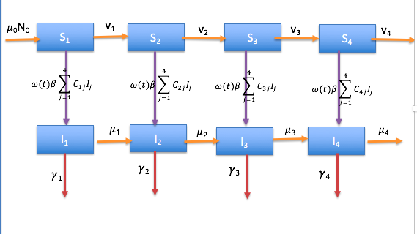**Four-Age Group Model: Prediction Compartmental Analysis**

## **2.3 Model Equations: Four and Eight-Age Class Groups**

The compartmental analyses above were developed to model the measles spread and vaccination strategies over the years with in a close population. After generating those analyses, the disease transmission model equations were constructed as follows. Consider first the situation with a single age class. If the number of contacts that an individual makes with another per unit time is C, then the number of contacts with an infectious individual is CI. If the number of new infected formed per infectious contact is β, then the rate at which susceptible become infected (force of infection) is βCI. Where contact rates vary throughout the year we introduce a periodic function ϖ(t) as a multiplier, hence with n age classes the force of infection in class i is $ω\left(t\right)β\sum_{j=1}^{n}{C_{ij}I_{j}}$. where Cij is the rate of contact between individuals in age class i and those in age class j. It is convenient to estimate contact rates relative to those in one selected class, for example age-class one. The parameter $β$ then has dimension (year)-1. This lead us to the construction of the model equations for the susceptible (Si) and Infectious (Ii) populations are:

$$\frac{dS_{1}}{dt}=μ_{0}N_{0}-\left(μ_{1}+ω\left(t\right)β\sum_{j=1}^{4}{C_{1j}I_{j}}\right)S_{1}$$

$$\frac{dI_{1}}{dt}=ω\left(t\right)βS_{1}\sum_{j=1}^{4}{C_{1j}I_{j}}-\left(μ_{1}+γ\right)I_{1}$$

And for $i=2,…,4$

$$\frac{dS_{i}}{dt}=v_{i-1}S_{i-1}-\left(μ_{i}+ω\left(t\right)β\sum_{j=1}^{4}{C_{ij}I_{j}}\right)S_{i}$$

$\frac{dI_{i}}{dt}=μ_{i-1}I_{i-1}+ω\left(t\right)βS_{i}\sum_{j=1}^{4}{C_{ij}I_{j}}-\left(μ_{i}+γ\right)I_{i}$

Now for the Prevention Model, which is the Eight-Age Group Model, the model equations for the susceptible (Si) and Infectious (Ii) populations are:

$$\frac{dS_{1}}{dt}=μ_{0}N_{0}-\left(μ_{1}+ω\left(t\right)β\sum_{j=1}^{8}{C_{1j}I_{j}}\right)S_{1}$$

$$\frac{dI_{1}}{dt}=ω\left(t\right)βS_{1}\sum_{j=1}^{8}{C_{1j}I_{j}}-\left(μ_{1}+γ\right)I_{1}$$

And for $i=2,…,8$

$$\frac{dS_{i}}{dt}=v_{i-1}S_{i-1}-\left(μ_{i}+ω\left(t\right)β\sum_{j=1}^{8}{C_{ij}I_{j}}\right)S_{i}$$

$$\frac{dI_{i}}{dt}=μ_{i-1}I_{i-1}+ω\left(t\right)βS_{i}\sum_{j=1}^{8}{C_{ij}I_{j}}-\left(μ_{i}+γ\right)I_{i}$$

# **2.4 Next Generation Matrix & Basic Reproductive Number**

The basic reproduction number is a key parameter in mathematical modelling of infectious diseases and helps figure out if the infectious disease to go into decline. It is defined as “average number of secondary infections produced when one infected individual is introduced into a host population where everyone is susceptible” [7], and is denoted as *Ro*. All that is required for a disease to go into decline is when *Ro* generates, on average, less than one other case. Similarly, Rv is defined as the average number of secondary cases generated by a primary case in a population rendered incompletely susceptible as a result of immunization. If Rv<1, disease elimination occurs.

## **2.4.1 Next Generation Matrix**

The next-generation matrix (NGM) is the natural basis for defining and calculation of *Ro* “where finitely many different categories of individuals are recognized” [9]. This method is used to derive the basic reproduction number, for a compartmental model of the spread of infectious diseases. Figure 1 depicts the matrix for the Four-Age Group Model. When generating the next generation matrix for the eight group model we use the same matrix, but with Ni is replaced with Si*, the steady state value of Si(t).

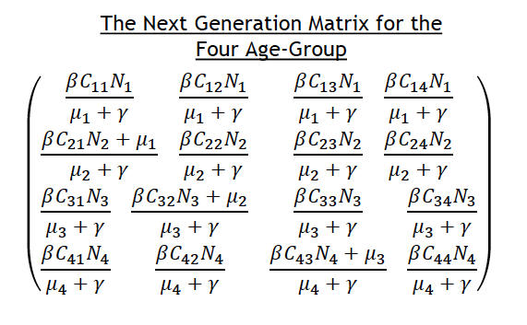

Figure 1: Next Generation Four-Age Class Group

# **3. Numerical Simulations**

## **3.1 Matlab Overview**

Though MATLAB is primarily a numerics package, it can certainly solve straightforward differential equations symbolically. The first component of this research Matlab code, is to create a function called cspsolveNewZ.m which would be the function that implemented the Prediction: Four-Age Class Group Model. The method used in this code was the Runge-Kutta Method, which “are a family of ODE solvers” [6] that numerically integrate ordinary differential equations by using a trial step at the midpoint of an interval. This is shown below in Figure 2, which shows the ordinary differential equations for both Susceptible and Infected Age classes.

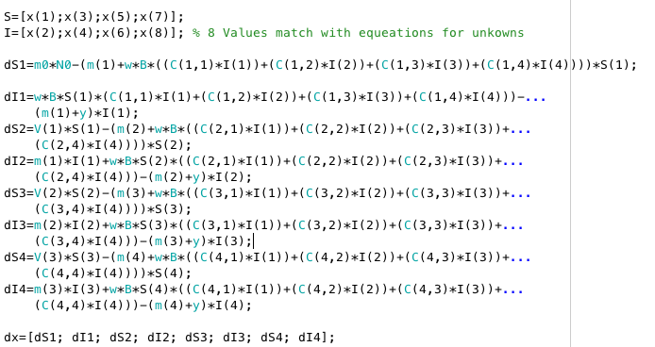

Figure 2: Runge-Kutta Method: Differential Equations

**3.2 Initial Conditions**

After creating the function, we start on the newzeal.m, which instantiates all the parameters of the Prediction: Four-Age Class Group, as well as creating initial conditions for the Susceptible and Infected classes. In order to solve the differential equations in Figure 3, we choose to use the Matlab ODE solve odes23. This ODE solver, “uses simultaneously second and third order Runge-Kutta formulas to make estimates of the error, and calculate the time step size. Since the second and third order RK require less steps, ode23 is ‘less expensive’ in terms of computation demands than ode45, but is also lower order” [6]. Below, the matlab code depicts the use of the ode23 solver, and the ODE is solved in the time interval 0 ≤ t ≤ 39 with initial condition S (1)=1000, I(1)=1, S(2)=1000, I(2)=1, S(3)=1000, I(3)=1, S(4)=100, and I(4)=1.

Figure 3: ODE23s Solver Four-Age Class Group

%% (1) Solution for Prediciton: Four-Age Class Group

%intial conditions explained [t,x]=ode23s('cspsolveNewZ',[time0 t],[S1,I1,S2,I2,S3,I3,S4,I4])

[t,x] = ode23s('cspsolveNewZ', [0 39], [1000 1 1000 1 1000 1 100 1]);

It is a similar format for the Prevention: Eight-Age Class Group, in that we had to create a function code, called cpeightgroup.m. Then, for instantiated the parameters and initial condition for the Susceptible and Infected classes we used the following shown in Figure 4.

Figure 4: ODE23s Solver Eight-Age Class Group

%% (1) Solution for Prevention: Eight-Age Class Group

%%intial conditions explained [t,x] = ode23s(‘cpeightgroup’, [time0 t],[S1,I1,S2,I2,S3,I3,S4,I4,S5,I5,S6,I6,S7,I7,S8,I8]);

[t,x] = ode23s('cpeightgroup', [30 100], [50 0 1000 10 1000 10 100 10 1000 10 1000 10 1000 10 **100 30]);**

fddf

The equations were then solved using historical vaccination rates and different values of the parameters that control inter-class contact rate (*𝜖*), the magnitude of the seasonal fluctuation in transmission (*𝛿*), and the basic reproduction ratio (R0). For understanding, the basic reproduction ratio (R0) of an infectious disease is defined as the average number of secondary cases generated by a primary case in a fully susceptible population. For code purposes, we had to use the matrix results of N, the population size of each age group for each model and simulate that through the Next Generation Matrix. The results found for Four Age-Group Classes shown in Figure 5. where the vaccination strategy was 20% of the population vaccinated. Then, for the Eight-Age Group we used, also shown in Figure 5, where the vaccination strategy was 5% of the population vaccinated.

%% RV for Four-Age Group

N= [43,076; 165,840; 203,460; 311,590]

%% RV for Eight-Age Group

N2= [28,718; 13,641; 12,959; 73,865; 93,533; 44,414; 195,860; 258,040]

# **4. Results and Discussions**

For this research we study the dynamics and control of Measles Epidemic in New Zealand. For the modelling, it was best to employ initial conditions for the susceptible and infectious within different age groups. This format, combined with assigning the boundaries between age groups to vaccination opportunities, provides a model amenable to analyze. Which leads us to the results for both Age Group Classes. First, the Four-Age Group Model, Figure 6 depict the results of the predicted number of susceptible (thousands) and infected (hundreds) in ages 0.5-25 years. With retrieving these results its shows various epidemic spikes over the years. With these spikes we were successfully able to reproduce the historical pattern of epidemics. In order to get these results, the matlab code had created pulse vaccination strategy of 20%. Which means that only 20% of the population was vaccinated. Then, Figure 7, shows just the Predicted number of susceptible in each class for the Four-Age Group Model.

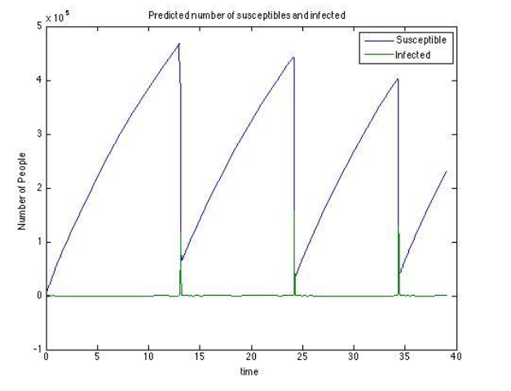

Figure 6: Four Age Group Susceptible and Infected

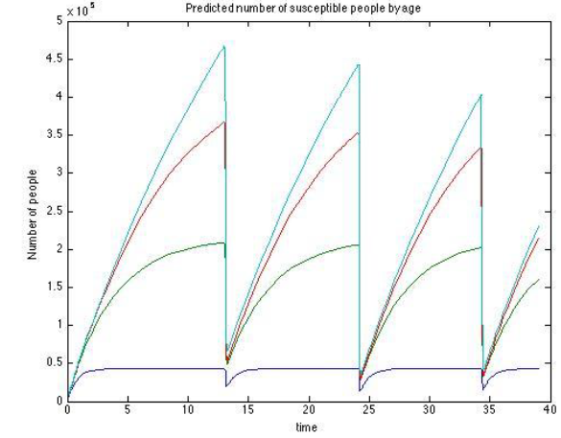

Figure 7: Four Age Group Predicted Susceptible

Next for the Eight-Age Group Prevention Model, Figure 8, depict the results of the predicted number of susceptible (thousands) and infected (hundreds) in ages 0.5-25 years. Also, Figure 9, shows just the Predicted number of susceptible in each age group for the Eight-Age Group Model.

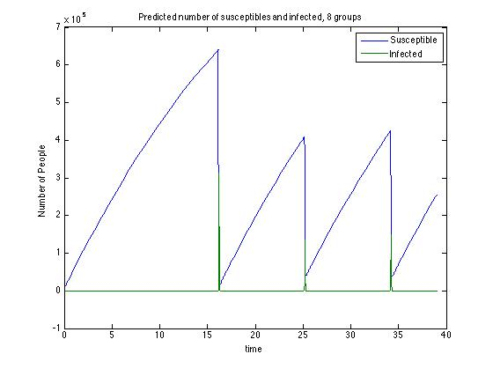

Figure 8: Predicted number of susceptible (thousands) and infected (hundreds) in ages 0.5-25 years, for Eight-Age Group Model.

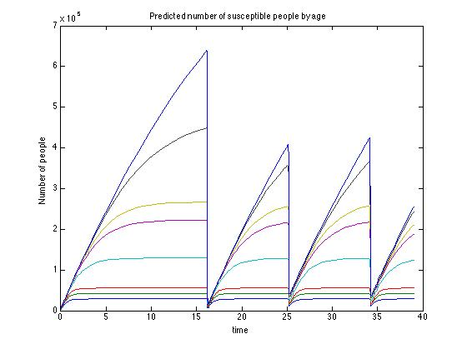

Figure 9: Predicted number of susceptible in Eight-Age Group classes.

## **4.1 Reproductive Number**

For the phenomena in the Four-Age Group Model the set of parameters that led to the best fit of model output to the historical timing of epidemics was consistent with a basic reproduction ratio (R0) equal 12.58 (ignoring seasonality). The value of R0 depends on the biological characteristics of the disease, and the social conditions under which it is transmitted. Our estimate is consistent with values of R0 between 12 and 13 quoted for measles in the United Kingdom and United States of America [10]. In addition, the Eight-Age Group Model. the reproductive number is R0=51.79. After obtain those results we choose to conduct the research with various vaccination strategies, denoted Rv. The Rv is used to show the steady states of the vaccination strategies thus the reproductive numbers vary which can be seen in Table 3.

Also in Table 3 we notice that when conducting the research at 20% to 30% of the population vaccinated there is a significant drop when it comes to the Rv for the Eight Age-Group. Since there is only limited evidence on the impact of different strategies for controlling measles, the consensus is that the most important factor is high coverage when most of the population is vaccinated.

**Table 3: Reproductive Numbers (Rv)**

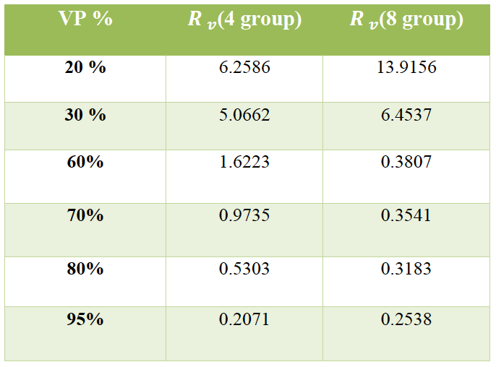

# **5. Conclusions & Future Work**

The motivation behind this research stirs from the exposure to the synthesis of mathematical applications with computational software and simulation models. In addition, I am able to use MATLAB (matrix laboratory) to do numeric computation, data analysis and visualizations, programming and algorithm development and these skills I can use in future research. This research helps me understand how computers and math are used to understand infections and how they spread.

In conclusion, the SI/SVI model with the estimated parameters, we are able to capture the endemic cycles in the history and to predict the possible future outbreaks of measles under various vaccination strategies. This research numerical simulation results captured the endemic cycles in the history and can be used to predict the possible future outbreaks of measles under various vaccination strategies. For my future simulation experiments, there will be numerical simulations to further explore the effects of some chosen parameters on the system dynamics. Also, explore various vaccination rates for difference age groups.

## **References**

[1] Roberts, M. G. and Tobias, M. I., Predicting and preventing measles epidemics in New Zealand: Application of a Mathematical Model. Epidemiol. Infect. (2000) 124, 279-281.

[2] Liu, X, Takecuchi, Y., Iwami, S., A Mathematical Investigation of Vaccination Strategies to Prevent Measles Epidemics. Journal of Theoretical Biology 253 (2008) 1–11.

[3] Scherer, A., McLean, A., Mathematical models of Vaccination. The British Council 2002. British Medical Bulletin 2002;62: 187–199.

[4] Mayo Clinic Staff. "Measles." Mayo Clinic. N.p., 4 May 2014. Web. <http://www.mayoclinic.org/diseases-conditions/measles/basics/definition/con-20019675>.

[5] The MathWorks Inc. "Mathlab Documentation Manual." MATLAB. N/A, n.d. Print.

[6] [1] Sauer, Timothy. *Numerical Analysis- Runge-Kutta Method*. Boston: Pearson Education, Inc. 2012. Print Pg. 316.

[7] Stone, L., B. Shulgin, and Z. Agur. "Theoretical Examination of the Pulse Vaccination Policy in the SIR Epidemic Model." Mathematical and Computer Modelling 31.4-5 (2000): 207-15.

[8] Stone, L., B. Shulgin, and Z. Agur. "Theoretical Examination of the Pulse Vaccination Policy in the SIR Epidemic Model." *Mathematical and Computer Modelling* 31.4-5 (2000): 207-15.

[9] Diekmann, O., J. A. P. Heesterbeek, and M. G. Roberts. "The Construction of Next-generation Matrices for Compartmental Epidemic Models." *Journal of The Royal Society Interface* 7.47 (2009): 873-85.

[10] Edelstein-Keshet L. *Mathematical Models in Biology*. New York: Random House, 1988.