Table S5. Papers and effect sizes in the primary analysis pool, by region. Studies reporting a northeastern state are labeled Northeastern U.S. rather than Other.
Region | Papers | Records
Other | 38 | 456
Great Plains | 32 | 401
Southeastern U.S. | 20 | 147
Europe | 12 | 39
Northeastern U.S. | 5 | 12
Multiple regions | 3 | 35
South America | 2 | 2

Table S6. Papers and effect sizes in the primary analysis pool, by best management practice and region.
BMP | Region | Papers | Records
Avoid Haying During Nesting Season | Northeastern U.S. | 2 | 4
Avoid Haying During Nesting Season | Europe | 2 | 3
Promote Edge and Shrub Habitat | Other | 11 | 104
Promote Edge and Shrub Habitat | Southeastern U.S. | 10 | 35
Promote Edge and Shrub Habitat | Great Plains | 2 | 6
Promote Edge and Shrub Habitat | Northeastern U.S. | 2 | 3
Promote Edge and Shrub Habitat | Europe | 1 | 2
Eliminate Pesticides | Europe | 7 | 31
Eliminate Pesticides | Great Plains | 2 | 10
Eliminate Pesticides | Other | 2 | 31
Eliminate Pesticides | Multiple regions | 1 | 25
Install Nest-Boxes | Other | 1 | 3
Install Nest-Boxes | Southeastern U.S. | 1 | 6
Install Nest-Boxes | Europe | 1 | 2
Manage Fields in Patches | Great Plains | 3 | 11
Manage Fields in Patches | Other | 2 | 18
Plant Native Grasses and Forbs | Great Plains | 11 | 60
Plant Native Grasses and Forbs | Other | 8 | 87
Plant Native Grasses and Forbs | Southeastern U.S. | 4 | 13
Plant Native Grasses and Forbs | Multiple regions | 1 | 6
Implement Prescribed Fire | Great Plains | 10 | 215
Implement Prescribed Fire | Other | 9 | 72
Implement Prescribed Fire | Southeastern U.S. | 2 | 14
Implement Prescribed Fire | Multiple regions | 1 | 4
Provide Overwintering Structure and Resources | Southeastern U.S. | 6 | 25
Provide Overwintering Structure and Resources | Other | 4 | 69
Provide Overwintering Structure and Resources | Great Plains | 1 | 12
Reduce Grazing Intensity | Great Plains | 2 | 21
Reduce Grazing Intensity | Other | 1 | 1
Reduce Grazing Intensity | Europe | 1 | 1
Reduce Grazing Intensity | Southeastern U.S. | 1 | 4
Remove Non-native Shrubs | Other | 4 | 37
Remove Non-native Shrubs | Great Plains | 1 | 31
Rotate Livestock Between Pastures | Great Plains | 5 | 35
Rotate Livestock Between Pastures | South America | 2 | 2
Rotate Livestock Between Pastures | Other | 1 | 6
Rotate Livestock Between Pastures | Northeastern U.S. | 1 | 5
Rotate Livestock Between Pastures | Southeastern U.S. | 1 | 2
Exclude Livestock From Streams and Plant Vegetative Buffers | Other | 3 | 28
Exclude Livestock From Streams and Plant Vegetative Buffers | Southeastern U.S. | 2 | 48

Table S7. Located studies by geography, those holding a modeled effect size against those screened out.
Grain | Place | Continent | Included | Excluded | Total
Continent | North America |  | 0 | 5 | 5
Country | Canada | Americas | 9 | 42 | 51
Country | France | Europe | 2 | 10 | 12
Country | Spain | Europe | 1 | 9 | 10
Country | Argentina | Americas | 1 | 8 | 9
Country | United States | Americas | 0 | 8 | 8
Country | Italy | Europe | 2 | 5 | 7
Country | United Kingdom | Europe | 1 | 6 | 7
Country | Australia | Oceania | 2 | 5 | 7
Country | Switzerland | Europe | 1 | 5 | 6
Country | Netherlands | Europe | 1 | 5 | 6
Country | Sweden | Europe | 1 | 4 | 5
Country | South Africa | Africa | 1 | 4 | 5
Country | Germany | Europe | 1 | 3 | 4
Country | Portugal | Europe | 0 | 4 | 4
Country | Czech Republic | Europe | 0 | 4 | 4
Country | Hungary | Europe | 1 | 2 | 3
Country | Slovenia | Europe | 0 | 2 | 2
Country | Poland | Europe | 0 | 2 | 2
Country | Finland | Europe | 1 | 1 | 2
Country | Ireland | Europe | 0 | 2 | 2
Country | Russian Federation | Europe | 1 | 1 | 2
Country | Bulgaria | Europe | 0 | 1 | 1
Country | Estonia | Europe | 0 | 1 | 1
Country | Ethiopia | Africa | 0 | 1 | 1
Country | Colombia | Americas | 0 | 1 | 1
Country | Uruguay | Americas | 1 | 0 | 1
Country | Mexico | Americas | 0 | 1 | 1
Country | Scotland | Europe | 0 | 1 | 1
Country | China | Asia | 0 | 1 | 1
Province | Saskatchewan | Americas | 5 | 13 | 18
Province | Ontario | Americas | 2 | 16 | 18
Province | Alberta | Americas | 1 | 8 | 9
Province | Quebec | Americas | 1 | 5 | 6
Province | Manitoba | Americas | 1 | 4 | 5
Province | British Columbia | Americas | 2 | 1 | 3
Province | Nova Scotia | Americas | 0 | 1 | 1
State | Kansas | Americas | 6 | 20 | 26
State | Iowa | Americas | 10 | 14 | 24
State | Missouri | Americas | 5 | 19 | 24
State | Illinois | Americas | 6 | 16 | 22
State | Nebraska | Americas | 4 | 16 | 20
State | Oklahoma | Americas | 5 | 14 | 19
State | Mississippi | Americas | 10 | 7 | 17
State | North Dakota | Americas | 4 | 13 | 17
State | Texas | Americas | 4 | 12 | 16
State | New York | Americas | 3 | 11 | 14
State | Wisconsin | Americas | 3 | 11 | 14
State | California | Americas | 1 | 13 | 14
State | Vermont | Americas | 3 | 10 | 13
State | Minnesota | Americas | 1 | 11 | 12
State | Montana | Americas | 2 | 10 | 12
State | Colorado | Americas | 2 | 9 | 11
State | South Dakota | Americas | 2 | 9 | 11
State | Florida | Americas | 3 | 7 | 10
State | Pennsylvania | Americas | 2 | 6 | 8
State | Kentucky | Americas | 2 | 5 | 7
State | Tennessee | Americas | 1 | 6 | 7
State | North Carolina | Americas | 5 | 2 | 7
State | Ohio | Americas | 3 | 4 | 7
State | Wyoming | Americas | 0 | 5 | 5
State | Maryland | Americas | 2 | 3 | 5
State | Michigan | Americas | 1 | 4 | 5
State | Massachusetts | Americas | 0 | 4 | 4
State | Indiana | Americas | 1 | 3 | 4
State | Arkansas | Americas | 1 | 3 | 4
State | Washington | Americas | 2 | 2 | 4
State | New Jersey | Americas | 1 | 2 | 3
State | Arizona | Americas | 1 | 2 | 3
State | Oregon | Americas | 0 | 3 | 3
State | South Carolina | Americas | 1 | 2 | 3
State | Louisiana | Americas | 0 | 3 | 3
State | Virginia | Americas | 1 | 2 | 3
State | Georgia | Americas | 0 | 3 | 3
State | New Mexico | Americas | 0 | 2 | 2
State | Alabama | Americas | 1 | 1 | 2
State | West Virginia | Americas | 0 | 2 | 2
State | Utah | Americas | 0 | 1 | 1
State | Nevada | Americas | 0 | 1 | 1
State | Delaware | Americas | 0 | 1 | 1
State | New Hampshire | Americas | 0 | 1 | 1
State | Maine | Americas | 0 | 1 | 1
State | Rhode Island | Americas | 0 | 1 | 1
State | Connecticut | Americas | 0 | 1 | 1
State | Idaho | Americas | 0 | 1 | 1

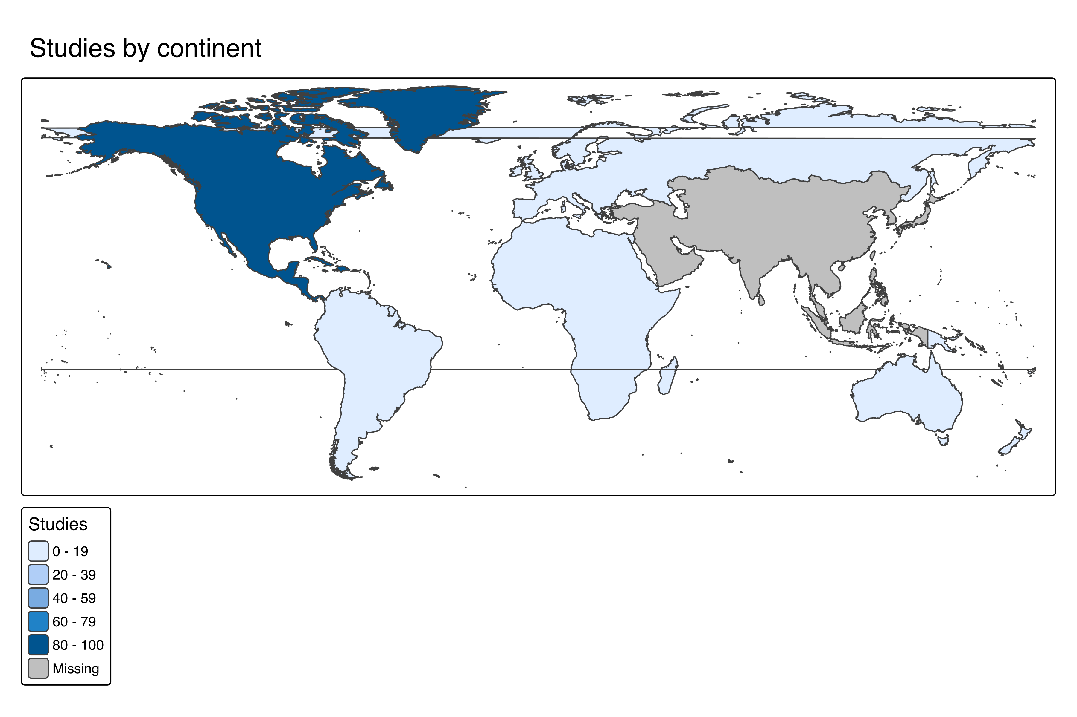
Figure S6. Studies by continent.

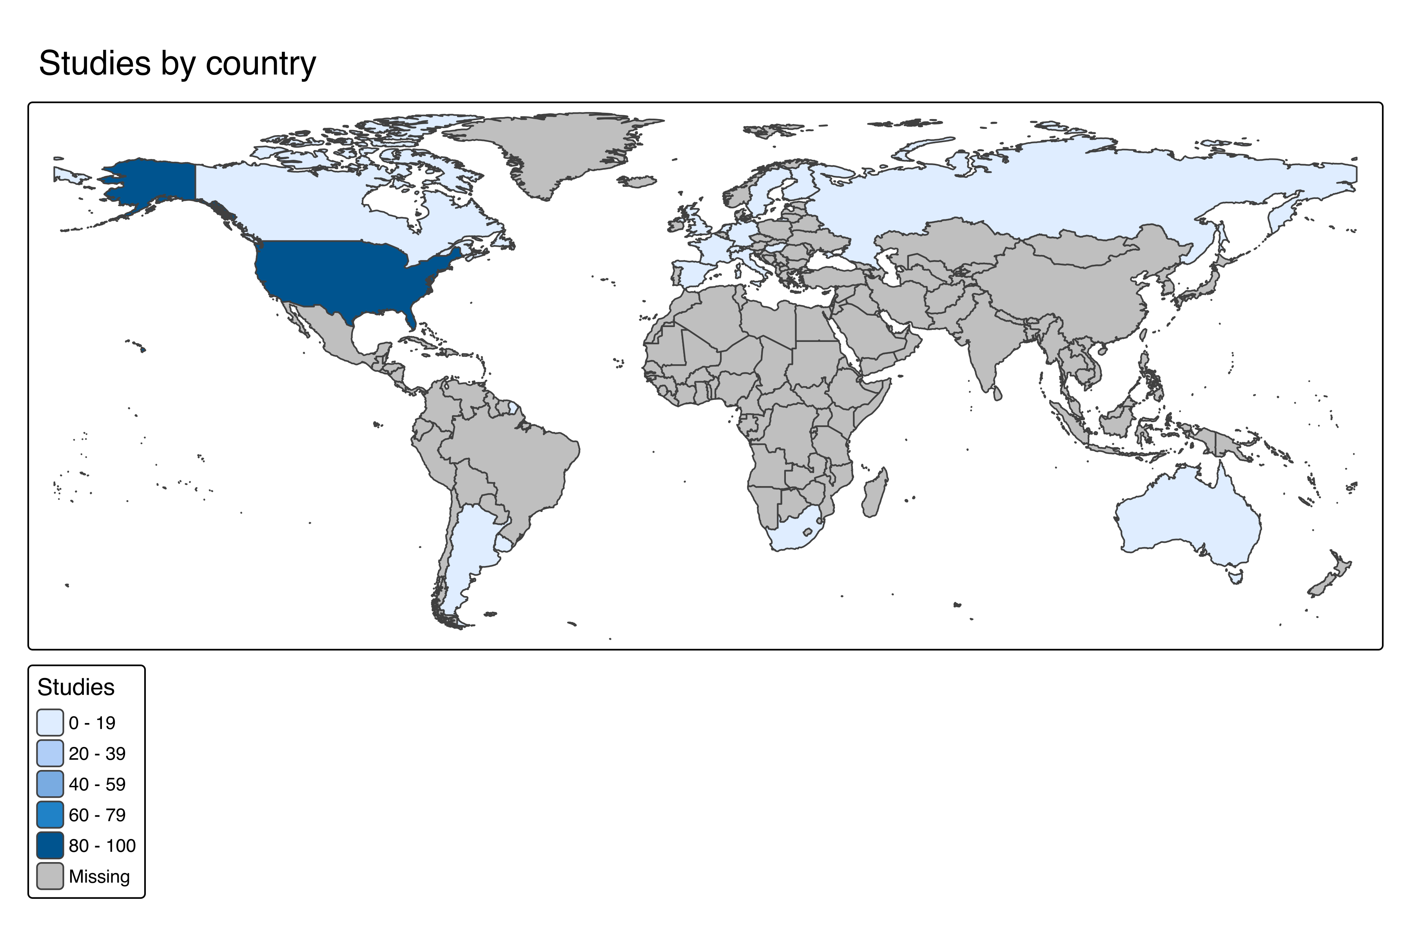
Figure S7. Studies by country.

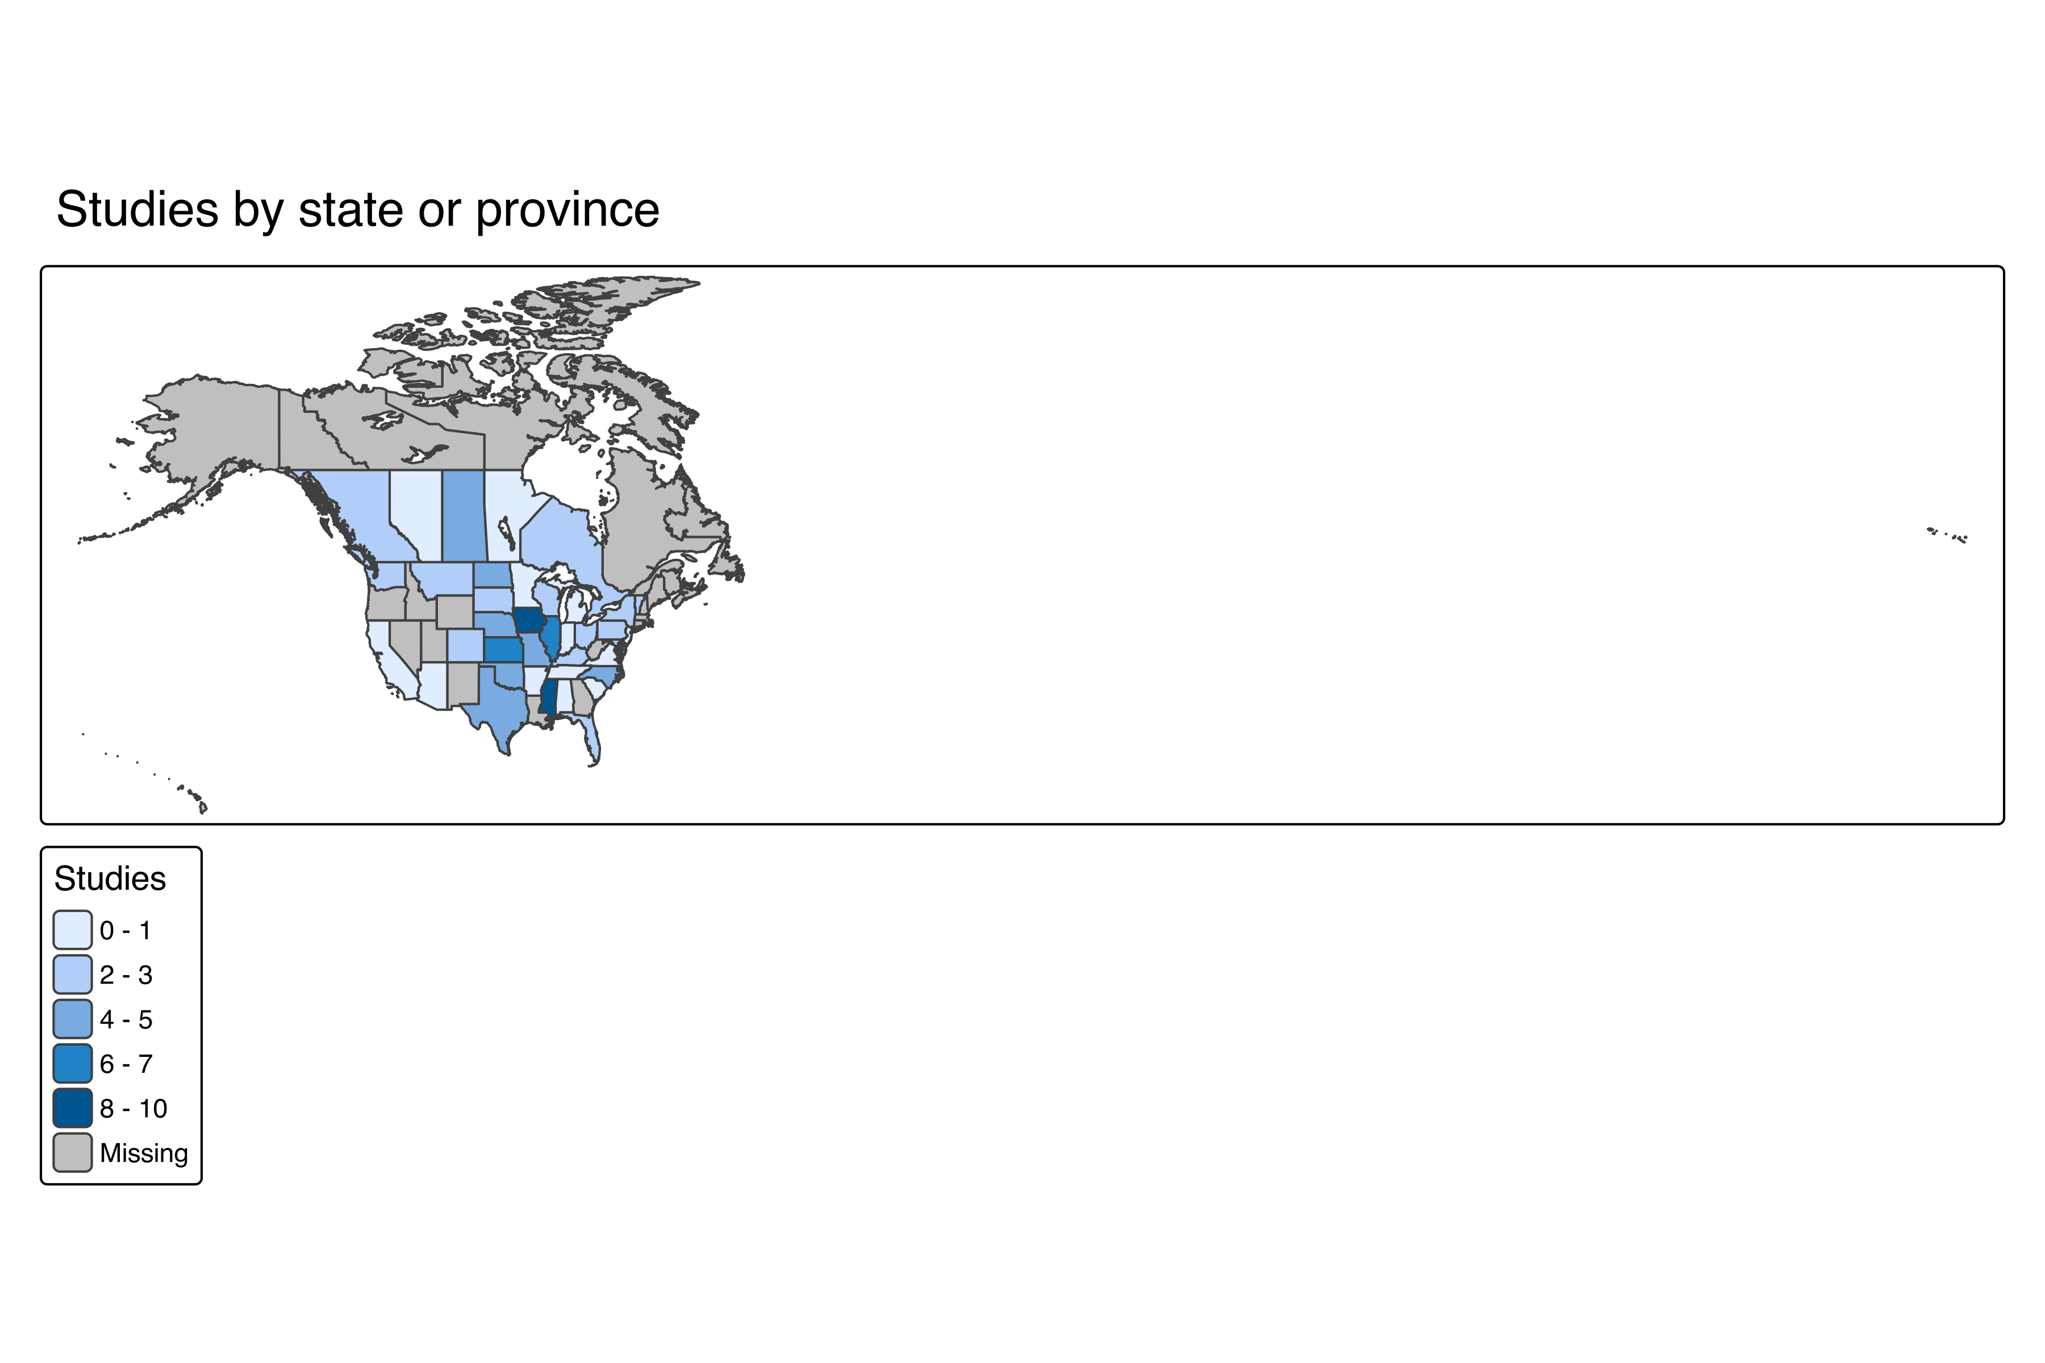
Figure S8. Studies by state or province.

