

**CHUKA UNIVERSITY**

**FACULTY OF SCIENCE, ENGINEERING AND TECHNOLOGY**

**DEPARTMENT OF COMPUTER SCIENCE**

**EVANS MBITHI IKINDU**

**EB3/32922/17**

**ACSC 484: SOFTWARE PROJECT II**

**E-SACCO SYSTEM**

**SUPERVISOR:**

**MR KEVIN GOGO**

**Report submitted to the department of computer science in a particular fulfillment of the requirements for the degree of Bachelor of Science Applied Computer Science.**

# **DECLARATION**

**DECLARATION BY THE STUDENT**

I………………………………………………………declare that this is my original work and has not been presented anywhere else for academic purpose.

Sign……………………

Date……………………

**CONFIRMATION BY THE SUPERVISOR**

I…………………………………………………….confirm this report has been submitted by IKINDU EVANS MBITHI with my approval as the university supervisor.

Sign……………………

Date…………………...

# **ACKNOWLEDGEMENT**

I acknowledge the almighty God for the gift of life and strength to proceed successfully in my pursuit of knowledge. Many thanks to my institutional supervisor Mr. Kevin Gogo for offering guidance where due. My gratitude also goes to my parents for their relentless support and guidance. My heart and prayers are always with you.

**TABLE OF CONTENTS**

DECLARATION i

ACKNOWLEDGEMENT ii

LIST OF TABLES v

LIST OF FIGURES vi

CHAPTER 1: INTRODUCTION 1

1.1 Background 1

1.2 Problem statement 1

1.3 Proposed solution 2

1.4 Aim of the project 2

1.5 Objectives 2

1.6 Significance of the project 2

CHAPTER 2: LITERATURE REVIEW 3

2.1 introduction 3

2.2 SACCO Management 3

2.3 Process Automation 3

CHAPTER 3: METHODOLOGY 5

Data collection methods 5

Challenges encountered 5

Technology to be used 5

CHAPTER 4: TIME PLAN 6

CHAPTER 5: SYSTEM ANALYSIS 7

5.1 Introduction 7

5.2 The current system 7

5.3 Intended system 7

CHAPTER 6: SYSTEM DESIGN 8

6.1 Introduction 8

6.2 Process Flow 8

6.3 Interface Design 9

6.4 Database Design 11

CHAPTER 7: IMPLEMENTATION 13

7.1 Introduction 13

7.2 System Interface 13

CHAPTER 8: SYSTEM TESTING 18

8.1 Introduction 18

8.2 Functional Testing 18

8.3 Security Testing 19

CHAPTER 9: CONCLUSION 22

9.1 Achievement of the aim 22

9.2 Skills Learnt 22

9.3 Challenges 22

9.4 Future Work 22

References 23

# **LIST OF TABLES**

Table 1: Time-plan Gantt chart 6

Table 2: User -login_tbl 11

Table 3:Member_details_tbl 11

Table 4: Savings_tbl 11

Table 5: Loans_tbl 11

Table 6: Loan_repayment_tbl 11

Table 7: Guarantor_details_tbl 11

# **LIST OF FIGURES**

Figure 1: Process flow diagram 8

Figure 2: Login form design 9

Figure 3:Registration form design 10

Figure 4: Entity relationship diagram 12

Figure 5: User login form 13

Figure 6: User registration form 14

Figure 7: Member registration form 15

Figure 8: Member verification 16

Figure 9: User dashboard 17

Figure 10: Functional Testing 18

Figure 11: Confidentiality testing 19

Figure 12: Authentication 20

Figure 13: Hash function 20

Figure 14: Form sanitizer class 21

Figure 15: Future work integrations 22

# **CHAPTER 1: INTRODUCTION**

Specialized software is becoming more and more popular among SACCOs and MFIs (Micro Finance Institutions). As compared to a regular Excel spreadsheet, such software is designed to monitor the dynamics of a microfinance organization or SACCO. It handles Member information and tracks the Savings and Loan activity with ease rendered over a secure intranet accessible via any standard web browser. This system, however utilizes the power of distributed processing where members can access quick information on their accounts, savings and loan balances through a detailed portal. This project focusses on the case study of a youth self-help group called ‘Ushindi SACCO’ and provides a system that enhances efficiency, accessibility and accountability of all the SACCO operations , as well as a self-service portal for members.

## **Background**

The name SACCO is an acronym for Savings And Credit Cooperative Organization. Main activities include accumulation of member deposits, reinvestment of the deposit in low risk investments like Treasury Bonds, Fixed Deposit Schemes, and Real Estate among others. SACCOs also advance low interest rates and flexible credit facilities to her members. Interest from loan repayment forms one of the main sources of income. Profits at the close of a financial year may be paid back to members as dividends. SACCOs are the most common financial institutions in Eastern and Southern Africa. E-sacco Microfinance system started as a SACCCO management system, among the first clients to adopt it were public transport SACCOs, Farmers SACCOs, Employees SACCOs and Multipurpose SACCOs. E-sacco has revolved to accommodate all kinds of SACCOs, promoting accountability, transparency and easy compliance to regulatory policies. . The E-SACCO consists of modular based applications that integrate to provide a fully-fledged Enterprise level Software Suite to manage the needs of Savings management and Loan management. An integrated General Ledger and Accounts Management Module ensures that Accounts reporting can be handled without having to use a separate system to handle the same.

## **Problem statement**

People are still using manual management system. In Kenya, it is difficult to adopt the latest technology, but it is quite difficult to achieve efficiency and reliability using manual work. Notwithstanding, even the existing management software do not give members complete power to gain mutual trust and manage their information. Things are not difficult, we make them difficult. To capture members’ savings, and keep track of loans borrow, SACCOs still do it manually rather than just running a simple software which makes the work simple. However, having a platform that is easily available to every member would keep them motivated to save more and keep track of loans easily.

## **Proposed solution**

Specialized software portals would be of great significance among SACCOs and MFIs (Micro Finance Institutions). As compared to a regular Excel spreadsheet, such software is designed to monitor the dynamics of a microfinance organization or SACCO. E-SACCO portals would allow SACCO and MFI services to be more interactive, accessible and transparent. Moreover, this platform would provide easy access to accurate and up-to-date information among its members.

## **1.4 Aim of the project**

The aim of this system is to help SACCO and MFI services to be more interactive, accessible and transparent. The E-SACCO aims to provide easy access to accurate and up-to-date information. For example, loan officers get information on loans that need follow-up; the SACCO management can monitor daily progress of the SACCO operations, and can get a full picture of the portfolio performance and quality. Members also get quick information on their accounts, savings and loan balances through a detailed portal. Activities, such as disbursements, repayments, deposits, withdrawals and money transfers can be completed faster and better controlled as the member pleases. From the portal, SACCO members can view their statements, request for loans, appoint loan guarantors, approve or reject requests from fellow members to guarantee their loans and directly send a message to the SACCO.

## **1.5 Objectives**

* To enhance interactivity, accessibility and transparency of SACCO services.
* To provide easy access to accurate and up-to-date information.
* To provide a self-service portal for SACCO members.
* To allow loan officers get information on loans that need follow-up

## **1.6 Significance of the project**

SACCOs and MFIs would benefit greatly from this project. This system is designed to track the dynamics of a microfinance company or SACCO, as opposed to the traditional Excel spreadsheet or in-house SACCO management software. SACCO and MFI services would be more participatory, accessible, and transparent with the use of e-SACCO portals. Furthermore, this platform would allow members to easily access accurate and up-to-date information.

# **CHAPTER 2: LITERATURE REVIEW**

## **2.1 introduction**

The Savings and Credit Cooperative Societies (SACCOS) are financial co-operatives that aim at meeting the financial needs of all members’ men/women, old/young, rich/poor in particular, by Encouraging savings and granting loans to the members. It belongs to its members who manage it (TUMWINE, 2015). The primary purpose of the SACCO is to encourage savings among members from which they can borrow at affordable terms decided by them collectively or through the elected directors. Other services SACCOs offer include asset management, mobile money transfer and custody of valuable documents. The SACCO generates income by providing these services which it uses to meet the related costs. Any income that remains after these costs is paid out to members as dividends and interest based on their shares or deposits (Kiragu, 2014).

## **2.2 SACCO Management**

According to Mwangi (2015) SACCOs are managed by staff employed by the Board on behalf of the members and the Chief Executive Officer is responsible for the day-to-day running of the SACCO business. The Board reports to the members on the management of the SACCO at least once a year during the annual general meeting (AGM) or annual delegates meeting (ADM). During the AGM or ADM, the members also get a chance to assess the performance of a SACCO and make decisions concerning their SACCO. SACCO Membership is open to all Kenyans regardless of race, tribe, gender, political affiliation, religion or job status. The common bond that unites all members of a SACCO is what all the members share in common. The members decide on what unites them this could be their occupation like employment, church, farming or where they live. SACCOs are categorized into financial and non-financial cooperatives.

Non-financial cooperatives deal with the marketing of members’ produce and services such as dairy, livestock coffee, tea, handicrafts and many more similar cooperatives. On the other hand financial cooperatives comprise SACCOs, housing and investment cooperatives. A member of the SACCO is a person admitted to membership after registration in accordance with the SACCO’s by-laws. KUSSCO (2018) states the objectives of SACCOs are mainly to organize, promote welfare and economic interests of its members, provide source of fair loans and reasonable rates of interest, and ensure progress of members through continuous education programs, reduction of poverty, human dignity and cooperation and promote personal growth through introduction of new products and services which promote economic base of its members.

## **2.3 Process Automation**

The process of how the SACCO works may be tiresome, bound to make errors and costly in terms of employment of manpower to carry out some of these operations like bookkeeping if manual records are kept (Kibande, 2019). Specialized software is becoming more and more popular among SACCOs and MFIs (Micro Finance Institutions). As compared to a regular Excel spreadsheet, such software is designed to monitor the dynamics of a microfinance organization or SACCO. E-sacco Microfinance system started as a SACCCO management system, among the first clients to adopt it were public transport SACCOs, Farmers SACCOs, Employees SACCOs and Multipurpose SACCOs. E-sacco has evolved to accommodate all kinds of SACCOs, promoting accountability, transparency and easy compliance to regulatory policies. The E-SACCO consists of modular based applications that integrate to provide a fully-fledged Enterprise level Software Suite to manage the needs of Savings management and Loan management.

An integrated General Ledger and Accounts Management Module ensures that Accounts reporting can be handled without having to use a separate system to handle the same. Today, SACCOs have evolved to serverless platforms that use cloud-based solutions. According to KIHORO and Ndegwa (2019), the motivation is to avoid server-based applications which require heavy investments and instead ride on the secure google cloud-based services for the development and deployment of the system. While the system is entirely dependent on google cloud apps, the user is provided with a mobile App which directly connects to the google sheets for individualized reports and formatted member information. The user only needs to use a device which senses gmail login in order to provide SACCO information at a click of a button. Both data capturing and visualization processes are managed in a single web interface, bringing easy-to-use benefits to end users.

# **CHAPTER 3: METHODOLOGY**

## **Data collection methods**

* **Dcument review**

The researcher was involved in going through various system documentations, as well as journals and articles about E-SACCOs that exist.

* **Observation**

The researcher was also involved in carrying out physical observation of SACCO operations by attending meetings of the self-help groups around.

## **Challenges encountered**

The major challenge encountered in the course of this project was time management. Other than this project, the student had been involved in coursework assignments and tight schedules. This was an added strain on the researcher as it was merely impossible to balance all the load in a squeezed timeframe.

## **Technology to be used**

**PHP Laravel framework**: The framework was used to facilitate rapid system development through the MVC architecture.

**MySQL**: this was the tool that was used for database querying and management of tables.

# **CHAPTER 4: TIME PLAN**

|  |  |  |  |  |  |  |
| --- | --- | --- | --- | --- | --- | --- |
| **Dates** | **Planning and Budgeting** | **Literature review** | **System Analysis** | **System Design** | **System Development** | **Implementation and Testing** |
| **January 11** |  |  |  |  |  |  |
| **January 18** |  |  |  |  |  |  |
| **February 1** |  |  |  |  |  |  |
| **February 12** |  |  |  |  |  |  |
| **February 15** |  |  |  |  |  |  |
| **March 5** |  |  |  |  |  |  |
|  |  |  |  |  |  |  |
| **August 2** |  |  |  |  |  |  |
| **September 6** |  |  |  |  |  |  |
| **September 10** |  |  |  |  |  |  |

Table 1: Time-plan Gantt chart

# **CHAPTER 5: SYSTEM ANALYSIS**

## **5.1 Introduction**

This project focusses on the case study of a youth self-help group called ‘Ushindi SACCO’ and provides a system that enhances efficiency, accessibility and accountability of all the SACCO operations , as well as a self-service portal for members. Ushindi SACCO is a growing urban SACCO with its headquarters in Nairobi. This being a group of young urban people, they are always upto date with the latest technology. However, most of their SACCO operations have often been manual and hectic. An automated system would definitely come in handy to enhance efficiency and also provide transparency through a detailed self-service portal.

## **5.2 The current system**

Ushindi SACCO majorly relied on spreadsheets to store information. However, this was a rather hectic and manual way of managing data. This also brought about trust issues among members, since information was only available to the record keeper. It had become even more problematic following up on unpaid loans. This lead to members defaulting and others getting demotivated to save up their monthly dues.

## **5.3 Intended system**

The requirements for the intended system were categorized as functional and nonfunctional requirements.

**Non-functional requirements**

* Loan and Shares adjustments for the current month/period.
* Cash remittance on loan, shares and interest.
* Cash refund on loan, shares and interest.
* Repayment and contribution rate adjustment on loans and shares.
* Registering new member loans, repayment amount, and loan guarantors.

**Functional requirements**

* Report on loan status
* Calculate members’ savings
* Compute interest rates on loans
* Compute members’ dividends

**System Requirement**

a) Any PC or Device with Standard Web Browser with Internet will access the system online.

b) Internet source

# **CHAPTER 6: SYSTEM DESIGN**

## **6.1 Introduction**

This chapter provides a conceptual framework by wire framing an abstract of how the system will look like.

## **6.2 Process Flow**



Figure 1: Process flow diagram

## **6.3 Interface Design**

Login interface



Figure 2: Login form design

Registration design



Figure 3:Registration form design

## **6.4 Database Design**

**Tables**

User-login_table

|  |  |  |  |  |
| --- | --- | --- | --- | --- |
| **\* User_ID** | **First_name** | **Second_name** | **Email** | **Password** |
|  |  |  |  |  |
|  |  |  |  |  |

Table 2: User -login_tbl

Member_details

|  |  |  |  |  |  |
| --- | --- | --- | --- | --- | --- |
| **\* Member_ID** | **No. of shares** | **Occupation** | **Address** | **Tel** | **User_ID** |
|  |  |  |  |  |  |
|  |  |  |  |  |  |

Table 3:Member_details_tbl

Savings_table

|  |  |  |  |
| --- | --- | --- | --- |
| **\* Savings_ID** | **Amount** | **Date** | **Member_ID** |
|  |  |  |  |
|  |  |  |  |

Table 4: Savings_tbl

Loans_table

|  |  |  |  |  |
| --- | --- | --- | --- | --- |
| **\* Loan_ID** | **Loan_type** | **Amount** | **Date_of_application** | **Member_ID** |
|  |  |  |  |  |
|  |  |  |  |  |

Table 5: Loans_tbl

Loan-repayment_table

|  |  |  |  |
| --- | --- | --- | --- |
| **\* LoanPay_ID** | **Amount** | **Date_paid** | **Member_ID** |
|  |  |  |  |
|  |  |  |  |

Table 6: Loan_repayment_tbl

Guarantor_details

|  |  |  |  |
| --- | --- | --- | --- |
| **\* Guarantor_ID** | **Guaranteed_amount** | **Member_ID** | **Loan_ID** |
|  |  |  |  |
|  |  |  |  |

Table 7: Guarantor_details_tbl

Relationships

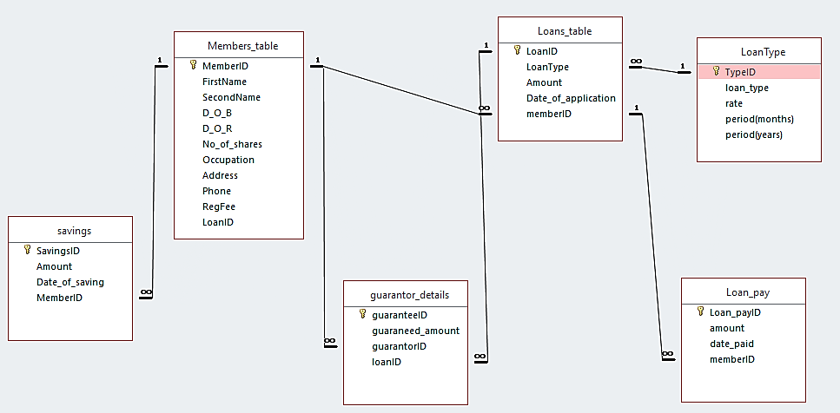

Figure 4: Entity relationship diagram

# **CHAPTER 7: IMPLEMENTATION**

## **7.1 Introduction**

This chapter describes how the system design was implemented into a functional system. It involves the look and feel of system, usability and reliability of the system. The sections section ensures that the system is usable and meets all user and system requirements.

## **7.2 System Interface**

**User login form**

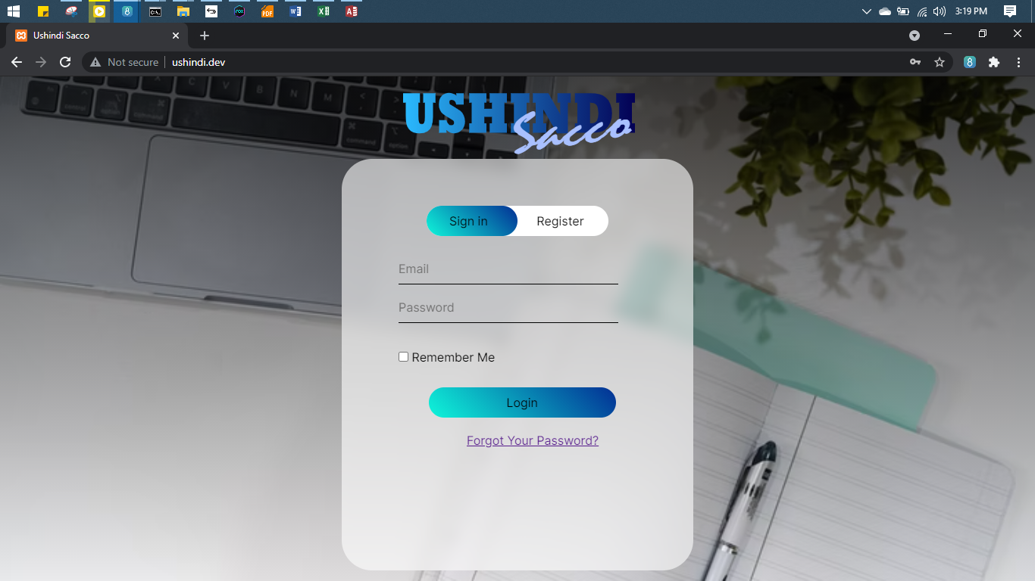

Figure 5: User login form

Allows access to members only

**User registration form**

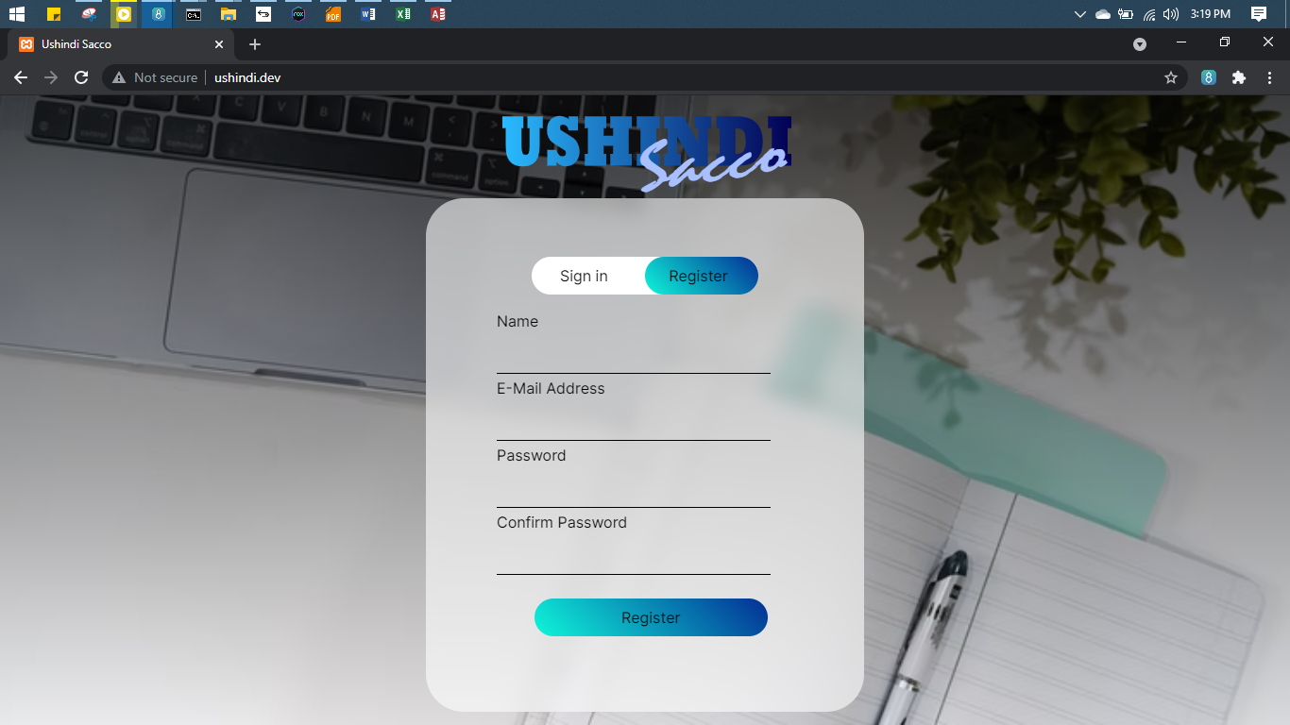

Figure 6: User registration form

Registers new users and verify user identity

**Member registration form**

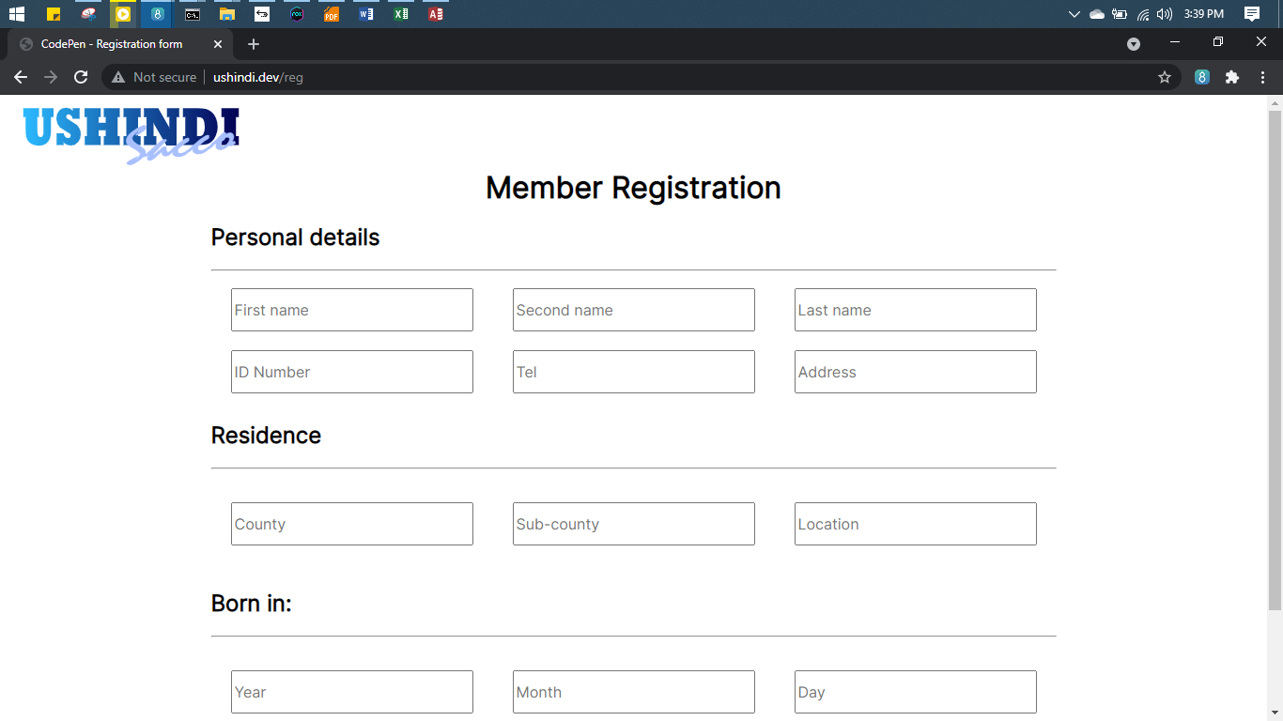

Figure 7: Member registration form

Registers new members to the SACCO upon registration

**Member verification**

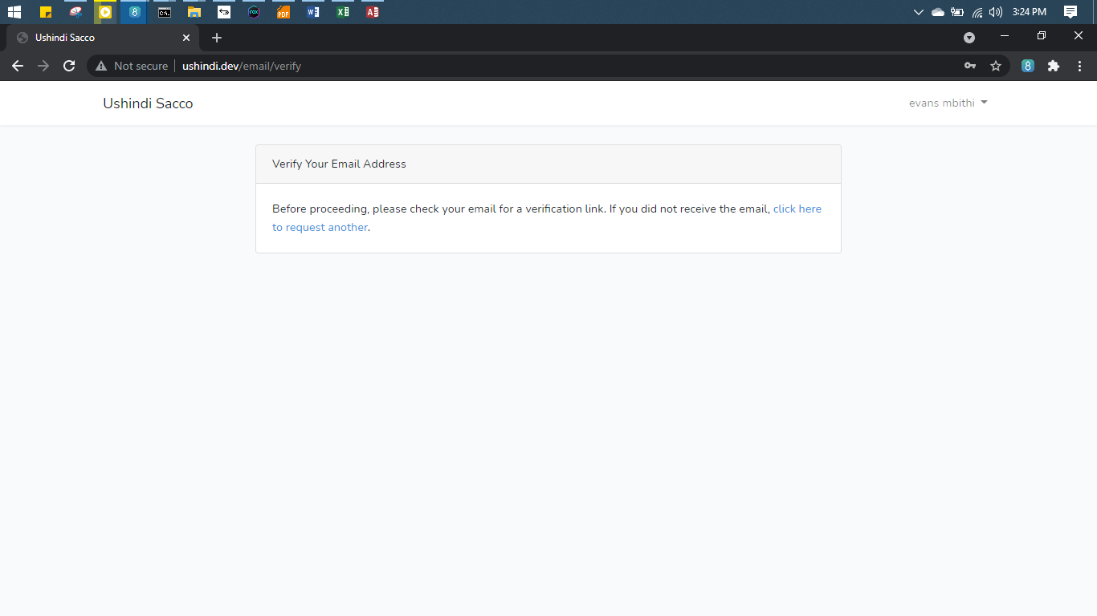

Figure 8: Member verification

Authenticates the true identity of members

**Member dashboard**

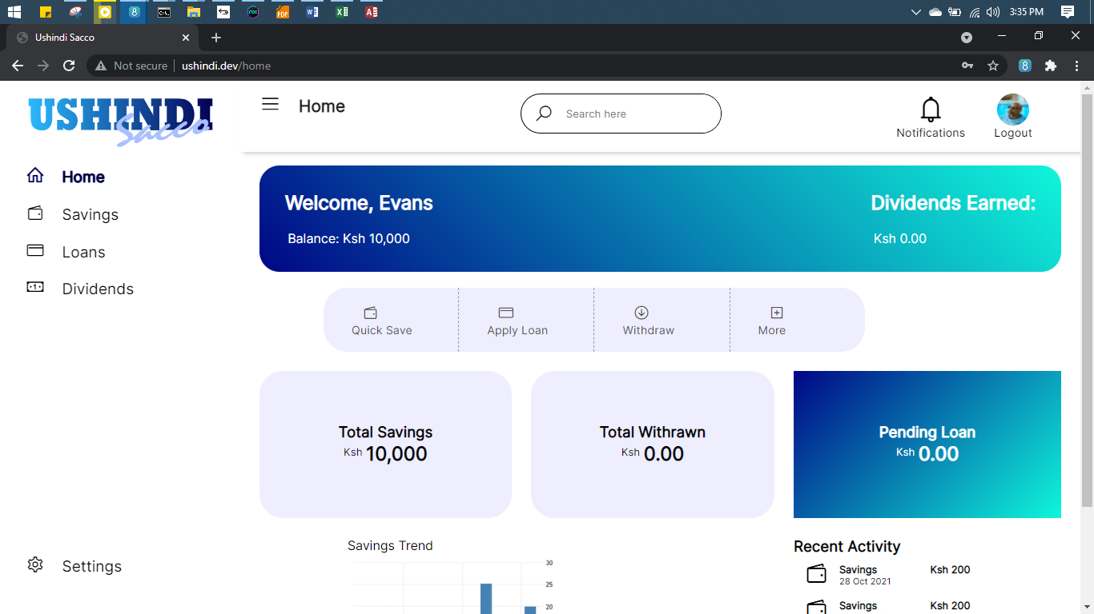

Figure 9: User dashboard

Provides an integrated portal with all operations on first view.

# **CHAPTER 8: SYSTEM TESTING**

## **8.1 Introduction**

This section analyzes the software attributes to check whether it meets the quality assurance standards. The chapter explains how the various components of the application interact together in the full, integrated system.

## **8.2 Functional Testing**

The system met the objective of accessibility and transparency among members by providing a detailed portal for users.



Figure 10: Functional Testing

## **8.3 Security Testing**

**Confidentiality**

The system ensured confidentiality of members’ information by restricting unauthorized access.

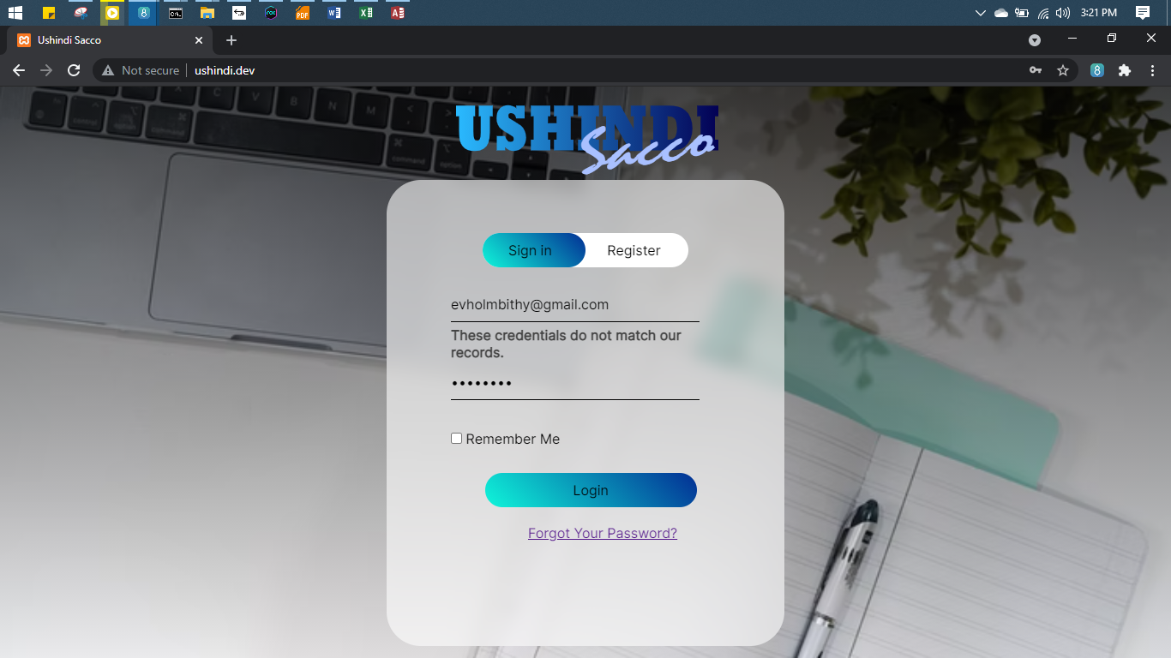

Figure 11: Confidentiality testing

**Authentication**

The system was ensured authentication by verifying a member’s real identity through email.



Figure 12: Authentication

**Hashing**

The system converted user passwords to a hash function “SHA 512”

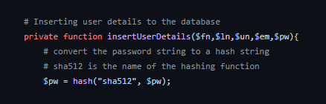

Figure 13: Hash function

**Form sanitizer**

The user input received was first passed through a FormSanitizer class where a sanitize function converted the string inputs to lowercase and removed irrelevant spaces before getting inserted to the database.

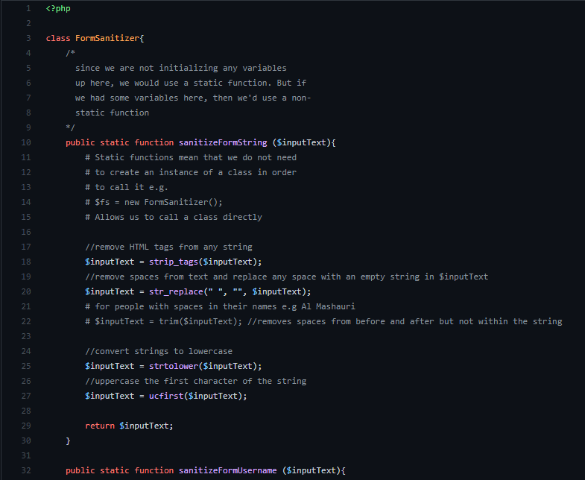

Figure 14: Form sanitizer class

# **CHAPTER 9: CONCLUSION**

## **9.1 Achievement of the aim**

The project was able to achieve a fraction of what it had targeted. The project accomplished the aim of making a more interactive, accessible and transparent system. The system was able to keep track of all recent and past activities for every user. Members also get quick information on their accounts, savings and loan balances through a detailed portal. Activities, such as disbursements, repayments, deposits, withdrawals and money transfers can be completed faster and better controlled as the member pleases. However, much of the administration side has been left out for future works due to the short time frame for making this project.

## **9.2 Skills Learnt**

The making of this project enabled the student to get an in depth coverage of the Model-View-Controller (MVC) architecture. This was well facilitated by the use of technologies such as the PHP Laravel Framework. Udemy, Youtube and LinkedIn Learning were major resources for learning the framework and technology used.

## **9.3 Challenges**

The major challenge encountered in the course of this project was time management. Other than this project, the student had been involved in coursework assignments and tight schedules. This was an added strain on the researcher as it was merely impossible to balance all the load in a squeezed timeframe.

## **9.4 Future Work**

There is still a lot of work to be done on this project. The software developer aims to finish up the administrative side of the system so that loan officers can get information on loans that need follow-up among other administrative functions. This system projects to scale up to production level with continuos Integration/Continuos Development (CI/CD). The system will later be integrated with Mpesa API for easy withdrawal and mobile transaction.

|  |  |
| --- | --- |
| **ITEM** | **DESCIPTION** |
| Mpesa API | for easy withdrawal and mobile transaction |
| USSD services | Integrate USSD services for customers easy access account by members |
| SMS alerts and Notification Modules | For easy communication and announcements |

Figure 15: Future work integrations

# References

Black, R. (2018, December 18). *system testing*. SearchSoftwareQuality. https://searchsoftwarequality.techtarget.com/definition/system-testing

D. (2015, October 18). *Sacco System Documentation*. Dokumen.Tips. https://dokumen.tips/documents/sacco-system-documentation.html

Kibande, M. (2019). *Automated SACCO management system for New Vision SACCO* (Doctoral dissertation).

KIHORO, J. M., & Ndegwa, P. (2019). Serverless Apps: A Google-drive-based Sacco Management System. *African Journal of Co-operative Development and Technology*, *4*(I), 36-40.

Kiragu, D. N. (2014). *The effect of Sacco societies regulatory authority’s regulations on financial performance of Saccos in Nairobi county* (Doctoral dissertation, University of Nairobi).

Mwangi, E., & Wambua, L. (2015). Factors influencing performance of Saccos in Kenya: A case of UNAITAS Sacco. *European Journal of Business and Strategic Management*, *1*(1), 20-38.

*Sacco Management System*. (2018, January 3). Microfinance Software System & Lending Platform - Jisort. https://www.jisort.com/sacco-management-system/

Tumwine, F., Mbabazize, M., & Shukla, J. (2015). Savings and credit cooperatives (SACCOs) services terms and members economic development in Rwanda: a case study of Zigama SACCO LTD. *International Journal of Community & Cooperative Studies, 3 (2), 1*, *56*.