
STORAGE AND BACKUP SYSTEM FOR KITENGELA CREATIVE STUDIO

SYSTEM DOCUMENTATION

SUBMITTED BY,
EVANS MUNENE
DIT-01-0285/2024

A SYSTEM DOCUMENTATION SUBMITTED IN PARTIAL FULFILMENT FOR THE AWARD OF DIPLOMA IN INFORMATION TECHNOLOGY BY ZETECH UNIVERSITY

OCTOBER 2025
CHAPTER ONE: PROJECT PLANNING AND ANALYSIS
(WORKPLAN)
  - Statement of Problem

The Kitengela Creative Studio has been experiencing frequent file loss among students and trainers, especially when working on creative projects such as animations, graphics, and video editing. This often results in wasted time, disrupted workflows, and in some cases, total loss of completed work. The situation is made worse by heavy reliance on unreliable storage devices like flash drives and memory cards, which are prone to damage and corruption (Backblaze, 2021). Most users have limited awareness of backup practices, and poor internet access further discourages the use of cloud-based solutions (UNESCO, 2023). As a result, files are rarely backed up, exposing users to risks such as accidental deletion, software crashes, or hardware failure (Norton, 2022). This persistent problem not only affects productivity but also compromises the quality and consistency of creative outputs. There is a growing need to develop affordable and practical strategies to improve digital storage and backup at the studio.

  - Study Justification

This study is important because it addresses the recurring issue of file loss at Kitengela Creative Studio, which negatively affects the productivity and learning outcomes of students and trainers. It aims to diagnose the root causes of the problem and explore how it impacts creative work in a training environment. By examining existing digital storage and backup solutions such as cloud services, external drives, and automated software the study will assess how these systems function, what technical skills or tools they require, and how long they may take to implement. This investigation will help simulate real-life solutions that respond directly to the identified challenges. Ultimately, the findings will offer a well-informed foundation for selecting a suitable solution or combination of solutions that can be developed

  - System Objectives
    - General Objective
- To develop a system that securely store data and run automatic data backups.

    - Specific Objectives
- To develop a safe login module where the users will sign up their details and access the system.

- To develop user dashboard module enabling users to upload and access the stored data.

- To develop a module that store user login data against their stored data and automatically backs up data once it is stored.

- To develop system admin module enabling the admin to receive the feedback for newly uploaded files, successful login as well as failed login also the module will allow the admin to approve signup details before user login data is stored, admin also will automatically receive backup logs of backed up files in real time.

  - Functional Requirements
User | User Activities | Features
Admin | Approve user registrations | Admin dashboard with signup approval panel
Admin | Monitor backup activities | Real-time backup logs display
Admin | Manage users and files | Add, Edit or delete user data and files
User | Register and login securely | Authentication with email and password
User | Upload files for storage and backup | File upload, storage and backup module with progress trucker
User | Access previously backed up files | File retrieval and download interface
User | View backup history | Backup history showing timestamp and file details
System Automated | Perform regular automatic backups | Schedule backup service
System Automated | Notify users and admin of successful backups | Email /notification alerts after backups
Table 1.4 Functional Requirements Table

  - Breakdown of Tools & Resources to Be Used

Category | Tools / Resources | Purpose / Description
Hardware | Computers / Laptops | Used for system development, testing, and documentation
Storage Devices | External Hard Drive / Cloud Storage (Google Drive, OneDrive) | Backup and file storage during testing
Software | Visual Studio Code / Node.js | Development environment for backend and frontend
Database | MySQL / SQLite | To store user credentials, file data, and backup logs
Web Technologies | HTML, CSS, JavaScript | Frontend design and user interface
Server Tools | Express.js / JSON Server | For running and testing APIs
Version Control | Git & GitHub | Code management and version control
Testing Tools | Postman | API endpoint testing
Documentation Tools | Microsoft Word, Draw.io, Lucidchart | For reports, diagrams, and documentation
Human Resources | Project Developer (Evans Munene) | System design, coding, and testing
Power & Internet | Electricity and Internet Access | Essential for system deployment and communication

1.6 Project Schedule Breakdown
 | PROJECT MILESTONES
WEEKS | Project Planning & Analysis  (System Documentation: Cover page & Chapter One) | Project Design & Modeling  (System Documentation Chapter Two) | Project Development & Testing  (System Documentation Chapter Three) | Project Deployment  (System Documentation Chapter Three) | Final Touches of System Documentation  (Preliminary Pages, Chapter Four & References) | Project Presentation
19th -26th September 2025
27th -10th October 2025
11th -31st October 2025

1st - 14th November 2025
15th -24th November 2025
25th -28th November
Table 1.6 Project Schedule Breakdown

CHAPTER TWO: DESIGN AND MODELING

2.1 Introduction to Modelling
In this chapter, I am presenting the various design and modeling diagrams that i created during the system planning and design phase. These models helped visualize how the Backup System for Creative Studio would function before any development began. Modeling allowed me to understand the relationships between different components, plan user interactions, and structure system logic clearly. By sketching and diagramming before development, I reduced design errors, improved efficiency, and ensured the system architecture was well thought out and consistent with user needs.

2.2 User Interface Models
This section presents the sketches and design of the system’s user interfaces. Each interface was conceptualized to show how users would interact with the system. The UI models helped visualize layout, input elements, and navigation flow before implementing them in code.

2.2.1 sign up form

Enter full name

Enter email

Create login password

Login Page Design

2.2.2 Login page
Enter email

Enter passward

2.2.3 Dashboard Page Design

HOME PAGE | UPLOAD BUTTON | UPLOADED FILES | BACKUPS

Figure Dashboard Interface Design, Hand-Sketched

2.2.4 File Upload Page Design

Upload

2.3 Logic Models
This section presents the logical and architectural diagrams developed to illustrate how the Backup System operates. These diagrams represent data flow, process logic, and interactions between users, system components, and data stores.

2.3.1 System Flowchart
The system flowchart illustrates the sequence of operations within the Backup System. It shows how users log in, upload files, and how the system validates, stores, and logs each operation.
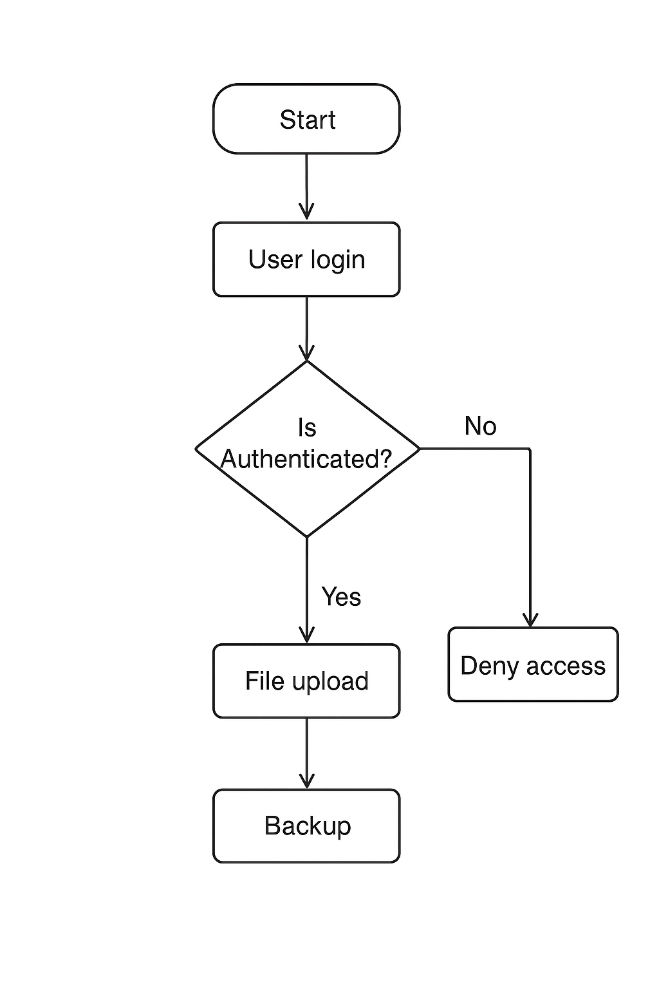

Figure 2.3.1.1System Flowchart for the Backup System

2.3.2 DFD Level 0 (Context Diagram)
This diagram shows the Backup System as a single process interacting with external entities such as users, administrators, and cloud storage providers. It defines the system boundary and the overall flow of data.

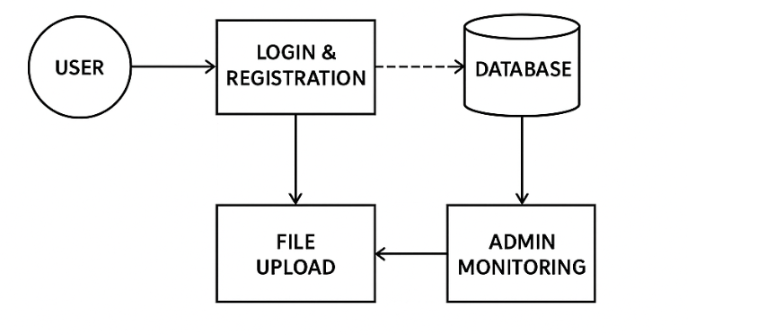

Figure 2.3.2.1 DFD Level 0 (Context Diagram)

2.3.3 DFD Level 1 (Detailed Data Flow Diagram)
The Level 1 DFD breaks down the main system into sub processes, including user authentication, file upload and validation, backup scheduling, and monitoring. It also shows how data moves between these processes and data stores.
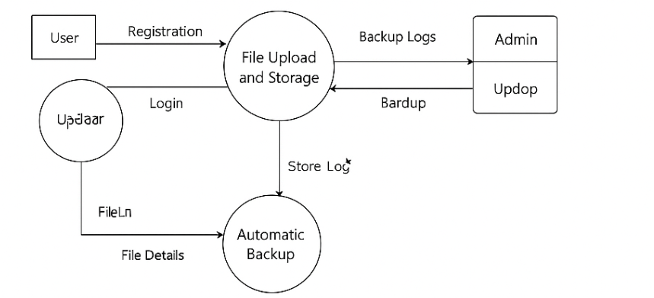

Figure 2.3.3.1 DFD Level 1 (Detailed Data Flow Diagram)

2.3.4 Entity Relationship Diagram (ERD)
The ERD defines the database structure of the Backup System. It highlights entities such as User, File, and Backup Logs, along with their relationships. The model ensures proper data organization, integrity, and efficient backup tracking.
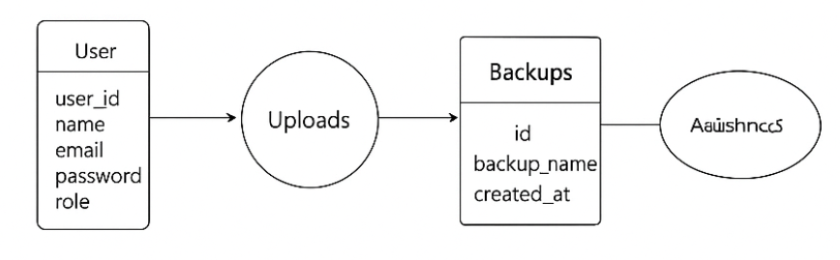
Figure 2.3.4.1 Entity Relationship Diagram (ERD)

2.3.5 Use Case Diagram
This diagram below illustrates the interactions between system actors and use cases. The main actors are the User, Administrator, and Backup Scheduler. It defines the operations each actor performs, such as uploading files, reviewing logs, and performing automated backups.

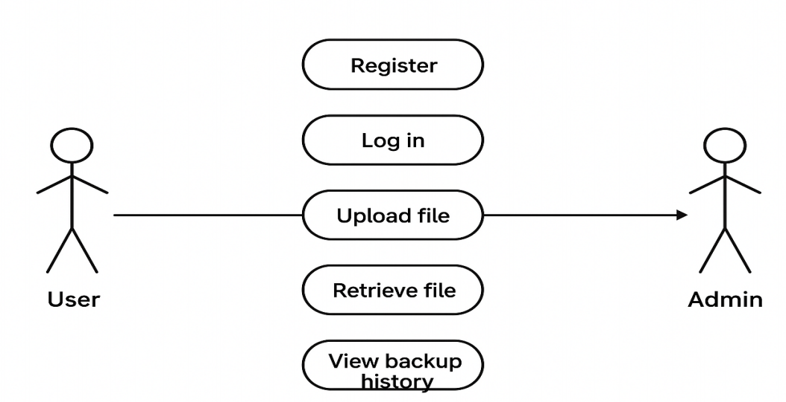

CHAPTER THREE: SYSTEM IMPLEMENTATION
(DEVELOPMENT, TESTING AND DEPLOYMENT)

3.1 Introduction
This chapter describes the complete implementation process of the Backup Management System. It presents the development journey — from setting up the development environment, coding both frontend and backend modules, configuring the database, to finally deploying and testing the system. The goal is to demonstrate how the proposed design was transformed into a fully functional application. The implementation involved using tools such as Visual Studio Code, Node.js, MySQL, and phpMyAdmin, alongside frontend technologies like HTML, CSS, and JavaScript.
3.2 User Interface Development
This chapter describes the complete implementation process of the Backup Management System. It presents the development journey — from setting up the development environment, coding both frontend and backend modules, configuring the database, to finally deploying and testing the system. The goal is to demonstrate how the proposed design was transformed into a fully functional application. The implementation involved using tools such as Visual Studio Code, Node.js, MySQL, and phpMyAdmin, alongside frontend technologies like HTML, CSS, and JavaScript.
Your system has two sides – the user side (where different users can interact with the system) and the logic side.
Under this section you will screenshot all the User Interfaces you have built (login pages, sign up forms, report page, dashboard, etc.) and the code for them if you built them from scratch, e.g. a screenshot of the html and css code for sign up form.
Organize them into subheadings e.g. 3.2.1 Login Page Development (under this section, a brief explanation of what it’s been built for, a screenshot of the page and a caption underneath it, screenshots of its html and css code used to develop it, and captions underneath every screenshot)

3.3 Logic Development
Your system has two sides – the user side (where different users can interact with the system) and the logic side. The logic side is how the system is performing activities using data e.g. login validation, processing checkout and generating a receipt, storing data into database, retrieving products from DB and showing them on a certain page. This is called logic.
Under this section you will screenshot all the Codes or Simulations that handle different processes/activities. Organize them into subheadings e.g. 3.3.1 Login Validation Code (herein, explain in brief how the system handles login, take screenshots of the login validation code, and caption it)
3.4 Testing
Detail out what actions you took to test whether different features of your system are working. And corrections you made to different parts to ensure that they are working as planned.

3.5 Deployment
Mention on what platform have you deployed your system (e.g. if it’s a website, what web hosting platform did you use – and copy paste a link to your website, if it’s an android application – the process of putting up your app on Google Playstore.). Essentially, detail out the process of how you transformed your project into a form that can be run/installed by anybody.

CHAPTER THREE: SYSTEM DESIGN AND IMPLEMENTATION
3.1 Introduction
This chapter presents the design and implementation of the proposed data backup system. It describes the system architecture, design tools, database design, data flow diagrams, and the modules developed for both users and administrators.
3.2 System Objectives
3.2.1 General Objective
To develop a secure system that stores data and performs automatic data backups.
3.2.2 Specific Objectives
1. To create a secure login module for users to register and access the system.
2. To develop a user dashboard that allows data upload and retrieval.
3. To implement automatic data backup linked to user activities.
4. To design an admin module that manages user approvals, monitors activity logs, and oversees backup processes in real time.
3.3 System Design Overview
The system adopts a modular design approach where each module performs specific functions. The architecture supports secure data handling, user authentication, and scheduled automatic backups.
3.4 System Architecture
The architecture follows a three-tier structure:
- **Presentation Layer:** Provides the user interface for system access.
- **Application Layer:** Handles logic, data validation, and interaction between modules.
- **Database Layer:** Stores user information, uploaded data, and backup logs.
3.5 System Modules
The main system modules include:
- **User Module:** Enables registration, login, file upload, and backup access.
- **Admin Module:** Manages users, monitors backups, and oversees activities.
- **Backup Module:** Automates and logs the data backup process.
3.6 Summary
This chapter outlines the structural and functional design of the system, ensuring that all objectives are met through efficient architecture and modular implementation.

