
STORAGE AND BACKUP SYSTEM FOR KITENGELA CREATIVE STUDIO

SYSTEM DOCUMENTATION

SUBMITTED BY,
EVANS MUNENE
DIT-01-0285/2024

A SYSTEM DOCUMENTATION SUBMITTED IN PARTIAL FULFILMENT FOR THE AWARD OF DIPLOMA IN INFORMATION TECHNOLOGY BY ZETECH UNIVERSITY

OCTOBER 2025
CHAPTER ONE: PROJECT PLANNING AND ANALYSIS
(WORKPLAN)
  - Statement of Problem

The Kitengela Creative Studio has been experiencing frequent file loss among students and trainers, especially when working on creative projects such as animations, graphics, and video editing. This often results in wasted time, disrupted workflows, and in some cases, total loss of completed work. The situation is made worse by heavy reliance on unreliable storage devices like flash drives and memory cards, which are prone to damage and corruption (Backblaze, 2021). Most users have limited awareness of backup practices, and poor internet access further discourages the use of cloud-based solutions (UNESCO, 2023). As a result, files are rarely backed up, exposing users to risks such as accidental deletion, software crashes, or hardware failure (Norton, 2022). This persistent problem not only affects productivity but also compromises the quality and consistency of creative outputs. There is a growing need to develop affordable and practical strategies to improve digital storage and backup at the studio.

  - Study Justification

This study is important because it addresses the recurring issue of file loss at Kitengela Creative Studio, which negatively affects the productivity and learning outcomes of students and trainers. It aims to diagnose the root causes of the problem and explore how it impacts creative work in a training environment. By examining existing digital storage and backup solutions such as cloud services, external drives, and automated software the study will assess how these systems function, what technical skills or tools they require, and how long they may take to implement. This investigation will help simulate real-life solutions that respond directly to the identified challenges. Ultimately, the findings will offer a well-informed foundation for selecting a suitable solution or combination of solutions that can be developed

1.3System Objectives

1.3.1 General Objective
To design and implement a secure system that stores user data and performs automated backups.

1.3.2 Specific Objectives
i. To design a secure user registration and authentication module.
ii. To develop a user dashboard for uploading and accessing stored data.
iii. To implement an automated data backup process linked to user activity.
iv. To develop an admin module for managing users, files, and backup logs.
1.3.4Functional Requirements
User | User Activities | Features
Admin | Approve user registrations | Admin dashboard with signup approval panel
Admin | Monitor backup activities | Real-time backup logs display
Admin | Manage users and files | Add, Edit or delete user data and files
User | Register and login securely | Authentication with email and password
User | Upload files for storage and backup | File upload, storage and backup module with progress trucker
User | Access previously backed up files | File retrieval and download interface
User | View backup history | Backup history showing timestamp and file details
System Automated | Perform regular automatic backups | Schedule backup service
System Automated | Notify users and admin of successful backups | Email /notification alerts after backups
Table 1.4 Functional Requirements Table

  - Breakdown of Tools & Resources to Be Used

Category | Tools / Resources | Purpose / Description
Hardware | Computers / Laptops | Used for system development, testing, and documentation
Storage Devices | External Hard Drive / Cloud Storage (Google Drive, OneDrive) | Backup and file storage during testing
Software | Visual Studio Code / Node.js | Development environment for backend and frontend
Database | MySQL / SQLite | To store user credentials, file data, and backup logs
Web Technologies | HTML, CSS, JavaScript | Frontend design and user interface
Server Tools | Express.js / JSON Server | For running and testing APIs
Version Control | Git & GitHub | Code management and version control
Testing Tools | Postman | API endpoint testing
Documentation Tools | Microsoft Word, Draw.io, Lucidchart | For reports, diagrams, and documentation
Human Resources | Project Developer (Evans Munene) | System design, coding, and testing
Power & Internet | Electricity and Internet Access | Essential for system deployment and communication

1.6 Project Schedule Breakdown
 | PROJECT MILESTONES
WEEKS | Project Planning & Analysis  (System Documentation: Cover page & Chapter One) | Project Design & Modeling  (System Documentation Chapter Two) | Project Development & Testing  (System Documentation Chapter Three) | Project Deployment  (System Documentation Chapter Three) | Final Touches of System Documentation  (Preliminary Pages, Chapter Four & References) | Project Presentation
19th -26th September 2025
27th -10th October 2025
11th -31st October 2025

1st - 14th November 2025
15th -24th November 2025
25th -28th November
Table 1.6 Project Schedule Breakdown

CHAPTER TWO: DESIGN AND MODELING

2.1 Introduction to Modelling
In this chapter, I am presenting the various design and modeling diagrams that i created during the system planning and design phase. These models helped visualize how the Backup System for Creative Studio would function before any development began. Modeling allowed me to understand the relationships between different components, plan user interactions, and structure system logic clearly. By sketching and diagramming before development, I reduced design errors, improved efficiency, and ensured the system architecture was well thought out and consistent with user needs.

2.2 User Interface Models
This section presents the sketches and design of the system’s user interfaces. Each interface was conceptualized to show how users would interact with the system. The UI models helped visualize layout, input elements, and navigation flow before implementing them in code.

2.2.1 sign up form

Enter full name

Enter email

Create login password

Login Page Design

2.2.2 Login page
Enter email

Enter passward

2.2.3 Dashboard Page Design

HOME PAGE | UPLOAD BUTTON | UPLOADED FILES | BACKUPS

Figure Dashboard Interface Design, Hand-Sketched

2.2.4 File Upload Page Design

Upload

2.3 Logic Models
This section presents the logical and architectural diagrams developed to illustrate how the Backup System operates. These diagrams represent data flow, process logic, and interactions between users, system components, and data stores.

2.3.1 System Flowchart
The system flowchart illustrates the sequence of operations within the Backup System. It shows how users log in, upload files, and how the system validates, stores, and logs each operation.
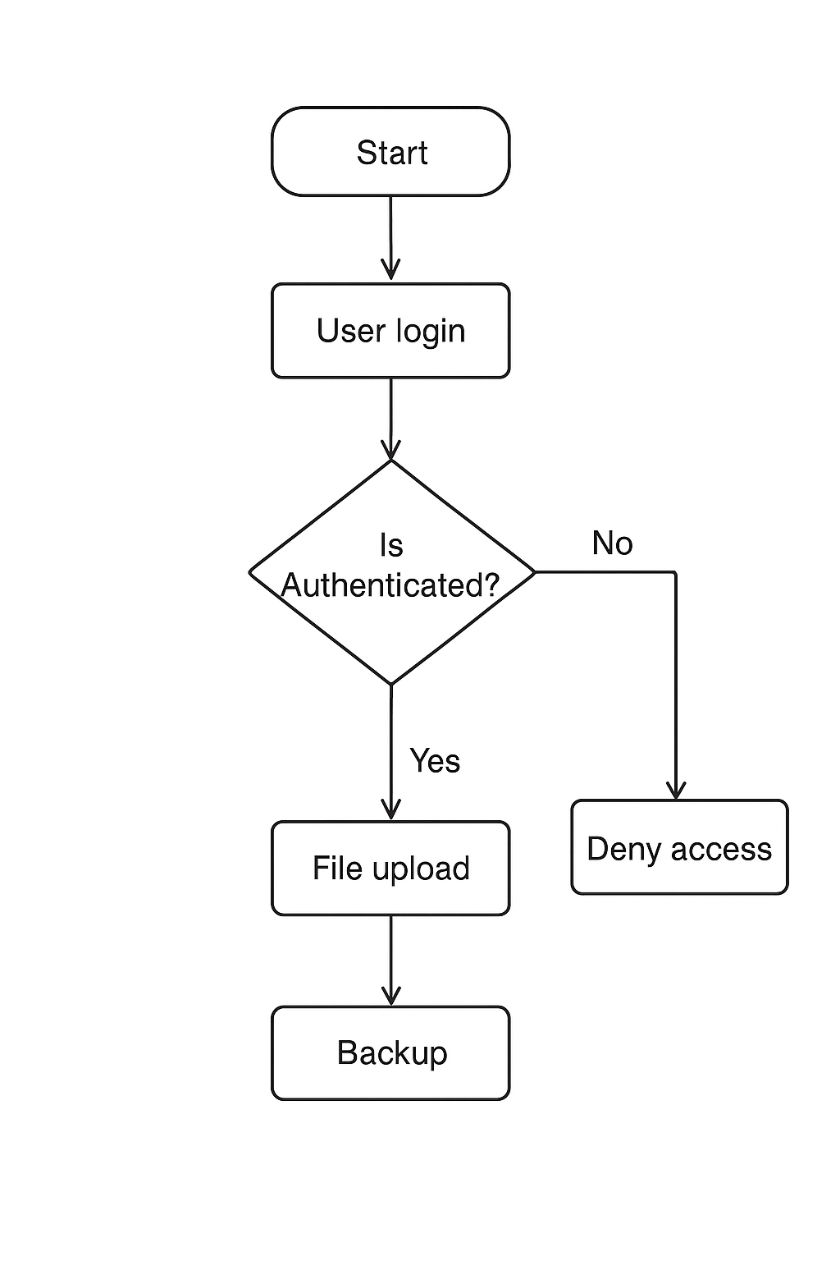

Figure 2.3.1.1System Flowchart for the Backup System

2.3.2 DFD Level 0 (Context Diagram)
This diagram shows the Backup System as a single process interacting with external entities such as users, administrators, and cloud storage providers. It defines the system boundary and the overall flow of data.

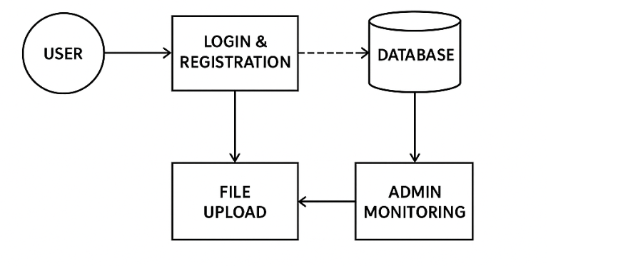

Figure 2.3.2.1 DFD Level 0 (Context Diagram)

2.3.3 DFD Level 1 (Detailed Data Flow Diagram)
The Level 1 DFD breaks down the main system into sub processes, including user authentication, file upload and validation, backup scheduling, and monitoring. It also shows how data moves between these processes and data stores.
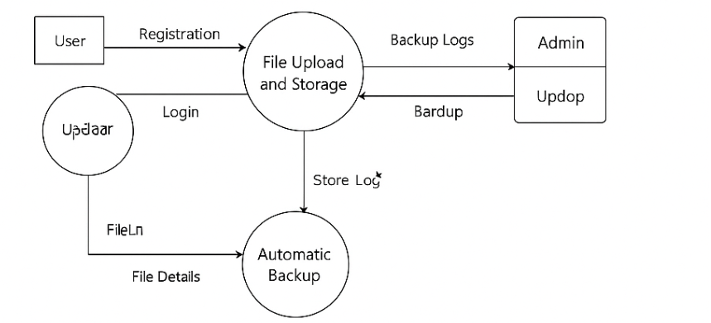

Figure 2.3.3.1 DFD Level 1 (Detailed Data Flow Diagram)

2.3.4 Entity Relationship Diagram (ERD)
The ERD defines the database structure of the Backup System. It highlights entities such as User, File, and Backup Logs, along with their relationships. The model ensures proper data organization, integrity, and efficient backup tracking.
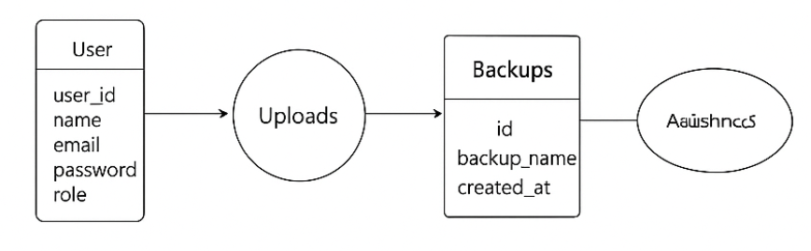
Figure 2.3.4.1 Entity Relationship Diagram (ERD)

2.3.5 Use Case Diagram
This diagram below illustrates the interactions between system actors and use cases. The main actors are the User, Administrator, and Backup Scheduler. It defines the operations each actor performs, such as uploading files, reviewing logs, and performing automated backups.

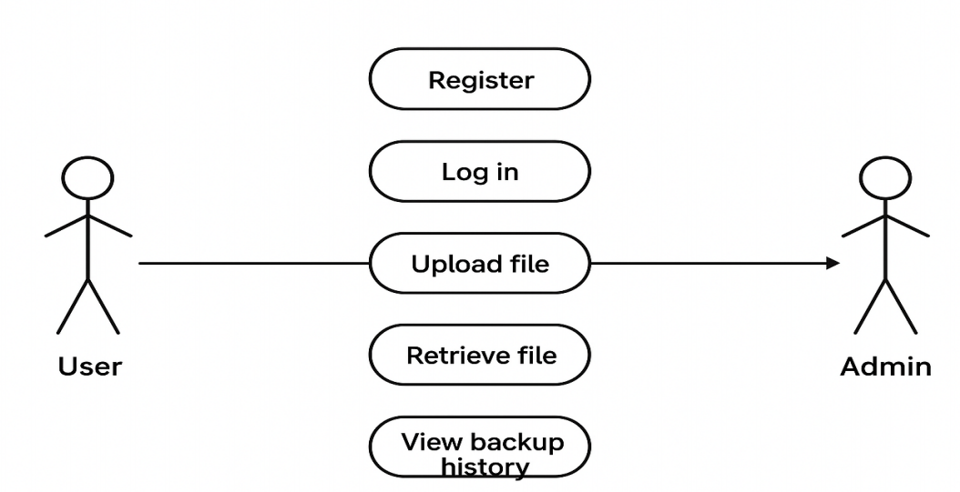

CHAPTER THREE: SYSTEM IMPLEMENTATION
(DEVELOPMENT, TESTING AND DEPLOYMENT)

3.1 Introduction
This chapter describes the complete implementation process of the Backup Management System. It presents the development journey from setting up the development environment, coding both frontend and backend modules, configuring the database, to finally deploying and testing the system. The goal is to demonstrate how the proposed design was transformed into a fully functional application. The implementation involved using tools such as Visual Studio Code, Node.js, MySQL, and phpMyAdmin, alongside frontend technologies like HTML, CSS, and JavaScript.
3.2 User Interface Development
This chapter describes the complete implementation process of the Backup Management System. It presents the development journey from setting up the development environment, coding both frontend and backend modules, configuring the database, to finally deploying and testing the system. The goal is to demonstrate how the proposed design was transformed into a fully functional application. The implementation involved using tools such as Visual Studio Code, Node.js, MySQL, and phpMyAdmin, alongside frontend technologies like HTML, CSS, and JavaScript.

Figure 3.2.2.1: User Registration Form Interface
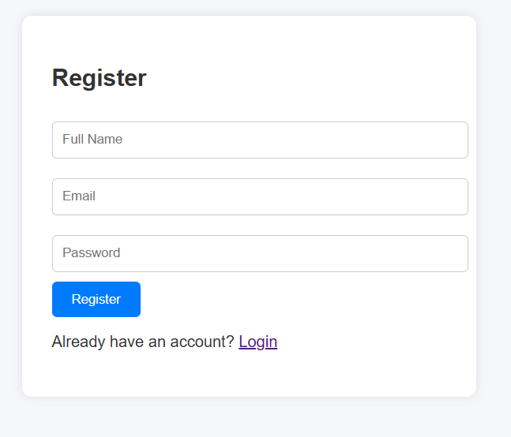
(Screenshot of registration page goes here)
Figure 3.2.2.2: Registration Page Code Snippet
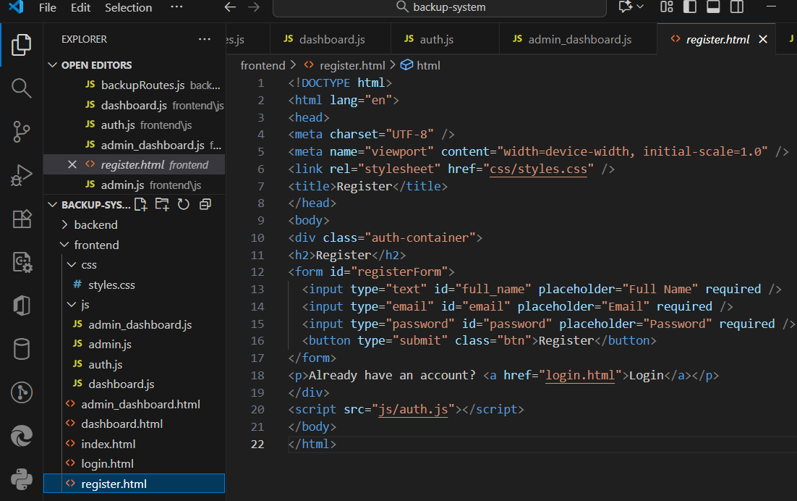
(Screenshot of HTML/JS code goes here)

3.2.3 Dashboard Page Development
The dashboard provides access to system functionalities such as uploading files, viewing uploaded files, and creating or downloading backups. It dynamically displays information retrieved from the backend through RESTful API endpoints such as /api/files/list and /api/backup/database.
Figure 3.2.3.1: User Dashboard Interface
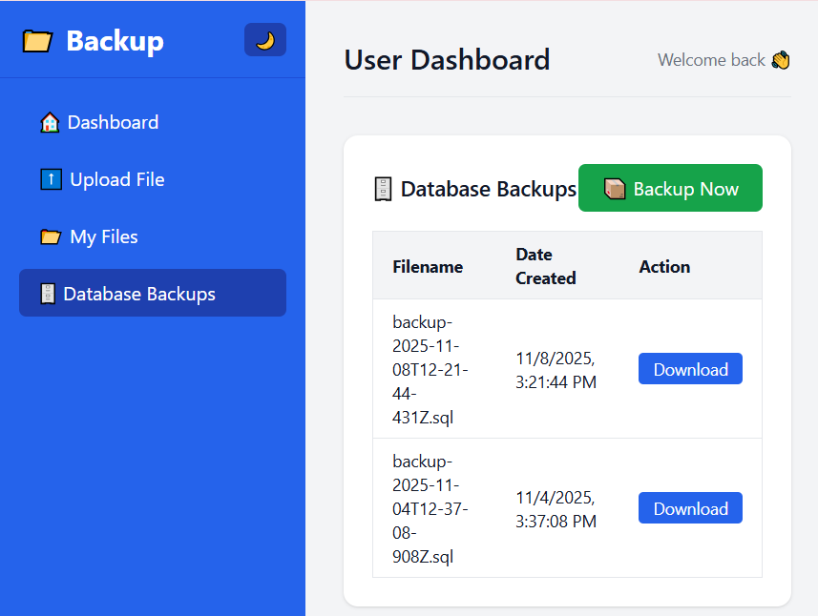
(Screenshot of dashboard page goes here)
Figure 3.2.3.2: Dashboard Script Code (dashboard.js)
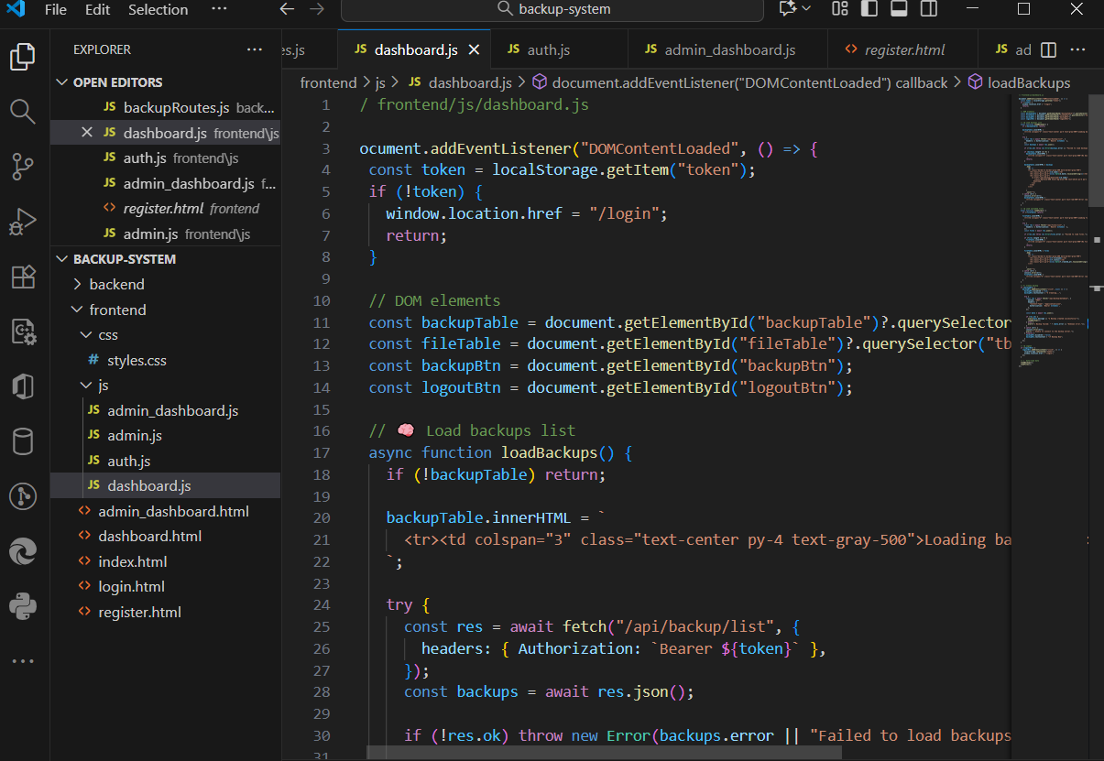
(Screenshot of code snippet goes here)

3.2.4 Admin Dashboard Page
The admin dashboard allows administrators to view all user activities, approve user accounts, and monitor backup operations. It provides real-time system logs and allows access to database backup files.
Figure 3.2.4.1: Admin Dashboard Interface
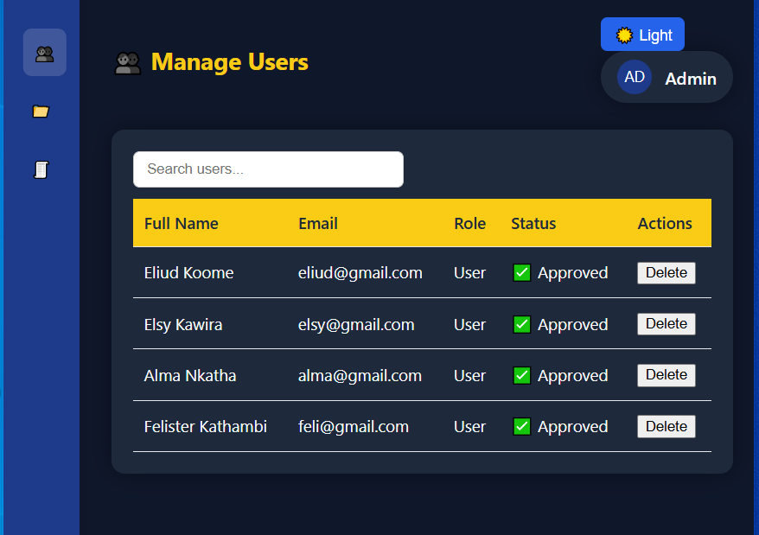
(Screenshot of admin_dashboard.html)
Figure 3.2.4.2: Admin Dashboard Logic Code (admin.js)
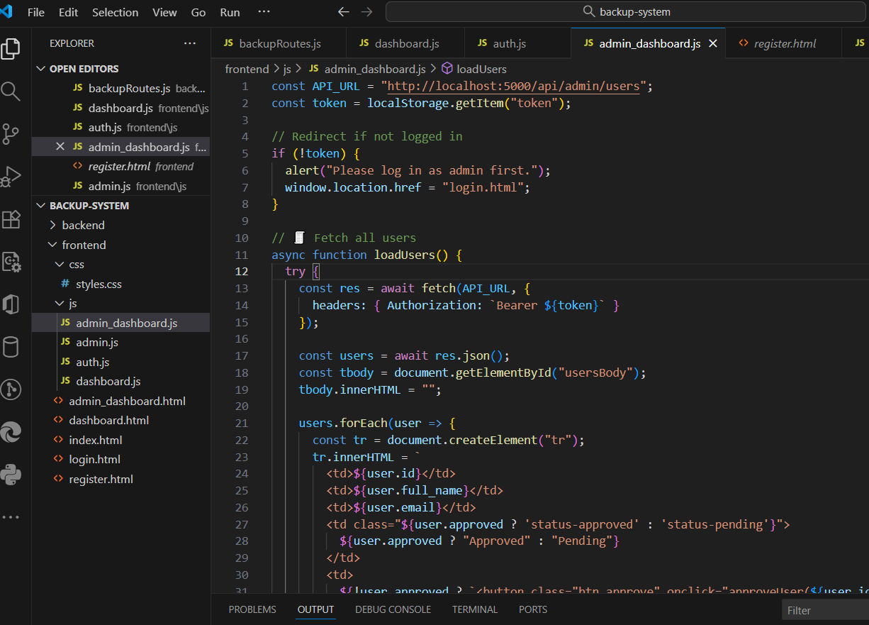
(Screenshot of code snippet goes here)

3.3 Logic Development
The logic of the system is implemented using Node.js and Express.js. This layer handles authentication, file uploads, database backup, and log management. Data is stored in a MySQL database, and backups are created using the mysqldump utility.

3.3.1 User Authentication Logic
The authentication logic in authRoutes.js manages registration and login. It uses hashed passwords for security and JSON Web Tokens (JWT) for session management.
Figure 3.3.1.1: Authentication Logic Code Snippet
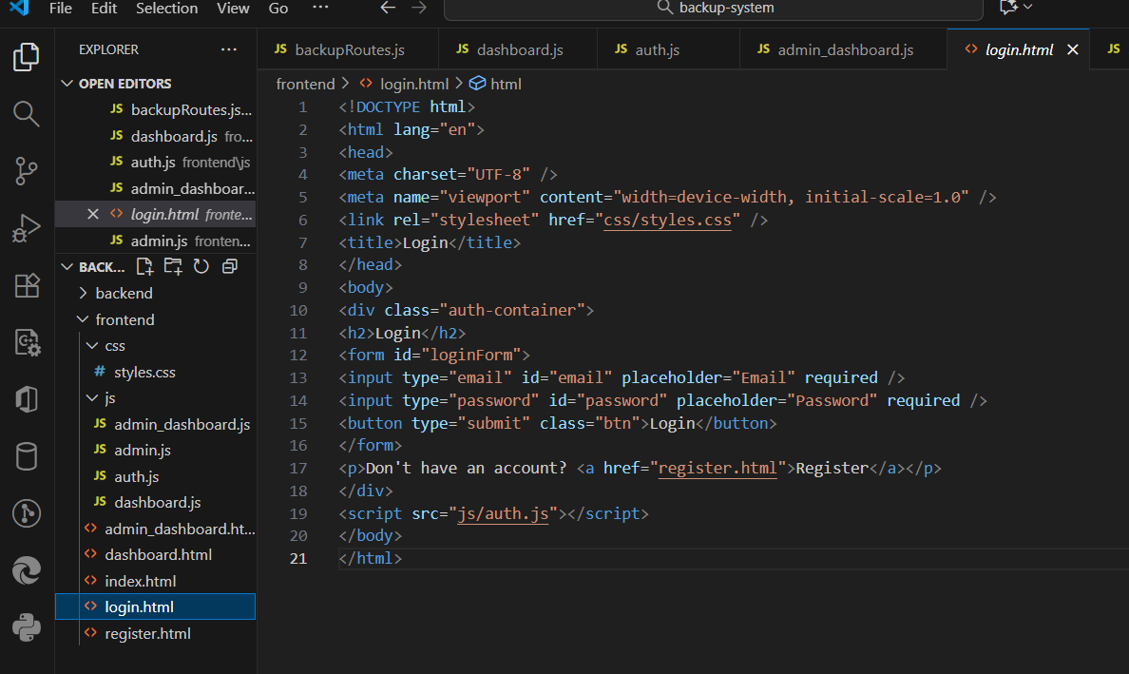
(Screenshot showing login and JWT generation code)

3.3.2 File Upload and Management Logic
The file upload feature is managed by fileRoutes.js, which uses the Multer library to handle file uploads. Each file uploaded by a user is stored in the /uploads folder, and its details are recorded in the database.
Figure 3.3.2.1: File Upload Logic Code
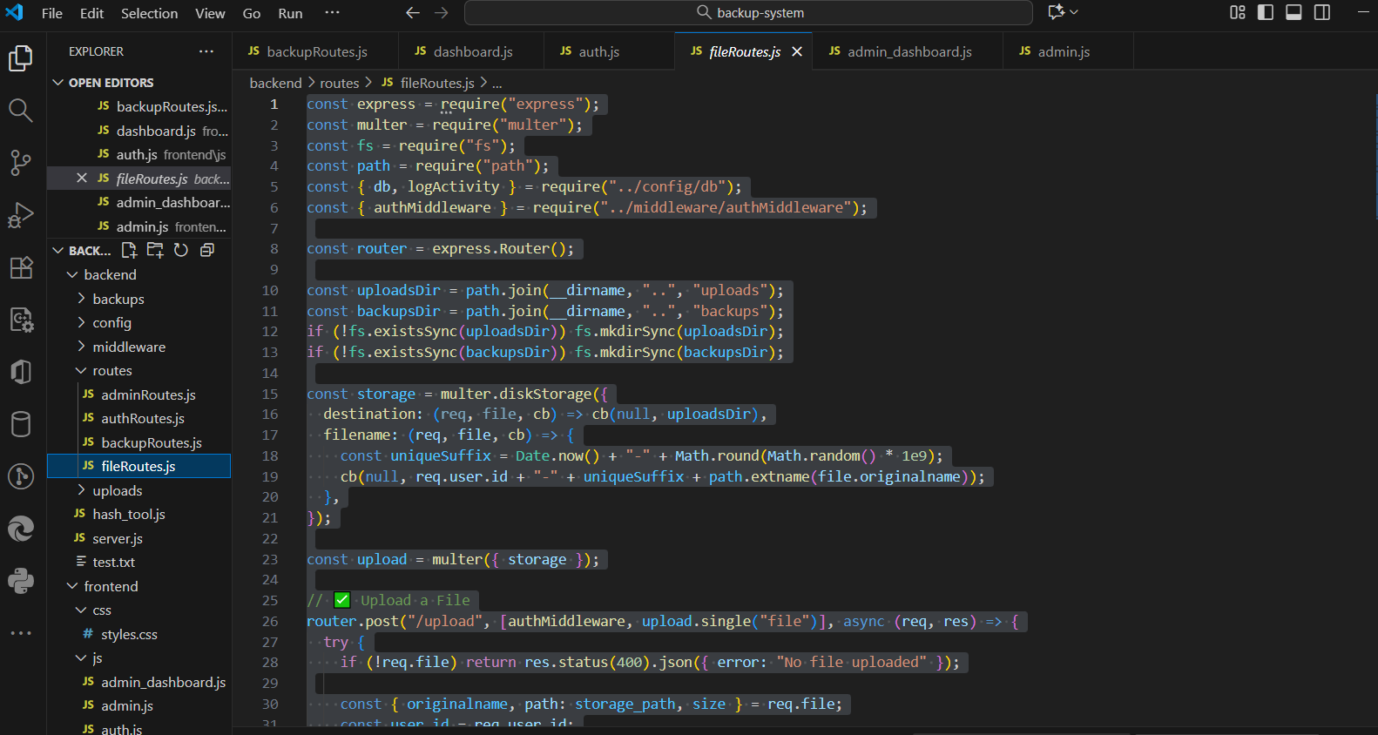
(Screenshot showing multer setup and database query)

3.3.3 Backup Creation Logic
The database backup functionality is handled in backupRoutes.js. The system uses the mysqldump command to create .sql dump files and saves them in the /backups directory. Users can manually initiate backups or schedule them for automation.
Figure 3.3.3.1: Database Backup Code Snippet
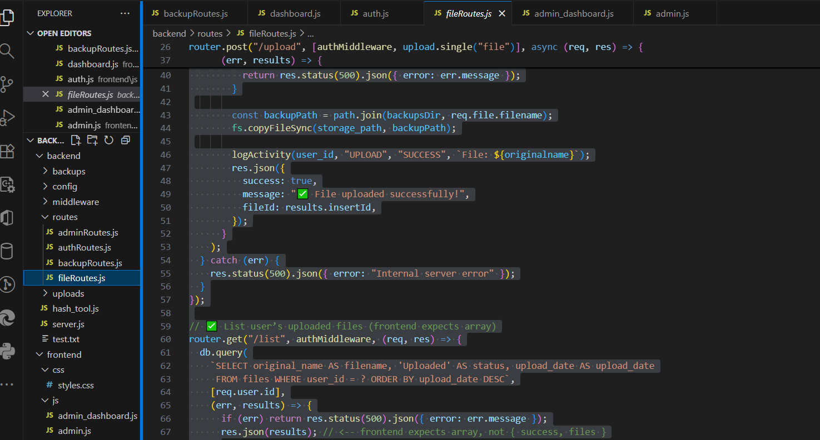
(Screenshot showing exec(mysqldump) command)

3.3.4 Database Configuration Logic
The database connection and activity logging logic are defined in config/db.js. It establishes a secure connection pool to the MySQL database and provides a logging function for recording system activities.
Figure 3.3.4.1: Database Configuration Code (db.js)
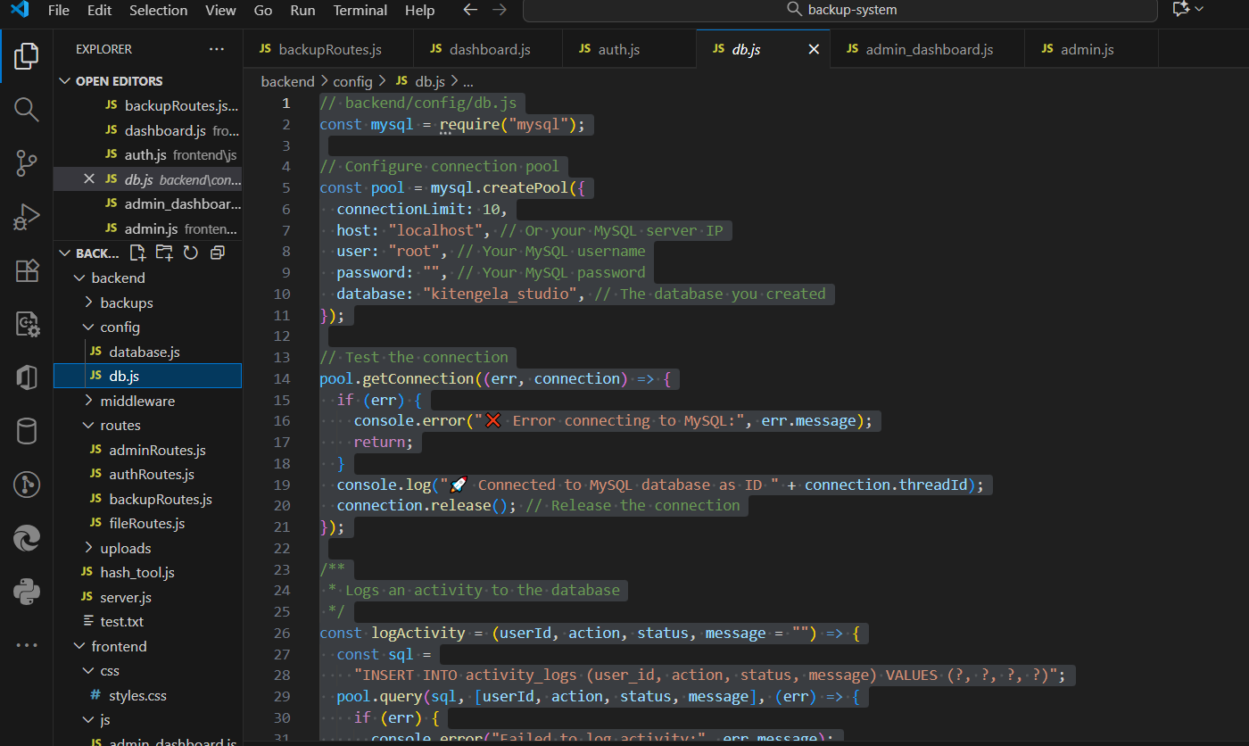
(Screenshot showing mysql.createPool code)
3.4 Testing
Testing is carried out to verify that all system modules work as intended. Both frontend and backend components are tested using manual input, Postman API requests, and browser console logs.
Feature tested | Testing method | Expected output | Results
User registration | Form submission | User data store in database | passed
Login | Login form and postman | Redirects user to dashboard | Passed
File upload | Dashboard upload | File save in/uploads | Passed
Backup creation | Backup now button | .sql file saved in /backups | Passed
Admin approval | Admin panel Action | User marked as approved | Passed

Detail out what actions you took to test whether different features of your system are working. And corrections you made to different parts to ensure that they are working as planned.

3.5 Deployment
The system runs on a local Node.js server using port 5000. The backend is connected to a MySQL database hosted in XAMPP. The frontend files are served using Express middleware.
Deployment steps include:
- Installing all required dependencies using npm install.
- Setting up the database connection in config/db.js.
- Starting the MySQL service using XAMPP.
- Running the backend server using node server.js.
- Accessing the system through http://localhost:5000.

Mention on what platform have you deployed your system (e.g. if it’s a website, what web hosting platform did you use – and copy paste a link to your website, if it’s an android application – the process of putting up your app on Google Playstore.). Essentially, detail out the process of how you transformed your project into a form that can be run/installed by anybody.

