Adequately Sized Pharma

CS 4354

Tara Salman

Vu Le, Richard Evans, Orlando Robles, James Gibson

May 3rd, 2024

Abstract 3

Team and Contributions 3

Introduction 4

I. Problem Statement 4

II. Requirements and Target Use 4

III. Data 4

Design 5

I. Users and Functionalities 5

II. EER Diagram 5

III. Relational Schema from EER 6

IV. Normal Forms 9

Implementation 11

I. Database Specification 11

II. Interface Specification 13

System Testing and Result analysis 18

Conclusion 20

# 

# Abstract

In the modern pharmaceutical landscape, efficient data management is paramount for streamlined operations and optimal patient care. This project addresses the limitations of traditional spreadsheet-based systems by proposing the development of a SQL database integrated with a user-friendly HTML interface tailored for an average pharmacy setting.

The project's main objective is to improve data organization, accessibility, and security while enhancing the workflow in the pharmacy environment. Leveraging the robust capabilities of SQL, the database structure is designed to efficiently store, retrieve, and manage vast amounts of pharmaceutical data including inventory, patient profiles, prescriptions, and sales records.

Additionally, the HTML user interface is crafted with a focus on simplicity, intuitiveness, and functionality, ensuring seamless interaction for pharmacy staff at various skill levels. Through this interface, users can perform essential tasks such as updating inventory, managing prescriptions, generating reports, and facilitating customer interactions.

# Team and Contributions

Vu Le: construct the EER diagram, write and present the Problem Statement for the presentation, write the abstract and format the report

Richard Evans: Created ER diagram, created and presented user interface in presentation, wrote chapter 3 and 4 in report.

Orlando Robles: Introduction, target use and requirements, conclusion, for final report and initial report.

James Gibson: mapped EER to relational schema, presented EER and relational schema for the presentation, wrote Chapter 2 in the report.

# Introduction

## Problem Statement

Our database aims to solve the problem of the overcomplicated nature of pharmacies. Many pharmacy databases can be streamlined to help pharmacy personnel thus making everything a better experience for all involved. The pharmaceutical business is always producing more medicine for those that need it, making the scale of the pharmacy rise with time. Excel sheets have many limitations keeping up with this rising trend because it would only prove more difficult to keep track of the thousands of patients and their respective medications. Data could also be easily lost and altered with a simple mis-click making it unreliable as well. Databases, however, scale up easily with their architecture and require admin privileges to alter any patient data.

Unlike an excel sheet, databases allow a view of what information the pharmacist or doctor needs without other patient information. When viewing an excel sheet other users can be seen and their selected cells can be seen as well and can distract from one's work. Databases avoid this problem and can be concurrently accessed and updated without distracting other employees. Excel sheets can violate HIPPA regulations because of the lack of privacy when viewing concurrently with other employees. Databases require privileges from authorized personnel to view sensitive patient data to avoid breaking HIPPA.

## Requirements and Target Use

The people that will use our database are pharmacy personnel and doctors from clinics or hospitals that prescribe the medication to patients. The database will emulate the health portals that professionals in the medical field already use to minimize the amount of training needed. The doctor will be able to change the medications that are prescribed and insert a pharmacy that the patient wishes to go to. A pharmacist can access patient information and verify medication prescribed by the doctor. The pharm-tech will also be able to have the same privileges as a pharmacist but will not be able to view employee data. The stock of medications will also be stored and managed by the pharmacist in coordination with the supplier. The supplier will notify the pharmacy of shortages or discontinuations of any medication affected. A patient’s information will be deleted only if the customer wishes for their information to be deleted. Stakeholders in the system will be customers, pharmacy employees, medical suppliers, and doctors. The users of the database will be pharmacy employees. The administrators of this database will be our group, who is making the database, and the employees or doctors who will use this database.

## Data

All database data will be manually created sample data to simulate a real-world pharmacy. Most of the attributes will be entered as if an employee of the pharmacy were entering it themselves. The employee and prescription ID will be generated as if they were randomly assigned. The reason that some data will be auto generated, and some data will be manually entered is to simulate the environment in which the database will be altered. Employees of the pharmacy will manually enter most data from new customers, suppliers, prescriptions, employees, and doctors. Care will be taken to ensure that these IDs remain unique as they are primary keys.

# 

# Design

## Users and Functionalities

All employees in the database are users of the database. These two employee subtypes, PharmTech and Pharmacist, have different privileges in the system. The Pharm Tech is an employee working under the pharmacist that has view privileges in the database and can sell prescriptions to customers. PharmTechs have access to everything except employee data. Pharmacists work as supervisors to the PharmTech employees; they can fill prescriptions for customers. They have access to view and edit employee data in addition to viewing and editing privileges for all other portions of the database. This includes adding, updating, and deleting data from tables.

## EER Diagram

Assumptions:

The pharmacy will be a store pharmacy and not a hospital pharmacy; therefore, the doctor will not be considered an employee of the pharmacy and will have their own clinic. If the customer buys multiple medications at once, then it will count as a single prescription just the same as if there were only one medication. Only the pharmacist is allowed to fill out a prescription and the PharmTech will sell the prescription. The doctor will be the only one with authorization to prescribe a customer medication, which the pharmacist will insert into the database.

PharmTech and Pharmacist will be specializations of Employee. We considered using “Person” as a generalization to include Doctor, Customer, PharmTech and Pharmacist, but decided to continue with using Employee as a Person superclass. This is because adding a Person generalization would not generalize enough attributes to be useful; the same amount of data will need to be put into the subclasses as if we continued to use the Employee generalization.

## Relational Schema from EER

The primary keys are indicated in the above diagram. An ID was chosen as the primary key employee, supplier, prescription, and customer as they are unique and ensured to not be duplicates. For Doctor, the license number is chosen as the primary key because it is also unique and cannot be a duplicate.

Primary/Foreign Keys

Employee

ID – a primary key, chosen as it ensures the primary key is unique, INT

Pharmtech

TechID – a foreign primary key, it is the primary key of Employee, INT

PharmID – a foreign key, PharmID identifies who the supervising pharmacist is, INT

Pharmacist

PharmID – a foreign primary key, it is the primary key of Employee, INT

Doctor

LiscenseNum – a primary key, chosen as it is unique to each doctor, INT

Supplier

SuppID – a primary key, chosen as it ensures the primary key is unique, INT

Supplies

SuppID – a foreign key, it is the primary key of Supplier, INT

PresID – a foreign key, it is the primary key of Prescription, INT

Both keys make up the primary key of Supplies, they were chosen while converting the N-M relationship, indicating what Prescription is supplied by what Supplier.

Customer

CustID – a primary key, chosen as it ensures the primary key is unique, INT

Buys

CustID – a foreign key, it is the primary key of Customer, INT

PresID – a foreign key, it is the primary key of Prescription, INT

Both keys make up the primary key of Buys, they were chosen while converting the 1-N relationship.

Indicates which Customer buys what Prescription.

Prescription

PresID – a primary key, chosen as it ensures the primary key is unique, INT

PharmID – a foreign key, PharmID indicate the Pharmacist who fills the prescription, INT

TechID – a foreign key, TechID indicates the Pharmtech who sells the prescription, INT

LiscenseNum – a foreign key, LiscenseNum indicates the Doctor who prescribes the prescription, INT

Attributes

Unless otherwise specified, attributes have no default value/cannot be set to NULL

Employee

Fname – first name of the employee, the purpose of Fname is to log the first name of the employee for reference, VARCHAR

Mname – middle name of the employee, the purpose of Mname is to log the middle name of the employee for reference, VARCHAR

Lname – last name of the employee, the purpose of Lname is to log the last name of the employee for reference, VARCHAR

Address – the address of the employee, the purpose of Address is to log the address of the employee for reference, VARCHAR

PhoneNumber – the phone number of the employee, the purpose of PhoneNumber is to log the phone number of the employee for reference, INT

Pharmtech

CertificateNum – the number of the certificate of the pharmtech, the purpose of CertificateNum is to ensure the pharmtech has a valid or up-to-date certificate, INT

Pharmacist

LiscenseNum – the number of the license of the pharmacist, the purpose of LiscenseNum is to ensure the pharmacist has a valid or up to date license, INT

Doctor

Specialty – the specialization of the doctor, the purpose of Specialty is to reference that the doctor has the appropriate specialization for the Prescription or for reference, VARCHAR, default = None

Clinic_name – the name of the clinic or hospital of the doctor, the purpose of Clinic_name is to document the workplace of the doctor prescribing medication, VARCHAR

Name – the name of the doctor, the purpose of Name is to log the name of the doctor for reference, VARCHAR

PhoneNumber – the phone number of the doctor, the purpose of PhoneNumber is to log the phone number of the doctor for reference, INT

Supplier

Name – the name of the supplier, the purpose of Name is to document the name of the supplier for reference, VARCHAR

Address – the address of the supplier, the purpose of Address is to document the address of the supplier for reference, VARCHAR

Supplies

Count – the amount of prescription to supply, the purpose of count is to indicate to the supplier how much of the prescription to supply, INT, default = 1

Customer

Fname – first name of the customer, the purpose of Fname is to log the first name of the customer for reference, VARCHAR

Mname – middle name of the customer, the purpose of Mname is to log the middle name of the customer for reference, VARCHAR

Lname – last name of the customer, the purpose of Lname is to log the last name of the customer for reference, VARCHAR

DoB – the date of birth of the customer, the purpose of DoB is to log the date of birth of the customer for reference, DATE

Address – the address of the customer, the purpose of Address is to log the address of the customer for reference, VARCHAR

PhoneNumber – the phone number of the customer, the purpose of PhoneNumber is to log the phone number of the customer for reference, INT

InsuranceNum – the insurance number of the customer, the purpose of InsuranceNum is to ensure that the insurance is valid or for reference, INT

Buys

Date – the date of the purchase, the purpose of Date is to log the date of the purchase for reference, DATE

Cost – the cost of the transaction, the purpose of Cost is to indicate to the customer the cost of the prescription transaction, INT

Prescription

Name – the name of the medication/prescription, the purpose of Name is to ensure that the prescription has the correct medication, VARCHAR

Price – the price of the prescription/medication, the purpose of Price is to indicate the appropriate cost for the prescription, INT

Stock – the stock left of the prescription/medication; the purpose of Stock is to indicate how much of the medication is left, INT, default = 0

Employee – derived from the Employee entity

Pharmtech – derived from the Pharmtech entity and the supervises relationship, the PharmID indicates which pharmacist is supervising

Pharmacist – derived from the Pharmacist entity

Doctor – derived from the Doctor entity

Supplier – derived from the Supplier entity

Supplies – derived from the Supplies relationship, this method was chosen because it is a N-M relationship, which requires a relation be created

Customer – derived from the Customer entity

Buys – derived from the Buys relationship, this method was chosen over the foreign key approach as it more accurately models a transaction instead of adding CustID as foreign key to Prescription. Also, because both entity’s participation is optional.

Prescription – derived from the prescription entity, the sells relationship, the fills relationship, and the prescribes relationship. The foreign key approach was chosen for these relationships because it is important to know who the prescription was prescribed, filled, and sold by.

## Normal Forms

First Normal Form:

Here there are no composite or multivalued attributes, meaning that this is in the first normal form.

|  |  |  |  |  |  |  |  |  |
| --- | --- | --- | --- | --- | --- | --- | --- | --- |
| PresID | Name | Price | Stock | PharmID | TechID | Doc_Lisc | Count | Supp_ Name |
| Supp_ Add. | Pharm_Lisc | Cert_  Num | Emp Fname | Emp  Mname | Emp  Lname | Emp_Add. | Emp  Phone | Doc_Spec |
| Clinic Name | Doc_  Name | Doc_  Phone | Date | Cost | Cust_  Fname | Cust_  Mname | Cust_Lname | Cust_  DoB |
| Cust_  Add. | Cust_  Phone | Insur_  Num | Emp_ID |  |  |  |  |  |

Second Normal Form:

Here partial dependencies have been eliminated, meaning that it is in the second normal form.

|  |  |  |  |  |  |  |  |  |  |
| --- | --- | --- | --- | --- | --- | --- | --- | --- | --- |
| Pres  ID | Name | Price | Stock | Count | Date | Cost | Pharm  ID | Tech  ID | Doc_  Lisc |

|  |  |  |
| --- | --- | --- |
| Supp_  ID | Supp_  Name | Supp_  Add. |

|  |  |
| --- | --- |
| PharmID | Pharm  _Lisc |

|  |  |  |
| --- | --- | --- |
| TechID | Cert_  Num | Pharm  ID |

|  |  |  |  |  |  |
| --- | --- | --- | --- | --- | --- |
| EmpID | Fname | Mname | Lname | Address | Phone  Number |

|  |  |  |  |  |
| --- | --- | --- | --- | --- |
| Doc_  Lisc | Doc_  Spec | Clinic_name | Doc_  Name | Doc_  Phone |

|  |  |  |  |  |  |  |  |
| --- | --- | --- | --- | --- | --- | --- | --- |
| Cust_ID | Fname | Mname | Lname | DoB | Address | Phone  Number | Insurance_Num |

Third Normal Form:

Here transitive dependencies based on non-prime attributes have been eliminated, meaning that it is in the third normal form.

|  |  |  |  |  |  |  |
| --- | --- | --- | --- | --- | --- | --- |
| Pres  ID | Name | Price | Stock | Pharm  ID | Tech  ID | Doc_  Lisc |

|  |  |  |
| --- | --- | --- |
| Supp_  ID | Supp_  Name | Supp_  Add. |

|  |  |
| --- | --- |
| PharmID | Pharm  _Lisc |

|  |  |  |
| --- | --- | --- |
| TechID | Cert_  Num | Pharm  ID |

|  |  |  |  |  |  |
| --- | --- | --- | --- | --- | --- |
| EmpID | Fname | Mname | Lname | Address | Phone  Number |

|  |  |  |  |  |
| --- | --- | --- | --- | --- |
| Doc_  Lisc | Doc_  Spec | Clinic_name | Doc_  Name | Doc_  Phone |

|  |  |  |  |  |  |  |  |
| --- | --- | --- | --- | --- | --- | --- | --- |
| Cust_ID | Fname | Mname | Lname | DoB | Address | Phone  Number | Insurance_Num |

|  |  |  |
| --- | --- | --- |
| SuppID | PresID | Count |

|  |  |  |  |
| --- | --- | --- | --- |
| CustID | PresID | Date | Cost |

# 

# Implementation

## Database Specification

Our database is written in MySQL Workbench and is managed through phpMyAdmin. Our database consists of the following tables: buys, customer, doctor, employee, pharmacist, pharmtech, prescription, supplier, and supplies. Most of the tables are entities, while the buys and supplies tables are relations.

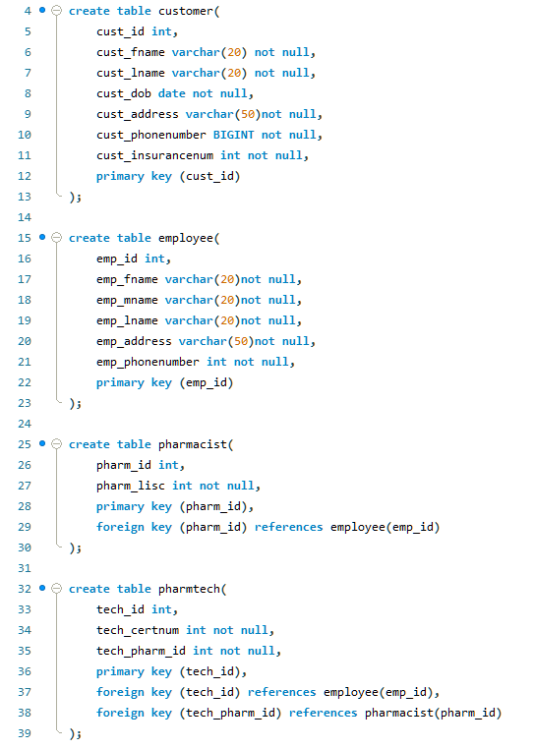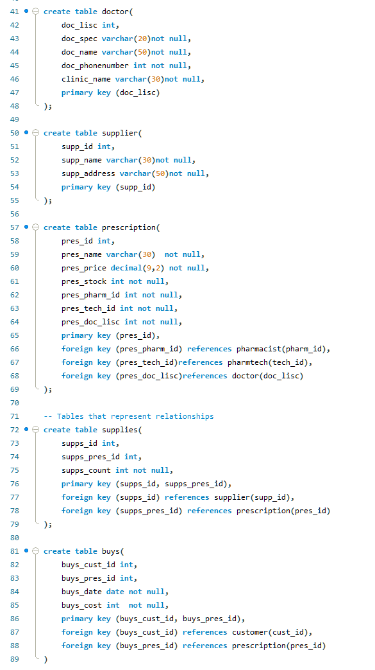

**MySQL Workbench Database –** Here is a screenshot of our SQL implementation of our tables

To get data to populate our database, we did not use any sources such as ChatGPT or online lists of information. Instead, we populated the tables ourselves. Our data includes random names and information made up on the spot. Below are some screenshots of the data populating the customer, employee, pharmacist, and pharmtech tables.

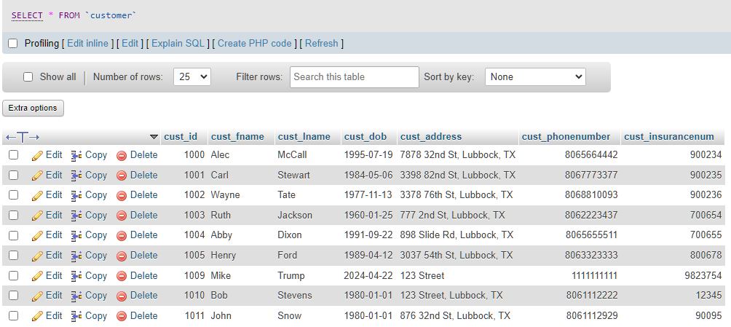**Customer Table –** Here is the data we have for customers in the customer table

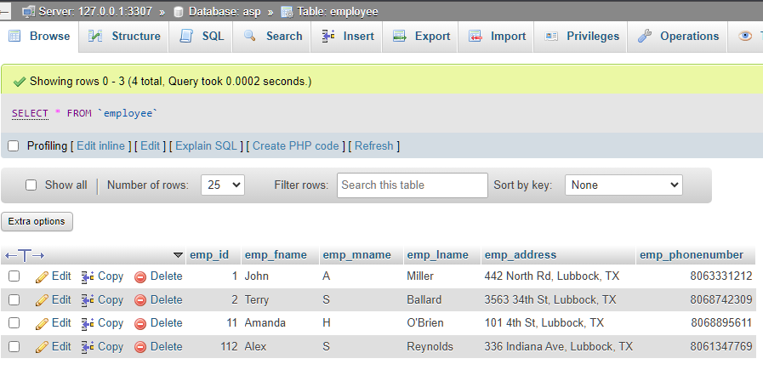**Employee Table –** Here is the data we have for employees in the employee table

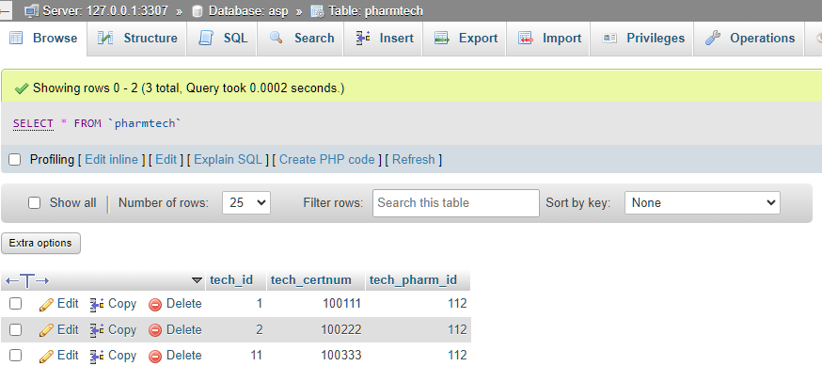**Pharmtech Table –** Here is the data we have for pharmtechs in the pharmtech table.

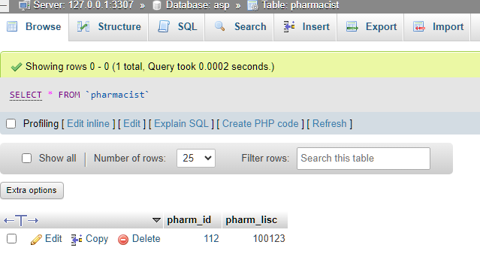**Pharmacist Table –** Here is the data we have for pharmacists in the pharmacist table

## Interface Specification

Our team decided to go with a web-based interface written in HTML and CSS. A web-based approach will allow for easier changes to be made if necessary. Furthermore, a web interface will be more familiar among users and should be easier to navigate and learn. The interface makes use of PHP and PhpMyAdmin to search and insert information into the database. The interface has a straightforward design, with main sections displayed in the center and a navbar that will direct the user to each section. Each section contains a search functionality and an insert functionality. The search functionality uses PHP to submit a search query to the database while the insert functionality uses insert queries.

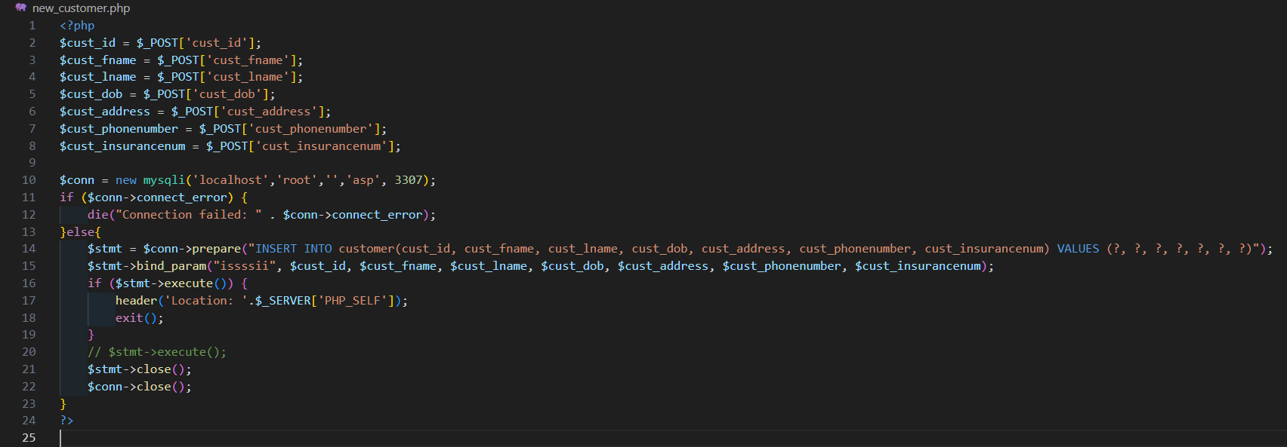**PHP for Inserting Customer Data –** Here is a snippet of the PHP file that deals with the insert query for inserting customer data into the customer table. It grabs the data from the HTML inputs and populates the INSERT query.

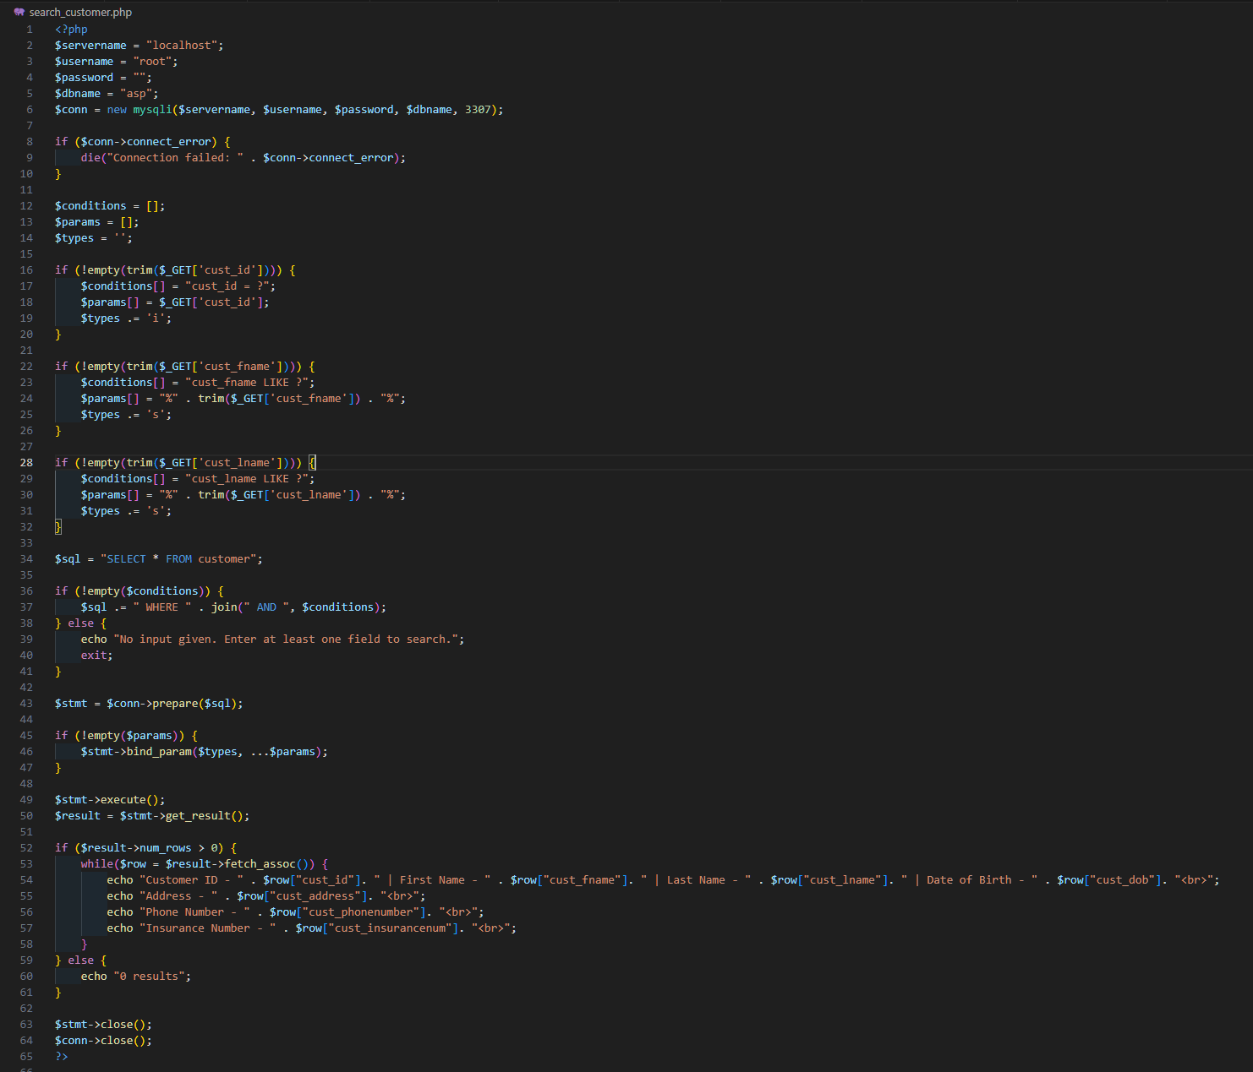**PHP for Selecting Customer Data –** Here is a snippet of the PHP file that deals with the select query for selecting customer data from the customer table. It grabs the data from the HTML inputs and uses these to search.

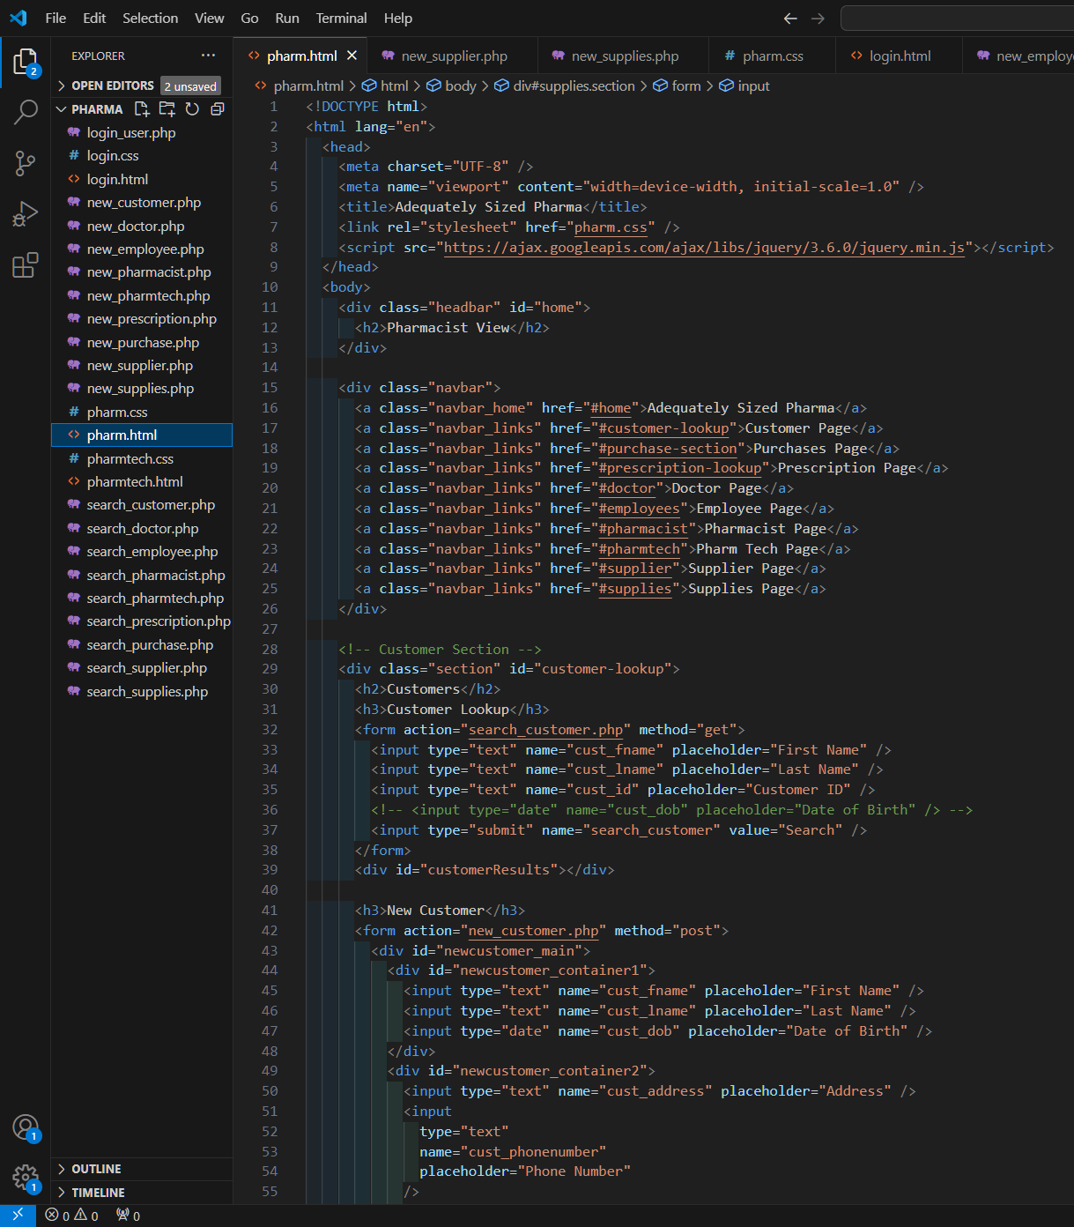

**HTML for Pharmacist View –** Here is a snippet of the HTML for the Pharmacist View page. The snippet includes the navbar and customer section.

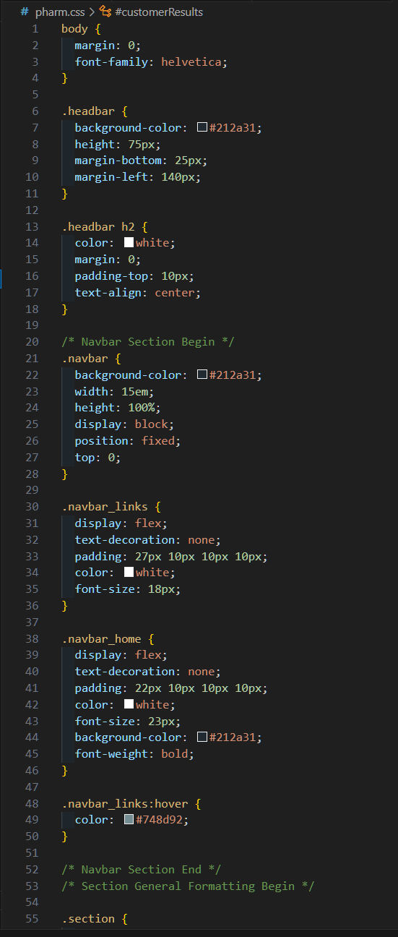

**CSS for Pharmacist View –** Here is a snippet of the CSS for the Pharmacist View Page. The snippet includes the CSS for the navbar.

# 

# System Testing and Result analysis

Using the interface is quite simple. It is a webpage that allows users to seamlessly add and access data from the database. The users will initially be presented with a login screen as seen below:

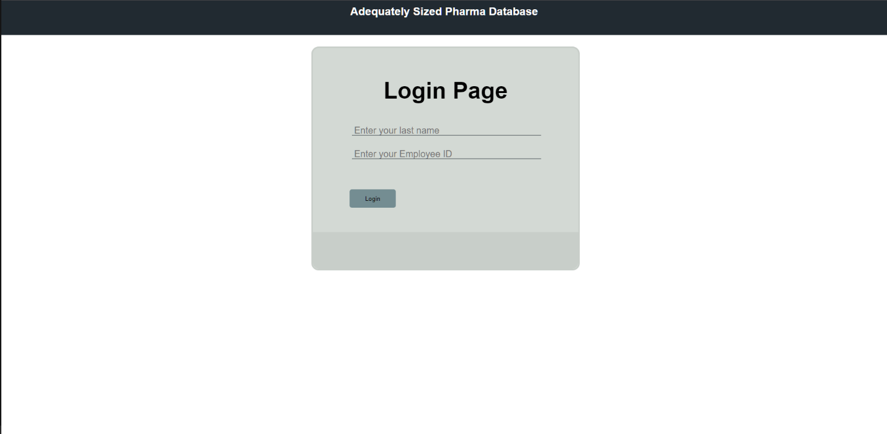**Login Page of Interface –** Here is the login page every user (Pharmacists and PharmTechs) will use to login.

To login, users must enter their last name and their employee ID. The employee ID is also the employee's pharmacist ID or pharmtech ID depending on their role. Based on this, after logging in the user will be met with one of two views:

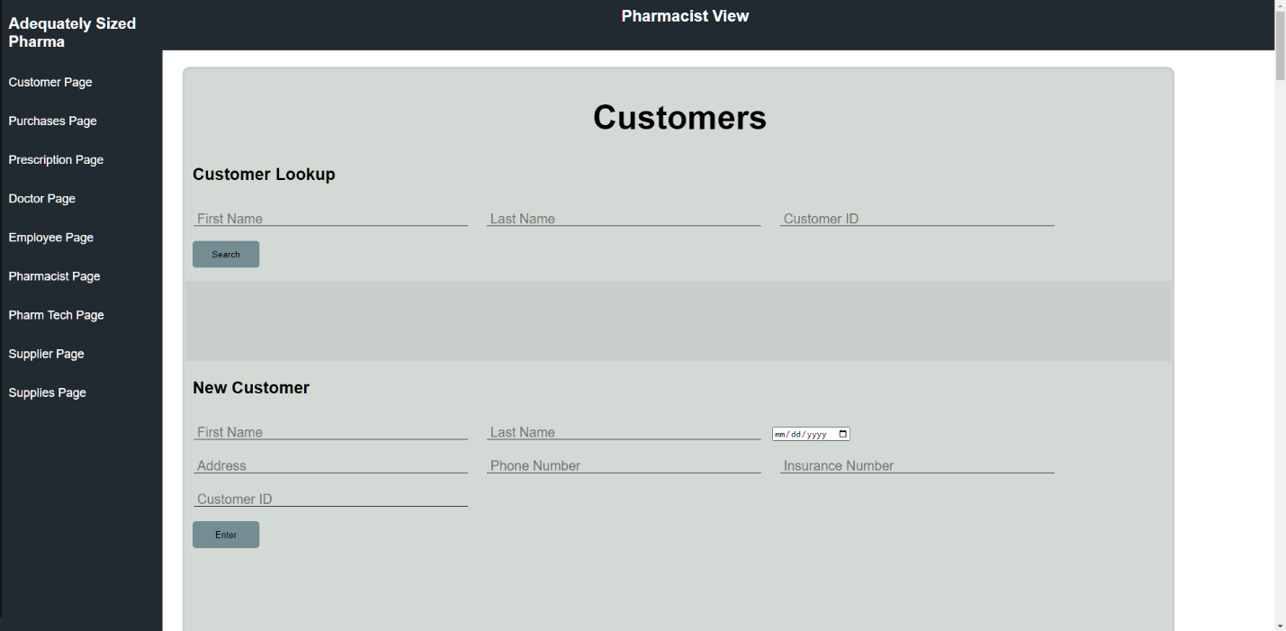**Pharmacist View –** Here is the main view of the interface that is available to those who login as a pharmacist. The pharmacist has access to every part of the database.

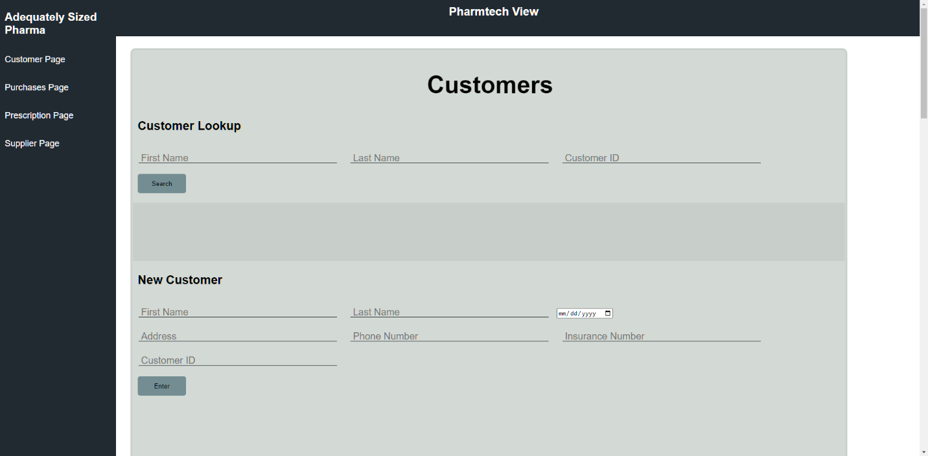**Pharmtech View –** Here is the main view of the interface that is available to those who login as a pharmtech. The pharmtech has limited access to the database.

If the user is a pharmacist, they will be brought to the pharmacist view page. This page includes everything as pharmacists will be leading the pharmacy and therefore will need access to all there is in the database. If the user is a pharmtech, they will be brought to the pharmtech view page. This page has limited access, and only has sections that are needed for a pharmtech to help assist customers.

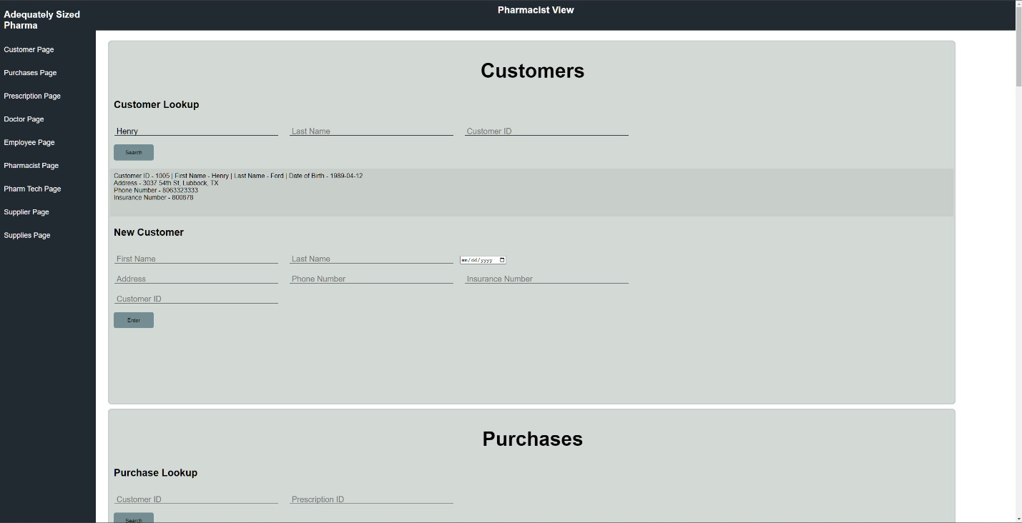**Searching for Customer –** Here is an example of searching for a customer using the customer lookup. Entering at least one field will present the user with the matching information of the customer.

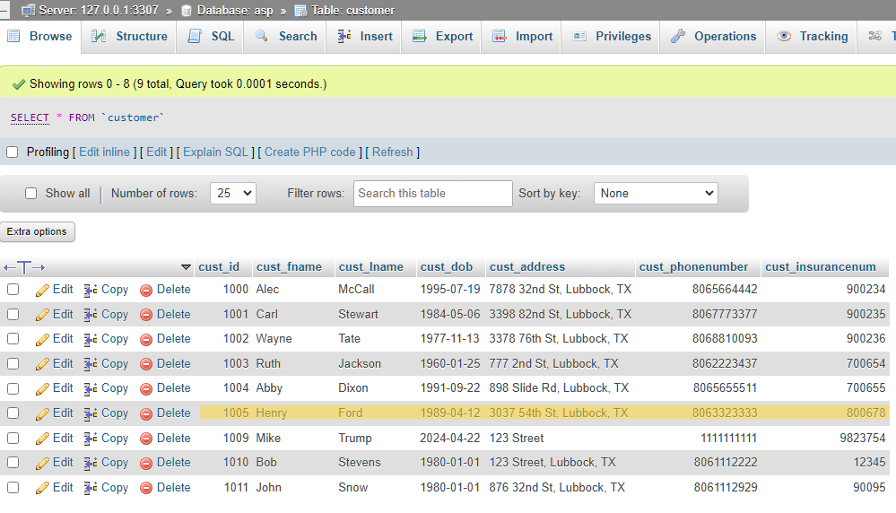**Searched Customer in Table –** Here is a screenshot of the customer information that was displayed in the interface in the previous example.

The insert and search functionalities for each section are shared between pharmacists and pharmtechs. The only difference is that the interface does not allow for certain sections to be present for pharmtechs, which prevents users who are not pharmacists in having access to unauthorized sections.

# Conclusion

The Adequately Sized Pharma database addresses all the issues that companies tend to have when relying on excel. All target users of the database have unique access to the database and view and change customer information based on their credentials. Our database trumps excel in every aspect that is important to the medical field, privacy, and autonomy. Our database complies with HIPPA regulations by allowing only the essential personnel to view the customer’s sensitive information. The database allows for all target users to simultaneously access and use the database without having to risk any information accidentally being modified. Our group has provided a streamlined process that all target users can easily understand and operate with minimal training meaning that pharmacies and small businesses alike can use our database for their needs.

We have provided a database and interface for a small pharmacy but there is always room for improvement. Some ideas are to make a dedicated interface for the customer to allow for online orders and view prescription history. Another idea is to make an interconnected network with other pharmacies so customers will always have access to their medications if one pharmacy does not carry it. Adequately Sized Pharma aims to make the medical field easier for professionals and customers alike with a streamlined and secure database.