Lab - Attacking a mySQL Database
Objectives
In this lab, you will view a PCAP file from a previous attack against a SQL database.
Part 1: Open Wireshark and load the PCAP file.
Part 2: View the SQL Injection Attack.
Part 3: The SQL Injection Attack continues…
Part 4: The SQL Injection Attack provides system information.
Part 5: The SQL Injection Attack and Table Information
Part 6: The SQL Injection Attack Concludes.
Background / Scenario
SQL injection attacks allow malicious hackers to type SQL statements in a web site and receive a response from the database. This allows attackers to tamper with current data in the database, spoof identities, and miscellaneous mischief.
A PCAP file has been created for you to view a previous attack against a SQL database. In this lab, you will view the SQL database attacks and answer the questions.
Required Resources
- CyberOps Workstation virtual machine
  - Start the CyberOps Workstation VM.
  - Click Applications > CyberOPS > Wireshark on the desktop and browse to the Wireshark application.
  - the Wireshark application, click Open in the middle of the application under Files.
  - Browse through the /home/analyst/ directory and search for lab.support.files. In the lab.support.files directory and open the SQL_Lab.pcap file.
    - The PCAP file opens within Wireshark and displays the captured network traffic. This capture file extends over an 8-minute (441 second) period, the duration of this SQL injection attack.
    - Within the Wireshark capture, right-click line 13 and select Follow > HTTP Stream. Line 13 was chosen because it is a GET HTTP request. This will be very helpful in following the data stream as the application layers sees it and leads up to the query testing for the SQL injection.
    - the Find field, enter 1=1. Click Find Next.
    - The attacker has entered a query (1=1) into a UserID search box on the target 10.0.2.15 to see if the application is vulnerable to SQL injection. Instead of the application responding with a login failure message, it responded with a record from a database. The attacker has verified they can input an SQL command and the database will respond. The search string 1=1 creates an SQL statement that will be always true. In the example, it does not matter what is entered into the field, it will always be true.
    - Close the Follow HTTP Stream window.
    - Click Clear display filter to display the entire Wireshark conversation.
    - Within the Wireshark capture, right-click line 19, and click Follow > HTTP Stream.
    - the Find field, enter 1=1. Click Find Next.
    - The attacker has entered a query (1’ or 1=1 union select database(), user()#) into a UserID search box on the target 10.0.2.15. Instead of the application responding with a login failure message, it responded with the following information:
    - Close the Follow HTTP Stream window.
    - Click Clear display filter to display the entire Wireshark conversation.
    - Within the Wireshark capture, right-click line 22 and select Follow > HTTP Stream. In red, the source traffic is shown and is sending the GET request to host 10.0.2.15. In blue, the destination device is responding back to the source.
    - the Find field, enter 1=1. Click Find Next.
    - The attacker has entered a query (1’ or 1=1 union select null, version ()#) into a UserID search box on the target 10.0.2.15 to locate the version identifier. Notice how the version identifier is at the end of the output right before the </pre>.</div> closing HTML code.
    - Close the Follow HTTP Stream window.
    - Click Clear display filter to display the entire Wireshark conversation.
    - Within the Wireshark capture, right-click on line 25 and select Follow > HTTP Stream. The source is shown in red. It has sent a GET request to host 10.0.2.15. In blue, the destination device is responding back to the source.
    - the Find field, enter users. Click Find Next.
    - The attacker has entered a query (1’or 1=1 union select null, table_name from information_schema.tables#) into a UserID search box on the target 10.0.2.15 to view all the tables in the
    - database. This provides a huge output of many tables, as the attacker specified “null” without any further specifications.
    - Close the Follow HTTP Stream window.
    - Click Clear display filter to display the entire Wireshark conversation.
    - Within the Wireshark capture, right-click line 28 and select Follow > HTTP Stream. The source is shown in red. It has sent a GET request to host 10.0.2.15. In blue, the destination device is responding back to the source.
    - Click Find and type in 1=1. Search for this entry. When the text is located, click Cancel in the Find text search box.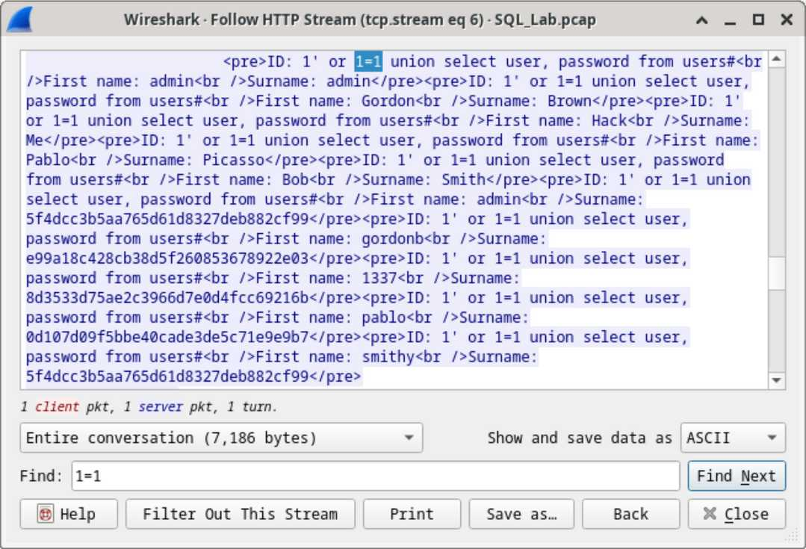
    - Using a website such ashttps://crackstation.net/, copy the password hash into the password hash cracker and get cracking.
    - Close the Follow HTTP Stream window. Close any open windows.
  - What is the risk of having platforms use the SQL langauge?
  - Browse the internet and perform a search on “prevent SQL injection attacks”. What are 2 methods or steps that can be taken to prevent SQL injection attacks?
Instructions
You will use Wireshark, a common network packet analyzer, to analyze network traffic. After starting Wireshark, you will open a previously saved network capture and view a step by step SQL injection attack against a SQL database.
Part 1: Open Wireshark and load the PCAP file.
The Wireshark application can be opened using a variety of methods on a Linux workstation.
Question:
What are the two IP addresses involved in this SQL injection attack based on the information displayed?
10.0.2.4 and 10.0.2.15
Part 2: View the SQL Injection Attack.
In this step, you will be viewing the beginning of an attack.
The source traffic is shown in red. The source has sent a GET request to host 10.0.2.15. In blue, the destination device is responding back to the source.
Part 3: The SQL Injection Attack continues...
In this step, you will be viewing the continuation of an attack.
The database name is dvwa and the database user is root@localhost. There are also multiple user accounts being displayed.
Part 4: The SQL Injection Attack provides system information.
The attacker continues and starts targeting more specific information.

Question:
What is the version?
MySQL 5.7.12-0
Part 5: The SQL Injection Attack and Table Information.
The attacker knows that there is a large number of SQL tables that are full of information. The attacker attempts to find them.
Question:
What would the modified command of (1' OR 1=1 UNION SELECT null, column_name FROM INFORMATION_SCHEMA.columns WHERE table_name='users') do for the attacker?
It will return a filtered list of only the column names from the users table, letting the attacker see that table’s structure (e.g., fields like user, password, etc.) instead of dumping all tables
Part 6: The SQL Injection Attack Concludes.
The attack ends with the best prize of all; password hashes.
The attacker has entered a query (1’or 1=1 union select user, password from users#) into a UserID search box on the target 10.0.2.15 to pull usernames and password hashes!
Question:
Which user has the password hash of 8d3533d75ae2c3966d7e0d4fcc69216b?
1337
Question:
What is the plain-text password?
charley
Type your answers here.
Reflection Questions
Type your answers here.
Type your answers here.
End of document

