Lab - Examining Telnet and SSH in Wireshark
Objectives
Part 1: Examine a Telnet Session with Wireshark
Part 2: Examine an SSH Session with Wireshark
Background / Scenario
In this lab, you will configure a router to accept SSH connectivity and use Wireshark to capture and view Telnet and SSH sessions. This will demonstrate the importance of encryption with SSH.
Required Resources
- CyberOps Workstation virtual machine
  - Start the CyberOps Workstation VM and log in with username analyst and password cyberops.
  - Open a terminal window and start Wireshark.
    - Start a Wireshark capture on the Loopback: lo interface.
    - Open another terminal window. Start a Telnet session to the localhost. Enter username analyst and password cyberops when prompted. Note that it may take several minutes for the “connected to localhost” and login prompt to appear.
      - Stop the Wireshark capture after you have provided the user credentials.
      - Apply a filter that only displays Telnet-related traffic. Enter telnet in the filter field and click Apply.
      - Right-click one of the Telnet lines in the Packet list section of Wireshark, and from the drop-down list, select Follow > TCP Stream.
      - The Follow TCP Stream window displays the data for your Telnet session with the CyberOps Workstation VM. The entire session is displayed in plaintext, including your password. Notice that the username that you entered is displayed with duplicate characters. This is caused by the echo setting in Telnet to allow you to view the characters that you type on the screen.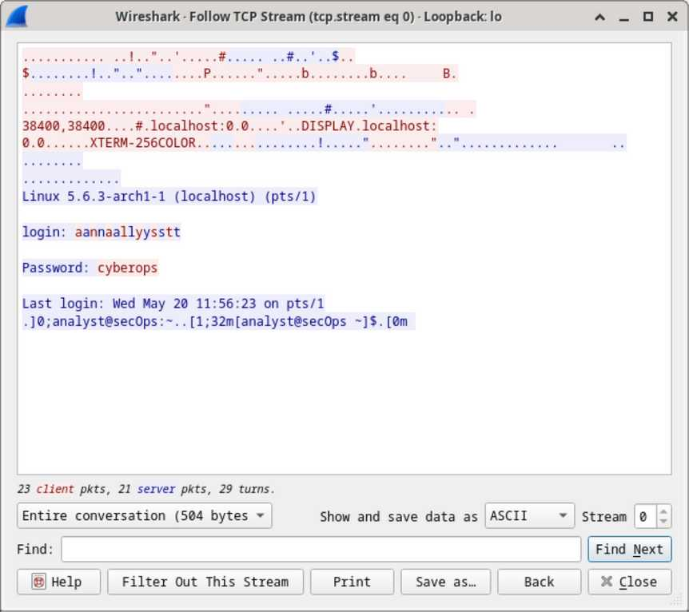
      - After you have finished reviewing your Telnet session in the Follow TCP Stream window, click Close.
      - Type exit at the terminal to exit the Telnet session.
      - Start another Wireshark capture using the Loopback: lo interface.
      - You will establish an SSH session with the localhost. At the terminal prompt, enter ssh localhost. Enter yes to continue connecting. Enter the cyberops when prompted.
      - Apply an SSH filter on the Wireshark capture data. Enter ssh in the filter field and click Apply.
      - Right-click one of the SSHv2 lines in the Packet list section of Wireshark, and in the drop-down list, select the Follow > TCP Stream.
      - Examine the Follow TCP Stream window of your SSH session. The data has been encrypted and is unreadable. Compare the data in your SSH session to the data of your Telnet session.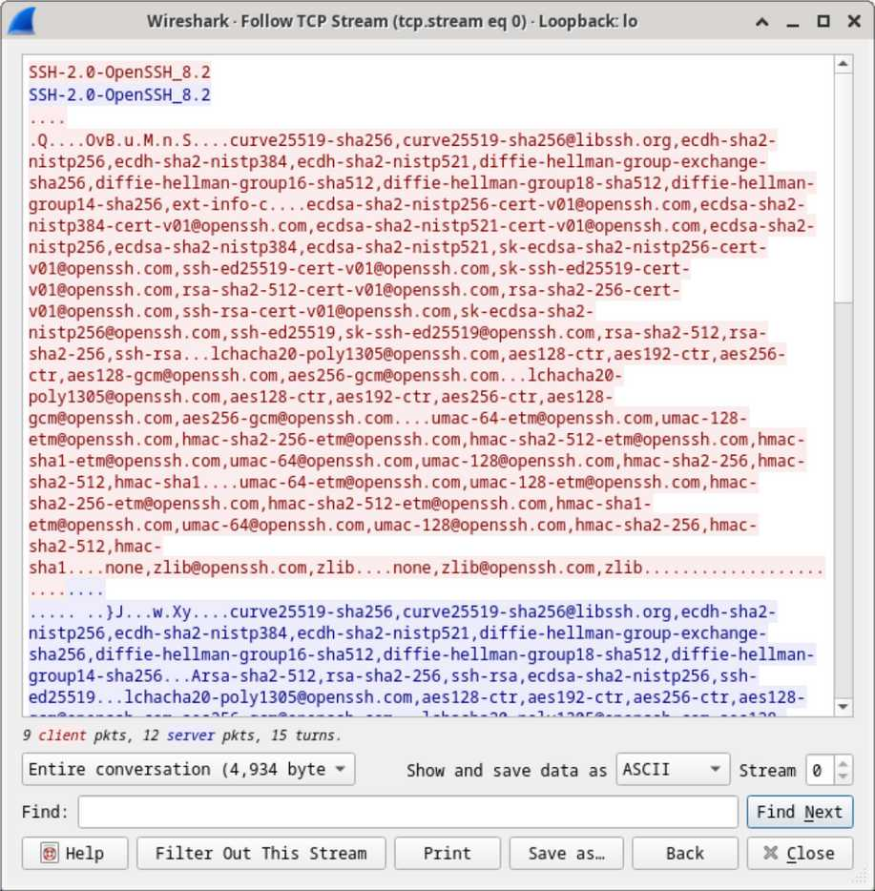
      - After examining your SSH session, click Close.
      - Close Wireshark.
Instructions
Part 1: Examining a Telnet Session with Wireshark
You will use Wireshark to capture and view the transmitted data of a Telnet session.
Step 1: Capture data.
[analyst@secOps ~]$ wireshark &
[analyst@secOps ~]$ telnet localhost
Trying ::1...
Connected to localhost.
Escape character is '^]'.
Linux 4.10.10-1-ARCH (unallocated.barefruit.co.uk) (pts/12)
secOps login: analyst
Password:
Last login: Fri Apr 28 10:50:52 from localhost.localdomain
[analyst@secOps ~]$
Step 2: Examine the Telnet session.
[analyst@secOps ~]$ exit
Part 2: Examine an SSH Session with Wireshark
In Part 2, you will establish an SSH session with the localhost. Wireshark will be used to capture and view the data of this SSH session.
[analyst@secOps ~]$ ssh localhost
The authenticity of host 'localhost (::1)' can't be established.
ECDSA key fingerprint is SHA256:1xZuV8NMeVsNQPRrzVf9nXHzdUP+EtgVouZVbWH80XA.
Are you sure you want to continue connecting (yes/no/[fingerprint])? yes
Warning: Permanently added 'localhost' (ECDSA) to the list of known hosts.
analyst@localhost's password:
Last login: Sat May 23 10:18:47 2020Stop the Wireshark capture.
Reflection Question
Why is SSH preferred over Telnet for remote connections?
SSH is preferred over Telnet because it encrypts all transmitted data, including usernames, passwords, and commands. This encryption prevents attackers from capturing sensitive information using packet-sniffing tools like Wireshark.
In contrast, Telnet sends all data in plaintext, making it easy for attackers to intercept and read credentials and session data. SSH also provides authentication, integrity, and confidentiality, making it a secure choice for remote administration.
Type your answers here.
End of document

