Lab - Extract an Executable from a PCAP
Objectives
Part 1: Analyze Pre-Captured Logs and Traffic Captures
Part 2: Extract Downloaded Files from PCAP
Background / Scenario
Looking at logs is very important, but it is also important to understand how network transactions happen at the packet level.
In this lab, you will analyze the traffic in a previously captured pcap file and extract an executable from the file.
Required Resources
- CyberOps Workstation virtual machine
  - Change directory to the lab.support.files/pcaps folder, and get a listing of files using the ls –l command.
    - Issue the command below to open the nimda.download.pcap file in Wireshark.
      - The nimda.download.pcap file contains the packet capture related to the malware download performed in a previous lab. The pcap contains all the packets sent and received while tcpdump was running.
      - Select the fourth packet in the capture and expand the Hypertext Transfer Protocol to display as shown below.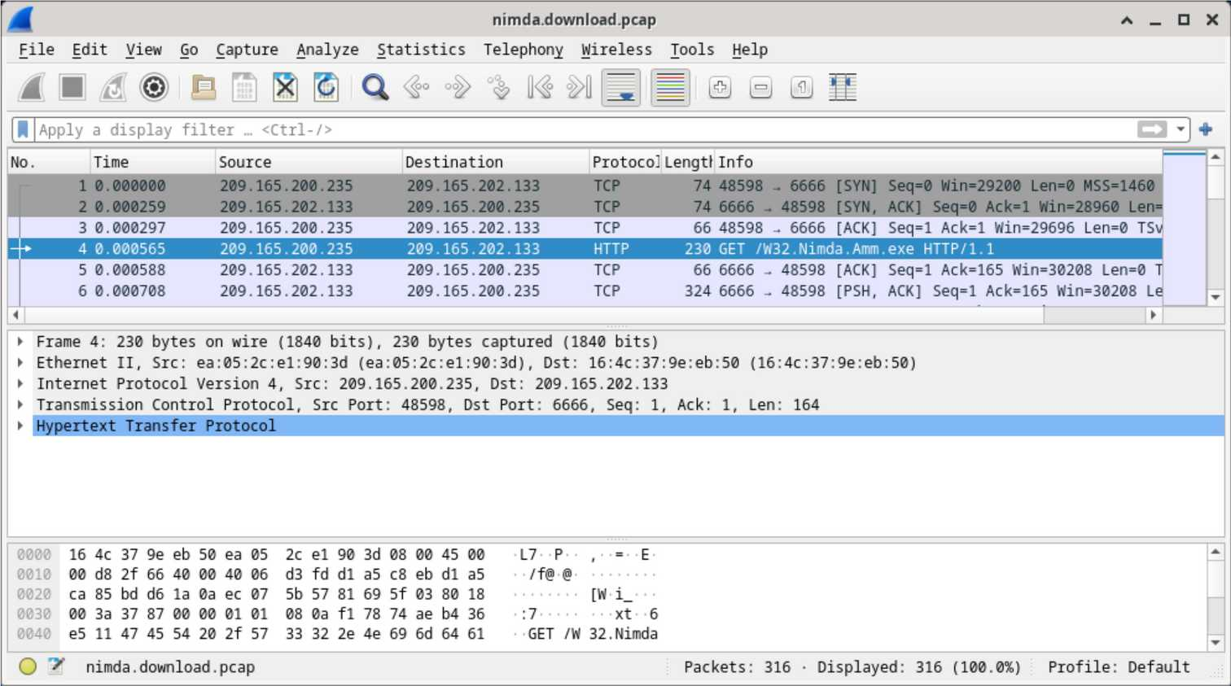
      - Packets one through three are the TCP handshake. The fourth packet shows the request for the malware file. Confirming what was already known, the request was done over HTTP, sent as a GET request.
      - Because HTTP runs over TCP, it is possible to use Wireshark’s Follow TCP Stream feature to rebuild the TCP transaction. Select the first TCP packet in the capture, a SYN packet. Right-click it and choose Follow > TCP Stream.
      - Wireshark displays another window containing the details for the entire selected TCP flow.
      - Click Close in the Follow TCP Stream window to return to the Wireshark nimda.download.pcap file.
      - that fourth packet in the nimda.download.pcap file, notice that the HTTP GET request was generated from 209.165.200.235 to 209.165.202.133. The Info column also shows this is in fact the GET request for the file.
      - With the GET request packet selected, navigate to File > Export Objects > HTTP, from Wireshark’s menu.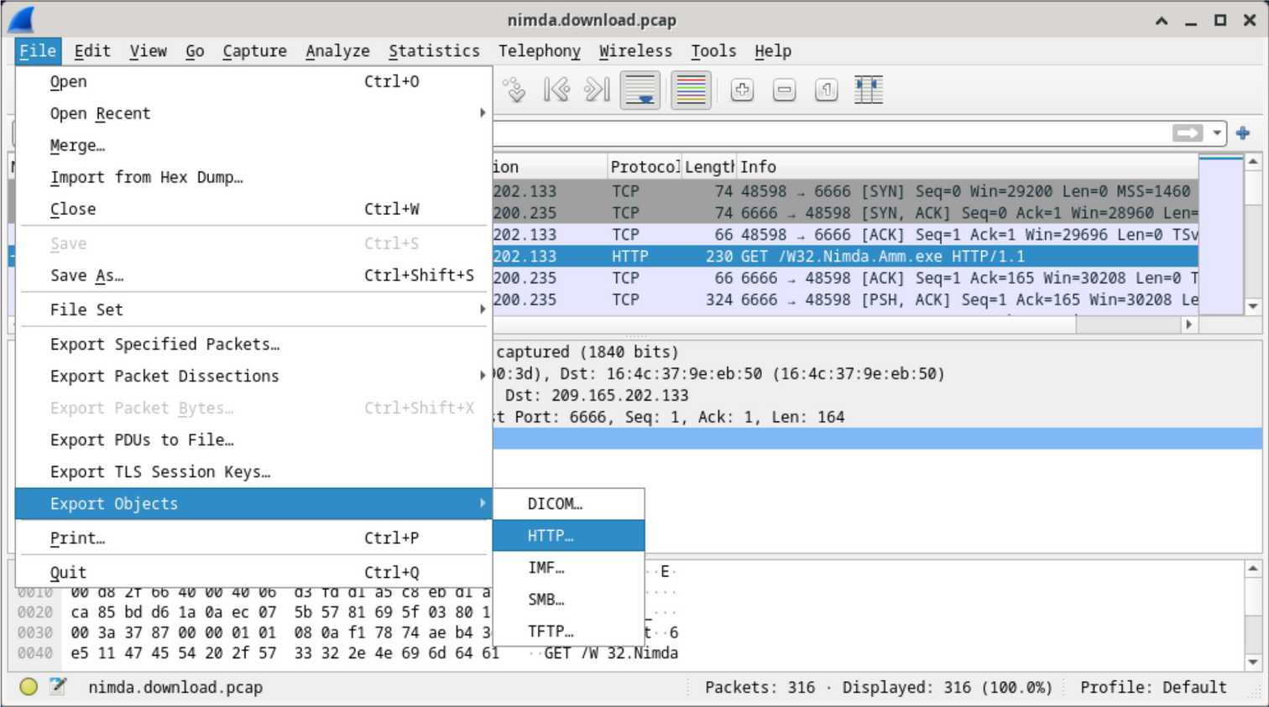
      - Wireshark will display all HTTP objects present in the TCP flow that contains the GET request. In this case, only the W32.Nimda.Amm.exe file is present in the capture. It will take a few seconds before the file is displayed.
      - the HTTP object list window, select the W32.Nimda.Amm.exe file and click Save As at the bottom of the screen.
      - Click the left arrow until you see the Home button. Click Home and then click the analyst folder (not the analyst tab). Save the file there.
      - Return to your terminal window and ensure the file was saved. Change directory to the /home/analyst folder and list the files in the folder using the ls -l command.
      - The file command gives information on the file type. Use the file command to learn a little more about the malware, as show below:
Instructions
Part 1: Analyze Pre-Captured Logs and Traffic Captures
In Part 2, you will work with the nimda.download.pcap file. Captured in a previous lab, nimda.download.pcap contains the packets related to the download of the Nimda malware. Your version of the file, if you created it in the previous lab and did not reimport your CyberOps Workstation VM, is stored in the /home/analyst directory. However, a copy of that file is also stored in the CyberOps Workstation VM, under the /home/analyst/lab.support.files/pcaps directory so that you can complete this lab. For consistency of output, the lab will use the stored version in the pcaps directory.
While tcpdump can be used to analyze captured files, Wireshark’s graphical interface makes the task much easier. It is also important to note that tcpdump and Wireshark share the same file format for packet captures; therefore, PCAP files created by one tool can be opened by the other.
[analyst@secOps ~]$ cd lab.support.files/pcaps
[analyst@secOps pcaps]$ ls -l
total 7460
- rw-r--r-- 1 analyst analyst 3510551 Aug 7 15:25 lab_prep.pcap
- rw-r--r-- 1 analyst analyst 371462 Jun 22 10:47 nimda.download.pcap
- rw-r--r-- 1 analyst analyst 3750153 May 25 11:10 wannacry_download_pcap.pcap
[analyst@secOps pcaps]$
[analyst@secOps pcaps]$ wireshark nimda.download.pcap &
Questions:
What are all those symbols shown in the Follow TCP Stream window? Are they connection noise? Data? Explain.
Type your answers here.
The symbols displayed in the Follow TCP Stream window represent the actual binary contents of the downloaded executable file. They are not connection noise.
Wireshark is attempting to display raw binary data as if it were text. Because executable files are compiled into machine code rather than human-readable characters, most of the bytes do not map cleanly to standard ASCII characters. As a result, Wireshark substitutes strange symbols to represent these byte values.
In short, what you are seeing is the payload data of the HTTP file transfer — the malware file itself — rendered in a text-based interface that is not designed for binary content.

There are a few readable words spread among the symbols. Why are they there?
Type your answers here.
The readable words appear because most executable programs contain embedded text strings. These strings are typically used for:
- Error messages
- Command-line output
- File paths
- Registry keys
- Debugging messages
- API or function references
Even though the program is compiled into binary machine code, these text strings remain stored in plain ASCII format inside the executable.
A skilled analyst can often extract intelligence from these fragments, such as clues about the malware’s purpose, the commands it may run, the servers it might contact, or the system functions it relies on. This technique is commonly used in static malware analysis using tools like strings.

Challenge Question: Despite the W32.Nimda.Amm.exe name, this executable is not the famous worm. For security reasons, this is another executable file that was renamed as W32.Nimda.Amm.exe. Using the word fragments displayed by Wireshark’s Follow TCP Stream window, can you tell what executable this really is?
Type your answers here.
By scrolling through the Follow TCP Stream window and observing the readable fragments, it becomes clear that the file contains references associated with the Windows command interpreter.
The visible strings strongly match those found in Microsoft’s cmd.exe program, which is the default Windows command-line shell.
Therefore, despite being named W32.Nimda.Amm.exe, the file is not the actual Nimda worm. It is a renamed copy of cmd.exe, likely used as a safe substitute for training purposes so that learners are not exposed to real malware.

Part 2: Extract Downloaded Files from PCAP
Because capture files contain all packets related to traffic, a PCAP of a download can be used to retrieve a previously downloaded file. Follow the steps below to use Wireshark to retrieve the Nimda malware.
Question:
Why is W32.Nimda.Amm.exe the only file in the capture?
Type your answers here.
W32.Nimda.Amm.exe is the only file present because the packet capture was started immediately before the malware download and stopped immediately after it completed.
No other web requests, background traffic, or unrelated network sessions were captured during that time. As a result, the PCAP file contains only:
- The TCP handshake
- The HTTP GET request
- The HTTP response
- The file data transfer for the executable
This clean capture makes it easier to isolate and reconstruct the downloaded file without interference from unrelated traffic.

[analyst@secOps pcaps]$ cd /home/analyst
[analyst@secOps ~]$ ls –l
total 364
drwxr-xr-x 2 analyst analyst 4096 Sep 26 2014 Desktop
drwx------ 3 analyst analyst 4096 May 25 11:16 Downloads
drwxr-xr-x 2 analyst analyst 4096 May 22 08:39 extra
drwxr-xr-x 8 analyst analyst 4096 Jun 22 11:38 lab.support.files
drwxr-xr-x 2 analyst analyst 4096 Mar 3 15:56 second_drive
-rw-r--r-- 1 analyst analyst 345088 Jun 22 15:12 W32.Nimda.Amm.exe
[analyst@secOps ~]$
Question:
Was the file saved?
Type your answers here.
Yes, the file was successfully saved.
This is confirmed by running the ls -l command in the /home/analyst directory, which shows the presence of the file W32.Nimda.Amm.exe along with its file size and timestamp. The listing proves that Wireshark correctly extracted the HTTP object and wrote it to disk.

[analyst@secOps ~]$ file W32.Nimda.Amm.exe
W32.Nimda.Amm.exe: PE32+ executable (console) x86-64, for MS Windows
[analyst@secOps ~]$
As seen above, W32.Nimda.Amm.exe is indeed a Windows executable file.
Question:
In the malware analysis process, what would be a probable next step for a security analyst?
Type your answers here.
A logical next step would be to move the extracted executable into a controlled malware analysis environment, such as a sandboxed virtual machine, and perform both static and dynamic analysis.
Typical next actions would include:
Static Analysis (without execution)
- Running the file command to confirm file type
- Using strings to extract readable text
- Calculating cryptographic hashes (MD5/SHA256) for identification
- Checking the file against known malware databases (e.g., VirusTotal)
- Inspecting headers using tools like PEview
Dynamic Analysis (controlled execution)
- Running the file inside an isolated VM
- Monitoring:
  - Network connections
  - File system changes
  - Registry modifications
  - Process creation
  - Memory usage
- Capturing traffic with Wireshark or tcpdump
- Logging system activity using host-based monitoring tools
The goal is to determine what the executable actually does, whether it is malicious, how it behaves, and what indicators of compromise (IOCs) it produces.
Internet-based services such as VirusTotal may also be used to compare the file’s hash against known malware samples and generate reputation and behavioural reports.

End of document

