Lab - Isolate Compromised Host Using 5-Tuple
Objectives
In this lab, you will review logs that were gathered during the exploitation of a documented vulnerability to determine the compromised hosts and file.
Part 1: Review Alerts in Sguil
Part 2: Pivot to Wireshark
Part 3: Pivot to Kibana
Background / Scenario
The 5-tuple is used by IT administrators to identify requirements for creating an operational and secure network environment. The components of the 5-tuple include a source IP address and port number, destination IP address and port number, and the protocol in use in the data payload. This is the protocol field of the IP packet header.
In this lab, you will also review the logs to identify the compromised hosts and the content of the compromised file.
Required Resources
- Security Onion virtual machine
  - Launch the Security Onion VM and log in. Log in with the user analyst and password cyberops
  - Open Sguil and log in. Click Select All to select the interfaces and then Start SGUIL.
  - Review the events listed in the Event Message column. One of these messages is GPL ATTACK_RESPONSE id check returned root. This message indicates that root access may have been gained during an attack. The host at 209.165.200.235 returned root access to 209.165.201.17. The alert ID 5.1 is used as an example in this lab.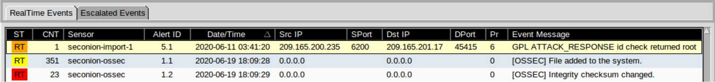
    - Select the Show Packet Data and Show Rule checkboxes to view each alert in more detail.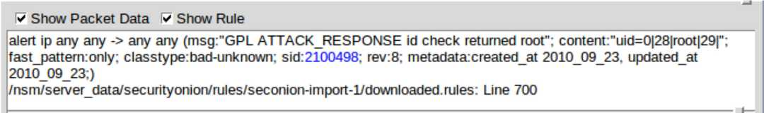
    - Right-click the alert ID 5.1 and select Transcript.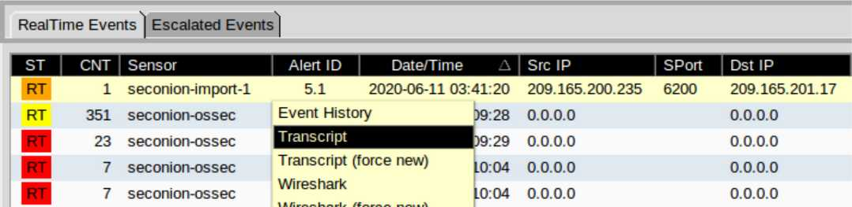
    - Review the transcripts for the alert. The transcript displays the transactions between the threat actor source (SRC) and the target (DST) during the attack. The threat actor is executing Linux commands on the target.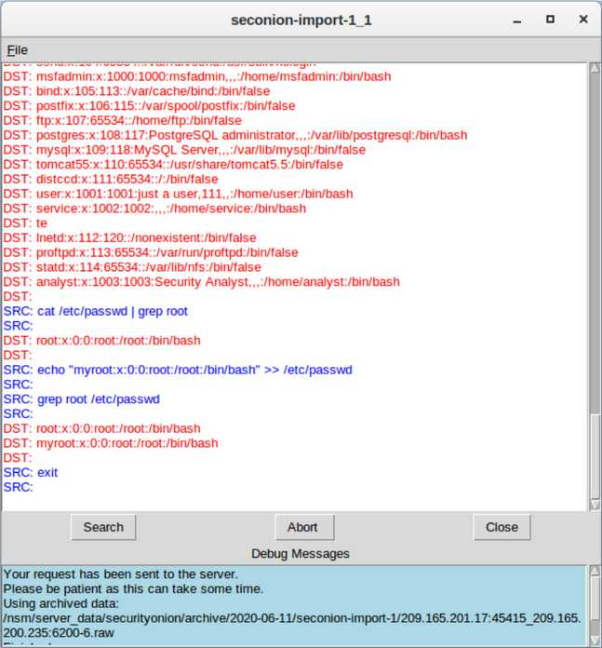
    - Select the alert that provided you with the transcript from the previous step. Right-click the alert ID 5.1 and select Wireshark. The Wireshark main window displays three views of a packet.
    - view all packets that are assembled in a TCP conversation, right-click any packet and select Follow > TCP Stream.
    - Exit the TCP stream window. Close Wireshark when you are done reviewing the information provided.
    - Return to Sguil. Right-click either the source or destination IP for the alert ID 5.1 and select Kibana IP Lookup > SrcIP. Enter username analyst and password cyberops if prompted by Kibana.
    - the time range is the last 24 hours, change it to June 2020 so June 11 is included in the time range. Use the Absolute tab to change the time range.
    - the displayed results, there is a list of different data types. You were told that the file confidential.txt is no longer accessible. In the Sensors - Sensors and Services (Pie Chart), ftp and ftp-data are present in the list, as shown in the figure. We will determine if FTP was used to steal the file.
    - Let's filter for bro_ftp. Hover over the empty space next to the count of bro_ftp data types. Select + to filter for only FTP related traffic as shown in the figure.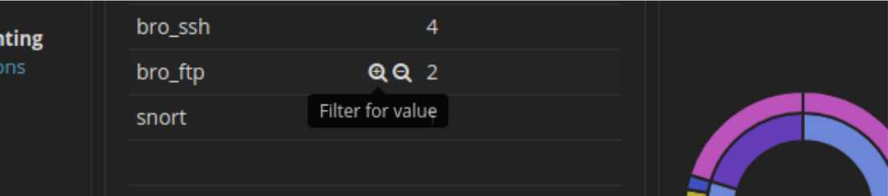
    - Scroll down to the All Logs section. There are two entries listed.
    - Expand and review both log entries. In one of these entries, the ftp_argument has an entry offtp://209.165.200.235/./confidential.txt. Also review the message in the log entry to learn more about this event.
    - Within the same log entry, scroll up back to the alert _id field and click the link.
    - Review the transcript for the transactions between the attacker and the target. If desired, you can download the pcap and review the traffic using Wireshark.
    - Now that you have verified that the attacker has used FTP to copy the content of the file confidential.txt and then deleted it from the target. So what is the content of the file? Remember one of the services listed in the pie chart is ftp_data.
    - Navigate to the top of the dashboard. Select Files under the Zeek Hunting heading in the left panel, as shown in the figure. This will allow you to review the types of the files that were logged.
    - Filter for FTP_DATA by hovering over the empty space next to the Count for FTP_DATA and click +.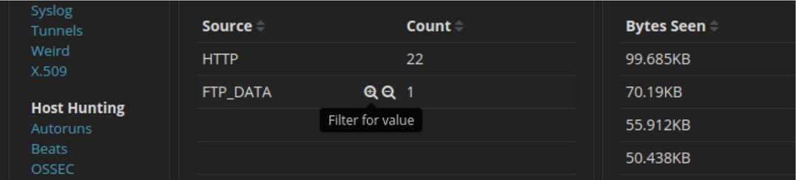
    - Scroll down to review the filtered results.
    - the File logs, expand the entry associated with FTP data. Click the link associated with alert _id.
Instructions
After the attack, the users no longer have access to the file named confidential.txt. Now you will review the logs to determine how the file was compromised.
Note: If this was a production network, it is recommended that analyst and root users change their passwords and comply with the current security policy.
Part 1: Review Aerts in Sguil
Question:
What kind of transactions occurred between the client and the server in this attack?
Type your answers here.
The transactions observed indicate a successful remote exploitation of the target system. The alert message “GPL ATTACK_RESPONSE id check returned root” confirms that the attacker was able to gain root-level access on the victim machine.
From the Sguil transcript:
- The source IP address (209.165.201.17) represents the threat actor
- The destination IP address (209.165.200.235) is the compromised host
- The attacker executed interactive Linux commands remotely
- Commands allowed the attacker to:
  - Navigate the filesystem
  - Read sensitive system files
  - Copy credential-related files such as /etc/shadow
  - Modify /etc/shadow and /etc/passwd
These actions demonstrate a command-and-control session, where the attacker had full administrative control over the server. This is a post-exploitation phase, meaning the attacker had already bypassed security controls and escalated privileges.

Part 2: Pivot to Wireshark
Question:
What did you observe? What do the text colors red and blue indicate?
Type your answers here.
The TCP stream shows the transaction between threat actor displayed in red text and the target in blue text. The information from the TCP stream is the same as in the transcript. The hostname of the target is metasploitable and its IP address is 209.165.200.235.
The attacker issues the whoami command on the target. What does this show about the attacker role on the target computer?
Type your answers here.
The whoami command returns root, which proves that the attacker has superuser (administrator) privileges on the compromised system.

Scroll through the TCP stream. What kind of data has the threat actor been reading?
Type your answers here.
The TCP stream shows the attacker reading user authentication and account data, including:
- System user account details
- Encrypted password hashes stored in /etc/shadow
- User and group configuration information from /etc/passwd

Part 3: Pivot to Kibana
Note: If you received the message "Your connection is not private", click ADVANCED > Proceed to localhost (unsafe) to continue.
Questions:
What are the source and destination IP addresses and port numbers for the FTP traffic?
Type your answers here.
The Kibana logs filtered for bro_ftp (Zeek FTP logs) show the following 5-tuple details:
- Source IP address: 192.168.0.11
- Source port: 52776 (ephemeral client port)
- Destination IP address: 209.165.200.235
- Destination port: 21 (FTP control port)
- Protocol: TCP
This confirms that FTP was used as the data exfiltration method, with the internal host acting as the client and the compromised server acting as the FTP server.

Question:
What are the user credentials to access the FTP site?
Type your answers here.
The Kibana FTP log entry clearly reveals the credentials used during the FTP session:
- Username: analyst
- Password: cyberops
These credentials were transmitted in clear text, which is a major security weakness of FTP. Any attacker monitoring the network could capture and reuse them.

Questions:
What are the different types of files? Look at the MIME Type section of the screen.
Type your answers here.
The Zeek file logs show multiple file types, including:
- Text files (text/plain)
- Image files (various image MIME types)
This demonstrates that the monitoring system is capable of detecting and categorizing transferred files based on their content.

Scroll to the Files - Source heading. What are the file sources listed?
Type your answers here.
The Files – Source section lists:
- HTTP
- FTP

Question:
What is the MIME type, source and destination IP address associated with the transfer of the FTP data? When did this transfer occur?
Type your answers here.
The FTP data transfer has the following attributes:
- MIME type: text/plain
- Source IP address: 192.168.0.11
- Destination IP address: 209.165.200.235
- Date and time: June 11, 2020 at approximately 03:53
This confirms that a plain text file was transferred using FTP during the attack timeline.

Question:
What is the text content of the file that was transferred using FTP?
Type your answers here.
CONFIDENTIAL DOCUMENT
DO NOT SHARE
This document contains information about the last security breach.
With all the information has gathered so far, what is your recommendation for stopping further unauthorized access?
Type your answers here.
Based on the evidence collected, the minimum recommended action is to:
- Immediately change the password for the user analyst on:
  - The compromised server (209.165.200.235)
  - The internal host (192.168.0.11)
Additional security recommendations include:
- Disable FTP and replace it with SFTP or SCP
- Enforce strong password policies
- Rotate all credentials used during the incident
- Audit systems for backdoors and persistence mechanisms
- Apply system patches and vulnerability fixes
- Implement network segmentation and least privilege access
- Monitor logs continuously using SIEM tools like Security Onion

End of document

