Evan Tilley

elt2141

1.

a. The example is from the application YouTube.

b. Flexibility and efficiency of use is the usability heuristic that is being used well here, as YouTube has a variety of useful keyboard shortcuts that allow experienced users to have a better experience when watching videos. For instance, while watching a video, if one presses the “J” key, the video will rewind 10 seconds, and if one presses the “L” key, the video will fast forward 10 seconds. Similarly, if one wants to navigate a video with a bit more precision, pressing the left arrow rewinds the video 5 seconds, and pressing the right arrow fast forwards the video 5 seconds. Pressing the “K” key pauses the video.

c. Before pressing the “L” key:

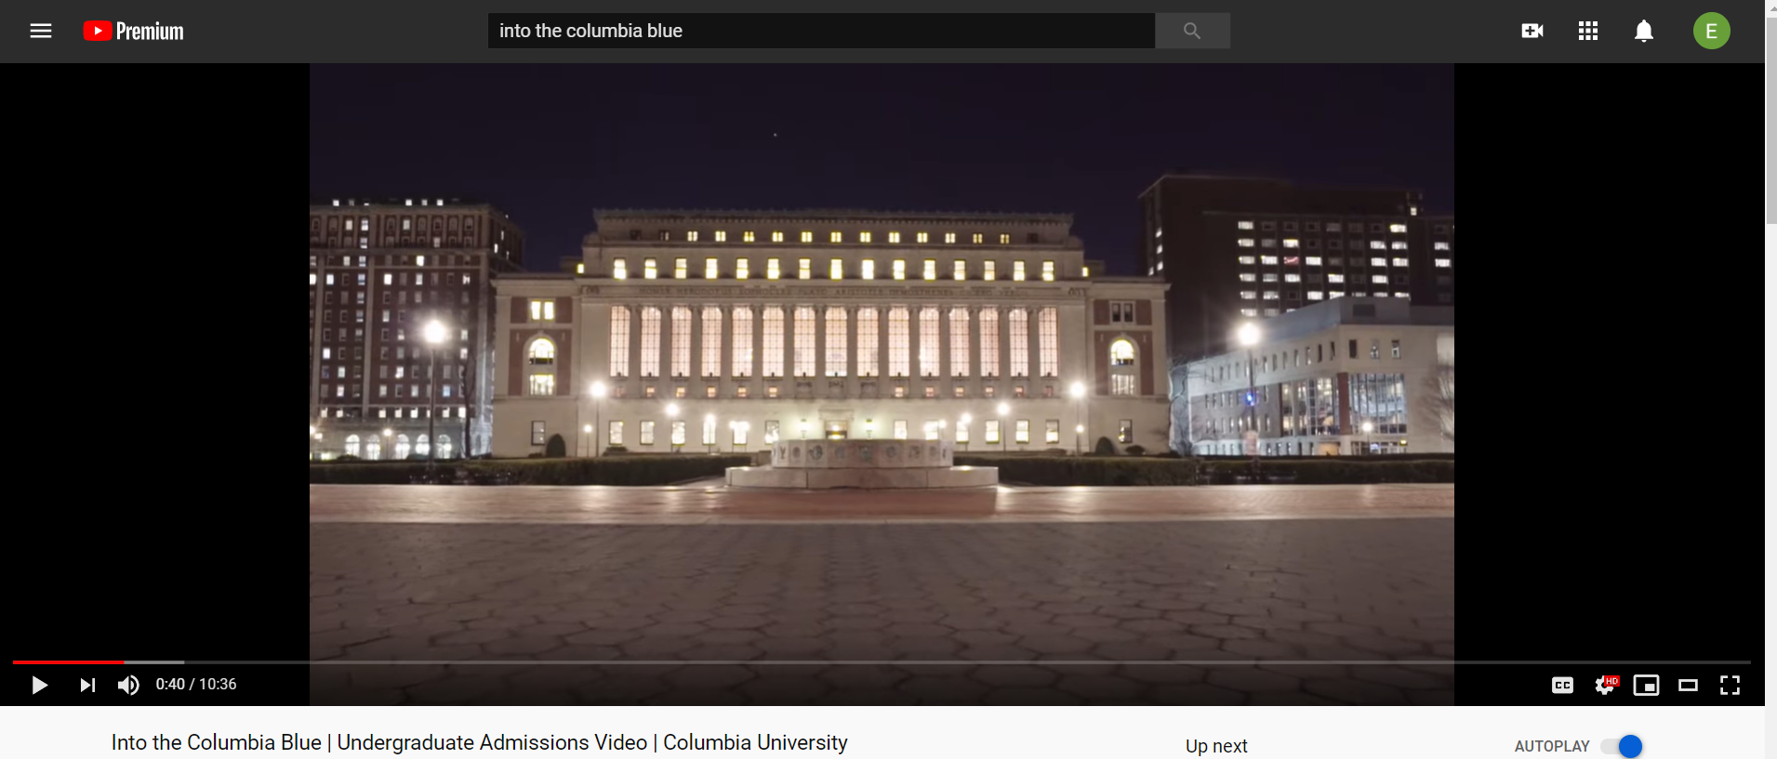

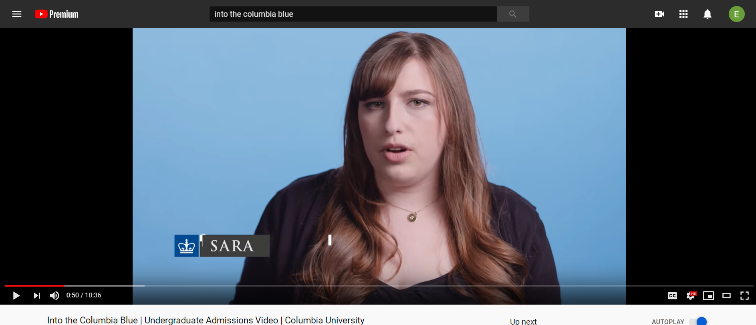After pressing the “L” key (notice how the video has advanced by 10 seconds):