Evan Tilley

elt2141

3.

a. The example is from the application SSOL.

b. User control and freedom is the usability heuristic that is being violated here. SSOL is very limited in term of allowing users to undo a system function that they have selected. In particular, if a user accidentally drops a class, there is no option to undo, in case the user accidentally pressed the drop button.

c. Selecting the class (and accidentally pressing drop):

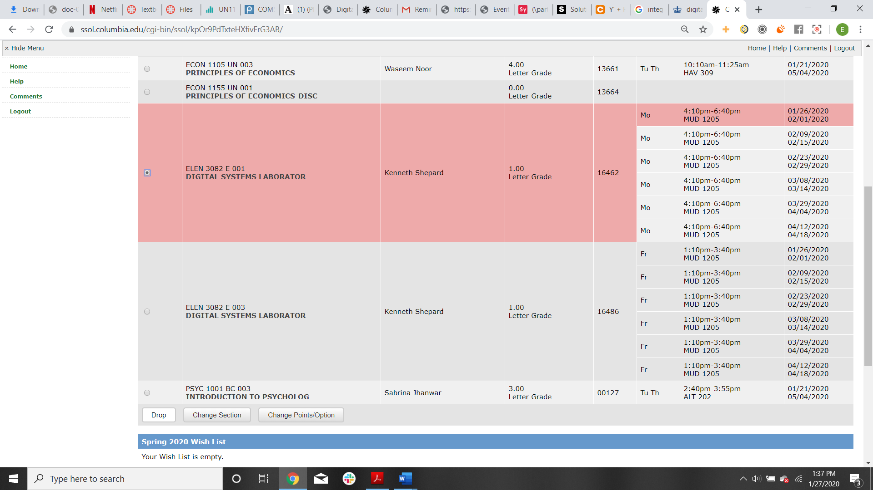

The class has now been dropped:

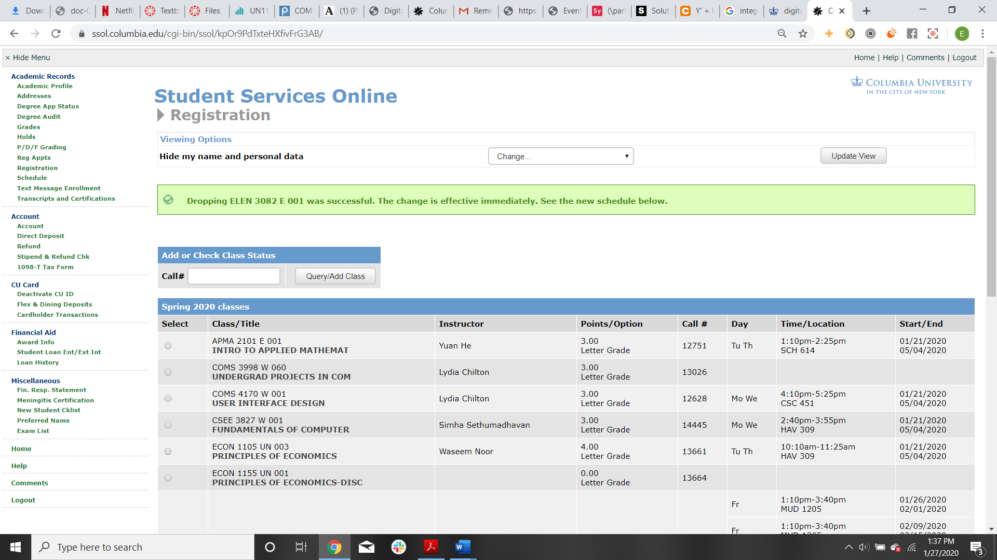

d. Violating this principle is particularly egregious for this application because SSOL is the only way in which a Columbia student can register and drop classes, which is the entire point of going to college. So, if a student accidentally drops a class they are enrolled in that has a waitlist of 200 students, they probably won’t be able to get back in, and their academic career could be pushed back by an entire semester.