Evan Tilley

elt2141

4.

a. The example is the application GroupMe.

b. The application violates the user control and freedom heuristic, because if a user chooses the “send” function by mistake, the user cannot fix his/her mistake and “undo” sending the message or “unsend” the message.

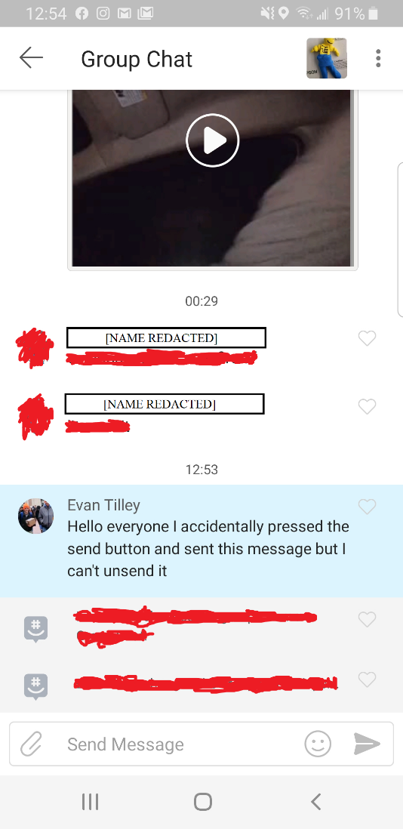c.

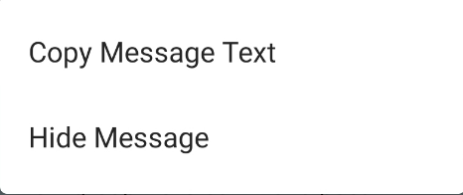

Pressing down on the message to unsend simply presents users with 2 options:

where “Hide Message” simply hides the message only on the user’s device, but there is no way to unsend a message.

d. Violating this principle is particularly egregious for this application because the entire point of this application is to send messages, and it is problematic if a user cannot unsend a message, as he/she could have mistyped something or changed their mind about something. Thus, the application is limited.