Evan Tilley

elt2141

6.

a.

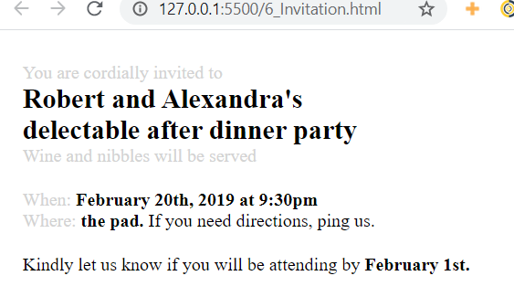

b.

i. Size is one of the information design tools that I used to emphasize important information – in this instance, the actual event “Robert and Alexandra’s delectable after dinner party” is arguably the most important part of the note, since it is telling the reader *what* they are invited to. Thus, I emphasized this information by making the text larger than the surrounding text. I also used contrast to emphasize important information; I bolded the event itself, the time of the event, the location of the event, and the RSVP date. This information, since it is bolded, stands out from the surrounding information. Together, the large size and bold aspect of certain terms highlights their importance.

ii. To implement the size design tool I used the CSS font-size property, and targeted the event itself with a larger font size (24 px). To implement the contrast design tool, I used the CSS font-weight property, and targeted important information with this property.

c.

i. I used contrast to de-emphasize lesser important elements of the letter, such as “You are cordially invited to” are in a light color. Thus, these elements don’t stand out from the background as much and are not as distracting to readers, who’s attention will instead be drawn to the more important information, like the event itself, and the time, location, and RSVP date of the event. I also used size to de-emphasize lesser information, as less important information is smaller. The most important information on the page – the event itself, is in the largest font size, and the other information is in a smaller font size. Making text both smaller and giving it a lighter color uses contrast and size together to de-emphasize it.

ii. To implement the contrast design tool, I used the CSS color property, and targeted less important elements with this property, giving them the color “lightgray”. To implement the size design tool, I targeted all text, besides the text describing the event itself, with the a smaller font-size CSS property, giving this text a font size of 16 px.

d. Code submitted.