Evan Tilley

elt2141

7.

a. The 3 groups in the information hierarchy are depicted and labeled below:

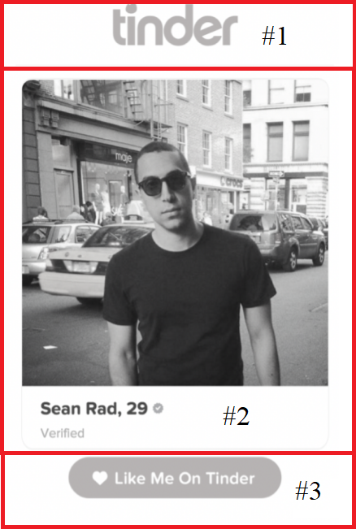

b. Each group has a concept behind it; Group #1 is the app name; Group #2 is the user profile; Group #3 is the like functionality.

c. Group #2 is the most complex of the three groups as it displays the most information. The 3 conceptual groups within group #2 are depicted and labeled below:

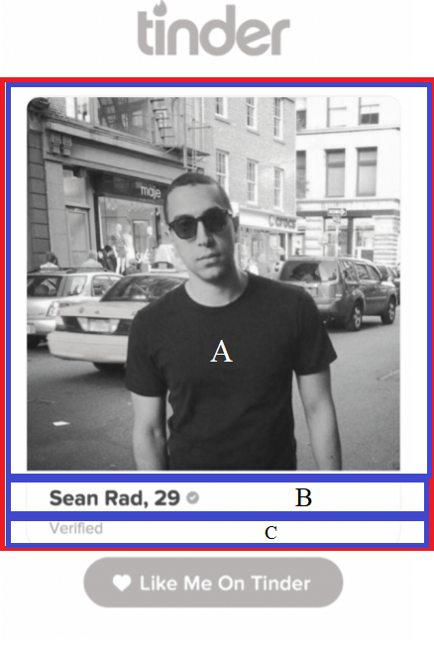

d. Each group has a concept behind it; Group #1 is the picture of the user; Group #2 is information about the user; Group #3 is the textual indication of verification (i.e. whether or not the user is verified)