Evan Tilley

elt2141

9.

a. Screenshot of my implementation

. 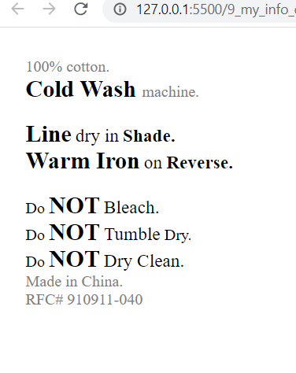

b.

i. The concept behind the first conceptual grouping the user will see is “washing”. The first group expresses the instructions to wash, which is the first step of cleaning the clothes. I also chose to include the material (e.g. “100% cotton”) in this section, in case a person has some special strategy they use when washing cotton.

ii. The concept behind the second conceptual grouping the user will see is “drying”, as this is the next logical step after washing. This group provides information for drying the clothes, and, if necessary, ironing the clothes after drying them.

iii. The concept behind the third conceptual grouping the user will see is “information”. This group provides information on what the user should NOT do while washing the clothes. It also provides other, less important information, such as where the clothes were made, and the RFC#.

c.

i. I emphasized that the clothing should be washed in a “Cold Wash”.

ii. I emphasized this information because I thought it was the most important information in the first conceptual grouping as it provides directions on how to properly wash the clothes.

iii. I used the “size” and “contrast” heuristics together to emphasize this emphasize. “Cold Wash” is bolded and larger than the smaller, lighter text around it, so it stands out to readers.

d.

i. I emphasized the method of drying (e.g. on a “line” in a “shade”) as well as the method of ironing (e.g. with a “warm iron” on “Reverse”).

ii. I emphasized these key words in the method of drying because I thought they were the most important to readers who would briefly glance at the drying information. Ideally, the words “Line”, “Shade”, “Warm Iron”, and “Reverse” would stand out to readers, and they would be able to understand how to dry and iron the clothing.

iii. I used the “size” and “contrast” heuristics together to emphasize this information. The important terms are larger than the surrounding words; they also are bolded so they stand out more.

e.

i. This one was a bit difficult, but I ended up emphasizing the “NOT” words in this conceptual grouping.

ii. I emphasized the “NOT” words because I was afraid that if words like “Bleach” were emphasized, readers might assume that they should use bleach. I wanted “NOT” to stand out and be distinguishable from everything else in the conceptual grouping.

iii. I used the “size” and “contrast” heuristics together to emphasizes this information. “NOT” is larger and bolded so as to stand out from surrounding words. In contrast, the information at the bottom is smaller and in a light color so it does not distract readers from the more important information in the conceptual group.

f.

Yes, I used varying shades of black and gray in order to make certain words stand out and make others not as noticeable. For instance, I made the information concerning where the clothing was made, and the clothing’s RFC# in a light gray, because I didn’t think it was essential information to readers.

g.

Code submitted.