Evan Tilley

elt2141

5 Lessons from Running Prototype #1 – Tunnels Map Website

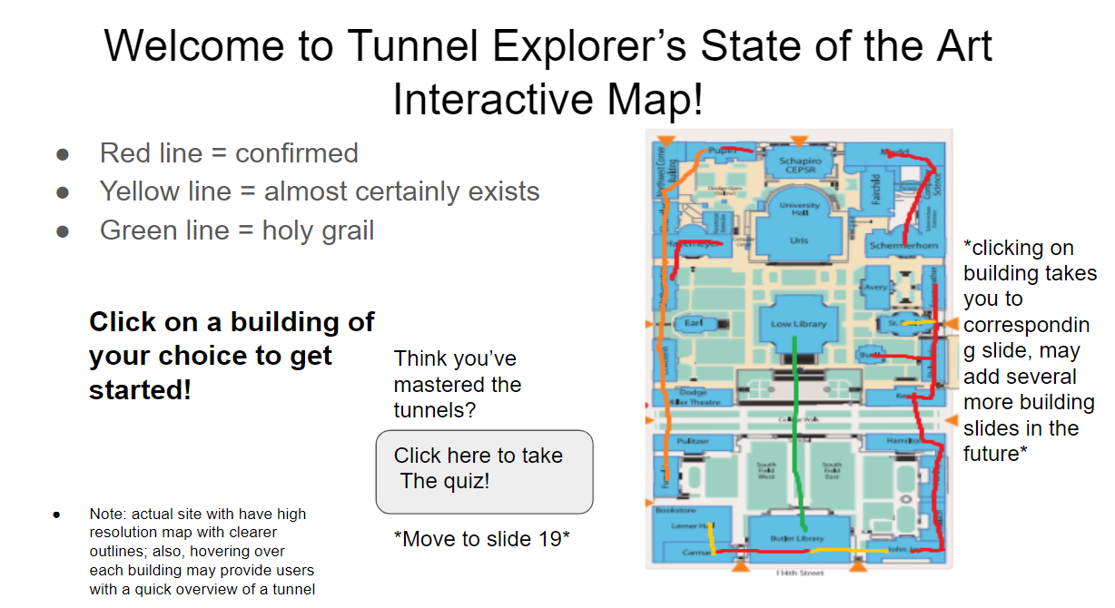

1. The map does not show progress/completion which can leave users lost as to where they are. This is seen from the lack of the progress bar in the home page above.

2. As seen above, the layout of the map is confusing and overwhelming, and it’s not clear where users can and cannot click.

3. The questions are too complex – a user can’t memorize an entire map layout in 10 minutes

4. There are no back buttons for users to return to the main map from within each submap.

5. Users don’t have a general sense of direction to proceed in.