Evan Tilley

elt2141

5 Lessons from Running Old Prototype #2 – Mushroom Website

1. Users want to see some indication of their progress while learning about mushrooms.

2. As is evident in this image:

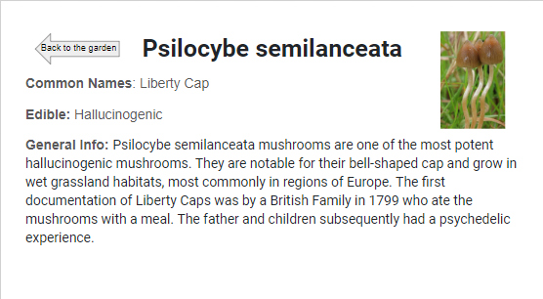

there is too much text here for users to properly absorb

3. Users enjoy selecting/dragging and dropping mushroom pictures more than simply answering multiple choice questions.

4. Users enjoy learning about the edibility of mushrooms.

5. Users like the idea of a “Garden of Mushrooms” because it makes the learning process feel like a game.