Evan Tilley

elt2141

5 Lessons from Running Revised Prototype #1 – Tunnels Website

1. Users like to make progress! A progress bar was added indicating the percentage of the tour that has been complete: 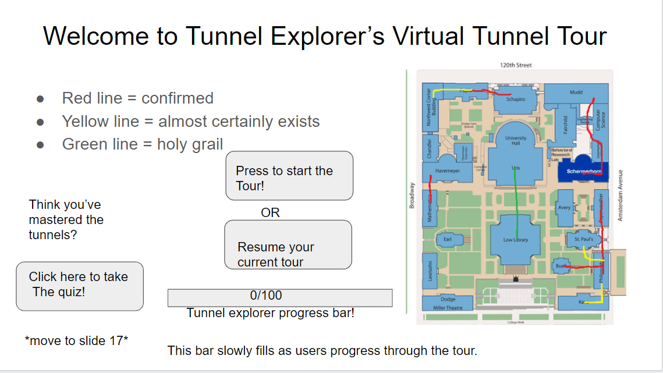

2. Users like to take a virtual, step-by-step tour.

3. People like games!

4. Short, simple questions are ideal.

5. Users are generally fascinated by the idea of the Columbia Tunnel system.