Evan Tilley

elt2141

5 Lessons from Running New Prototype #2 – Mushroom Website

1. Users like small, short text snippets, as is evident in the updated mushroom description here:

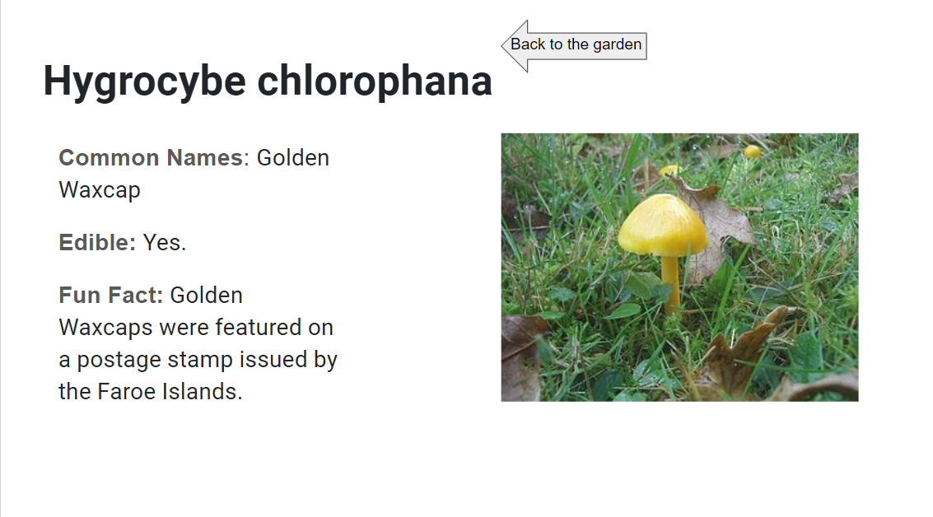

2. Users like large, colorful pictures that are easy to press.

3. Users like a simple, linear layout.

4. It’s important to indicate to users that a button can be clicked on – this can be done by having it hover when a user mouses over it.

5. It’s important to pick one theme for a site and stay consistent with it.