Evan Tilley

elt2141

1.

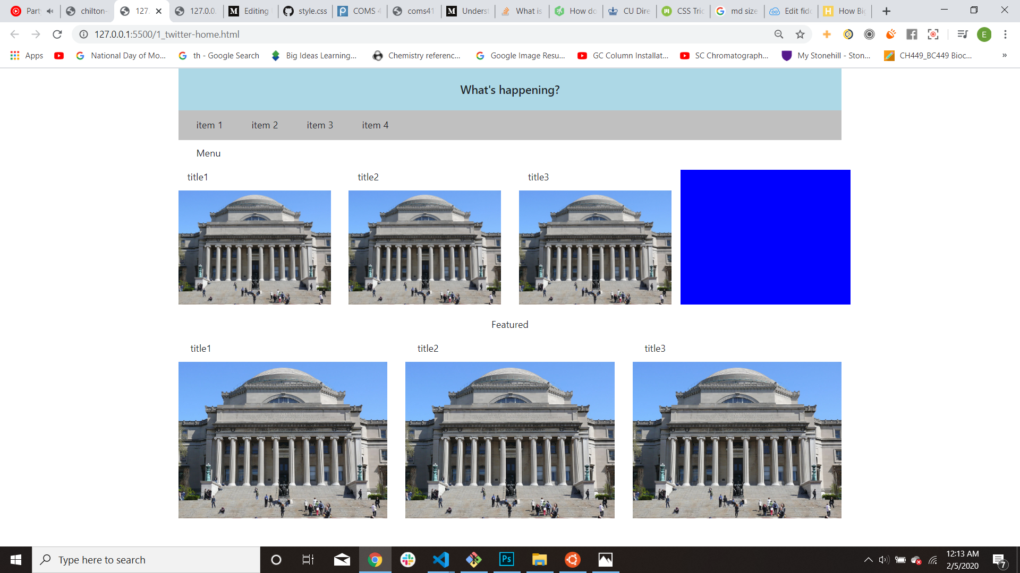a.

b. The images are always the right size because I specified that the class of the image is equal to “img-fluid” so the images scale to their parent columns. The default padding/margins between the columns creates the white space in between the images.

c. The blue square is taller than the images next to it. I accomplished this by creating 1 row that contained multiple columns; each column had both the text (e.g. “title 1”) and the image. However, I did not put any text in the column with the blue square, so the blue square took up the entirety of the column and appears larger than the images next to it.

(part d. on next page)

d. Before making any modifications, when the screen size is 500px, the rows with grid tiles wrap so that there appears to be only one grid tile per row.

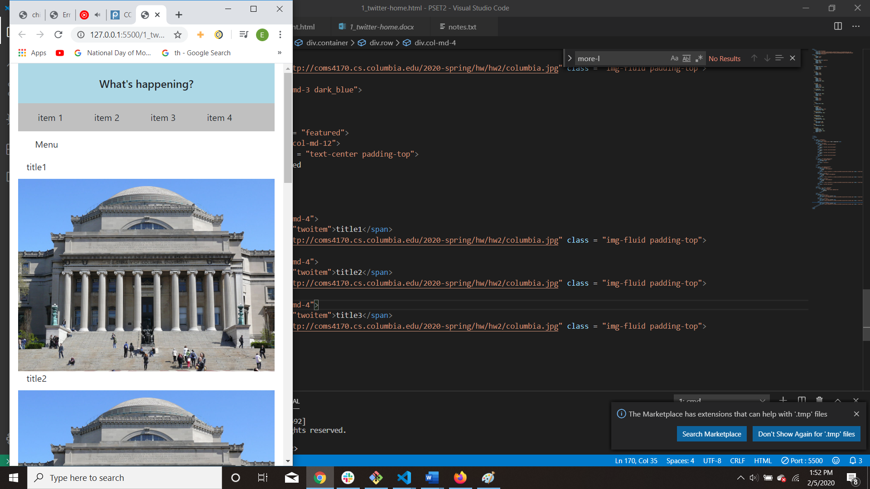

a. To change it so that when the site is 500px you see two grid tiles per row, add “col-6” to each div that defines every column in both rows of images. This will ensure that, when the display is in small mode, there are 2 columns per row. A screenshot of this is below.

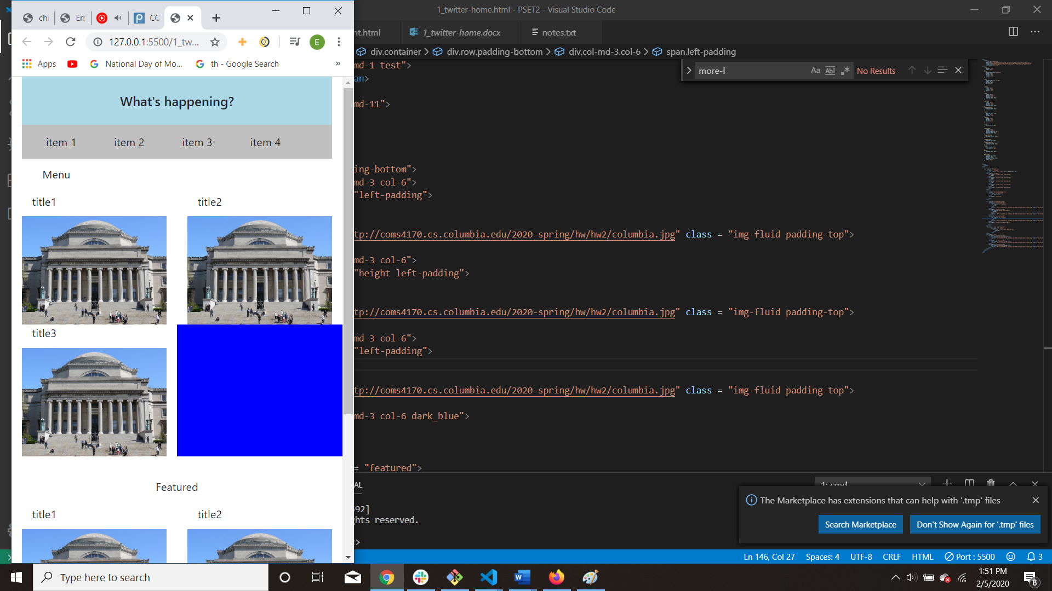

e. Code submitted.