Evan Tilley

elt2141

Screenshot:

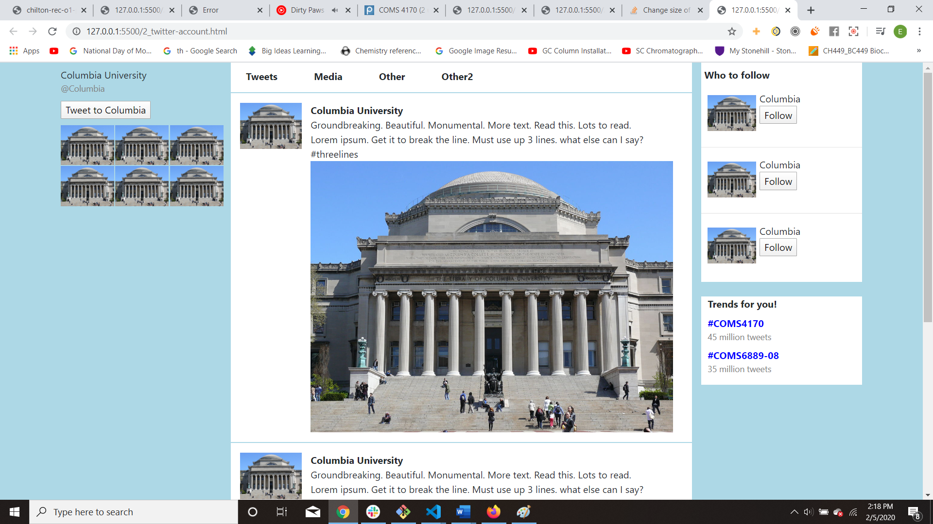

1. I colored the background blue by applying a “background-color: light-blue” to the left and right columns making up the site. I also used a container fluid so that the columns expanded to take up the entirety of the screen, thus making the background blue. To create white areas on the right-most column I created divs that were targeted with “background-color: white”.

2. For column 3 I got the image next to the text and button by placing a div, after the image, with the property “display: inline-block”. Inside of this div I placed 2 more divs, one for the text and one for the button. Both of these divs have the property: “display: block”. This arrangement ensured that the text and the button would be properly placed next to the image.

3. For column 3, I didn’t have to worry about the text being centered, because, by default, the text appeared at the left-most part of the column. However, I needed to add padding to some text to ensure that the display appeared properly.

(4 on next page)

4. I used a container fluid bootstrap in the first place to create the project, to ensure that the content of the columns fully expanded to take up the page. If I use a regular bootstrap container instead a fluid bootstrap, I get the following (notice the white space to the left and right):

a.

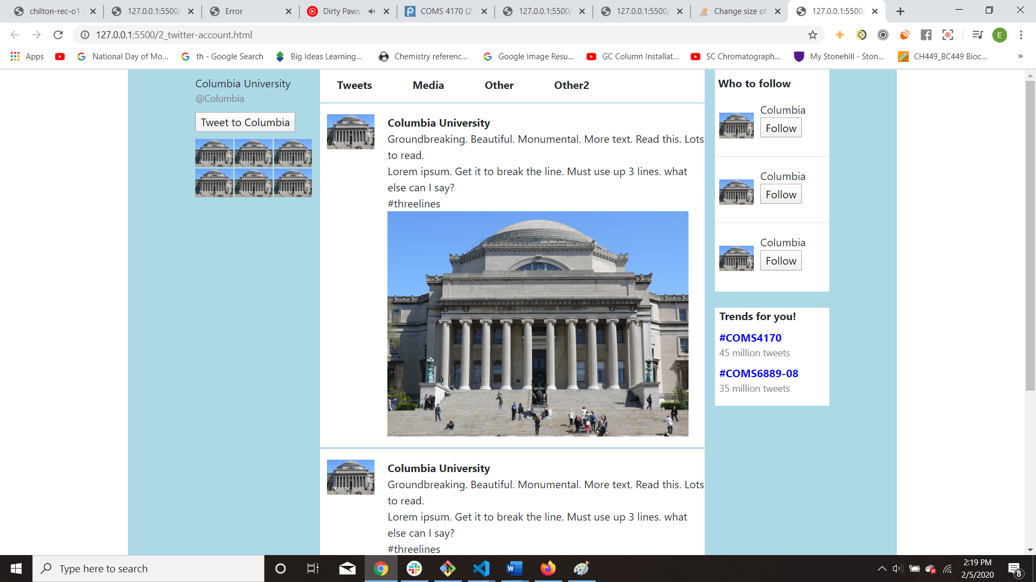

b. The container fluid ensures that the columns are taking up the entire width of the screen, so using a regular container removes the blue color on the left and right edges, since the columns aren’t taking up the entire width of the screen.

5. For the hashtags like #COMS4170 the three tools I used to recreate the style so that they pass the squint test were contrast, color, and size. I applied a bold property to the hashtags so they stood out from the surrounding text (contrast). I also applied a blue text color property to the hashtags so they could be easily differentiated from surrounding text (color). Also, I applied a smaller font property to some of the surrounding text (e.g. the “46 million tweets”) text, so the hashtags were more noticeable and could pass the squint test (size).

6. I implemented the thin line separating the tweets by putting each tweet in its own column of width 12 (which is within a column of width 6). I made each tweet a new row, so, between the two rows, I inserted an <hr> which was colored light-blue and had a height of 2px.

7. Code submitted.