Evan Tilley

elt2141

Homework 6: Search Application Functionality

1. My website allows users to search through a database of various mushrooms.

2. A woman finds a mushroom while hunting in her backyard and wants to search through the database to see if she can find a picture that resembles the mushroom she found. She then can determine whether to eat the mushroom. (or maybe cook is given mushroom and wants to look up what to do with it, but this isn’t too focu

3.

{

**Id**: 23,

**Species**: "Cantharellus formosus",

**Image**: "https://upload.wikimedia.org/wikipedia/commons/thumb/8/8e/Cantharellus_formosus_174975_Belfair.jpg/353px-Cantharellus_formosus_174975_Belfair.jpg",

**Edible**: "Yes.",

**Info**: "Cantharellus formosus mushrooms vary in color from orange to yellow and are native to the Pacific Northwest region of North America. They have a mild, sweet odor. The mushrooms are edible and are the most important commercially harvested Cantharellus species in the Pacific Northwest. Fun Fact: Cantharellus formosus is the state mushroom of Oregon.",

**CommonNames**: [

"Pacific Golden Chanterelle"

],

**ApproximateCapSize**: 3,

**Comments**: [

"Whoo, go Oregon! Born and raised in Seattle. Never saw one of these mushrooms, but I guess that's because I lived in Seattle haha",

“Interesting note: Pacific golden Chanterelle mushrooms have a pinkish hue on their false gills.",

"Mushrooms are so colorful! Who doesn't love them?!"

]

}

4. When deleting the data, I got the data item to disappear by actually deleting the item from the database in the backend. When the delete button was pressed, a call would be sent to the backend, containing the id of the mushroom entry corresponding to the pressed button. In the backend, that mushroom entry would be removed, and the updated array would be sent back to the client.

5. The input page to create a new item looks something like this:

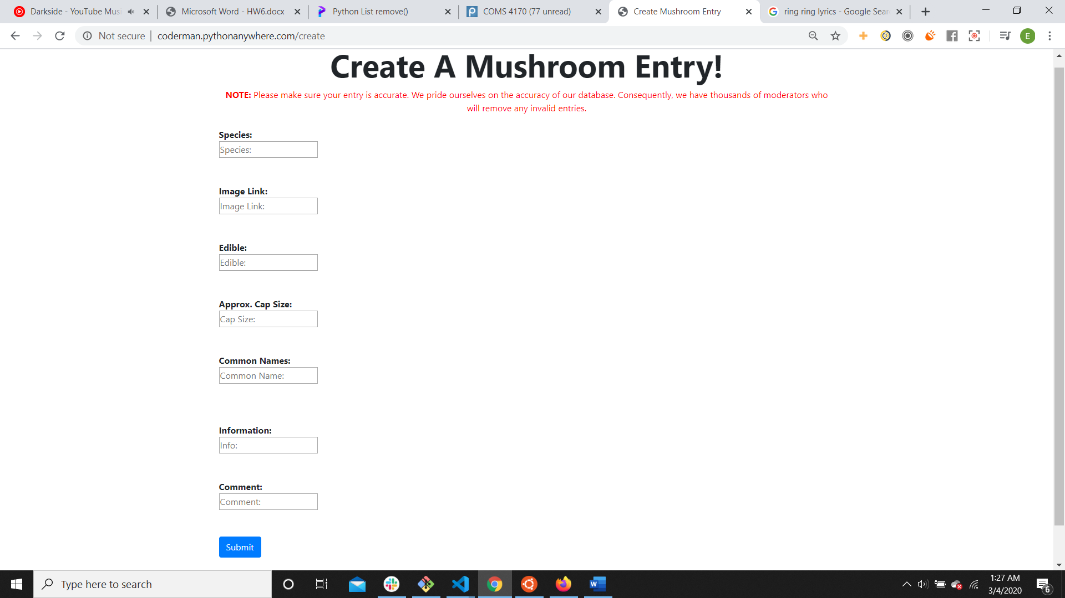

An example entry would be:

**Species**:

Boletus edulis

**Image Link**:

<https://upload.wikimedia.org/wikipedia/commons/thumb/b/b0/Boletus_edulis_EtgHollande_041031_091.jpg/351px-Boletus_edulis_EtgHollande_041031_091.jpg>

**Edible**:

Yes.

**Approx. Cap Size:**

7

**Common Name:**

Penny Bun

**Information:**

Boletus edulis mushrooms are relatively large light brown mushrooms. They grow in deciduous and coniferous forests and can be found all over the globe, from North American to China. Penny Buns are considered one of the safest wild mushrooms to pick, as few poisonous species closely resemble it. The mushrooms taste nutty and slightly meaty and are often used in soup and sautées.

**Comment**:

Try eating these raw! Even without any additional flavoring they are surprisingly tasty!

6. A user can search for any mushroom they desire. If they aren’t sure of the exact name, they can enter something similar (i.e. letters that are in the name of the mushroom species). Alternatively, the user can just press (“Submit”) without entering any text and all the entries will be displayed.

a. If a user recalsl a mushroom with the name “semi” in it, but don’t recall the exact name, just type “semi” into the search bar and press “Submit”. The entry to “Psilocybe semilanceta” will appear. After clicking on the entry, the user will be taken to a page similar to this one:

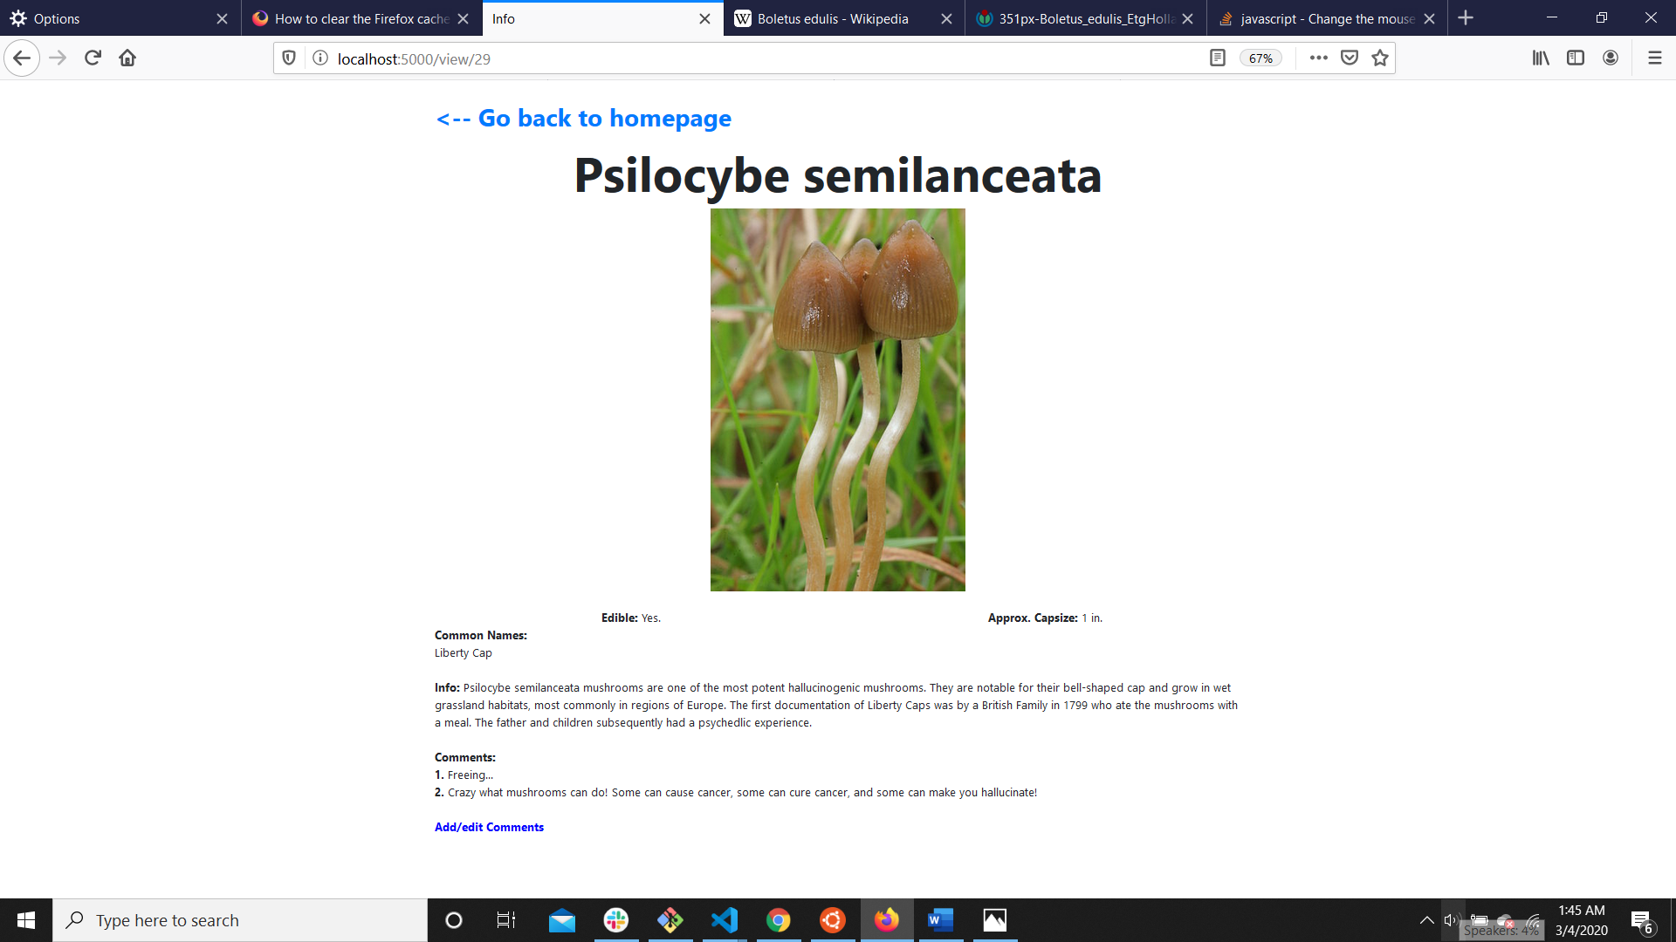

From here, a user can click on “Add/edit Comments” to add a comment. (Note: Piazza Post @421 specifies that we can implement an “add” functionality rather than an “edit” functionality if that better suits our purposes. To make it easier for the graders it was recommended by Professor Chilton that call our button “Add/Edit”. In this case, I thought it was more logical to add your own comments (since it’d be odd if you could edit other users’ comments)).

6b.

At this point, you’ll see a screen that’s something like this:

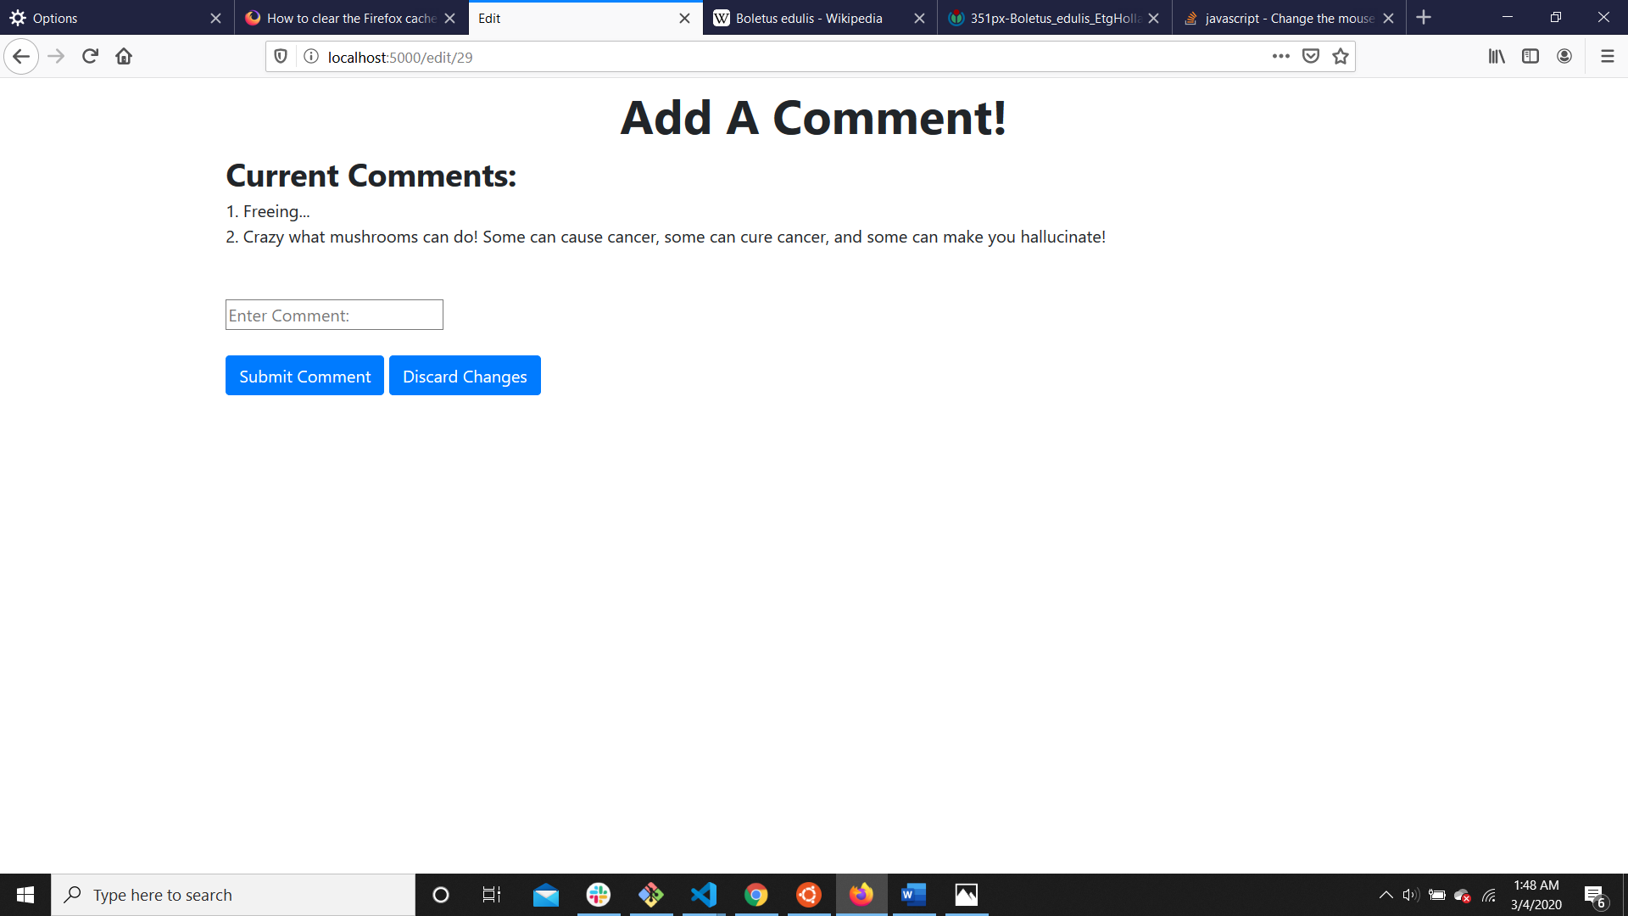

You can add the comment “Make sure you don’t accidentally pick these!” and press Submit Comment. This will take you back to the page with the info about these mushrooms and you’ll see your new comment! Alternatively, if you pressed “Discard Changes” you would be taken back to the page with the info about these mushrooms but you won’t see your new comment.