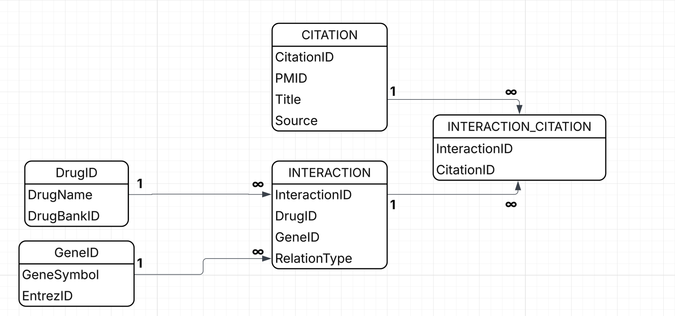Database Design Explanation
This database is built to store and manage information about drug–gene interactions and the related scientific references.
The goal is to make the data clear, consistent, and easy for the system and LLM to use when generating summaries.
1. Main Tables
- DRUG
Stores information about each drug, including a unique ID (DrugID), the name of the drug (DrugName), and an external reference such as DrugBankID.
One drug can have many interaction records.
- GENE
Stores each gene’s information with a unique ID (GeneID), gene symbol (GeneSymbol), and Entrez ID (EntrezID).
One gene can also appear in many interactions.
- INTERACTION
This table connects drugs and genes.
Each record describes one relationship between a drug and a gene.
It includes the type of relationship (RelationType, such as inhibits, induces, or binds) and optional notes (Notes) about how they interact.
This design allows many-to-many connections between drugs and genes.
- CITATION
Stores information about the research papers or databases that support each interaction.
It includes CitationID, PMID, Title, Source, and Year.
One citation can support several interaction records.
2. Relationship Table
- INTERACTION_CITATION
Links each interaction with the citations that support it.
One interaction can have many citations, and one citation can be linked to many interactions.
This table helps the system show where each piece of information came from.
3. How the Data Works
When a user types a drug or gene name:
- The system searches the INTERACTION table for matching records.
- It connects with the DRUG and GENE tables to show full names and IDs.
- It also checks CITATION through INTERACTION_CITATION to display the sources.
This way, the LLM can use all this organised data to create clear and reliable summaries.
4. Why the Design Is Good
- Each table has only one clear purpose (no repeated data).
- Relationships are clean and easy to understand.
- The structure can grow later if we want to add new features (for example, user feedback or more biomedical APIs).
- All information is connected and traceable, which makes the system trustworthy and easy to maintain.

