Phase 3: Project 2

Phase End

GitHub: <https://github.com/evanwatson98/HCL-Simplilearn/tree/main/Assignments/TaskManager>

Pre Req: The application.properties is running off of a database named “ManageUsers”

* 1. To begin the application type mvnw spring-boot:run
  2. Type into your browser <http://localhost:8080/>
  3. The landing page is the login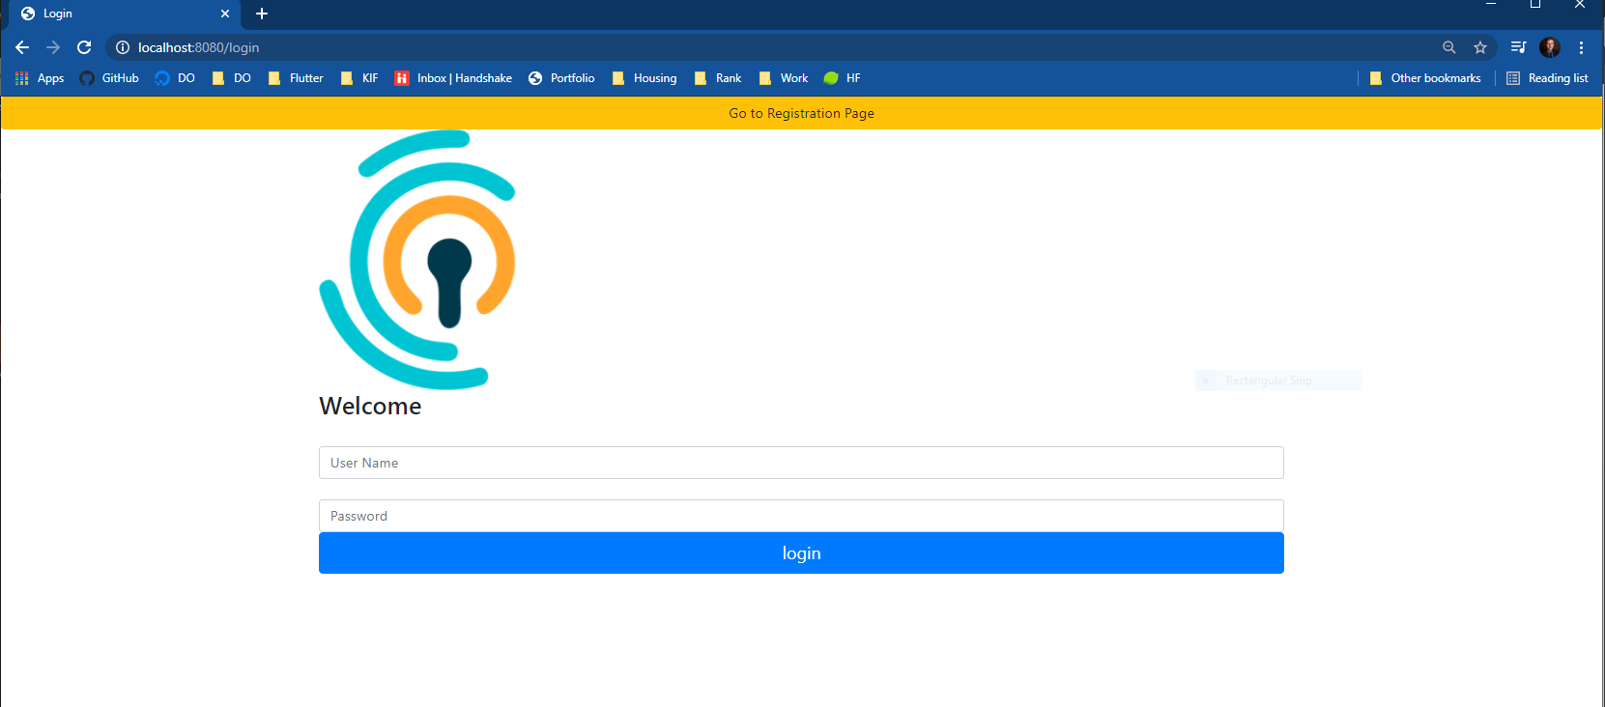
  4. Click register at the top of the page to make an account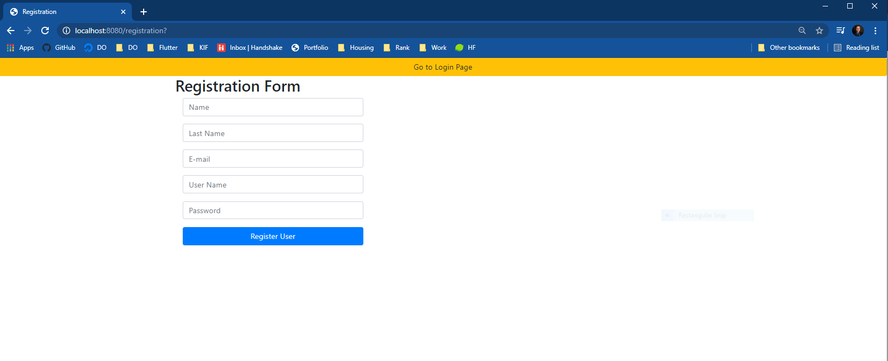
  5. Go back to login page
  6. Login

**ADMIN Prefix: All admin privileges are contained in a single page.**

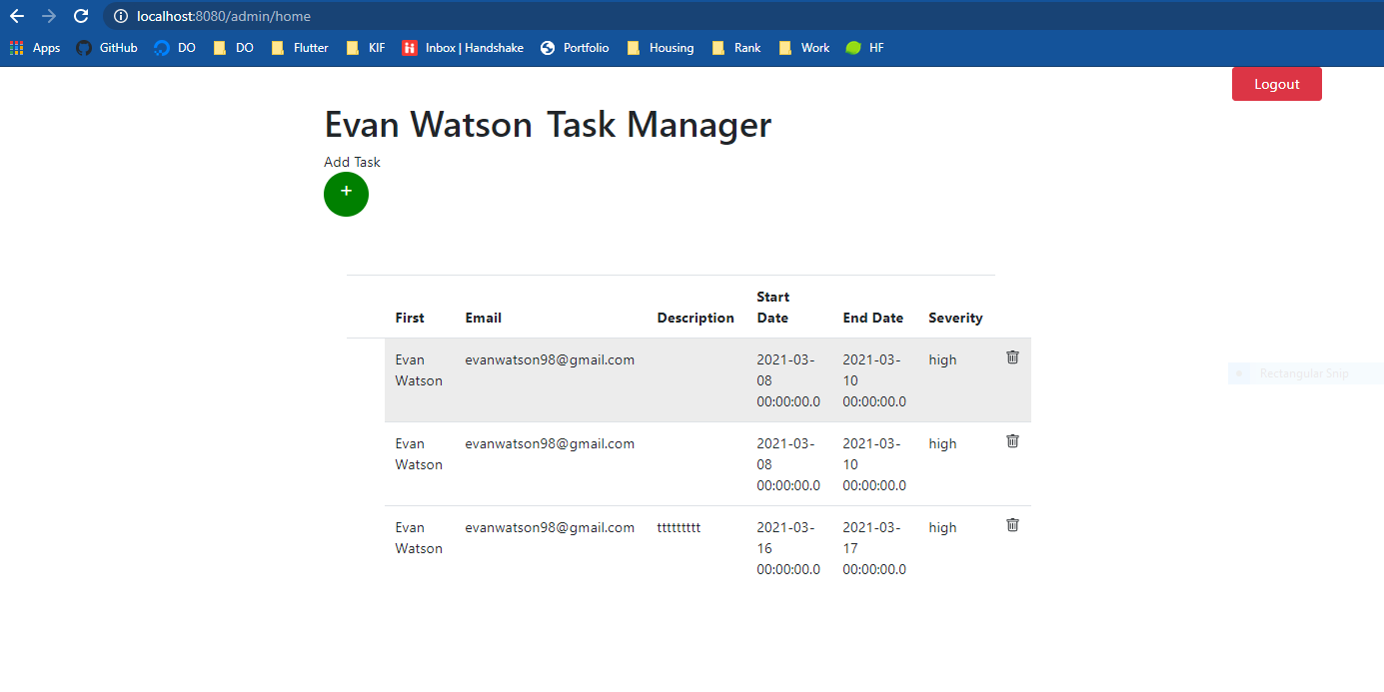

* 1. The Table Displays all tasks for the signed in user
  2. Click the add (green plus “+”) button to add a task. I did not have enough time to do error checking on this form(Only 2 days), and was not a part of requirements. **YOU MUST FILL OUT ALL FIELDS FOR THIS ADD TASK FORM TO WORK**

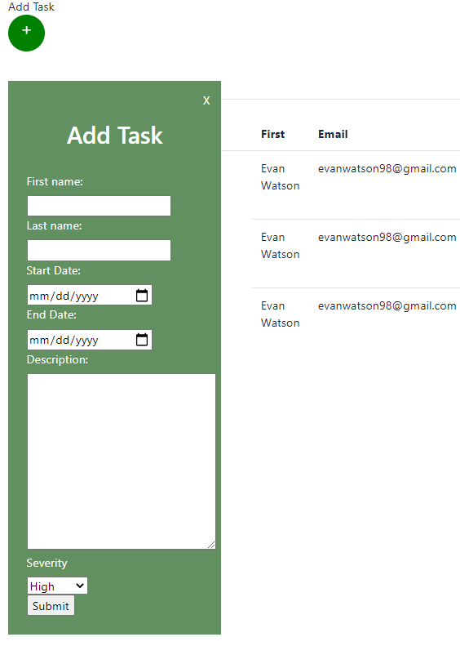

* 1. To Update A Task simply hover over the row you wish to edit and double click on it. Edit any fields and press the green submit button. **DO NOT DOUBLE CLICK ON ROW A SECOND TIME. IF YOU DO YOU WILL NEED TO REFRESH THE PAGE. YOU CAN NOT DELETE THE ROW WHILE IT IS BEING UPDATED, IT WILL NOT WORK. ALL FIELDS MUST BE FILLED OUT TO WORK, JUST LIKE ADDING A NEW TASK I DID NOT HAVE THE TIME TO VALIDATE NOR IS IT A REQUIREMENT.**

**ONLY OPEN ONE ROW TO UPDATE AT A TIME. IF YOU OPEN 2 ROWS TO UPDATE THEN THE FORM WILL NOT WORK. TO FIX THIS I WOULD CREATE A BOOLEAN TO SEE IF ONE IS OPEN AND IF SO, IGNORE THE ABILITY TO OPEN FORM**

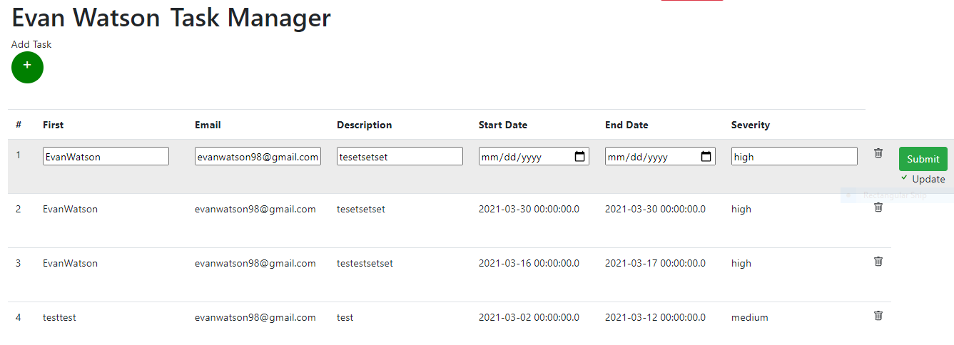

**!!- DO NOT DO WHAT’S BELOW. ONLY ONE UPDATE CAN BE OPEN AT A TIME**

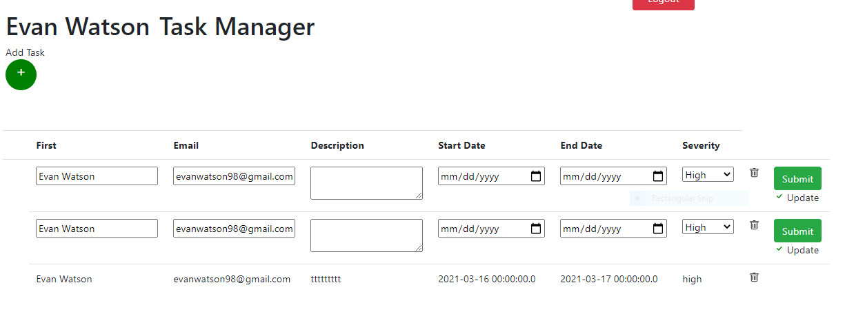

* 1. To delete an object press the trash icon next to the row, as long as that row is not being updated(please refer to 2.3 if confused)

**Suffix: After any crud operation the form is redirected back to the home page to show the backend being updated on the frontend**.

**ALL IMAGES ARE A PART OF SCREENSHOTS SUBMISSION ON SIMPLILEARN**