Evan WB - Homework 1

Evan Woelk Balzer

07/01/2020

## R Markdown

library(tidyverse)

## ── Attaching packages ────────────────────────────────────────────────────────── tidyverse 1.3.0 ──

## ✓ ggplot2 3.2.1 ✓ purrr 0.3.3  
## ✓ tibble 2.1.3 ✓ dplyr 0.8.3  
## ✓ tidyr 1.0.0 ✓ stringr 1.4.0  
## ✓ readr 1.3.1 ✓ forcats 0.4.0

## ── Conflicts ───────────────────────────────────────────────────────────── tidyverse_conflicts() ──  
## x dplyr::filter() masks stats::filter()  
## x dplyr::lag() masks stats::lag()

library(matrixStats)

##   
## Attaching package: 'matrixStats'

## The following object is masked from 'package:dplyr':  
##   
## count

#Question 1#

TsA <- c(0.17, 0.20, 0.13, 0.20, 0.24, 0.25, 0.15, 0.21, 0.21)  
TsA

## [1] 0.17 0.20 0.13 0.20 0.24 0.25 0.15 0.21 0.21

TsB <- c(0.47, 0.21, 0.34, 0.32, 0.33, 0.29, 0.18, 0.20, 0.25)  
TsB

## [1] 0.47 0.21 0.34 0.32 0.33 0.29 0.18 0.20 0.25

Cs <- c(0.44, 0.33, 0.37, 0.33, 0.31, 0.27, 0.22, 0.30, 0.28)  
Cs

## [1] 0.44 0.33 0.37 0.33 0.31 0.27 0.22 0.30 0.28

strains <- tibble(TsA, TsB, Cs)  
strains

## # A tibble: 9 x 3  
## TsA TsB Cs  
## <dbl> <dbl> <dbl>  
## 1 0.17 0.47 0.44  
## 2 0.2 0.21 0.33  
## 3 0.13 0.34 0.37  
## 4 0.2 0.32 0.33  
## 5 0.24 0.33 0.31  
## 6 0.25 0.290 0.27  
## 7 0.15 0.18 0.22  
## 8 0.21 0.2 0.3   
## 9 0.21 0.25 0.28

#Question 2, 3#

mtsa <- mean(TsA)  
mtsb <- mean(TsB)  
mcs <- mean(Cs)  
  
mabdif <- (mtsb - mtsa)  
mabdif

## [1] 0.09222222

mcadif <- (mcs - mtsa)  
mcadif

## [1] 0.1211111

The difference between the means of the two transgenic strains is 0.09222. The difference between the means of the transgenic strain A and the common strain is 1.1211.

#Question 4#

a <- ggplot(strains, aes(Cs))  
#getting the same breaks as given by the standard hist command#  
brx <- pretty(range(strains$Cs), n = nclass.Sturges(strains$Cs),min.n = 1)  
ggcommonhist <- a+geom_histogram(breaks = brx, alpha = 0.5, color = "black")+labs(x = "Concentration", y = "Count")+theme_classic()+scale_x_continuous(breaks = seq(0,1, 0.05))  
ggcommonhist

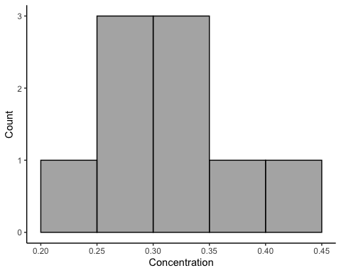

#Question 5#

Peroxide <- c(0.27, 0.21, 0.34, 0.32, 0.24, 0.29, 0.18, 0.20, 0.29)  
Growth.rate <- c(1.79, 1.01, 1.71, 1.89, 1.41, 1.15, 1.13, 1.20, 1.10)  
pergro <- tibble(Peroxide, Growth.rate)

#Question 6#

b <- ggplot(pergro, aes(Peroxide, Growth.rate))  
pergroscatter <- b+geom_point()+theme_classic()+labs(x = "Hydrogen Peroxide Concentration (μmoles/g)", y = "Growth Rate (cm/day)")+geom_smooth(method='lm')  
pergroscatter

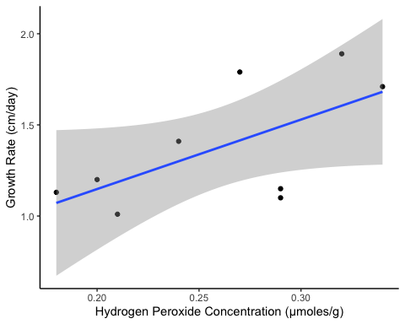

#Question 7#

As the concentration of hydrogen peroxide increases, so does the growth rate of the fungus. This result contradicts the hypothesis, suggesting that this application of hydrogen peroxide promotes fungal growth.

#Question 8, 9#

trep <- read_csv("turtle_reproduction.csv", col_names = (TRUE), col_types = cols(Nesting_Success = "f", Species = "f"))  
contingency_trep <- table(trep)  
contingency_trep

## Species  
## Nesting_Success Olive Ridley Hawksbill Leatherback  
## Success 16 4 4  
## Aborted 4 3 2

#Question 10#

b <- ggplot(trep, aes(x = Species, fill = Nesting_Success))  
turtletable <- b+geom_bar(position = "dodge")+scale_fill_manual(name = "Nesting Outcome", values = c("green4", "firebrick3"))+theme_classic()+scale_y_continuous("Number of Nesting Attempts")  
turtletable

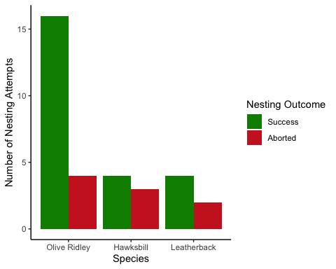

#Question 11#

asd<- table(trep)  
asd

## Species  
## Nesting_Success Olive Ridley Hawksbill Leatherback  
## Success 16 4 4  
## Aborted 4 3 2

samean <-rowMeans(asd)  
samean

## Success Aborted   
## 8 3

sasd <- rowSds(asd)  
sasd

## [1] 6.928203 1.000000

Across all three species, the mean number of nesting successes is 8 the standard deviation of nesting success is 6.928.

#Question 12#

propOR <- prop.table(contingency_trep[1:2, "Olive Ridley"])  
propOR

## Success Aborted   
## 0.8 0.2

propH <- prop.table(contingency_trep[1:2, "Hawksbill"])  
propH

## Success Aborted   
## 0.5714286 0.4285714

propL <- prop.table(contingency_trep[1:2, "Leatherback"])  
propL

## Success Aborted   
## 0.6666667 0.3333333

Of the three species, the Hawksbill nests experienced the highest nest attempt abortion proportion: 0.43. Since this species seems to be having the least nesting success of the three, I would prioritize it for a conservation response.

#Question 13#

scramble <- read_csv("scrambled_eggs.csv", col_names = (TRUE), col_types = cols(Nest = "f", Species = "f", Eggs = "d"))  
scramble

## # A tibble: 48 x 3  
## Nest Species Eggs  
## <fct> <fct> <dbl>  
## 1 1 Olive Ridley 127  
## 2 2 Olive Ridley 110  
## 3 3 Olive Ridley 112  
## 4 4 Olive Ridley 110  
## 5 5 Olive Ridley 118  
## 6 6 Olive Ridley 115  
## 7 7 Olive Ridley 120  
## 8 8 Olive Ridley 108  
## 9 9 Olive Ridley 120  
## 10 10 Olive Ridley 126  
## # … with 38 more rows

#Question 14#

d <- ggplot(scramble, aes(x = Species, y = Eggs, fill = Species))  
box_of_eggs <-d+geom_boxplot(position = "dodge", show.legend = FALSE)+theme_classic()+geom_jitter(width=0.1,alpha=0.2)+theme(legend.position = "none")+scale_y_continuous("Number of Eggs per Nest")  
box_of_eggs

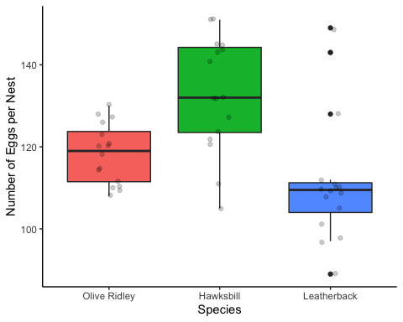

#Question 15#

eggscramble <- read_csv("leatherhawk_eggs.csv", col_names = (TRUE), col_types = cols(Hawksbill = "d", Leatherback = "d", Nest = "f"))  
eggscramble

## # A tibble: 16 x 3  
## Leatherback Hawksbill Nest   
## <dbl> <dbl> <fct>  
## 1 149 143 1   
## 2 143 144 2   
## 3 128 124 3   
## 4 111 145 4   
## 5 110 122 5   
## 6 109 132 6   
## 7 110 121 7   
## 8 105 127 8   
## 9 89 151 9   
## 10 98 105 10   
## 11 112 141 11   
## 12 108 132 12   
## 13 109 145 13   
## 14 101 132 14   
## 15 97 151 15   
## 16 110 111 16

e <- ggplot(eggscramble, aes(x = Hawksbill, y = Leatherback, color = Nest))  
LeatherHawk <- e+geom_point()+theme_classic()+scale_y_continuous("Number of Eggs per Leatherback Nest", limits = c(80, 160))+scale_x_continuous("Number of Eggs per Hawksbill Nest", limits = c(80,160))  
LeatherHawk

