Introduction and problem

Where My Idea Came From:
My idea for this project came from games like Destiny 2 and Borderlands 3. I enjoyed the core loop of shooting enemies, earning loot and levelling up and having a cool storyline, but I found three problems that stopped me from playing them. First, these games are very hard to get used to because there are a lot of weapons, skills and maps, this will confuse new players even with tutorials. Second, you have to play for a long time for the game to become fun, so it's really time consuming. Third, those games need a high end PC to run, so not everyone can play them.

Understanding the Problem:
The main issues I saw are complexity, time and hardware requirements. Games like Destiny 2 and Borderlands 3 have too many weapons, abilities, maps and leveling systems. These systems may give experienced players a lot of content, but they can be hard for a new player to understand what they are supposed to do. The games can also require a large amount of time before the player has unlocked enough equipment and abilities to experience the full game. My project focuses on reducing this complexity by limiting the number of weapons, upgrades and enemy types while keeping meaningful choices.

Why This Problem Matters:
These are not just my opinions. I have noticed them from my experience with my friends while playing together. The problem I am solving is how to create the core FPS RPG loop of shooting, earning XP, choosing upgrades and fighting bosses in a way that is immediately fun, easy to understand and runs on modest hardware.

How My Game Solves It:
A wave based arena shooter can solve these problems because the loop is immediate. The player spawns, fights, upgrades and repeats. Complexity is introduced gradually through upgrade choices instead of straight forward menus and a single 3D arena is far less demanding than open world games like Destiny and Borderlands.

End users

The primary end users for my project are players who enjoy the progression of RPG and skill based FPS games. These people could be my classmates. They might not be professional, but they represent players who want a fun but easy to access and cheap single player FPS RPG.

Secondary End Users:
The secondary end user is the same group of people who will give feedback throughout development to help balance gameplay, spot bugs and improve the overall experience. Their role is to playtest the game constantly, comment on whether the levels feel right, report bugs and suggest improvements.

My Father as an End User:
My father will also be one of my end users. He is also into FPS game it is him that bring this into my life. He is some of the OGs. He said now days, FPS games are getting more and more realistic but lost their original fun. He can test the controls and the feel of the game, to give views on how opinions on how a real FPS game should be.

Research on Similar Games

Destiny 2
The first game I researched was Destiny 2. It has realistic gun feel different loot and a strong endgame. However, it can be confusing for new players because of the number of too much information at once. It also requires a powerful PC and it will take a lot of time on grinding.

From Destiny 2, I will try to take the gun feel and gameplay loop. However, I will not make the game system too complicated avoiding confusion to new players.

Borderlands 3
The second game I researched was Borderlands 3. It has good graphics and a broad range of weapons really attracts players. However, this will need a powerful PC to run it, players will have to spend a lot of money just to play it.

From Borderlands 3, I will take the idea of having different weapon types. This is why my game will have a rifle, shotgun and pistol, with each weapon feeling different and having a different purpose. However, I will avoid with creating complicated animation and graphics to give everyone a chance to play.

Doom Eternal
The third game I researched was Doom Eternal. It gets the player into the action immediately, has a fast combat loop, clear enemy roles and a short tutorial. However, it may be too much for a beginner causing player to quit immediately.

From Doom Eternal, I will take the idea of immediate combat and enemy wave systems. I will also use clear enemy roles such as rusher, debuffer and ranged enemies.

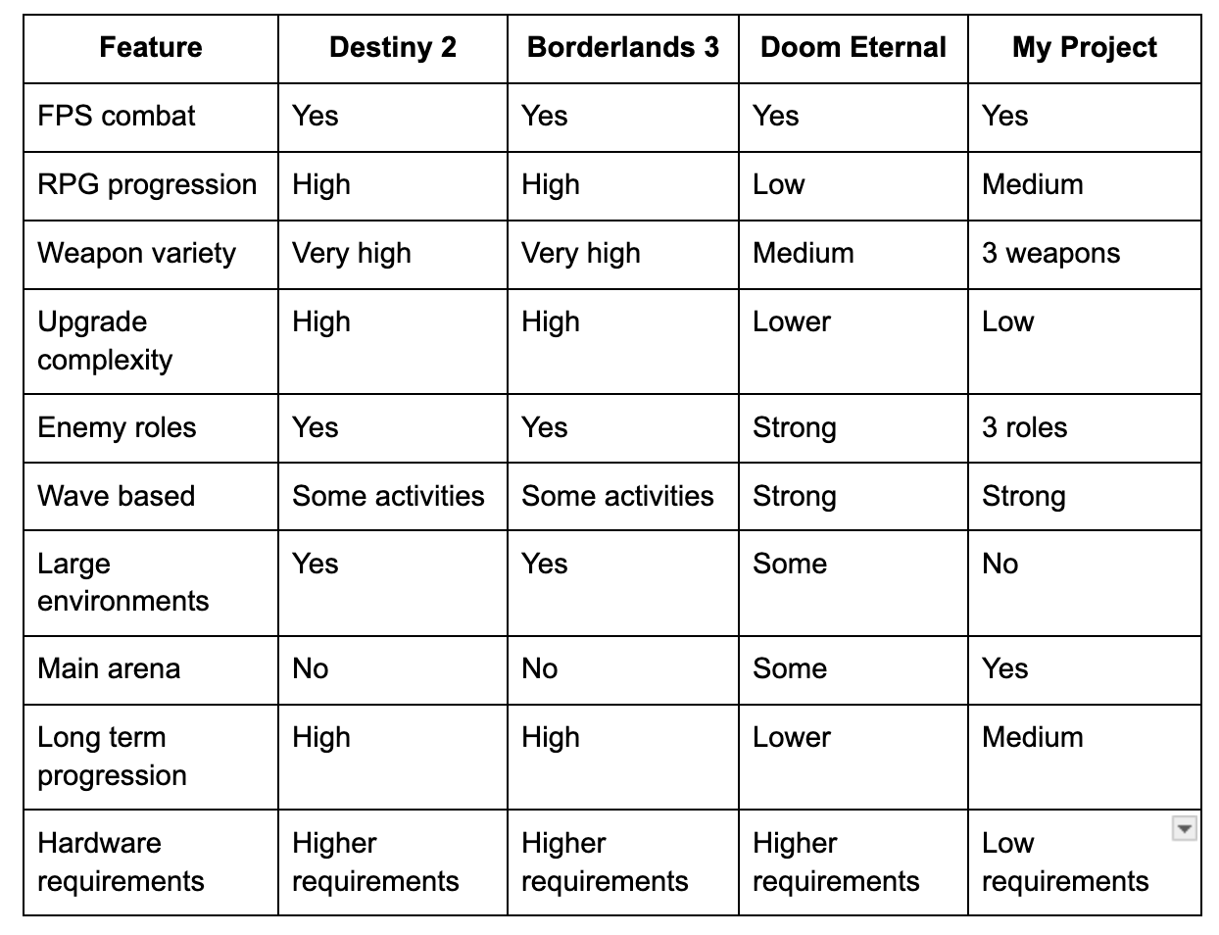
This comparison table shows the design direction of my project. I am not trying to replicate the content and features of the games. Instead, I am taking ideas from them and combine them into one game.

The game will use the combat system of Doom Eternal, the weapon choices and RPG progression from Destiny 2 and Borderlands 3.

Constraints and Limitations

Development Time
I am developing the project mostly myself, I’ll also ask for opinions with my teachers and end users. I cannot realistically create the amount of content found in a commercial FPS RPG.

I will create the core gameplay systems instead of creating a game with fancy graphics, animations and models.

Hardware
The game should run on PC. I will therefore avoid unnecessarily detailed environments and excessive numbers of enemies or visual effects.

Development Resources
I’ll be using Unity as my game engine will be using programming language like python, C++ and HTML.

Scope
To keep the project achievable, the initial scope will contain:
- 1 main arena.
- 3 weapons.
- 3 enemy types.
- 6 upgrades.
- 10+ waves.
- A boss every 5 waves.
- XP and levelling.
- Player health and ammunition.
- Basic UI.

Game Structure and Systems

Game loop:
Start →Start Wave → Spawn Enemies → Fight → Gain XP/Ammo → Complete Wave → Level Up/Upgrade → Start Next Wave → Boss → Reward → Continue

The player will start in the arena and a wave will start. Depending on the current wave, enemies will spawn.

The player will have to kill the enemies with his weapons. Defeating enemies will give XP and may give ammunition or other rewards.

When the player has killed all enemies in the wave, they will progress to the upgrade stage. The player then selects an upgrade and the next wave begins.

Every fifth wave will have a boss. The boss will have higher health than normal enemies and stronger attacks. If the player kills the boss, they will be rewarded and continue.

Enemy System

There will be three main categories of enemies.

Rusher
The rusher enters the player and tries to attack from a short distance.
Purpose: Keeps the player at a distance.
Counter: Shoot and move.

De buffer
The debuffer is a ranged attack on the player that buffs them with a debuff such as slowed movement or reduced player effectiveness.
Purpose: Creates a priority target that the player must deal with.
Counter: Rifle, accurate shooting.

Ranged Enemy
The ranged enemy is further away and attacks the player with projectiles or ranged attacks.
Purpose: Prevents a player from simply standing still.
Counter: Pistol and move.
Exact damage, health, speed and attack values will be adjusted through playtesting.

Weapon System
The game will feature three main weapons.

Rifle
The rate of fire of the rifle will be higher and it will be effective for accurate attacks of enemies at medium range.

Shotgun
The shotgun will be able to deal high damage in close range and be especially good against enemies that rush toward you.

Pistol
The pistol will be a less powerful weapon that uses less ammo, useful for certain targets and situations.

Each weapon will have different characteristics like:
- Damage.
- Rate of fire
- Magazine size.
- Reload time.
- Distance.

That means the player will have to choose weapons based on the situation, instead of one weapon that’s always the best.

XP and Levelling System
The player will gain XP by defeating enemies.

The amount of XP required to level up will increase as the player's level increases.

The system will be designed so that early levels are achieved relatively quickly, allowing the player to experience the upgrade system early. Later levels will require more XP, creating increasing progression difficulty.

A possible XP requirement model is:

XP Required = Base XP × Level Growth

The exact values will be tested during development to ensure that players are rewarded frequently enough without progressing too quickly.

Requirements
The game needs to have a set of functional and non functional requirements to make sure that the game works correctly and give the end user a good experience.

Functional Requirements
- player must be able to move around the arena and use weapons to attack enemies.
- game will contain three different weapons: a rifle, shotgun and pistol.
- each weapon must have different stats, including damage, rate of fire, magazine size and reload time.
- contain three enemy types: rusher, debuffer and ranged.
- enemies be able to target the player and attack them according to their role.
- player must have a health system and the game must end when the player's health reaches zero.
- defeating enemies must award experience points.
- player level up when they reach the required XP threshold.
- player be able to select from six upgrades to improve their character.
- increase in difficulty as the player progresses through the waves.
- a boss must appear every five waves.
- display important information, including player health, ammunition, XP, level and current wave.
- when all enemies in a wave have been defeated and progress to the next stage.

Non functional Requirements
- game should run on a PC.
- controls should be easy to understand.
- user interface should be clear and readable.
- game will not contain high graphical effects that could reduce performance.
- game should handle incorrect or unexpected inputs without crashing.
- gameplay should be balanced so that the player will have a good experience.

Data Analysis
Player will be able to control the player. Enemies, weapons, upgrades and wave progression the in game will be stored in different types of data. Each data type will have its own purpose in the game.

This current wave will be kept as an int to know which wave is currently active and when the boss comes. Enemy Health will be an int or float that defines how much damage the enemy can take before dying. Enemy Type will tell whether this enemy is rusher, debuffer, ranged or boss.

Each weapon will have stored variables for damage, fire rate, magazine size and reload time. To remember the selected upgrades from the upgrade system and properly apply the effect.

Variables will be used to keep changing values. Classes and objects can be used to keep entities like the player, weapons and enemies. It allows each entity to have their own set of attributes and behaviors.

If the health of an enemy gets to zero, the enemy dies, the player gains some experience, and the number of living enemies reduces. If the experience points of the player get to the next required value, the player goes to the next level.

The data will be changed throughout the game to keep the interface and the gameplay consistent with the current situation of the player and the arena.

Algorithms
Algorithms would be necessary to handle the battles, enemy spawning, XP gaining, levelling up, upgrades and progression of waves within the game. This is because the algorithms dictate how the game reacts to player actions.

Defeat Enemy Algorithm
- Detect when a weapon hits an enemy.
- Compute the damage caused by the weapon.
- Reduce the enemy’s health by the damage value.
- Check whether the health of the enemy is equal to zero or less.
- Mark the enemy as defeated and give XP.
- Decrement the enemy count.
- If the enemy count becomes zero, mark the wave completed.

Wave Sequence Algorithm
- Initialize the wave sequence.
- Determine the number of enemies that need to be spawned considering the wave number.
- Check whether the wave number is a multiple of five.
- If yes, then spawn a boss enemy along with the other enemies.
- Spawn the enemies.
- Let the player fight till he defeats all enemies or dies.
- If he survives till he defeats all enemies, mark the wave as complete.
- Award the reward for completing the wave and allow the player to choose an upgrade where possible.
- Increment the wave number and start the next wave.

XP and Leveling Algorithm
- Recognize when the enemy is killed.
- Increase the player’s total XP with the XP value of the killed enemy.
- Calculate whether the player’s XP is enough for increasing a level.
- If yes, increment the player’s level.
- Evaluate the level up according to the algorithm.
- If possible, do it once again because of the ability to get enough XP to
- increase several levels at once.

Weapon Damage Algorithm
- Recognize when the player shoots with his weapon.
- Ensure that the weapon has enough ammo and can shoot.
- Decrease the number of the weapon’s ammo by one.
- Calculate whether the shot hit the enemy.
- If yes, calculate the damage based on the parameters of the weapon.
- Apply the damage to the enemy.
- Decide whether the enemy is dead.

These algorithms will be tested during development to spot errors and ensure that the game progresses correctly.

Inputs and Outputs
The input will be from the player using keyboard and mouse. These inputs will control the character inside the game.

Inputs
- WASD: move the player front, back, left and right the arena.
- Mouse: changes the camera angle of where the character is aiming.
- Left click fire the weapon.
- R: reloads the weapon.
- Scrolling/123456789: change the currently equipped weapon.
- M: allows the player go to the upgrade page (game will not be paused).
- ESC: resume game or pause the game.

Outputs
- Player health bar: Represents the amount of health left with the player.
- Ammo counter: Represents magazine ammo and backup ammo.
- Level progress bar: Represents the progress toward the next level.
- Wave counter: Indicates the current wave.
- Enemy models and animations: Represents enemy positioning, movements, and attack.
- Hit and defeat effects: Provides feedback for hitting or defeating an enemy.
- Upgrade menu: Gives players options of upgrading their characters.
- Boss wave notification: Tells the player that the boss wave is about to start.
- Victory/defeat screen: Displays the result of the game.

Potential Solution
My solution is to create an FPS RPG set in a single 3D arena. The player starts with a single weapon and fights increasingly difficult waves of enemies. Each enemy type will have a specific role, meaning the player must think about which weapon and strategy to use. Defeating enemies gives XP and ammo, while completing waves allows the player to select upgrades. Every five waves will contain a boss fight, creating a larger objective for the player to work towards.

The solution is to keep the game simple, without taking away the progression that makes RPG games fun. The game will focus on 3 weapons, 3 main enemy types and 6 upgrades rather than hundreds of weapons, complicated menus and large maps. This should allow the player to pick up the systems quickly but still provide meaningful choices. The single arena and small number of enemies should also help to keep the hardware requirements lower than big open world FPS RPGs.

My solution is a mix of fast FPS action, simple RPG progression game. The goal is to design a game that is easy to understand, constantly rewarding and remains challenging during the player’s progression, in accordance with the technical and development constraints of the project.

