Introduction and problem

Where My Idea Came From:
My idea for this project came from games like Destiny 2 and Borderlands 3. I enjoyed the core loop of shooting enemies, earning loot, and levelling up and having a cool storyline, but I found three problems that stopped me from playing them. First, these games are very hard to get used to because there are a lot of weapons, skills, and maps, this will confuse new players even with tutorials. Second, you have to play for a long time for the game to become fun, so it's really time consuming. Third, those games need a high end PC to run, so not everyone can play them.

Understanding the Problem:
The main issues I saw are complexity, time and hardware requirements. Games like Destiny 2 and Borderlands 3 have too many weapons, abilities, maps and leveling systems. These systems may give experienced players a lot of content, but they can be hard for a new player to understand what they are supposed to do. The games can also require a large amount of time before the player has unlocked enough equipment and abilities to experience the full game. My project focuses on reducing this complexity by limiting the number of weapons, upgrades and enemy types while keeping meaningful choices.

Why This Problem Matters:
These are not just my opinions. I have noticed them from my experience with my friends while playing together. The problem I am solving is how to create the core FPS RPG loop of shooting, earning XP, choosing upgrades, and fighting bosses in a way that is immediately fun, easy to understand and runs on modest hardware.

How My Game Solves It:
A wave based arena shooter can solve these problems because the loop is immediate. The player spawns, fights, upgrades, and repeats. Complexity is introduced gradually through upgrade choices instead of straight forward menus and a single 3D arena is far less demanding than open world games like Destiny and Borderlands.

End users

The primary end users for my project are players who enjoy the progression of RPG and skill based FPS games. These people could be my classmates. They might not be professional, but they represent players who want a fun but easy to access and cheap single player FPS RPG.

Secondary End Users:
The secondary end user is the same group of people who will give feedback throughout development to help balance gameplay, spot bugs, and improve the overall experience. Their role is to playtest the game constantly, comment on whether the levels feel right, report bugs and suggest improvements.

My Father as an End User:
My father will also be one of my end users. He is also into FPS game it is him that bring this into my life, he is some of the OGs. He said now days, FPS games are getting more and more realistic but lost their original fun. He can test the controls and the feel of the game, to give views on how opinions on how a real FPS game should be.

Research on Similar Games

Destiny 2
The first game I researched was Destiny 2. It has realistic gun feel different loot and a strong endgame. However, it can be confusing for new players because of the number of too much information at once. It also requires a powerful PC, and it will take a lot of time on grinding.

From Destiny 2, I will try to take the gun feel and gameplay loop. However, I will not make the game system too complicated avoiding confusion to new players.

Borderlands 3
The second game I researched was Borderlands 3. It has good graphics and a broad range of weapons really attracts players. However, this will need a powerful PC to run it, players will have to spend a lot of money just to play it.

From Borderlands 3, I will take the idea of having different weapon types. This is why my game will have a rifle, shotgun and pistol, with each weapon feeling different and having a different purpose. However, I will avoid with creating complicated animation and graphics to give everyone a chance to play.

Doom Eternal
The third game I researched was Doom Eternal. It gets the player into the action immediately, has a fast combat loop, clear enemy roles and a short tutorial. However, it may be too much for a beginner causing player to quit immediately.

From Doom Eternal, I will take the idea of immediate combat and enemy wave systems. I will also use clear enemy roles such as rusher, debuffer and ranged enemies.

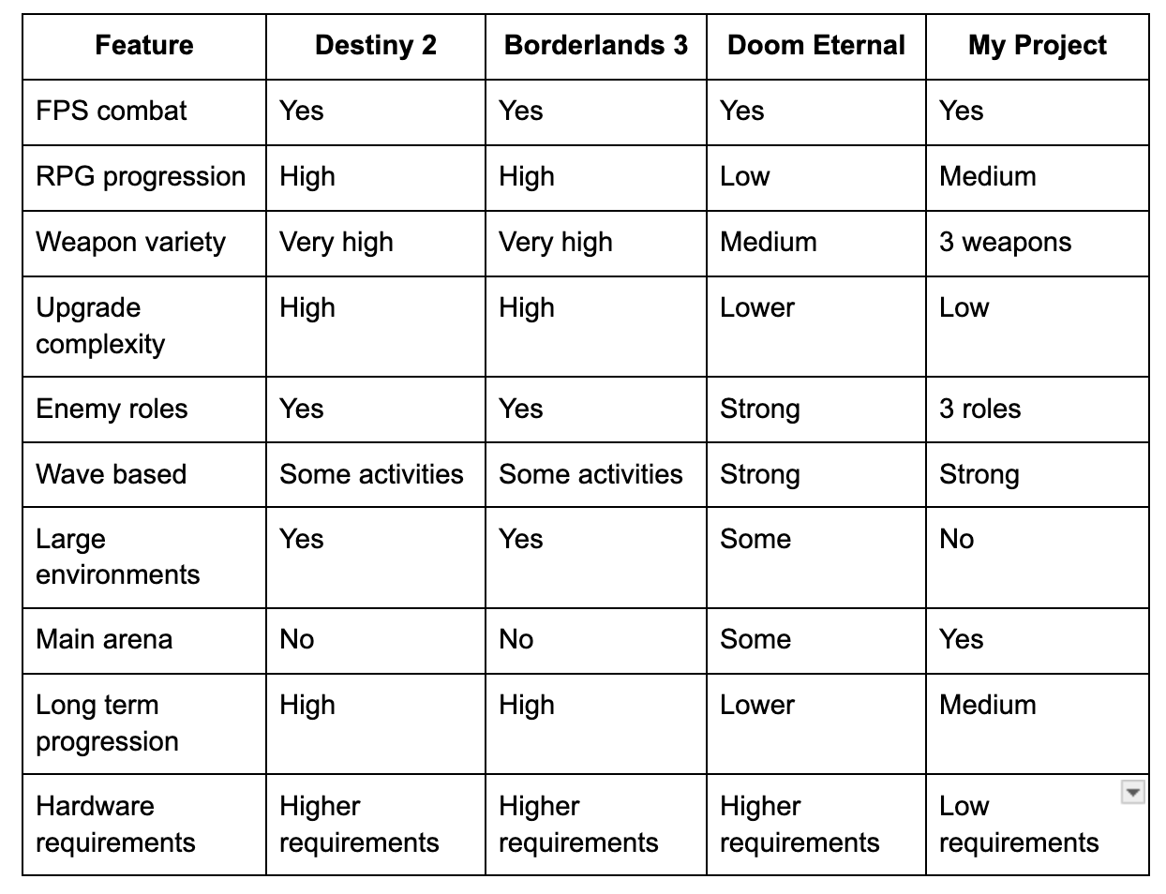
This comparison table shows the design direction of my project. I am not trying to replicate the content and features of the games. Instead, I am taking ideas from them and combine them into one game.

The game will use the combat system of Doom Eternal, the weapon choices and RPG progression from Destiny 2 and Borderlands 3.

Constraints and Limitations

Development Time
I am developing the project mostly myself, I’ll also ask for opinions with my teachers and end users. I cannot realistically create the amount of content found in a commercial FPS RPG.

I will create the core gameplay systems instead of creating a game with fancy graphics, animations and models.

Hardware
The game should run on PC. I will therefore avoid unnecessarily detailed environments and excessive numbers of enemies or visual effects.

Development Resources
I’ll be using Unity as my game engine will be using programming language like python, C++ and HTML.

Scope
To keep the project achievable, the initial scope will contain:
- 1 main arena.
- 3 weapons.
- 3 enemy types.
- 6 upgrades.
- 10+ waves.
- A boss every 5 waves.
- XP and levelling.
- Player health and ammunition.
- Basic UI.

Game Structure and Systems

Game loop:
Start →Start Wave → Spawn Enemies → Fight → Gain XP/Ammo → Complete Wave → Level Up/Upgrade → Start Next Wave → Boss → Reward → Continue

The player will start in the arena and a wave will start. Depending on the current wave, enemies will spawn.

The player will have to kill the enemies with his weapons. Defeating enemies will give XP and may give ammunition or other rewards.

When the player has killed all enemies in the wave, they will progress to the upgrade stage. The player then selects an upgrade and the next wave begins.

Every fifth wave will have a boss. The boss will have higher health than normal enemies and stronger attacks. If the player kills the boss, they will be rewarded and continue.

Enemy System

There will be three main categories of enemies.

Rusher
The rusher enters the player and tries to attack from a short distance.
Purpose: Keeps the player at a distance.
Counter: Shoot and move.

De buffer
The debuffer is a ranged attack on the player that buffs them with a debuff such as slowed movement or reduced player effectiveness.
Purpose: Creates a priority target that the player must deal with.
Counter: Rifle, accurate shooting.

Ranged Enemy
The ranged enemy is further away and attacks the player with projectiles or ranged attacks.
Purpose: Prevents a player from simply standing still.
Counter: Pistol and move.
Exact damage, health, speed and attack values will be adjusted through playtesting.

Weapon System
The game will feature three main weapons.

Rifle
The rate of fire of the rifle will be higher, and it will be effective for accurate attacks of enemies at medium range.

Shotgun
The shotgun will be able to deal high damage in close range and be especially good against enemies that rush toward you.

Pistol
The pistol will be a less powerful weapon that uses less ammo, useful for certain targets and situations.

Each weapon will have different characteristics like:
- Damage.
- Rate of fire
- Magazine size.
- Reload time.
- Distance.

That means the player will have to choose weapons based on the situation, instead of one weapon that’s always the best.

XP and Levelling System
The player will gain XP by defeating enemies.

The amount of XP required to level up will increase as the player's level increases.

The system will be designed so that early levels are achieved relatively quickly, allowing the player to experience the upgrade system early. Later levels will require more XP, creating increasing progression difficulty.

A possible XP requirement model is:

XP Required = Base XP × Level Growth

The exact values will be tested during development to ensure that players are rewarded frequently enough without progressing too quickly.

Potential Solution
My solution is to create an FPS RPG set in a single 3D arena. The player starts with a single weapon and fights increasingly difficult waves of enemies. Each enemy type will have a specific role, meaning the player must think about which weapon and strategy to use. Defeating enemies gives XP and ammo, while completing waves allows the player to select upgrades. Every five waves will contain a boss fight, creating a larger objective for the player to work towards.

The solution is to keep the game simple, without taking away the progression that makes RPG games fun. The game will focus on 3 weapons, 3 main enemy types and 6 upgrades rather than hundreds of weapons, complicated menus and large maps. This should allow the player to pick up the systems quickly but still provide meaningful choices. The single arena and small number of enemies should also help to keep the hardware requirements lower than big open world FPS RPGs.

My solution is a mix of fast FPS action, simple RPG progression game. The goal is to design a game that is easy to understand, constantly rewarding and remains challenging during the player’s progression, in accordance with the technical and development constraints of the project.

