**Preparing the Olfactometer:**

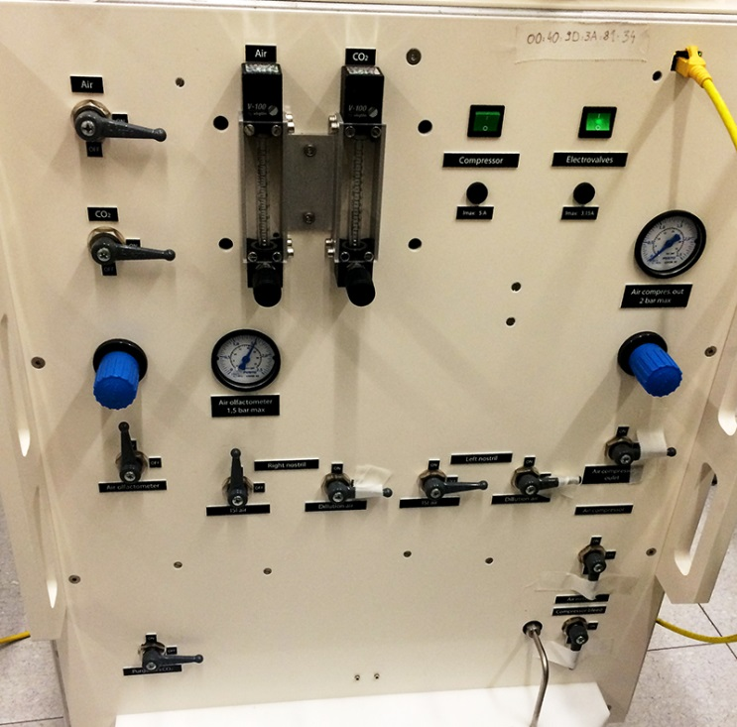**1.** Plug it in the power cable into wall (**P**)

**Y**

**2.** Plug in the yellow Ethernet cable (**Y**)

**E**

**I.**

**3.** Turn Electrovalves (**E**) on

* + - Can already test whether olfactometer is being read by the computer

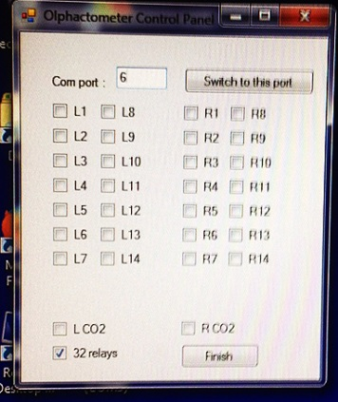

**II.**

* + - * On the desktop -> Icon that says Test olfactometer

**V.**

* + - * Click on one of the options on the left side (Port 4 for PPL, Port 6 for fMRI) to see if it is connected. If you hear a clicking sound from the olfactometer, then it is connected.

**P**

**IV.**

**III.**

**4.** Turn **ON**

* + 1. Air
    2. Air Olfactometer
    3. Right nostril - ISI air
    4. 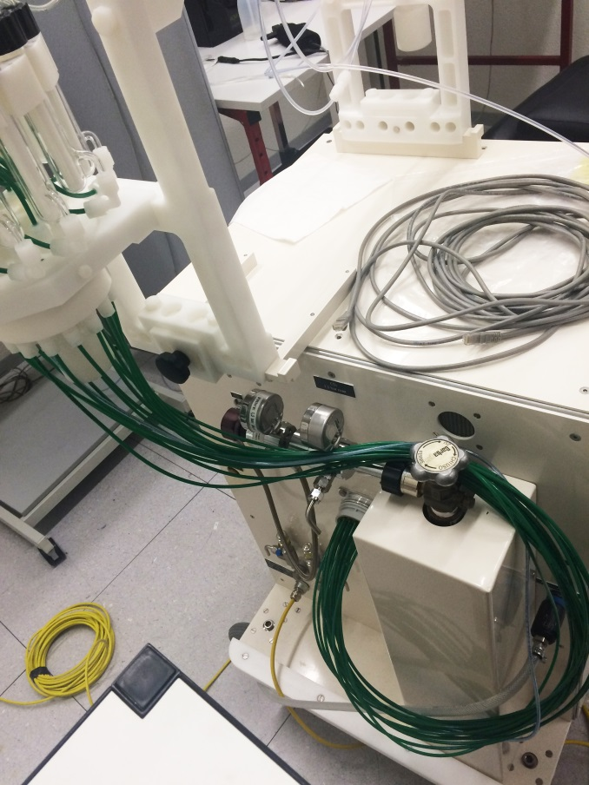Air olfactometer should be set at 1.5
  + The rest should be **OFF**

**5.** Plug in the cable for the air in the olfactometer (Air Network inlet -**ANI**) and in the Air technique pipe on the wall by the sink. Should hear 2 clicking sounds when you plug the cable for both ends

**B**

**6.** Turn on the Air from the wall using the handle (it’s on when the handle is horizontal)

**7.** Plug in the odors to the olfactometer using the connector with green cables.

**A**

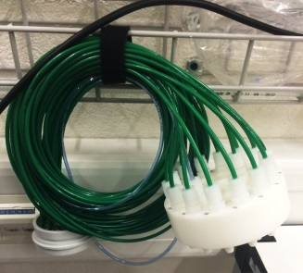

**A**

**B**

**i)** Connect part A to the olfactometer

**ANI**

**ii)** Unscrew the cap underneath the vials in order to plug part B underneath the vials

**iii)** Attach part B, while making sure to match the numbers on the vials side of the olfactometer and the numbers on part B

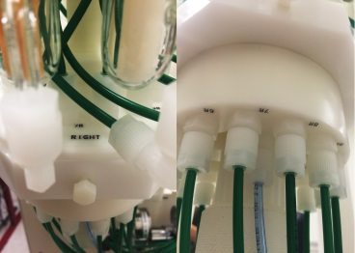

**Below**

**Above**

**iv)** Screw cap back once part B is in place

**8.** Clean nasal cannula

* Use toilet paper and Alcohol

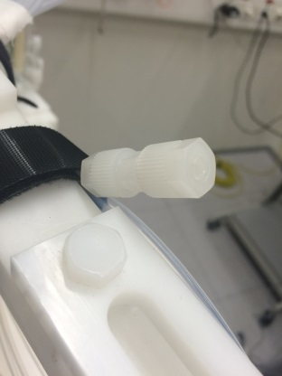**9.** Connect nasal cannula to olfactometer. Connect side that has not been blocked off.

* Unscrew part Z to be able to insert cannula

**Z**

* Insert cannula
* Tighten part Z but not too tight

**At the end of the session**

**1.** Unplug everything turn off the olfactometer and unplug everything you’ve plugged.

**Troubleshooting**

If the olfactometer is not working:

1. Check everything is plugged in correctly

2. Go into digi Realport, see if the olfactometer is present on the list

* If it is and it is still not working, try re-installing it.
* the IP address can be found on the olfactometer, by the yellow Ethernet cable.

If it still does not work:

* Contact Sylvain Delplanque: **90905**