

Established under sub section (3) of Section 1 of Garden City University Act, 2013 (Karnataka Act No. 47 of 2013)

Dr. A P J Abdul Kalam School of Engineering

B.Tech in Computer Science and Engineering (AI & ML, CS and DS)

Web Designing Project Report

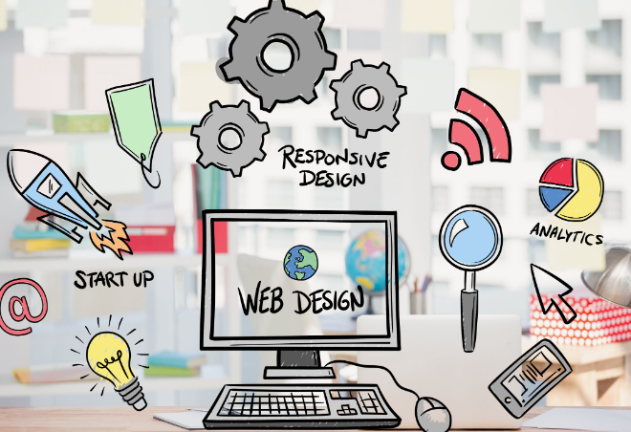

Project Title:

Submitted by

NAME : EVA PRIYAL NORONHA

REGISTER NUMBER : BTAI152, BTAI131 & BTAI162

SECTION : A

Teammates Names : Shrenik & Rounik Goswami

COURSE CODE: 10ABTEC22215 COURSE INSTRUCTOR: Mrs.Chinta Indira Devi

COURSE NAME: Web Designing SEMESTER: II

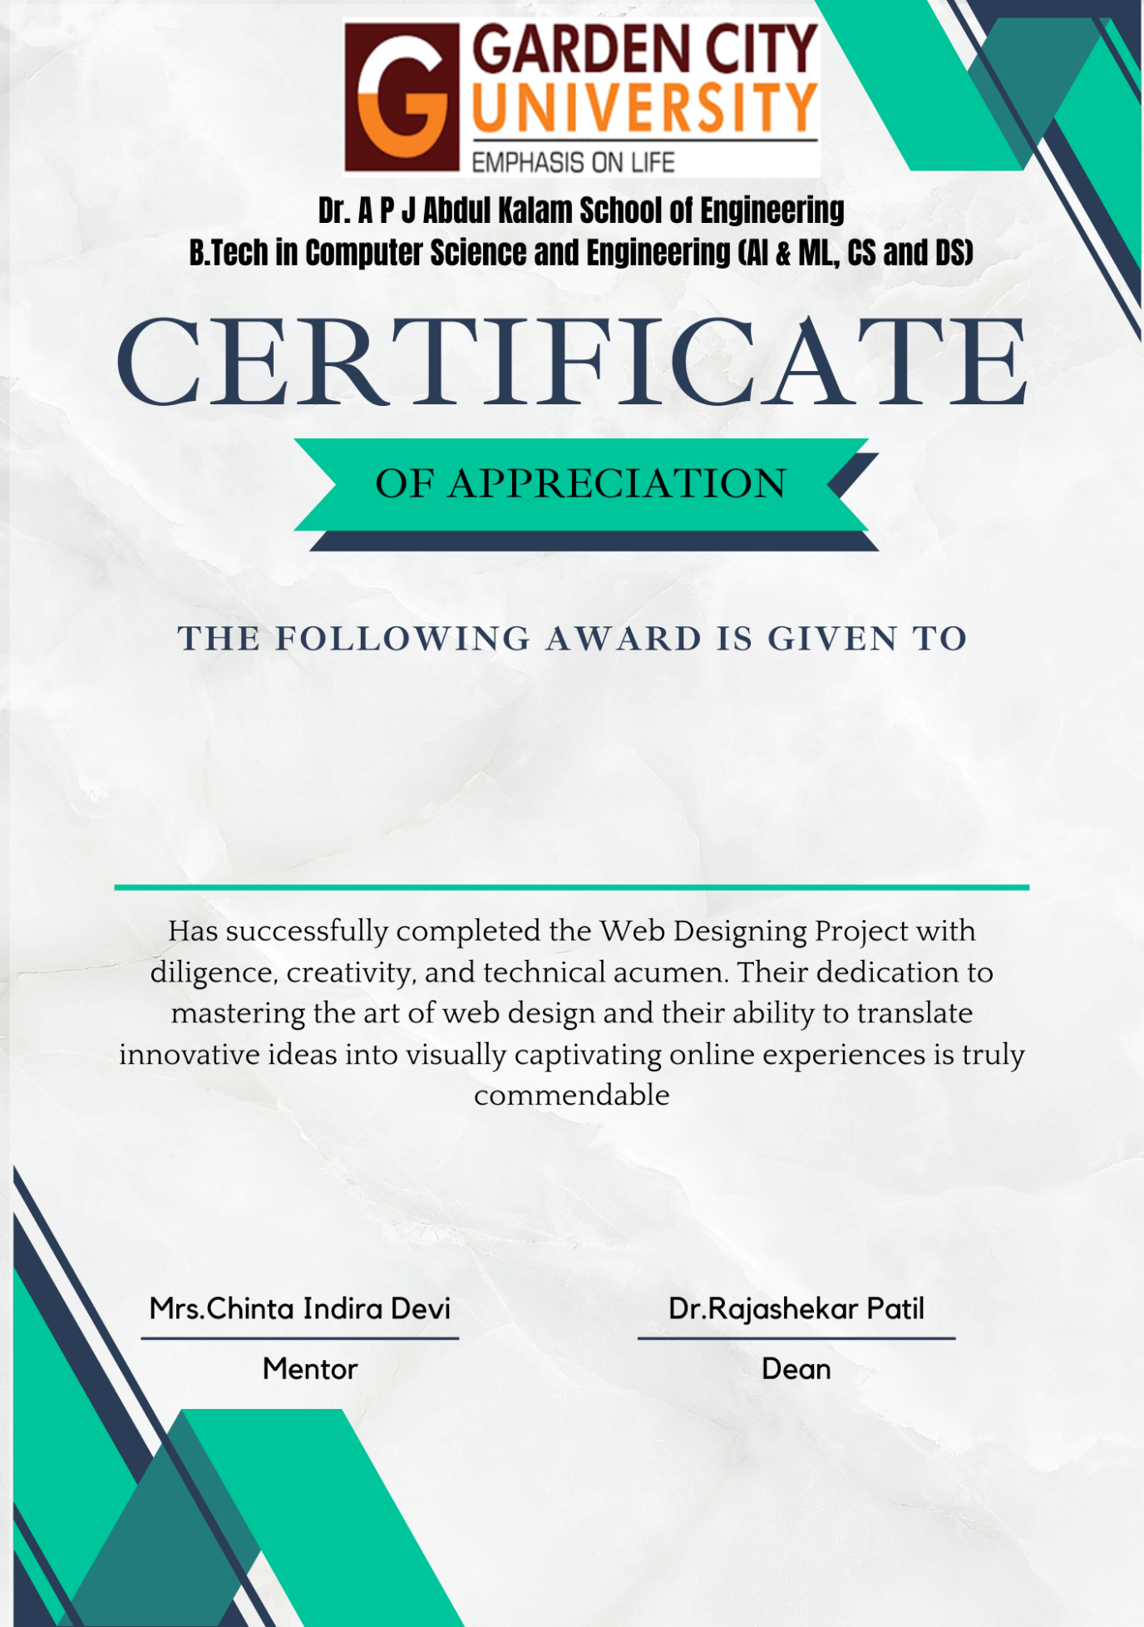

**Acknowledgement**

We wish to express our sincere gratitude to our esteemed professors Mrs. Chinta Indira Devi for imparting her knowledge and expertise in the fields of HTML, CSS, and Java programming. Her guidance, mentorship, and dedication has been instrumental in shaping our skills and understanding of these essential technologies.

As We embark on future endeavours in the realm of web development, we carry with us the valuable insights and skills that you have imparted. Your contribution to our educational journey is immeasurable, and we are excited to apply what we have learned to create meaningful and impactful digital experiences.

With deep appreciation,

Shrenik Sudhir, Eva Priyal Noronha and Rounik Goswami

**Description of project**

The development of Piatti’s online restaurant website is a transformative project that melds the authentic charm of Italian cuisine with the modern world of digital innovation. This venture encapsulates our dedication to delivering an immersive dining experience, seamlessly transitioning the essence of our culinary offerings into the digital realm. The website's architecture, meticulously designed using HTML, CSS, and JavaScript for intuitive navigation and captivating storytelling, draws visitors into a virtual journey mirroring the ambience of our physical restaurant. Through interactive menu exploration, powered by JavaScript, patrons can savour the intricate details of each dish, complete with imagery and wine pairing recommendations. The integration of an effortless online ordering system, driven by JavaScript, underscores our commitment to convenience, enabling customers to curate their culinary choices with ease. With sustainability at its core, the platform's efficient design minimizes resource consumption, while aligning with eco-conscious trends by eliminating paper menus. Looking ahead, the project's potential for growth remains promising, with opportunities to incorporate emerging technologies and personalized experiences, ensuring Piatti’s online presence, crafted with HTML, CSS, and JavaScript, continues to be a dynamic reflection of the harmonious blend between culinary excellence and digital advancement.

**HTML: Crafting the Digital Canvas**

At the heart of Piatti Online Website presence lies HTML (Hypertext Markup Language), a foundational technology that constructs the structural framework of our website. HTML serves as the digital blueprint, enabling us to create the virtual space where our patrons embark on their culinary journey. It structures content with semantic precision, defining headings, paragraphs, images, and links that seamlessly guide users through our offerings and engage them in an immersive gastronomic experience.

**CSS: Aesthetic Alchemy**

CSS (Cascading Style Sheets) serves as the aesthetic maestro that transforms Piatti’s digital canvas into a visually captivating masterpiece. Through CSS, we meticulously choreograph colours, typography, layouts, and design elements that resonate with the elegance and warmth of Italian culture. The synergy between HTML and CSS breathes life into our platform, evoking emotions and setting the stage for an enchanting exploration of our culinary delights.

**JavaScript: Interactive Enchantment**

JavaScript, the dynamic scripting language of the web, infuses our online portal with interactive enchantment. By seamlessly integrating JavaScript into our website, we transcend static content and transform it into an engaging digital realm. Interactive elements like real-time feedback forms, and visually captivating animations provide a dynamic and user-centric experience that keeps patrons captivated throughout their digital journey.

**Screenshots of each page of the website with brief description down about that page**

**Home Page:**

Explore menu for traditional pasta, wood-fired pizzas, and more. Have questions? Contact us anytime for assistance or feedback. Craving Italian excellence? Place an online order and enjoy dishes at home. [Hyperlinks: View Our Menu/ Contact Us/ Place an Order Online].

**HTML & CSS:**

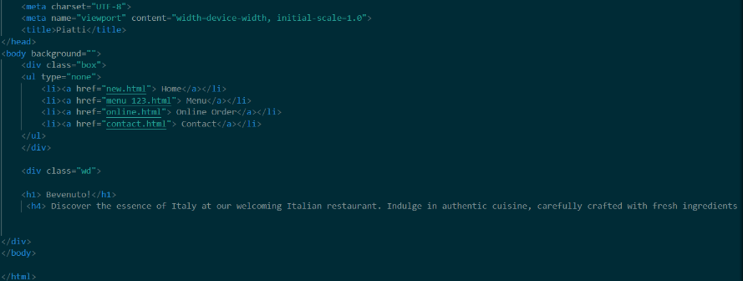

** 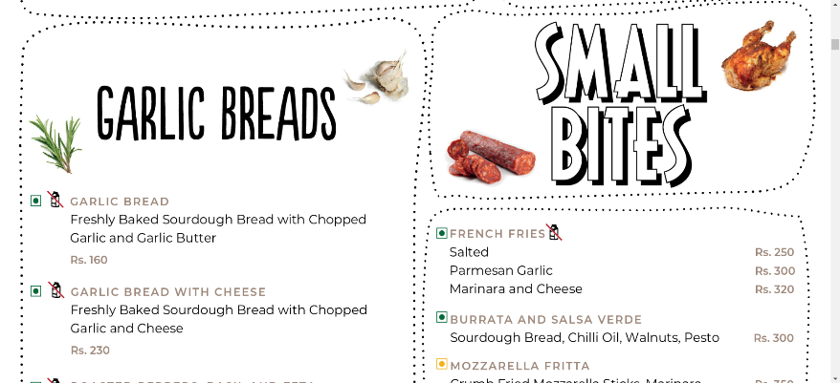

The traditional practice of offering physical menus in a restaurant setting has been replaced by an online menu for several reasons. First, the online platform allows patrons to peruse our extensive menu offerings at their own pace, promoting informed choices. Secondly, it caters to the growing preference for contactless interactions, aligning with changing consumer behaviour post-pandemic.

**HTML & CSS:**

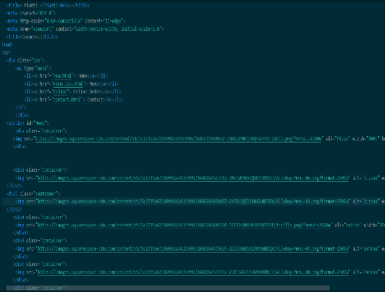

**Order Online in the Comfort of Your Own Space:**

Craving Italian excellence? Indulge in the authentic Flavors of Italy by placing an online order through our seamless and convenient process. Whether you're yearning for the comfort of traditional pasta or the sizzling delight of wood-fired pizza, our online ordering system brings the Piatti experience directly to your doorstep. Navigating our online order form is as effortless as savouring our dishes. Begin by entering your name and email address, allowing us to personalize your experience.

**HTML, CSS & JavaScript:**

**Accessibility and Customer Support:**

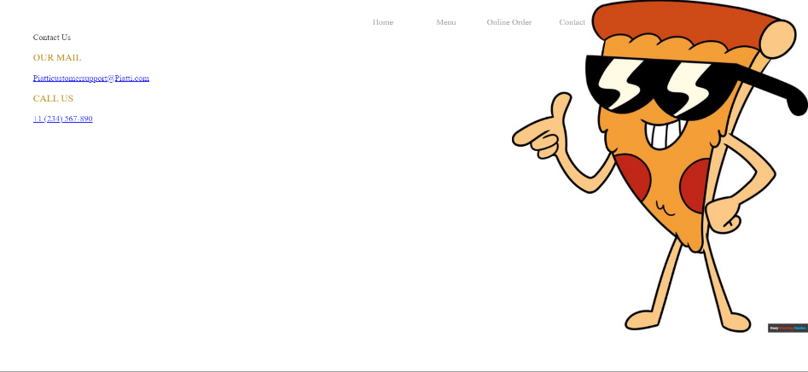

The online platform ensures that our patrons have instant access to crucial information. Whether it's allergy inquiries, dish recommendations, or addressing concerns, our customer support team is readily available to assist. This convenience not only enhances the overall customer experience but also empowers patrons to make well-informed dining choices.

**HTML & CSS:**

**Future Scope of Piatti Online Restaurant Website:**

1. Enhanced User Experience: Continuously improve responsiveness and user interfaces across devices.
2. Personalized Recommendations: Use data analytics to offer tailored dish suggestions and promotions.
3. Virtual Culinary Workshops: Host online classes to educate participants about Italian cooking techniques.
4. Interactive Virtual Tours: Provide immersive behind-the-scenes glimpses of our kitchen and dining spaces.
5. Integration with Emerging Tech: Explore AR and VR integration for unique brand experiences.
6. Expanded Online Ordering: Include catering services and meal kits to cater to diverse customer needs.
7. Sustainability Initiatives: Showcase eco-friendly practices, resonating with environmentally conscious patrons.
8. Social Media Integration: Seamlessly connect with customers through social media platforms for community engagement.

**Bibliography**

1. Brick Oven Restaurant. "Web Design Inspiration: Crafting an Engaging User Experience." Restaurant Design Blog, Brick Oven Restaurant, 2021.
2. Italian Culinary Institute. "Exploring Italian Cuisine: From Tradition to Modernity." Online Course Materials, 2023.
3. Environmental Protection Agency. "Reducing Paper Waste: Benefits for Businesses and the Environment." EPA Sustainability Guides, 2021.
4. Thompson, Emily. "Embracing Sustainability in the Restaurant Business." Sustainable Dining Blog, Bella Cucina, 2023.
5. Smith, John. "The Digital Transformation of the Restaurant Industry." Journal of Culinary Technology, vol. 23, no. 2, 2022, pp. 45-62.