Title

**Application of Image Processing to Roundabouts’ Circulating Headway Determination**

**Abstract**

Gap acceptance models are applicable in determination of capacity of unsignalized intersections. In roundabouts, determination of circulating headway is one of the steps necessary to obtain critical gap, an input in the capacity models. A well-known technique to headways determination involves manually recording of the time events from videos recorded at intersection, the process which can be semi-automated to include computer techniques. However, this process is time consuming and is associated with human errors during the process. This paper presents a tool for determination of the circulating headways using image processing techniques which begins with processing techniques like foreground detection, morphological operations and developing region of interest leading to the headways determination. The techniques have been programmed and implemented through Matlab software. For the 21 vehicles recorded, the proposed method shows comparably similar results to that determined manually when the threshold value is set to 60 percent of the ROI area. The method is then proposed for headway determination a step towards capacity determination.

**Introduction:**

Capacity analysis of roundabouts utilizes the gap acceptance theory. Roundabouts’ capacity determination involves collection of circulating vehicles’ headways for determination of critical gap. Collection of the circulating headways has been done manually through video observation and hence record of the said events. Another option, has been to semi-automate the process by creating a program which records timestamps of events associated with passage of a circulating vehicle through a reference point in the video.

The processes mentioned, since they involve human decisions upon the event, are not free from human errors in correctly recording the time events. In addition, the process is time consuming since a single video has to be played more than one times if an anticipated accuracy is to be expected.

This paper aims at utilizing the image processing methods in determination of the roundabout’s circulating headways. Since the process runs solely depending upon computer vision, it reduces human errors and expedited extraction process.

**Related Works**

An attempt to use image processing in study of traffic flow operations and vehicle detection has been applied as substitute to human vision in much of literature. The studies range from incorporating feature detection methods from still images to foreground detection methods in video imaging.

Kembhavi, Harwood, & Davis, (2011) [1] developed a vehicles detector from aerial images by incorporating rich set of image descriptors which includes color probability maps. Their tool involved image properties like Color Probability Maps, Histograms of Oriented gradients and Pairs of Pixels (PoP) methods. The vehicles features were then extracted through the use of Partial Least Squares classification after training the images.

[2] developed an image detection algorithm to detect and eventually count vehicles in the road using a combination of both frame differentiation and edge detection algorithms. By using Kalman filter, the position of the image was estimated and tracked. The filter also helped in classification of vehicles such that the counting was done in specified groups. He found that the counting was inaccurate by 4% and that classification was inaccurate by 5%.

[3] Developed an algorithm that uses the digital video, image processing and computer vision to automatically the vehicle speed in an accurate manner. The algorithm involved camera calibration, background generation and vehicle detection methods which led to speed measurement. The speed of the vehicle was calculated using the position of the vehicle in each frame. To obtain a good foreground, the authors generated a background based on two modes in the Hue-Saturation-Value (HSV) model; one with advantage of saturation and the other based on value. With this diversity, based upon value, the object with the white and bright color is recognized explicitly. On the other hand, since the vehicles with dark colors could not be well recognized by this attribute, the authors used Saturation attribute in HSV model to classify the dark colored objects. The detected speeds were found to differ from the actual vehicle speeds by the range of 0.4kph to 4.7kph.

**Data Used and Study design**

To carry out this study, a three-legged roundabout located at Weems Drive. intersecting with Easterwood Drive. in Tallahassee, Fl. with single lane approaching and single lane circulating was used. The study involved recording a video capturing approaching vehicles from Easterwood Dr. as well as circulating vehicles conflicting them as shown in figure xxx below. The video had a length of about 2 minutes with a total of 21 circulating vehicles passing.

|  |  |
| --- | --- |
| Figure 0‑1:(a) Overview of the roundabout | C:\Users\Evarist\Pictures\vlcsnap-2018-01-06-18h41m44s802.png  Figure 1: (b) Video recording view of the approach |

The purpose is to track the circulating vehicles’ timestamps when passing a region of interest as they conflict the approaching vehicles. The vehicles’ timestamps will then help in determination of headway. Two main steps are used: Foreground development and headway determination process.

**Foreground Development**

The purpose for foreground detection is to obtain a series of images or frames with only the moving vehicles detected with the rest of the cells being zero. This is an important step for tracking the change in cell values at the region of interest for record of timestamps or frame numbers associated with the vehicles’ position. Therefore, image processing techniques are applied to result into detection of a refined foreground. The following are steps leading to determination of foreground

1. Background modeling
2. Foreground detection
3. Morphological operations

***Background Modeling***

Background modeling involves creating a reference image that defines all the static features of the image like parking vehicles, road surface, building conditions together with climatic conditions or illuminations. This is an important component in the motion analysis. Several methods to obtain the background have been developed [4] classifies techniques into two major categories, recursive techniques and non-recursive techniques. Recursive techniques need no formation of buffer of several frames for modeling foreground [5]. Non-recursive techniques involve creating a buffer of frames and then estimates a background image based upon the temporal variation of each pixel within a buffer [4]. A mathematical operation is then applied to the buffer to form a background frame. The mathematical approaches applied to that background range from average filter, median filter and linear predictive filter. Median filter determines the median value of all the cell values in the background.

In this paper, a median filter mechanism was applied to model the background. Background subtraction is determined by finding the median value of the given pixel numbers. a number of frames are selected from the video and median value for each pixel is determined. For this method, considering a video with n frames, where we have to pick k frames for background, the video was divided into n/k parts and from each portion 1 frame chosen as a representative. The median value for such frame was chosen. a value of k was chosen depending upon the quality of the foreground obtained. For this study, a 20 frames buffer was used for the determination of background.

***Foreground Detection***

Foreground detection is done by comparing the background generated with the original frames. A threshold of the difference between the frames is chosen that will filter the background and retain the foreground. According to [5] a good foreground is obtained if the values are normalized, that is: the pixel difference is divided by the original frame values. A threshold is also chosen such that, it will remove the noise of the background in the foreground without affecting the quality of the foreground. A threshold value can be done through trial and error method to obtain clear foreground.

***Morphological Operations***

Morphological operations are applied to the foreground detected for the purpose of removing noise. The existing morphological operations are such as disk, open and closed operations are usually applied to the detected foreground. Considering the foreground obtained, the suitable operation was closed operation. This modified the foreground to fill in the voids in the foreground. Fig xx shows one of the images before and after morphological operations.

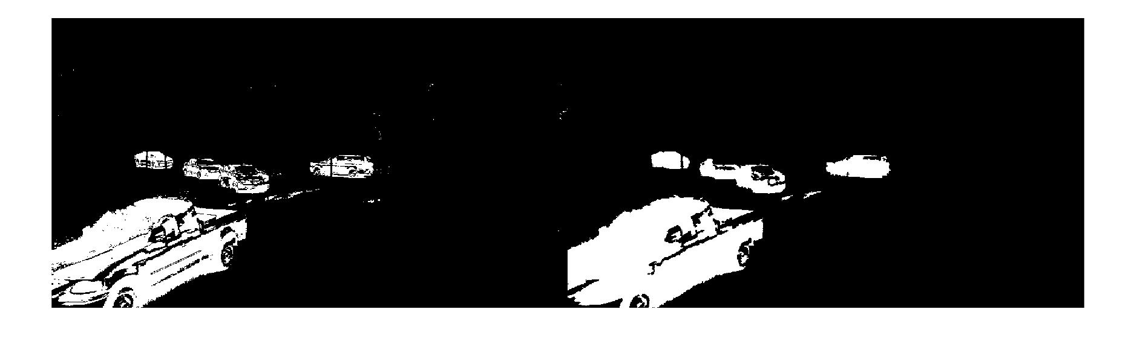

After morphological operation

Before morphological operation

**Headway determination**

Within this region the change in cell values is traced to detect the times when the vehicles pass through the point.

Three steps were followed for headway determination:

1. Choice of region of interest (ROI)
2. Headway determination by video processing
3. Validation process

A 2 seconds video was used which had 21 vehicles circulating the roundabouts. circulating vehicles

***Region of interest***

From the circulating lane, a region closer to conflict region with area equivalent to 957 cells was selected as a region of interest (ROI). It is at this region where the change in pixel values is traced and then regular issues are traced. A code is written to capture the cells corresponding to this region so that the change in foreground values at this address is traced. The change in such values will reflect the vehicle movement past the region.

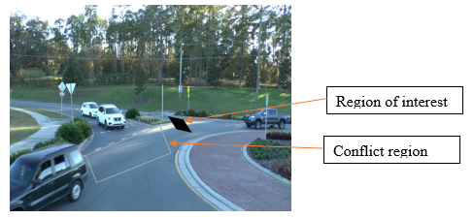

Figure 0‑2:.....

***Headway determination***

A change in pixel values of masked binary image at the region of interest will reflect the presence or absence of a vehicle. Graphically, the filled area variations can be plotted against frame number which shows the frame intervals where there is presence of vehicles. Figure xxx(b) shows the pixel distribution showing peaks reflecting the presence of vehicle in ROI and other regions with zero values showing the absence of vehicles. Though selection of suitable threshold, a plot specifying a frame number where the area becomes greater than threshold is specified as shown in Fig …(b).

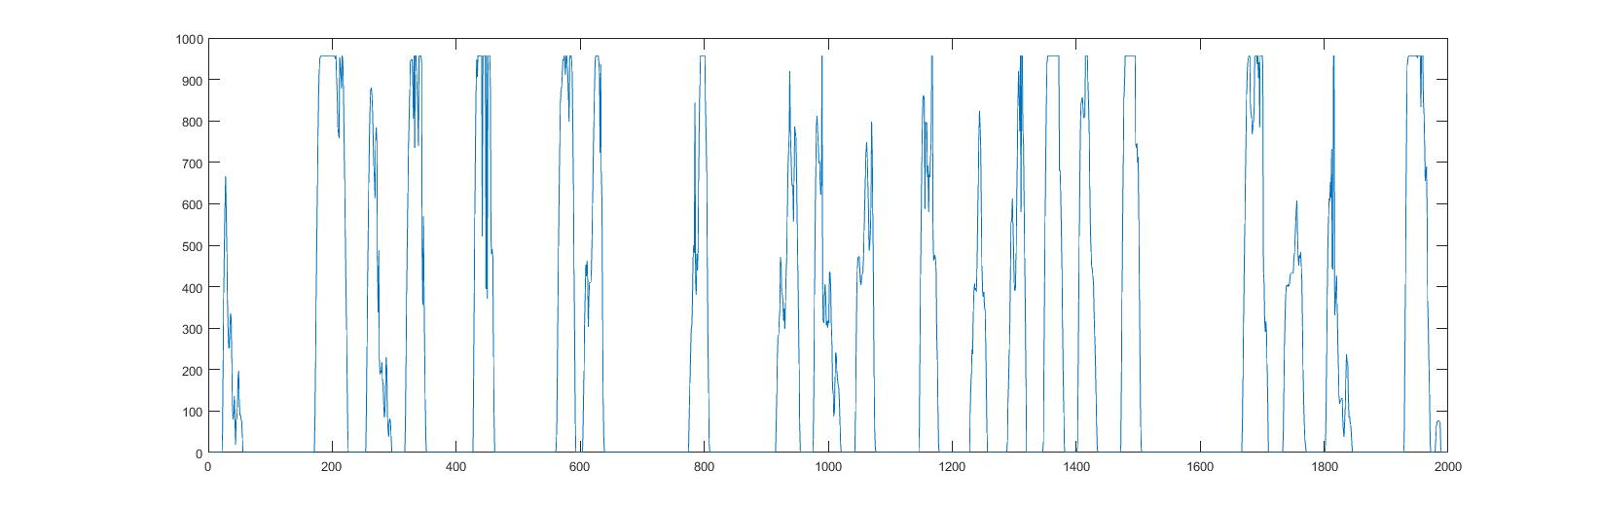

Threshold 1 = 669.2

Threshold 2 = 574.2

Figure 0‑3: Area variations of ROI

Depending upon the quality of foreground image, the cells of the ROI can either be fully or partially filled as shown in fig xxx. with filled ROI values ranging from 0 to the maximum value of 957. A masked image with good foreground will have a trapezoidal shape indicating three regions: first is positively sloping region showing increasing cell values from zero to maximum, second is horizontal spanning region with maximum cell value and third a negatively sloping region with decreasing area value from maximum value to zero. The other shapes of curves reflect an eroded foreground which partially filled in the cells. To capture the half-filled cells representing vehicles, a threshold value less than the maximum value is chosen.

From the visible plot of the area variations (fig. 3) two thresholds are chosen at 70 percent and 60 percent of the maximum area respectively, and the number of vehicles trapped by these values can be determined. The frame number of the beginning of each peak value is recorded to reflect the start of entry of vehicle at the ROI. The difference between each frame number reflect the headway of between successive vehicles (in frame number). The first threshold traps 19 vehicles while the second threshold trapping all vehicles.

***Results and validation***

From the obtained frame numbers, the timestamps are determined through dividing frame number by the frame rate which is 30 frames per second. The timestamp difference between successive vehicles gives the headway values. Manual recording is then done to determine the timestamps related to the events and eventually headways. Table xxx summarizes frame numbers, timestamps as well as headways of circulating vehicles’ arrival events for each selected threshold values as well as timestamps and headways of the manually determined values..

Table of results:

|  |  |  |  |  |  |  |  |  |  |
| --- | --- | --- | --- | --- | --- | --- | --- | --- | --- |
| Threshold = 0.7*Area = 669.9 cells | | |  | Threshold = 0.6*Area = 574.2 cells | | |  | Manually determined | |
| Frame number | Timestamp (sec) | Headway (sec) |  | Frame number | Timestamp (sec) | Headway (sec) |  | Timestamp (sec) | Headway (sec) |
| 177 | 5.900 |  |  | 27 | 0.900 |  |  | 0.76 |  |
| 260 | 8.667 | 2.767 |  | 176 | 5.867 | 4.967 |  | 5.81 | 5.05 |
| 323 | 10.767 | 2.100 |  | 259 | 8.633 | 2.767 |  | 8.48 | 2.67 |
| 431 | 14.367 | 3.600 |  | 322 | 10.733 | 2.100 |  | 10.64 | 2.16 |
| 567 | 18.900 | 4.533 |  | 430 | 14.333 | 3.600 |  | 14.2 | 3.56 |
| 621 | 20.700 | 1.800 |  | 566 | 18.867 | 4.533 |  | 18.72 | 4.52 |
| 785 | 26.167 | 5.467 |  | 620 | 20.667 | 1.800 |  | 20.13 | 1.41 |
| 935 | 31.167 | 5.000 |  | 785 | 26.167 | 5.500 |  | 25.85 | 5.72 |
| 980 | 32.667 | 1.500 |  | 935 | 31.167 | 5.000 |  | 30.54 | 4.69 |
| 1060 | 35.333 | 2.667 |  | 980 | 32.667 | 1.500 |  | 32.52 | 1.98 |
| 1151 | 38.367 | 3.033 |  | 1059 | 35.300 | 2.633 |  | 34.65 | 2.13 |
| 1243 | 41.433 | 3.067 |  | 1151 | 38.367 | 3.067 |  | 38.1 | 3.45 |
| 1305 | 43.500 | 2.067 |  | 1242 | 41.400 | 3.033 |  | 40.91 | 2.81 |
| 1351 | 45.033 | 1.533 |  | 1297 | 43.233 | 1.833 |  | 42.82 | 1.91 |
| 1406 | 46.867 | 1.833 |  | 1351 | 45.033 | 1.800 |  | 44.99 | 2.17 |
| 1476 | 49.200 | 2.333 |  | 1406 | 46.867 | 1.833 |  | 46.71 | 1.72 |
| 1674 | 55.800 | 6.600 |  | 1476 | 49.200 | 2.333 |  | 49.03 | 2.32 |
| 1812 | 60.400 | 4.600 |  | 1673 | 55.767 | 6.567 |  | 55.6 | 6.57 |
| 1933 | 64.433 | 4.033 |  | 1755 | 58.500 | 2.733 |  | 57.75 | 2.15 |
|  |  |  |  | 1808 | 60.267 | 1.767 |  | 60.07 | 2.32 |
|  |  |  |  | 1932 | 64.400 | 4.133 |  | 64.34 | 4.27 |

The table of results reveals that the second threshold values captures all the circulating vehicles’ timestamps with comparably similar headway values. The slight discrepancy between the vehicles’ headway for the two vehicles is attributed to two factors: the quality of the foreground and possibility of errors when recording timestamp manually. The difference however, is negligibly small enough to assume that the proposed method effectively determines the headway values.

Conclusions?

# References

|  |  |
| --- | --- |
| [1] | A. Kembhavi, D. Harwood and L. S. Davis, "Vehicle Detection Using Partial Least Squares," *IEEE Transactions on Pattern Analysis And Machine Intelligence,* pp. 1250-1265, 2011. |
| [2] | A. Tourani and A. Shahbahrami, "Vehicle Counting Method Based on Digital Image Processing Algorithms," in *2015 2nd International Conference on Pattern Recognition and Image Analysis (IPRIA 2015)* , Rasht, Iran, 2015. |
| [3] | A. G. Rad, A. Dehghani and M. R. Karim, "Vehicle speed detection in video image sequences using CVS method," *International Journal of the Physical Sciences,* vol. 5, no. 17, pp. 2555-2563, 2010. |
| [4] | M. a. e. A. Marzouk, "Modified Background Subtraction Algorithm for Motion Detection in Surveillance Systems," *AMARABAC, Journal of American Arabic Academy of Sciences and Technology,* vol. 1, no. 2, pp. 112-123, 2010. |
| [5] | H. Hassanpour, M. Sedighi and A. R. Manashty, "Video Frame’s Background Modeling: Reviewing The Techniques," *Journal of Signal and Information Processing,,* pp. 72-78 , 2011. |
| [6] | E. Altay, B. A. Güvenç and L. Güvenç, "Lidar Data Analysis for Time to Headway Determination in the DriveSafe Project Field Tests," *International Journal of Vehicular Technology,* p. 9, 2013. |