Title

**Application of Image Processing to Roundabouts’ Circulating Headway Determination**

**Abstract**

Gap acceptance models are applicable in determination of capacity of unsignalized intersections. In roundabouts, determination of circulating headways is one of the steps necessary to obtain critical gap, an input in the capacity models. A well-known technique to headways determination involves recording of the time events from videos recorded at intersection. When recorded manually, the process takes time with results prone of errors subject to an individual performing the extraction. Improvements made have been semi-automatic processes which involves use of software capable of recording timestamps related to keystrokes on the computer. With the emerging technology of computer vision and artificial intelligence, automated data collection and extraction methods have been deployed most of which focus on highways and signalized intersections. Having limited research focusing on roundabouts, this paper presents a methodology for determination of the circulating headways using image processing techniques. Just like a presence detector installed in the pavement detects vehicles, this study introduces the creation of region of interest in the video, to detect the presence of vehicles in that region and hence enable headway determination. The techniques have been programmed and implemented through Matlab software from a set of three video clips recorded at different times, the automatically extracted headways were compared to manually extracted headway values and they were found to be statistically the same. The results suggest that, depending upon the foreground quality, high accurate results are expected with minimum intervention.

**Introduction:**

Development of roundabouts capacity models has mainly been depending upon gap-acceptance parameters and circulating traffic volumes. Determination of gap acceptance parameters involves observation and recording of vehicle movements in the roundabout, focusing on an approach of interest. The event of interest has been approaching vehicle’s arrival and departure from the yield line (involving approaching vehicles) as well as circulating vehicle’s arrival at the conflict region (figure 1). The data collection and processing has mainly been done through the use of videos recorded at a particular location in the intersection. Extraction of events of interest happening in the video follows, which enables determination of parameters necessary for calculation of roundabouts’ capacity.

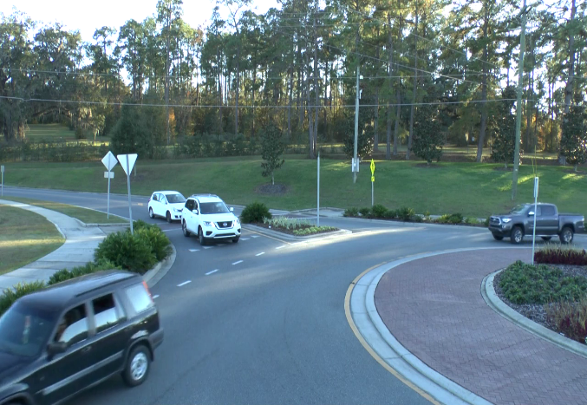

Approaching vehicle

Circulating vehicle

Figure 1: Approachign and circulating vehicles

The events extraction has been carried out through methods ranging from manual to semi-automatic approaches. Manually, extraction process can involve the use of stopwatch where events in video are extracted by record of timestamps associated with them. Alternatively, a frame by frame review of the videos have been done to increase accuracy [1]. In this process, the frame numbers associated with each event is recorded and then through the use of frame number and the video’s frame rate (number of frames per second) then, timestamps can be determined. The frame-by frame process has been achieved through the use of QuickTime player software, capable of extraction of time events. This increases accuracy as slow motion playing is possible. However, since a person has to record the frame numbers, the process is time consuming and can eventually result inaccuracy especially after fatigue.

Another approach is through semi-automatic processes that involves a program capable of extracting keystrokes associated with particular events [2, 3, 4, 5]. The timestamps of the observation made in the video is stored directly into a computer with a record of the key pressed in the keyboard. Therefore, one has to select keys that will reflect different events of interest in the video like vehicle arrival, departure and exit, perform the operation and finally open the log file to extract the timestamp. This method increases speed of operation and increases accuracy especially when the program is embedded into a player capable of recording timestamps in slow motion, related to the actual time in th video instead clock time of the computer. This was achieved and applied by Vasconcelos et al [4, 5] who developed a semi-automatic tool namely LUT||VP3 player.

Since all these methods requires human operation, still human errors can be experienced especially when the keys are wrongly pressed either before or after the vehicle has passed the reference position. With the emerging use of existing computer vision techniques in automatic traffic data extraction and monitoring, there is a need to find application of such techniques in roundabouts. This research paper therefore, aims at providing a means on how these video-processing techniques can be applied to determination of circulating vehicles’ headway in the roundabout, an important step towards determination of gap acceptance parameters. The method involves application of background subtraction and morphological operation techniques to obtain a foreground from which the vehicle’s position will be traced through its trajectory, to when it passes a region of interest which is actually the conflict region. Through monitoring the variations in behavior of the region of interest, the timestamps related to the passage of the vehicle through the region of interest is monitored.

**Related Works**

Most of research related with video-based data collection and extraction has been focusing upon highways or arterial roads on areas experiencing high traffic flows for the purpose of obtaining video-based speed detection, vehicle counting and other related studies. [6] [7]. For example, [6] developed an image detection algorithm on a highway to detect and eventually count vehicles in the road using a combination of both frame differentiation and edge detection algorithms. By using Kalman filter, the position of the image was estimated and tracked. The filter also helped in classification of vehicles such that the counting was done in specified groups. Also, [7] Developed an algorithm that uses the digital video, image processing and computer vision to automatically determine the vehicle speed in an accurate manner. The algorithm involved camera calibration, background generation and vehicle detection methods which led to speed measurement. The speed of the vehicle was calculated using the position of the vehicle in each frame.

Limited research involving vision-based traffic monitoring and operation to unsignalized intersections exists. For example, [8] perform a study on turning movement count based upon computer vision. Similar to this study are [9, 10, 11] Despite the fact that these methods were automated, still all except one depended upon wireless sensors in collection of information form the intersections.

Among the limited sources that focuses on roundabouts known to the authors, Dinh and Tang (2017) [11] is one of them that focused on determination of roundabout capacity using purely video-based monitoring. However, the methods used still require camera calibration that required establishment of relationship between image distances with that of actual distances for accurately extraction of information.

Considering that the capacity evaluation of roundabouts requires record of time events, and that it hardly depend upon the geometry of roundabouts [2, 12, 13, 14] this research developed a different approach that won’t necessitate going through calibration processes. With identification of region of interests, record of time events is made possible and hence determination of circulating vehicles’ headway made possible.

**Data Used and Study design**

To carry out this study, a three-legged roundabout located at Weems Drive intersecting with Easterwood Drive. in Tallahassee, Fl. with single approaching lane conflicted with single circulating lane was used. The study involved recording a video capturing both approaching and circulating vehicles shown in figure 2(b) below. The video had a length of about 2 hours from which three portions (clips) each of length 1.5 min in the video were selected to test the accuracy of the proposed approach. One clip being obtained at the beginning, the second in the middle and the third at the end.

|  |  |
| --- | --- |
| Figure 2:(a) Overview of the roundabout | C:\Users\Evarist\Pictures\vlcsnap-2018-01-06-18h41m44s802.png  Figure 2: (b) Video recording view of the approach |

The purpose is to track the circulating vehicles’ timestamps when passing a region of interest as they conflict the approaching vehicles. The vehicles’ timestamps are then used to determine headways. Two main steps are used: Foreground development and headway determination process.

**Foreground Development**

The purpose for foreground detection is to obtain a series of images or frames having pixel values of one where a moving object is present and zero elsewhere. This is an important step for tracking the change in cell values at the region of interest for record of timestamps or frame numbers associated with the vehicles’ position. Therefore, image processing techniques are applied to result into detection of a refined foreground. The following are steps leading to determination of foreground

1. Background modeling
2. Foreground detection
3. Morphological operations

***Background Modeling***

Background modeling involves creating a reference image that defines all the static features of the image like parking vehicles, road surface, building conditions together with climatic conditions or illuminations. This is an important component in the motion analysis. Several methods to obtain the background have been developed [15] classifies techniques into two major categories, recursive techniques and non-recursive techniques. Recursive techniques need no formation of buffer of several frames for modeling foreground [16]. Non-recursive techniques involve creating a buffer of frames and then estimates a background image based upon the temporal variation of each pixel within a buffer [15]. A mathematical operation is then applied to the buffer to form a background frame. The mathematical approaches applied to that background range from average filter, median filter and linear predictive filter. Median filter determines the median value of all the cell values in the background.

In this paper, a median filter mechanism was applied to model the background. Given three channels in the RGB color space which are Red (R), Green (G), and Blue (B), a median value was formed form a series of selected frames picked at equal intervals throughout the whole duration. Equation 1 illustrates the consideration which is similar to that used by Zhang, et al (2006) [17]. of Considering a video with n frames, where we have to pick k frames for background, the video was divided into n/k parts and from each portion 1 frame chosen as a representative. A median value considering all video frames increase chances for a better background, but a larger amount of memory is required and may lead to slow running of the program. In this study, the whole video frames were divided into 20 portions and each frame which is a multiple of 20 was selected from which a median value was chosen.

…………………………………………. (1)

***Foreground Detection***

Foreground detection is done by comparing the background generated with the original frames. A threshold of the difference between the frames is chosen that will filter the background and retain the foreground. According to [16] a good foreground is obtained if the values are normalized, that is: the pixel difference is divided by the original frame values. A threshold is also chosen such that, it will remove the noise of the background in the foreground without affecting the quality of the foreground. A threshold value can be done through trial and error method to obtain clear foreground.

***Morphological Operations***

Morphological operations are applied to the foreground detected for the purpose of removing noise. The existing morphological operations are such as disk, open and closed operations are usually applied to the detected foreground. Considering the foreground obtained, the suitable operation was closed operation. This modified the foreground to fill in the voids in the foreground. Fig xx shows one of the images before and after morphological operations.

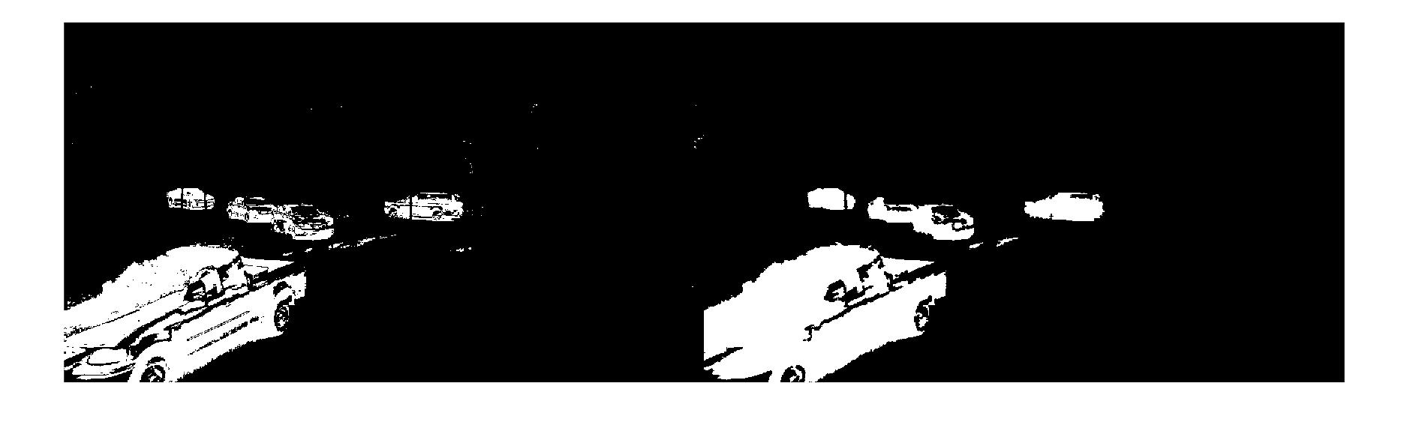

After morphological operation

Before morphological operation

Figure3: Morphological operation

**Headway determination**

Within this region the change in cell values is traced to detect the times when the vehicles pass through the point. Three steps were followed for headway determination:

1. Choice of region of interest (ROI)
2. Headway determination by video processing
3. Validation process

To each of the video clip the same processes were done until all the headway values were determined.

***Region of interest***

The algorithm used in this study enables the user to interact with one of the frames in the video and map a region of interest on the video. The region of interest can be of any polygonal shape that acts as a reference region to trace the moving vehicles. This region acts as a presence detector which is installed into the pavement to trace the presence of vehicles in that region. From the circulating lane, a region closer to conflict region with area equivalent to about 1000 cells is selected as a region of interest (ROI). A Matlab code was written to capture the cells corresponding to this region so that the change in foreground values at this address is traced. The change in such values will reflect the vehicle movement past the region.

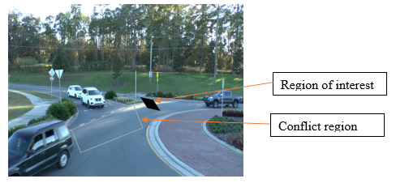

Figure 4: Region of interest

***Headway determination***

A change in pixel values of masked binary image at the region of interest will reflect the presence or absence of a vehicle. Graphically, the filled area variations can be plotted against frame number which shows the frame intervals where there is presence of vehicles. Figure 5(a-c) shows the pixel distribution with peaks reflecting the presence of vehicle in ROI and other regions with zero values showing the absence of vehicles. Though selection of suitable threshold, a plot specifying a frame number where the area becomes greater than threshold is specified as shown in Fig …(b).

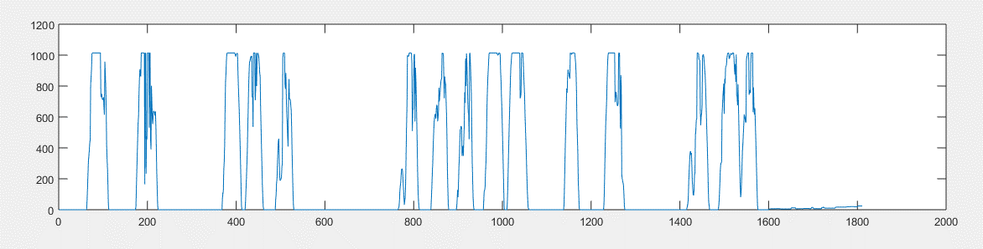

Threshold 1 = 669.2

Threshold 2 = 574.2

(a)

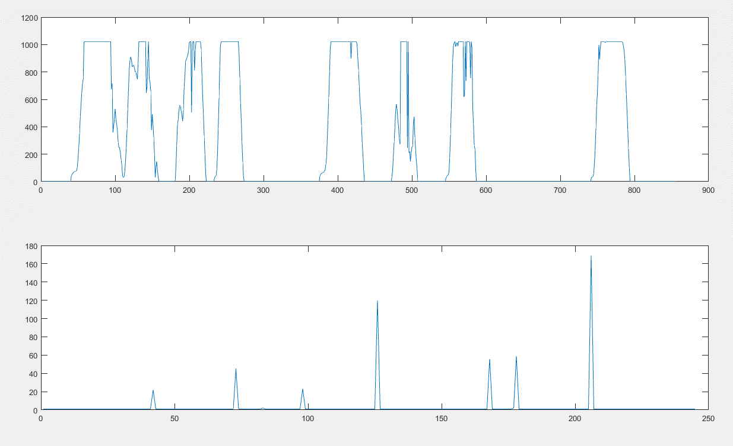

(b)

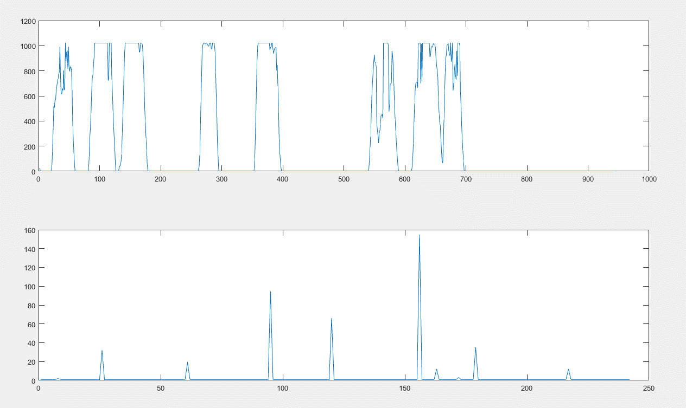

(c)

Figure 5 (a-c): Area variations in ROI for three different video locations

Depending upon the quality of foreground image, the cells of the ROI can either be fully or partially filled, with filled ROI values ranging from 0 to the maximum value of 957. A masked image with good foreground will have a trapezoidal shape indicating three regions: first is positively sloping region showing increasing cell values from zero to maximum, second is horizontal spanning region with maximum cell value and third a negatively sloping region with decreasing area value from maximum value to zero. The other shapes of curves reflect an eroded foreground which partially filled in the cells.

To capture the half-filled cells representing vehicles, a threshold value of 70 percent of the maximum value was chosen. The frame number of the beginning of each peak value is recorded to reflect the start of entry of vehicle at the ROI. The difference between each frame number reflect the headway of between successive vehicles (in frame number).

***Results and validation***

From the obtained frame numbers, the timestamps are determined through dividing frame number by the frame rate which is 30 frames per second. The timestamp difference between successive vehicles gives the headway values. For validation purposes, a manual determination of headways is done by recording timestamps as vehicles pass through the region of interest. The video is played in slow motion to increase accuracy of the timestamps recorded. Table xxx summarizes frame numbers, timestamps as well as headways of circulating vehicles’ arrival events for each selected threshold values as well as timestamps and headways of the manually determined values.

Table 1: Headway results

|  |  |  |
| --- | --- | --- |
| Proposed Method | Manual method | Squared diff |
| 3.63 | 3.63 | 0.00 |
| 6.50 | 6.59 | 0.01 |
| 1.73 | 1.71 | 0.00 |
| 2.57 | 2.26 | 0.09 |
| 9.37 | 9.18 | 0.03 |
| 2.37 | 2.52 | 0.02 |
| 1.93 | 1.81 | 0.02 |
| 1.70 | 2.24 | 0.29 |
| 1.70 | 1.81 | 0.01 |
| 4.27 | 4.35 | 0.01 |
| 3.00 | 2.76 | 0.06 |
| 6.80 | 6.27 | 0.28 |
| 1.93 | 2.41 | 0.23 |
| 1.77 | 1.65 | 0.01 |
|  | Total | 1.07 |
|  | Average | 0.08 |
|  | RMSE | 0.28 |

Table 2: Two sample paired t-test

|  |  |  |
| --- | --- | --- |
|  | *Variable 1* | *Variable 2* |
| Mean | 3.52 | 3.51 |
| Variance | 5.76 | 5.26 |
| t Stat | 0.07 |  |
| P(T<=t) two-tail | 0.94 |  |
| t Critical two-tail | 2.16 |  |

The table of results reveals that the proposed method results in headway values comparably similar to the manually obtained method. Comparing between the two datasets, the root mean squared error was determined to check the difference between the two datasets. The slight discrepancy between the vehicles’ headway for the two vehicles is attributed to two factors: the quality of the foreground and possibility of errors when recording timestamp manually. The difference however, is negligibly small enough to assume that the proposed method effectively determines the headway values.

**Conclusions**

The use of video processing in determination of headway helps in expediting the overall data collection process. The proposed method since it runs automatically is effective in determination of headways without limited human interference.

# **References**

|  |  |
| --- | --- |
| [1] | A. Gazzarri, M. T. Martello, A. Pratelli and R. R. Souleyrette, "Gap Acceptance Parameters for HCM 2010 Roundabout Capacity Model Applications in Italy," in *Intersections Control and Safety.*, 2013, pp. 1-16.. |
| [2] | M. Hunter, M. Rodgers, J. Bansen, L. Schmitt, C. Barry and W. Suh, "Callibration of HCM 2010 Single lane Roundabout Capacity Equations for Georgia Conditions," Atlanta, GA, 2010. |
| [3] | L. Rodegerdts, M. Blogg, E. Wemple, E. Myers, M. Kyte, M. Dixon, G. List, A. Flannery, R. Troutbeck, W. Brilon, N. Wu, B. Persaud, C. Lyon, D. Harkey and D. Carter, "Appendixes to NCHRP Report 572: Roundabouts in the United States," 2007. [Online]. Available: http://onlinepubs.trb.org/onlinepubs/nchrp/nchrp_rpt_572.pdf. [Accessed 20 September 2017]. |
| [4] | A. L. P. Vasconcelos, Á. J. M. Seco and A. M. C. B. Silva, "Comparison of Procedures to Estimate Critical Headways at Roundabouts," *PROMET - Traffic & Transportation,* vol. 25, no. 1, pp. 43-53, 2013. |
| [5] | L. Vasconcelos, A. Silva, Á. Seco and G. Rouxinol, "Estimation of critical headways at unsignalized intersections - a microscopic approach.," *Advances in Transportation Studies.,* pp. 59-72, 2012. |
| [6] | A. Tourani and A. Shahbahrami, "Vehicle Counting Method Based on Digital Image Processing Algorithms," in *2015 2nd International Conference on Pattern Recognition and Image Analysis (IPRIA 2015)* , Rasht, Iran, 2015. |
| [7] | A. G. Rad, A. Dehghani and M. R. Karim, "Vehicle speed detection in video image sequences using CVS method," *International Journal of the Physical Sciences,* vol. 5, no. 17, pp. 2555-2563, 2010. |
| [8] | S. M and M. B, "Vision-based turning movement monitoring: count, speed & waiting time estimation," *IEEE Intelligent Transportation System Management,* vol. 8, no. 1, pp. 23-34, 2016. |
| [9] | D. Y. S. P. V. P. Datondji S, "A survey of vision-based traffic monitoring of road intersections," *IEEE Intelligent Transportation Systems Magazine,* vol. 17, no. 10, pp. 2681-2698, 2016. |
| [10] | Minnesota Department of Transportation, "Portable Cellular Wireless Mesh Sensor Network for Vehicle Tracking in an Intersection," MInnesota, 2008. |
| [11] | H. Dinh and H. Tang, "Development of a Tracking-Based System for Automated Traffic Data Collection for Roundabouts," *J. Mod. Transport,* vol. 25, no. 1, p. 12–23, 2017. |
| [12] | L. Rodegerdts, M. Blogg, E. Wemple, E. Meyers, M. Kyte, M. Dixon, G. List, A. Flannery, R. Troutbeck, W. Brilon, N. Wu, B. Persaud, C. Lyon, D. Harkey and D. Carter, "NCHRP Report 572 Roundabouts in the United States," *Transportation Research Board of the National Academies,* 2007. |
| [13] | L. A. Rodegerdts, A. Malinge, P. S. Marnell, S. G. Beaird, M. J. Kittelson and Y. S. Mereszczak, "Assessment of Roundabout Capacity Models for the Highway Capacity Manual:," Federal Highway Administration, Washington, D.C., 2015. |
| [14] | HCM, HIGHWAY CAPACITY MANUAL, A guide for multimodal mobility analysis., chptr 22 6th ed., WASHINGTON, D.C.: TRB, 2016. |
| [15] | M. a. e. A. Marzouk, "Modified Background Subtraction Algorithm for Motion Detection in Surveillance Systems," *AMARABAC, Journal of American Arabic Academy of Sciences and Technology,* vol. 1, no. 2, pp. 112-123, 2010. |
| [16] | H. Hassanpour, M. Sedighi and A. R. Manashty, "Video Frame’s Background Modeling: Reviewing The Techniques," *Journal of Signal and Information Processing,,* pp. 72-78 , 2011. |
| [17] | E. Altay, B. A. Güvenç and L. Güvenç, "Lidar Data Analysis for Time to Headway Determination in the DriveSafe Project Field Tests," *International Journal of Vehicular Technology,* p. 9, 2013. |
| [18] | A. Kembhavi, D. Harwood and L. S. Davis, "Vehicle Detection Using Partial Least Squares," *IEEE Transactions on Pattern Analysis And Machine Intelligence,* pp. 1250-1265, 2011. |