**Technical** **Stack**

|  |  |
| --- | --- |
| Existing | New |
| Java | Java |
| JSP | JSP |
| Spring | Spring Boot & Spring Annotations |
| EJB 3 | JPA |
| Maven 3.0 | Maven 4.0 |
| MySQL | **MySQL** |

**Changes Details**

1. **SpringBootApplication**

**Create SpringBootApplication**

|  |  |
| --- | --- |
| **Issue** | Application is not a Springboot application. |
| **Impact** | Not able to use many advantages of the Spring boot. |
| **Remediation** | Create Spring boot application to use the Spring boot related components |

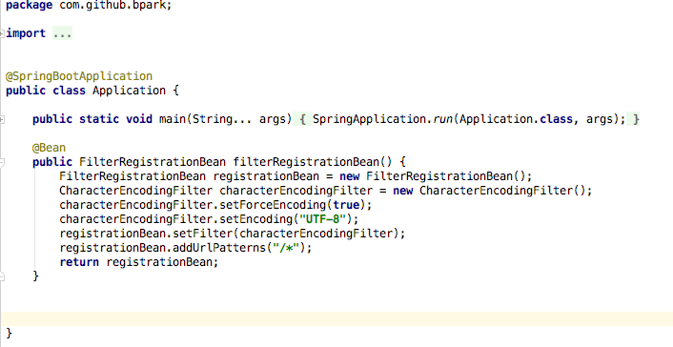

1. **Update POM.xml**

**Add spring-boot-starter-parent in pom.xml**

|  |  |
| --- | --- |
| **Issue** | Spring Boot Starter initialization in POM |
| **Impact** |  |
| **Remediation** | * Added Spring Boot related starters in the POM. * Also Spring Test related starters are added. |

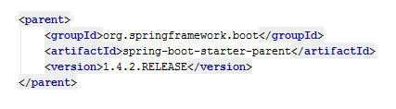

* **Add the dependencies**
* 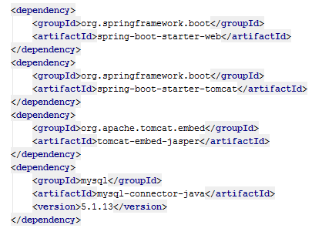
* 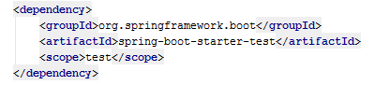

1. **Create CI-CD Pipeline**

|  |  |
| --- | --- |
| **Issue** | CI-CD pipeline doesn’t exists |
| **Impact** | Manual deployment every time |
| **Remediation** | Create CI-CD pipeline in pipeline.yml file along with private.yml and secure.yml  **Challenges and Solution:**   * Connecting Github from the Concourse. Found the way to generate private key and use it. * Creating the Release in github. |

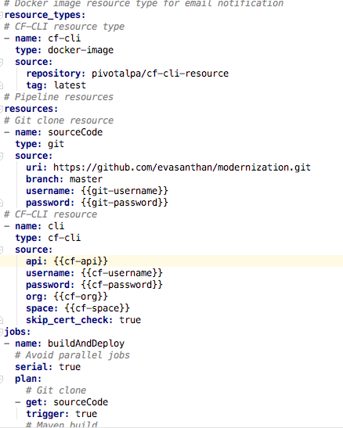

1. **Create manifest.yml**

**Create manifest.yml with the following**

|  |  |
| --- | --- |
| **Issue** | CF Push related information not exists |
| **Impact** |  |
| **Remediation** | Create manifest .yml with the following information which contains basic need for CF Push.   * Application Name * Instances * Memory * Services |

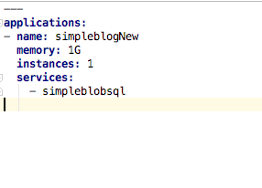**Filters**

**Removed filters from web.xml**

|  |  |
| --- | --- |
| **Issue** | Filters to be moved to the SpringBootApplication in order |
| **Impact** |  |
| **Remediation** | Create corresponding FilterRegistrationBean methods for each filter in SpringBootApplication |

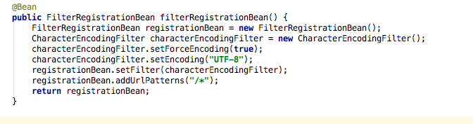

1. **BlogPostController.Java**

**@GetMapping("/") returns the posts page**

|  |  |
| --- | --- |
| **Issue** | Index related mapping exists in web.xml |
| **Impact** |  |
| **Remediation** | Create WebController and move and add **@GetMapping("/")** that returns the index page |

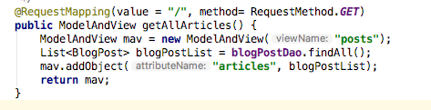

1. **BlogPostBeanDaoBean**

|  |  |
| --- | --- |
| **Issue** | Create DAO Bean to be moved to SpringBoot |
| **Impact** |  |
| **Remediation** | * Create Beans for each DAO in SpringBootApplication * Create constructor with SessionFactory as an argument |

**Create Beans for each DAO in SpringBootApplication**

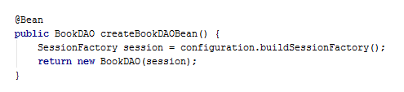

**Create constructor with SessionFactory as an argument**



1. **Test**

**Create Test class and Use application-qa.yml**

|  |  |
| --- | --- |
| **Issue** | Tests to be enhanced |
| **Impact** |  |
| **Remediation** | Create Test class and Use application-qa.yml |

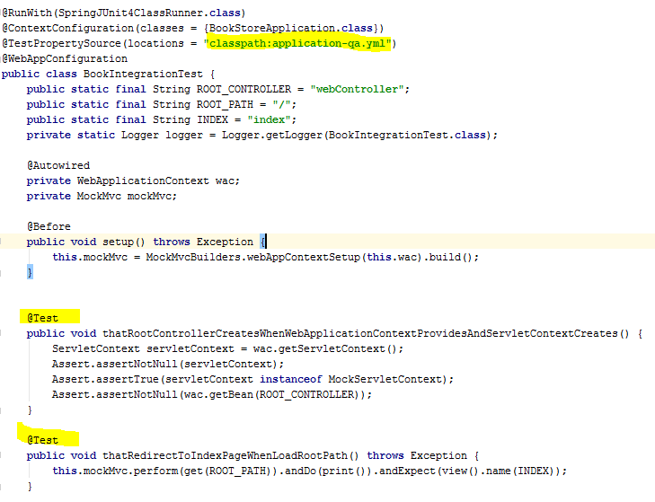

1. **Using Hibernate.cfg.xml in SpringBoot**

**Add the following changes in the SpringBootApplication**

|  |  |
| --- | --- |
| **Issue** | Datasource is exists in Hibernate.cfg.xml |
| **Impact** |  |
| **Remediation** | Move the data source related info to Springboot and read it from the application properties. |

