You are using pip version 8.0.2, however version 9.0.1 is available.
You should consider upgrading via the 'pip install --upgrade pip' command.
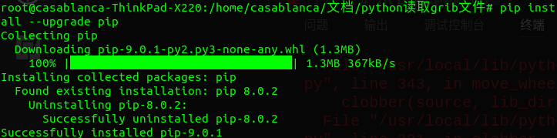
安装最新版本的pip-9.0.1即可

