**Media Evaluation Project** **User Manual**

by xiaochen wang

course: cs370

******************************************************************************

Content:

I.Introduction

II.Installation

III.GUI Instruction

******************************************************************************

I.Introduction

This program is using java API hash table to create a inventory database system for [www.shopgoodwill.com](http://www.shopgoodwill.com) It can store data, delete data and modify data on local database. There are one java file, and three txt file.

1. MyGUI.java

It's the main class, used to create a GUI and created related hash table methods

2.input.txt

It's the test data, stored in directory. The format is just name user want to search

3.output.txt

It's the default output file name, inventory information will be stored by input format, all data divided by "|". The format is "Item Number | Item Title | Price | Auction Date | Seller | Timestamp".

4.log.txt

It's the default log file name, it used to track the operation of the System. Every transition is stored by "Activity | Item | Time" format.

5.currentSearch.txt

******************************************************************************

II.Command Line

1. Data prepared

MyGUI.java can be run in terminal or venus system, first put MyGUI.java in directory.(The default directory is "/Users/eva"), user can use "$cd" to change their preference directory. So input data can be put into the directory, and also output and log file can be checked here.

2.Compile program

Type "$javac MyGUI.java"in command line to compile

3.Using flags

user can use the following flags to upload source data, name the files

all flags are followed by “$java MyGUI”

-i input.txt means the input file name is "input.txt", it will be the source data for program.

-o output.txt means create the output data is "output.txt".

-l log.txt means the logged information is stored in "log.txt".

-d path means the directory is changed to user's preference path

-s currentSearch.txt means the current search information can be stored in local

******************************************************************************

IV.GUI Instruction

1.Insert data file

Using "Insert" button, user can find the source file's name to upload data.

2.Output current inventory

User can get output file, all inventory's information is stored there.

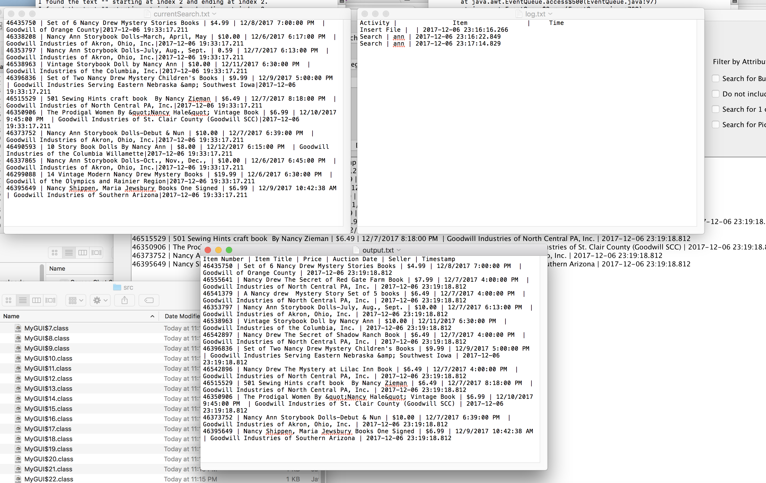

3.Search offline Data

After clicking the "Search" user can search data by item name and classification

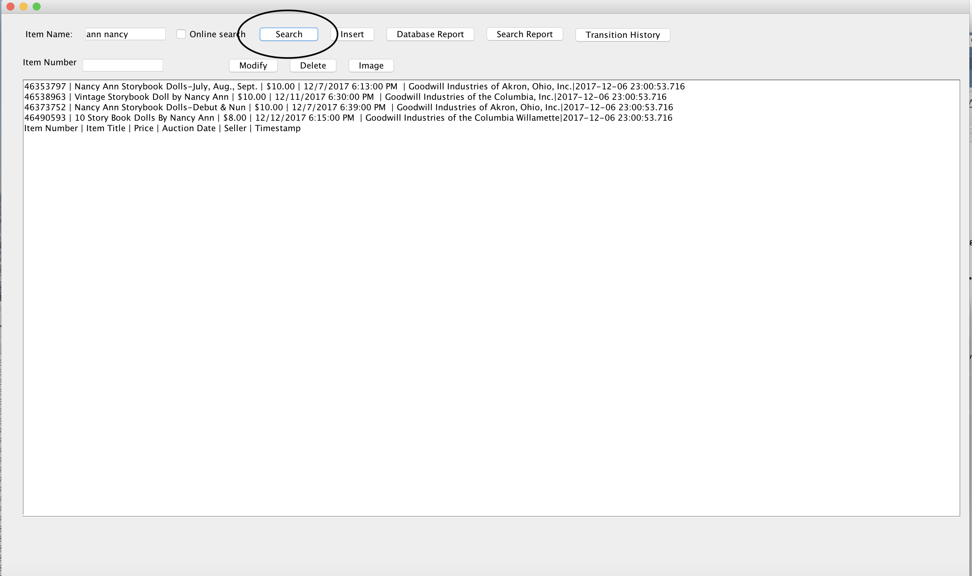

4.online searching

click the box online searching, user can put item name to search products

There are many constrains to narrow the search results.

1. search by item number, user can put product number to get product information
2. category, user can define the category of the product
3. international shipping option, user can use the check box to choose the destination
4. seller, user can choose the seller of product
5. for the search result, user can choose the order of results, the result can be in descending order or not
6. filter attribute have 4 options "Search for Buy Now items only?"; "Search for Pickup Only items only?" "Do not include Pickup Only items?"; "Search for 1 cent shipping only?"

user can choose the option as they needs.

5.manage local database

1).Modify data

Clicking "Modify" button, user can modify item's parameter.

2).Delete item

User can delete item by clicking "Delete".

3)get image from current database

User put the product number, then click “Image” the program will download the image for user.