**Tesla, Inc. Stock: A Time Series Analysis**

Team 2: Jazz Ling, Chris Fake, Nick Miller, Eva Wang

Spring 2023

**Introduction**

As the leader in the electric automobile industry, Tesla, Inc. and its shareholders have enjoyed strong returns. However, recent trends have shown a downtrend in the stock’s price, inducing pain for new and existing investors. We, as common investors, are seeking to conduct a comprehensive analysis of Tesla’s stock over time. Our objective is to compare the performance of the company before and after the pandemic, evaluate the impact of the global chip shortage on its stock performance, and provide a buy/sell recommendation.

It is important to acknowledge that the stock price reflects both the company's financial performance and the market's expectations, which induces volatility. Thus, we aim to closely examine the market's expectations of Tesla, which may differ from its actual financial performance. Additionally, we plan to employ time series forecasting models to predict the future trend of Tesla's stock price. Through this analysis, we hope to identify the most effective forecasting model to generate accurate predictions.

**Data**

The original data used for this project is daily stock data of Tesla, Inc. stock. The data includes various information on trading volumes and price metrics, but for the purpose of this project, we will focus on the adjusted close price. The adjusted close price accounts for corporate actions, such as dividends and stock splits, that affect the stock's value. We obtained the data through Yahoo! Finance, an online platform that provides users with real-time stock quotes and financial news (Yahoo, n.d.).

The original data collected was from 1/2/2017 – 2/14/2023. We will use the entire dataset to conduct visualizations to understand how the pandemic influenced Tesla’s stock performance. For the time series analysis and forecasting, we used *window()* function to slice data from 6/1/2019 – 2/14/2023. Then, the daily data were split into two data frames: monthly and weekly. The monthly data includes the median adjusted close price for each month, while the weekly data includes the median adjusted close price for each week. These data frames were created using the *aggregate()* function in R, which summarizes data by grouping on a variable (in this case month or week). The median adjusted close price was used for each data frame to reduce the influence of outliers.

The dataset provides a rich source of information on Tesla stock, allowing for detailed analysis of its past performance and prediction of its future trends. By focusing on the adjusted close price, the analysis is better able to capture the true value of the stock. The use of monthly and weekly data frames also enables a more detailed analysis of the stock's short-term and long-term performance.

**Visualizations**

Tesla stock price experienced the first big jump in 2020, which is when the pandemic hit (see Figure 1). Undoubtedly, retail investors and Elon Musk’s influence played a major role in boosting Tesla’s brand name, further attracting more investors to join, and thus, contributing to this skyrocketing growth (Sharma, 2021). Later on, the global chip shortage further impacted the electric automobile industry. Due to the technology emphasis on Tesla, each Tesla car uses a wide array of chips for everything from seatbelts to airbags. Thus, the global chip shortage really affected Tesla’s deliverability, which led to a drop in stock price. However, Tesla later announced that their software team has been developing alternative methods to supplement the current shortage (Cleantechnica, 2022).

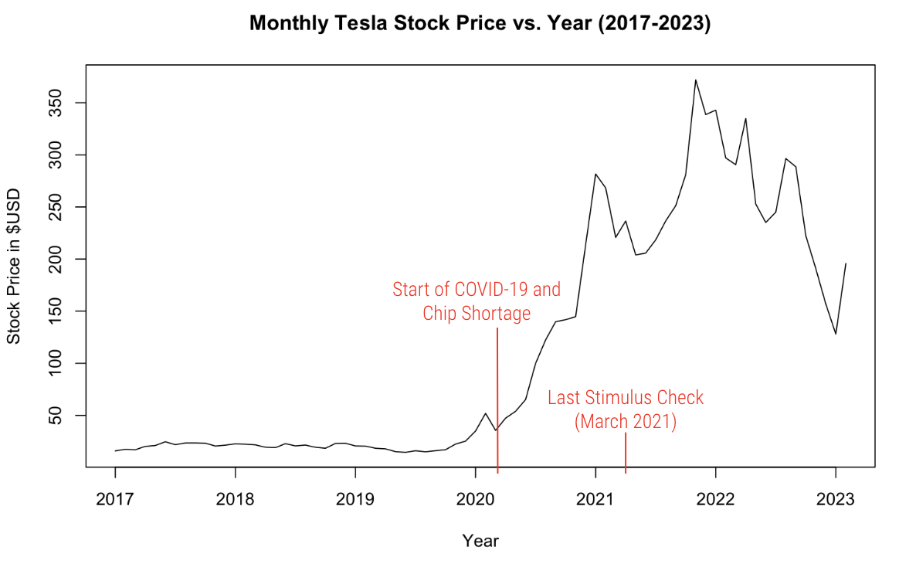

**Figure 1: Monthly Tesla Stock Price (2017-2023).** This time series plots the monthly Tesla Stock Adjusted Close Price in USD. Red text denotes the start of the Pandemic and global chip shortage when the last stimulus check was sent out.

Before implementing time series forecasting models, we visualized the ACF of differences on weekly and monthly data (see Figure 2). The weekly differences ACF has more lines outside the boundary which is a clear sign of non-random walk. The monthly differences ACF shows more marginal signs, but we would assume it is not a completely random walk. After all, Tesla's stock price is very volatile and subject to many external factors.

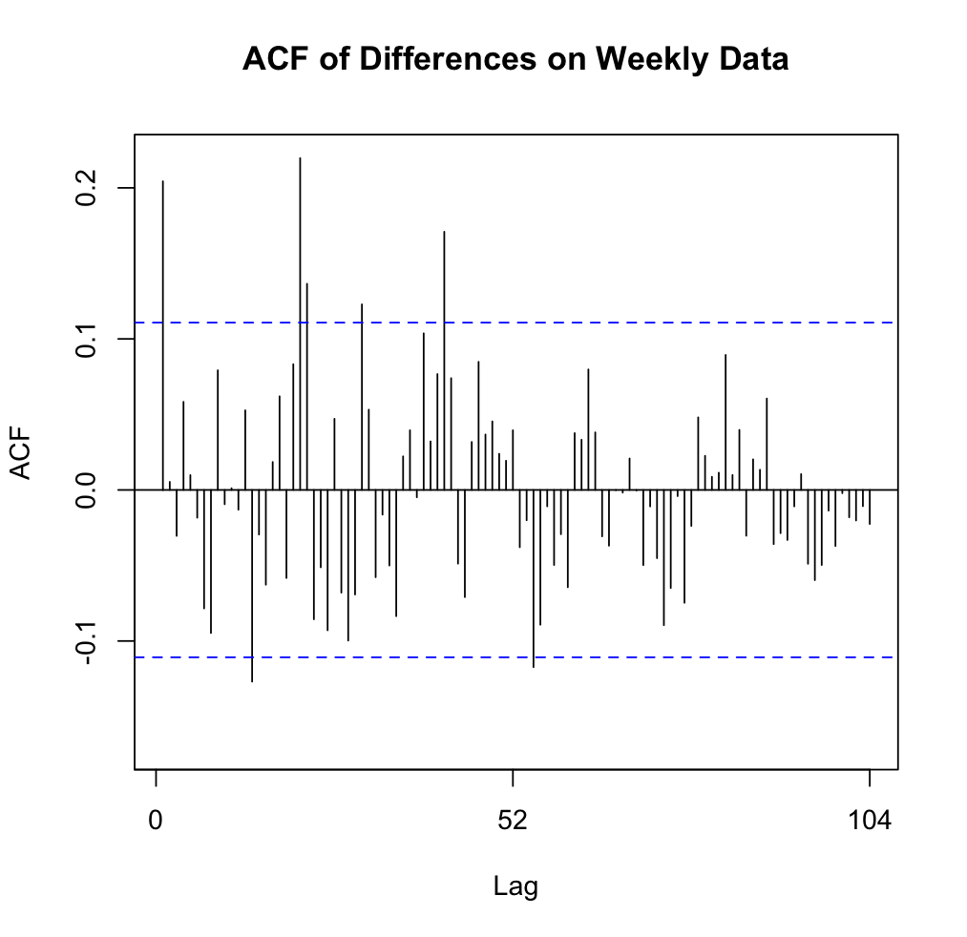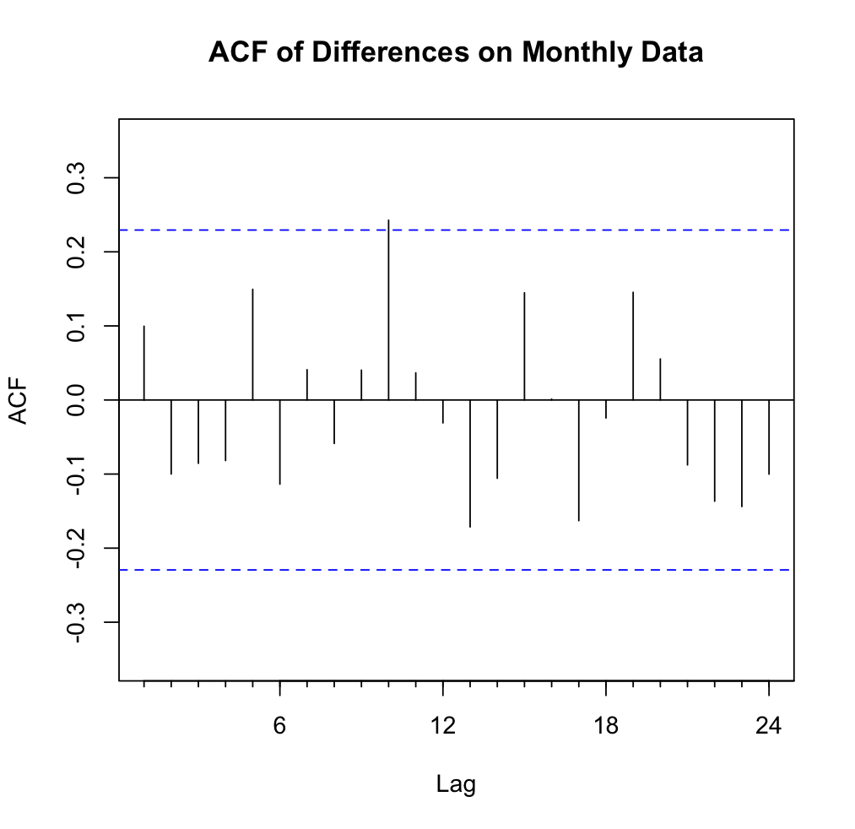

**Figure 2: ACF of Differences on Weekly and Monthly Data.** This graph indicates both the weekly and monthly time series are not random walks.

**Forecasting models**

***Regression-based models.*** For this data, we wanted to first evaluate if any regression-based models would be appropriate for this data. Looking at the data at first glance, there are no obvious trends or seasonality trends that seem to characterize this time series data. Regardless, we wanted to explore whether any regression-based methods would be effective for forecasting this Tesla stock data. We used the *tslm()* function in R to create three models based on trend, trend and seasonality, and exponential trend and seasonality on the training data. Different models fit the weekly and monthly training data better; for the weekly data, the linear model with trend and seasonality fit the data the best with a MAPE of 55.7, and the linear model with just trend fit the monthly time series data the best with a MAPE of 124.99. Thus, there were no reliable regression-based models for the monthly time series data; the best model available was the trend and seasonality linear method for the weekly time series data, with a close second best model being the linear model with just trend with the weekly time series data having a MAPE of 58.83.

***Smoothing Methods.*** The Tesla Stock data does not have any apparent trends or seasonality and thus we chose to use a Simple Exponential Smoothing (SES) model on both the weekly and monthly data and then use the *ets()* function in R to automatically generate an alpha. The *ets* function generated a “MAN” model for both the weekly and monthly data which indicates a **m**ultiplicative error, **a**dditive trend, and **n**o seasonality. We then compared the two results. The SES model for the weekly data generated prediction errors with MAE and MAPE at 133.76 and 63.24, respectively. This model outperformed the *ets* “MAN”model with an automatically generated alpha (MAE: 179.54, MAPE: 82.86). For the monthly data, the *ets* function generated a model with the same alpha as the SES model with the MAE and MAPE for both equal to 34.15 and 19.35, respectively.

***ARIMA Model.***  Due to the volatility of the stock market, we wanted to use an ARIMA model in order to generate predictions of the Tesla stock. The lack of seasonality in the Tesla stock data makes it a good candidate for the ARIMA model. We used the *auto.arima()* function in R on both the weekly and monthly data. The weekly model generated prediction errors with MAE at 137.13 and MAPE at 63.60. The monthly model generated prediction errors with MAE at 33.91 and MAPE at 24.42.

***Neural Networks.***  Among all the advanced models, neural networks are commonly used for time series forecasts, especially in financial forecasting where external information is useful. Inspired by the biological activities in the brain, neural networks’ structure can capture complex relationships between predictors and the response. Despite the drawbacks of the lack of explanatory ability of neural networks, we are more interested in finding a model that can predict the stock price more accurately. At this current stage, we only use historical stock prices as the predictor for our model.

From the textbook, we used the *nnetar* function in R on the weekly and monthly data. After tuning the models, we assigned 2 periods of seasonal lag and set the Box-Cox transformation parameter, lambda, at 1 to improve the normality of the dependent variable which is the stock price. At seed 80, the weekly model generated prediction errors with MAE at 25.71 and MAPE at 10.66. At seed 2678, the monthly model generated prediction errors with MAE at 5.10 and MAPE at 3.35.

***Naive Method.***  After plotting the ACFs of the weekly and monthly data, we decided to run a Naive model because of how close the graphs looked to indicating a random walk. The model generated a MAE of 105.9412 and MAPE of 49.16016 for the weekly data. The monthly model was the same model that the ARIMA model generated for the monthly data, thus the MAE and MAPE were the same as that of the ARIMA model.

**Model Comparison and Forecast Accuracy**

***Weekly Data.*** The Neural Network model outperformed all the other models by far regarding the weekly stock data with an MAE of 25.70525 and MAPE of 10.66127. The second best-performing model was the Linear Regression Model with Trend and Season. This model had an MAE of 115.7363 and a MAPE of 55.71151. The prediction accuracies for the other models can be seen in Table 1 below. After plotting the predictions of all the models on top of a plot of the entire time series including the validation data, we see that the Neural Network model was the only model to correctly predict the downward trend of the validation data. All the other models predicted an upward trend which is expected as the training data had a strong upward trend.

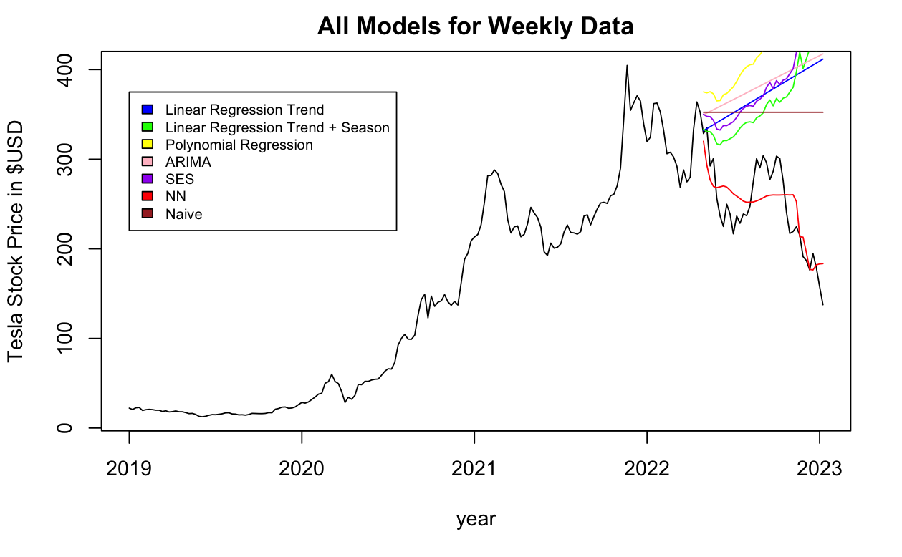

**Figure 3: Model Comparison for Weekly Data.** This graph indicates the Neural Network model had the best accuracy in prediction power when tested on the weekly validation data.

**Table 1. Accuracy Comparison for All Models on Weekly Data**

|  |  |  |
| --- | --- | --- |
| **Model** | **MAE** | **MAPE** |
| Linear Regression Trend | 125.3561 | 58.83129 |
| Linear Regression Trend + Season | 115.7363 | 55.71151 |
| Polynomial Regression | 184.9798 | 85.94993 |
| ARIMA | 137.1278 | 63.60255 |
| SES | 133.7566 | 63.23887 |
| Neural Network | 25.70525 | 10.66127 |
| Naive | 105.9412 | 49.16016 |

***Monthly Data.*** The Neural Network model also outperformed the other models regarding the monthly stock data with an MAE of 4.578915 and MAPE of 3.095081. The second-best-performing model for the monthly data was the Smoothing model. The SES and ETS models generated an MAE of 34.1464 and a MAPE of 19.34789. While the ARIMA model was a close second with a slightly better MAE (33.91) than SES/ETS, the ARIMA model’s MAPE was 24.41626 which was a noticeable enough difference compared to the SES/ETS’ MAPE. Thus, the second-best-performing model was SES/ETS. The rest of the models’ prediction accuracies are seen in Table 2 below. After plotting the predictions of all the models on top of a plot of the entire time series including the validation data, we see that the Neural Network model was the best predictor but was not the only model to accurately predict the downward trend, unlike the weekly data. The SES model was able to predict the downward trend with a respectable slope but the Neural Network model outperforms due to its ability to predict the sudden upward trend in 2023. This sudden upward trend is where the SES model falls short.

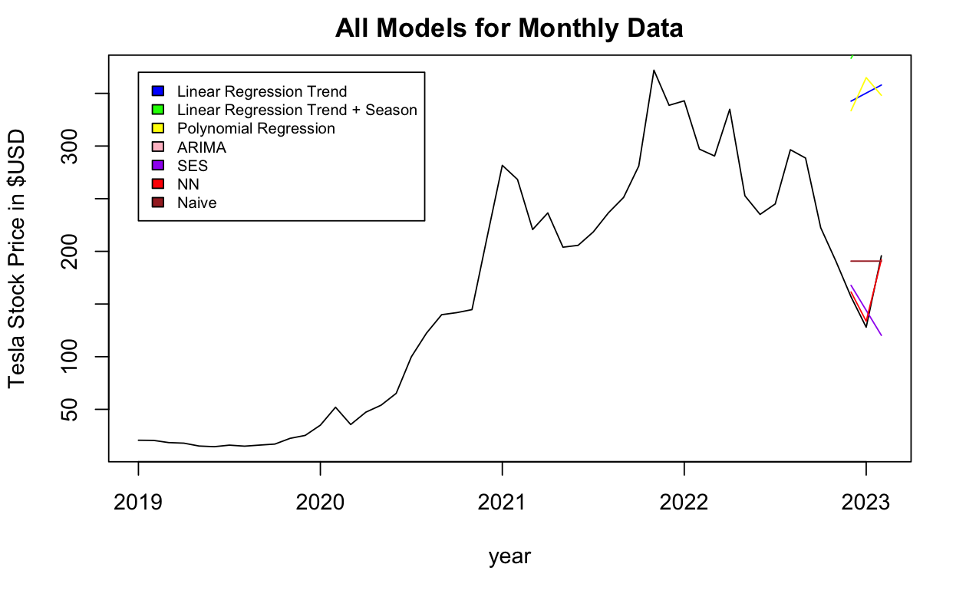

**Figure 4: Model Comparison for MonthlyData.** This graph indicates the Neural Network model had the best accuracy in prediction power when tested on the monthly validation data.

**Table 2. Accuracy Comparison for All Models on Monthly Data**

|  |  |  |
| --- | --- | --- |
| **Model** | **MAE** | **MAPE** |
| Linear Regression Trend | 190.067 | 124.9972 |
| Linear Regression Trend + Season | 115.236.3771 | 155.6273 |
| Polynomial Regression | 188.6827 | 125.2315 |
| ARIMA | 33.91 | 24.41626 |
| SES/ETS | 34.1464 | 19.34789 |
| Neural Network | 4.578915 | 3.095081 |
| Naive | 33.91 | 24.41626 |

**Future Forecast**

With model comparison, we determined that the neural networks model is the best model for predicting the weekly and monthly Tesla stock price. Since our current dataset ends on February 14, 2023, we don’t have sufficient data to compare our predictions, but we would be interested to wait a while and compare our model predictions to the real stock price. We used the neural networks to forecast future 3 months (Figure 5 and Table 3) and 12 weeks (Figure 6 and Table 4) stock prices. Please note that our conducted median price for monthly and weekly data, so the absolute value from monthly and weekly predictions may differ, but the trend is what investors should focus on. For potential investors, we would suggest you buy Tesla stock at a future low point which is around 3 weeks to 8 weeks (i.e., 2 months) after February 14, 2023.

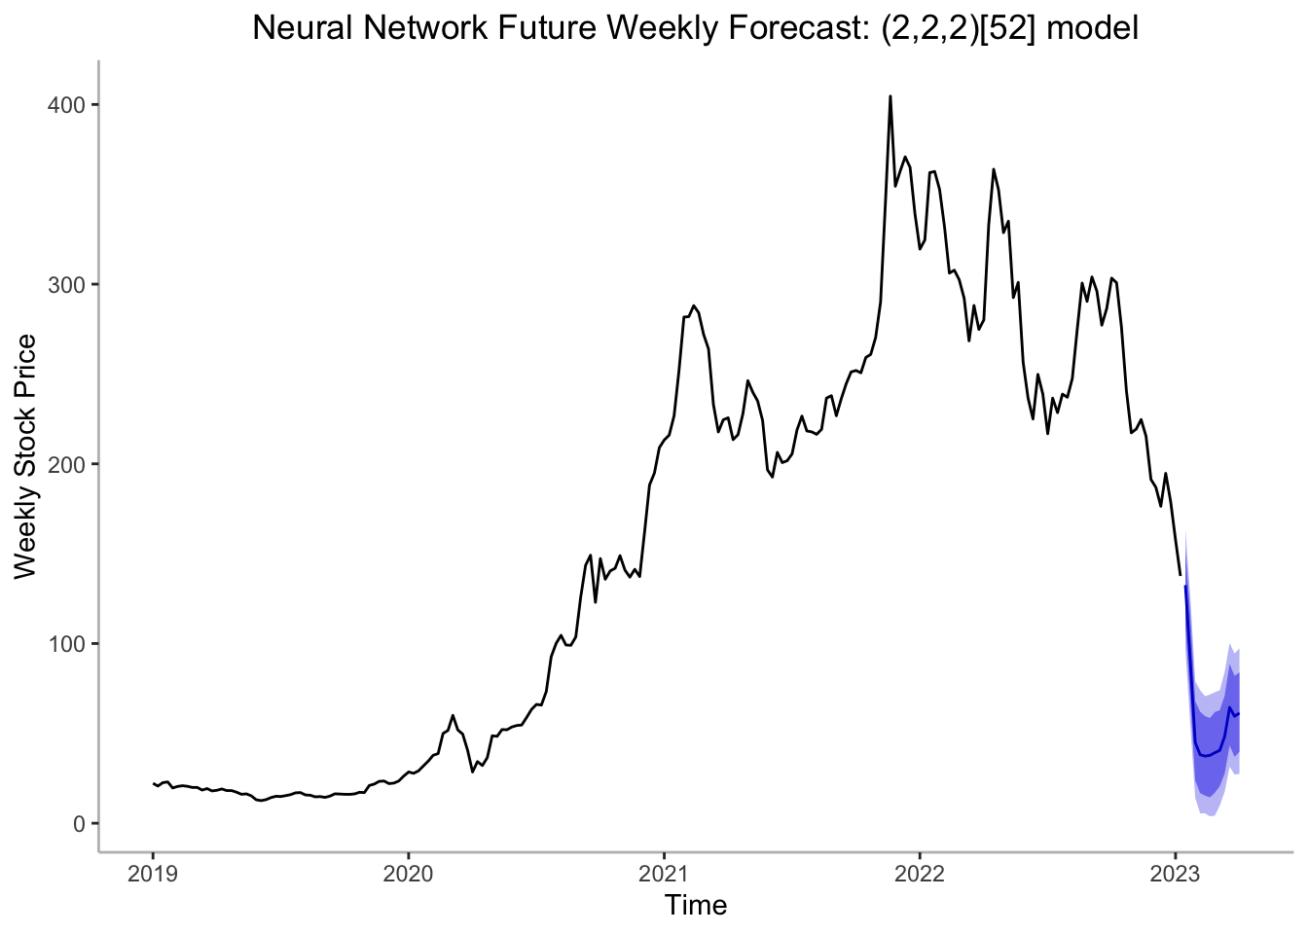

**Figure 5:** Forecasting the future 3 months’ stock price performance using NNs.

**Table 3. Predicted Future Monthly Stock Price**

|  |  |  |  |
| --- | --- | --- | --- |
|  | **March** | **April** | **May** |
| 2023 | $179.78 | $161.04 | $188.33 |

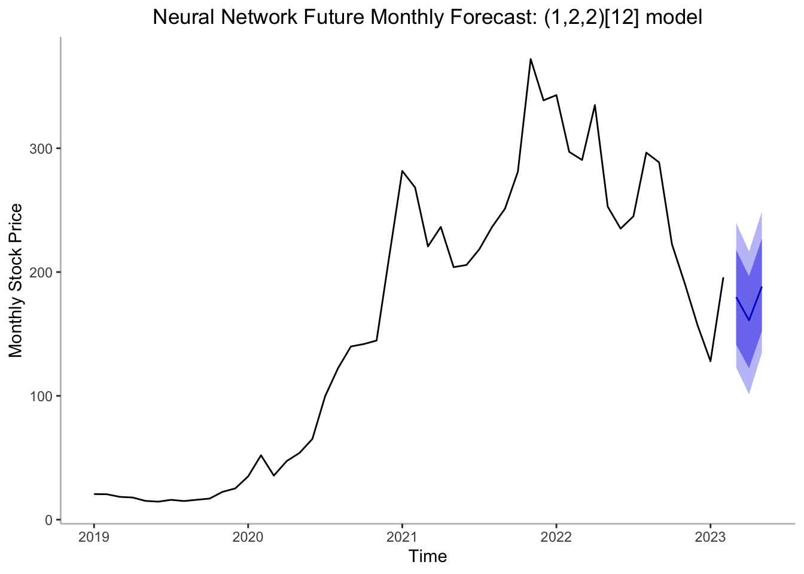

**Figure 6:** Forecasting the future 12 weeks’ stock price performance using NNs

**Table 3. Predicted Future Weekly Stock Price**

|  |  |  |  |  |  |
| --- | --- | --- | --- | --- | --- |
| 23W3: $132.50 | 23W4: $90.17 | 23W5: $44.97 | 23W6: $38.13 | 23W7: $37.33 | 23W8: $37.77 |
| 23W9: $39.25 | 23W10: $40.53 | 23W11: $48.39 | 23W12: $64.44 | 23W13: $59.52 | 23W14: $61.30 |

**Conclusion**

Stock data can be extremely hard to predict. The Random Walk Theory states that stocks and securities take a random and unpredictable course in their prices, effectively making the naive forecasting method the most effective method for forecasting stock prices. However, many investors disagree with this and believe that short-term changes in the market are predictable with the correct forecasting methods. When evaluating our Tesla stock model on a daily, weekly, and monthly basis, we found that the ACF of our differenced data was not within the confidence interval that would declare it a random walk; however, that does not mean that the Tesla stock was easily forecasted.

When evaluating our models made on Tesla stock data on a weekly and monthly basis from January 2019 to February 2023, we found only one model that could capture the validation period’s downwards, and then sudden upwards, trend and produce a reliable forecast of the Tesla stock at the weekly level. This model was a neural network with a MAPE of 10.66 – outperforming the second most accurate method, the naive method, by almost 40 error percentage points. We also saw a similar trend in the monthly data; the neural network was by far the most accurate method, having a MAPE of 3.09, while the second most accurate method, a simple exponential smoothing method, had a MAPE of 19.35. Thus, a neural network is decidedly the most effective method of forecasting Tesla stock data.

As seen in the previous section, we were able to forecast Tesla stock price into the future using our most effective model, the neural network, on a 3-month and 12-week basis. The 12-week basis on the weekly neural network model forecasts a large dip into the stock price in the first five weeks, then slowly rising, albeit not reaching its initial price. The 3-month forecast on the monthly neural network model also forecasts a dip for the first 2 months, but a much smaller dip that will be corrected by a subsequent rise in price of equal size. Thus, if one were to strictly adhere to our model of Tesla stock price as their trading method, they should sell in the short term. However, this is only a forecast, and there is a chance that market fluctuations and stock volatility can deem our forecast void at any given time.

**Reference**

How Tesla reworked its software to survive the semiconductor chip shortage. (2022). *Cleantechnica*. Retrieved from https://cleantechnica.com/2022/08/19/how-tesla-reworked-its-software-to-survive-the-semiconductor-chip-shortage/#:~:text=Additionally%2C%20it's%20more%20than%20just,plainly%20explained%20in%20the%20call.

Sharma, R. (2021). Why Tesla (TSLA) skyrocketed during the Pandemic. *Investopedia*. Retrieved from https://www.investopedia.com/why-tesla-skyrocketed-during-pandemic-5211590#:~:text=(TSLA)%20was%20valued%20at%20%24117,25%2C%202021.

Tesla, Inc. (TSLA) - Yahoo Finance. (n.d.). *Yahoo! Finance*. Retrieved on 20 Feb. 2023, from https://www.finance.yahoo.com/quote/TSLA/history?p=TSLA.

**Appendix**

**Data Overview**

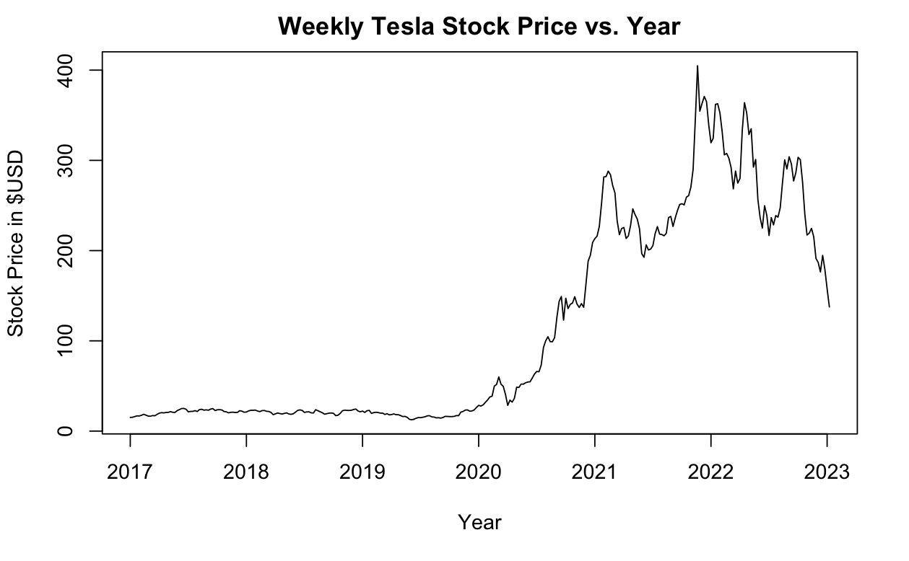

**Figure 7:** Weekly Tesla Stock Adjusted Close Price (2017-2023).

**Linear Regression Models**

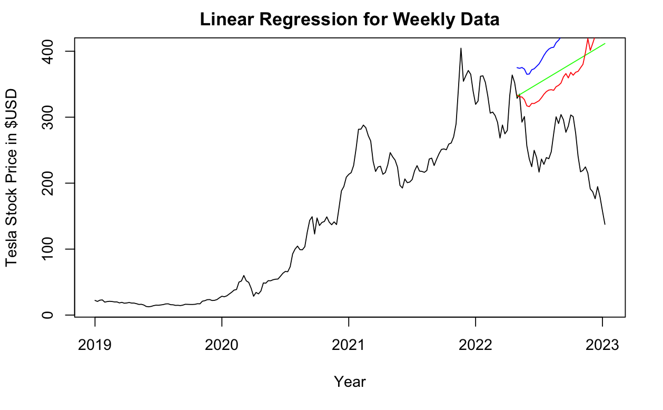

**Figure 8:** Linear Regression Model (Trend + Season) on Weekly Tesla Data. The green line denotes Linear Regression with Trend, the red line denotes Linear Regression with Trend and Season, and the blue line denotes Polynomial Regression.

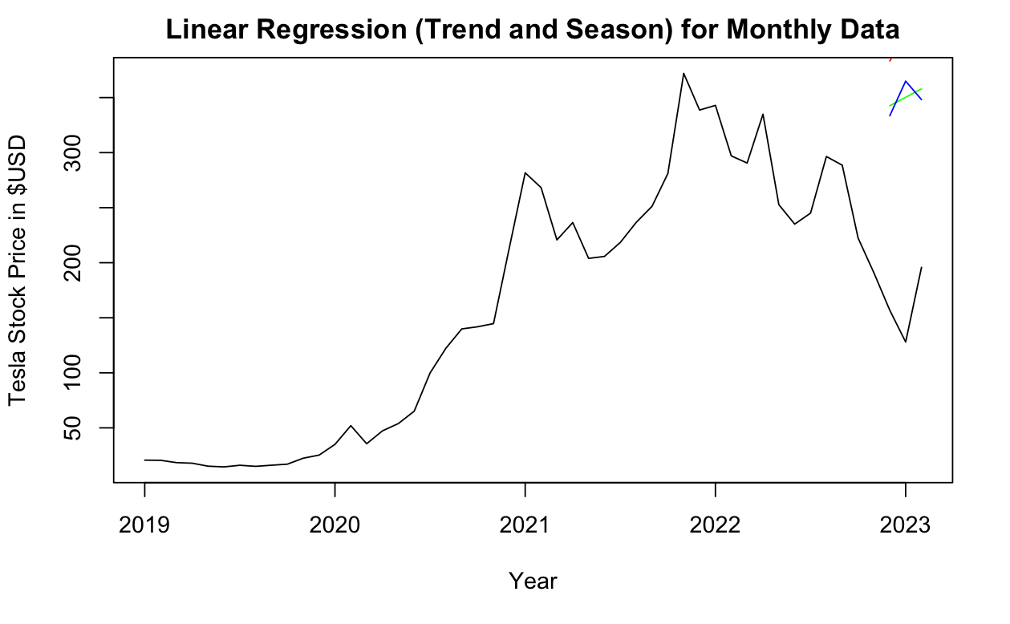

**Figure 9:** Linear Regression Model on Monthly Tesla Data. The green line denotes Linear Regression with Trend, the red line denotes Linear Regression with Trend and Season, and the blue line denotes Polynomial Regression.

**ARIMA Models**

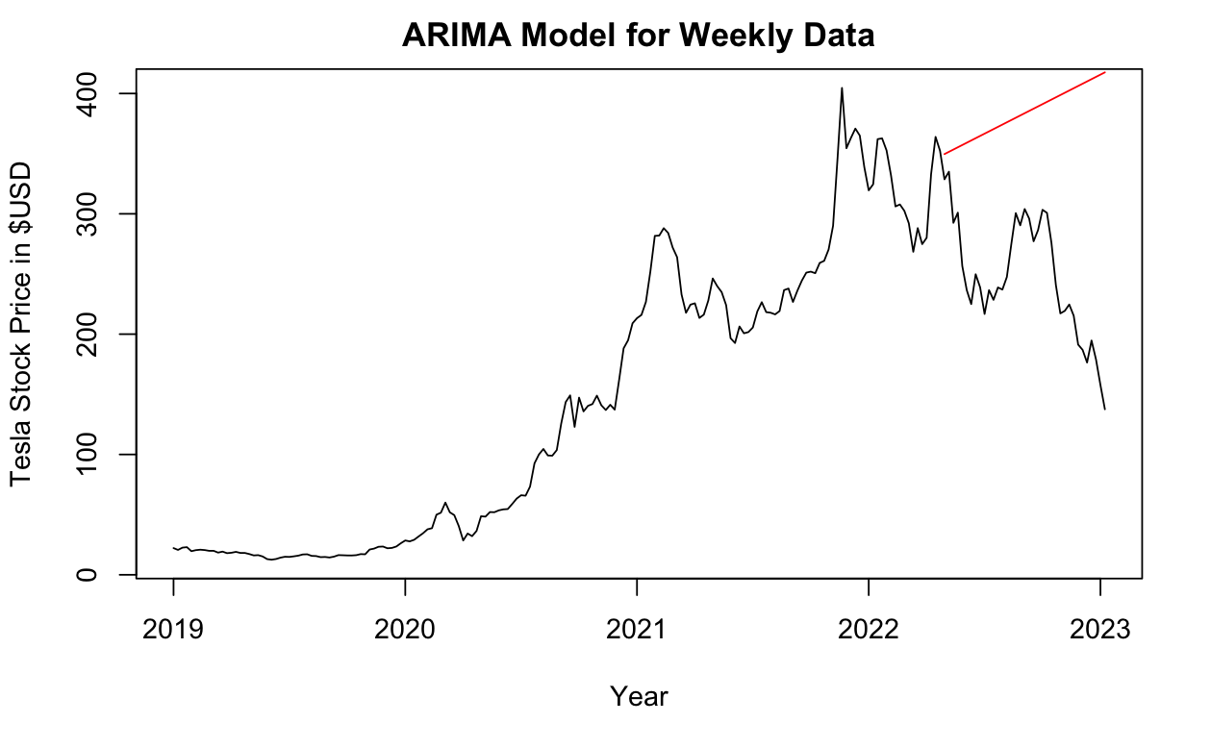

**Figure 10:** ARIMA Model on Weekly Tesla Data.

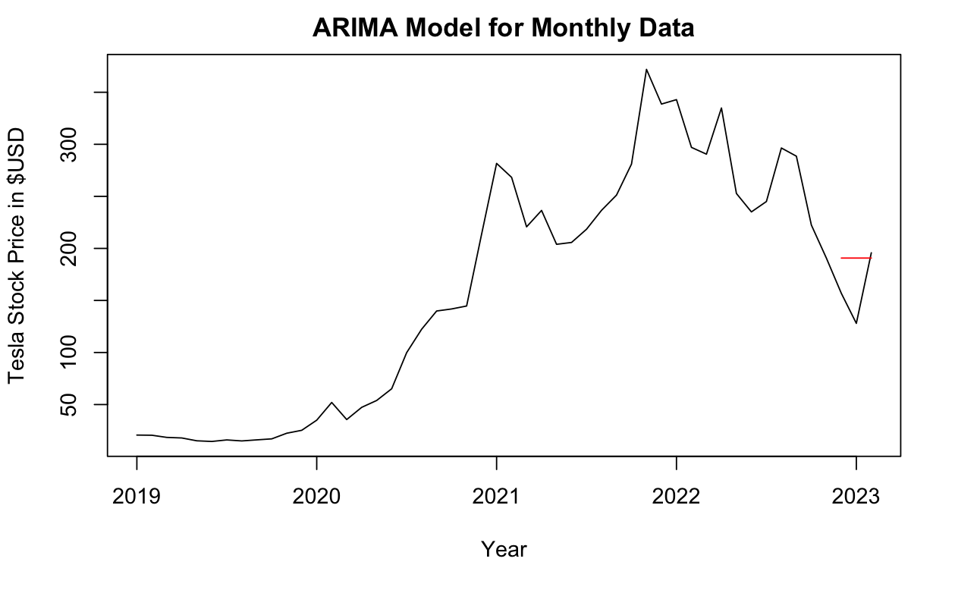

**Figure 11:** ARIMA Model on Monthly Data

**SES Models**

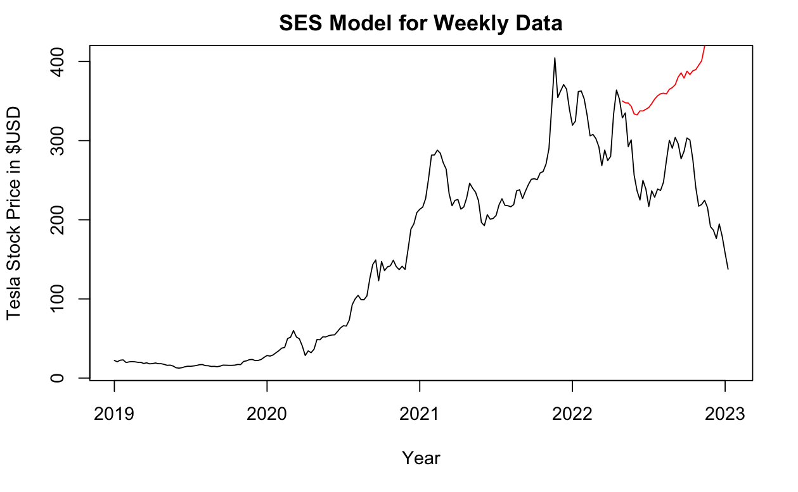

**Figure 12:** SES Model on Weekly Data.

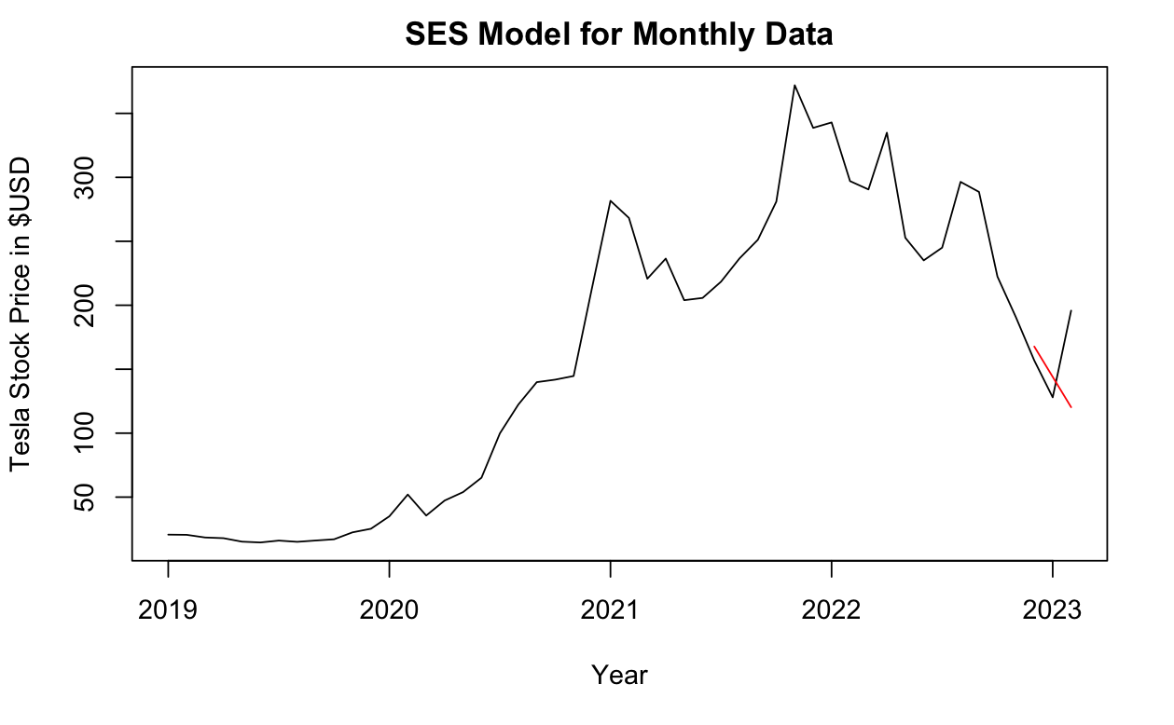

**Figure 13:** SES Model for Monthly Data.

**ETS Models**

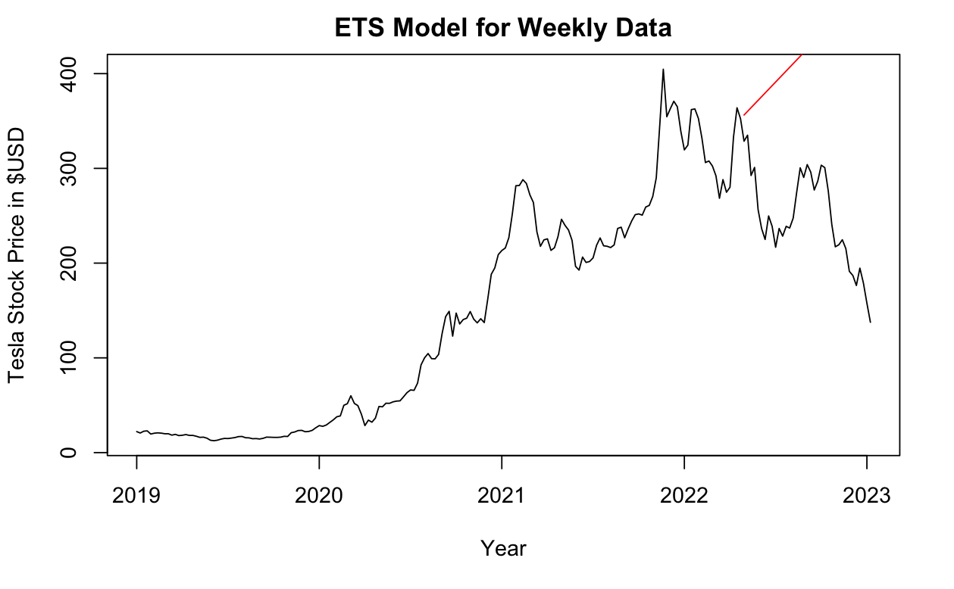

**Figure 14:** ETS Model for Weekly Data.

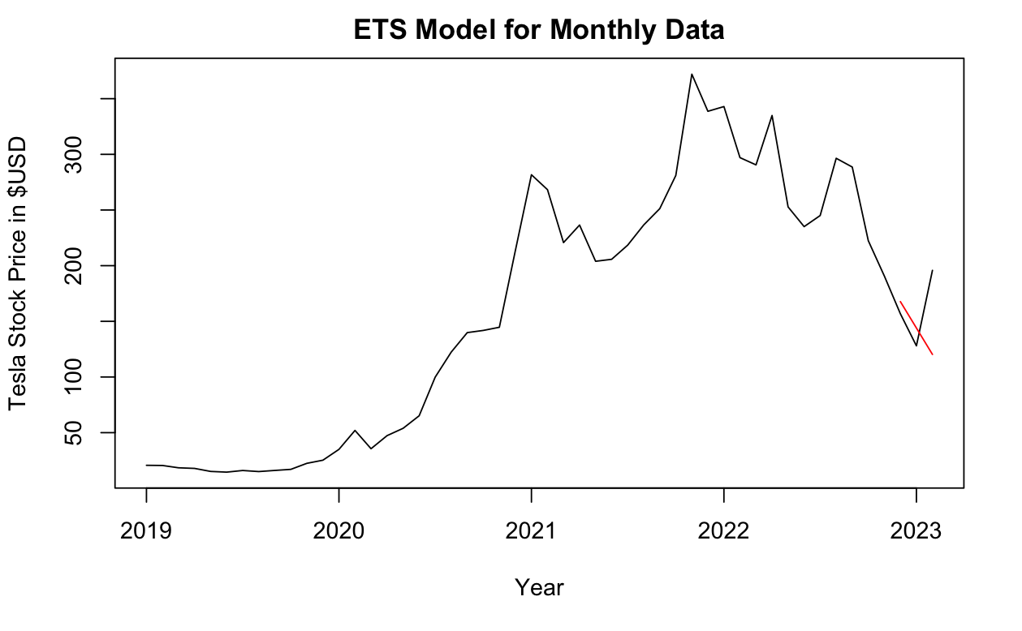

**Figure 15:** ETS Model for Monthly Data.

**Neural Networks**

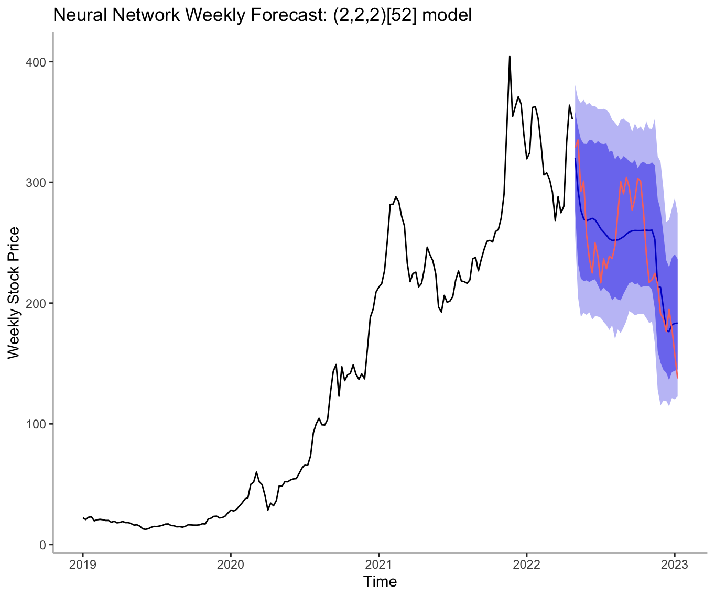

**Figure 16:** Weekly stock price forecast using Neural Networks

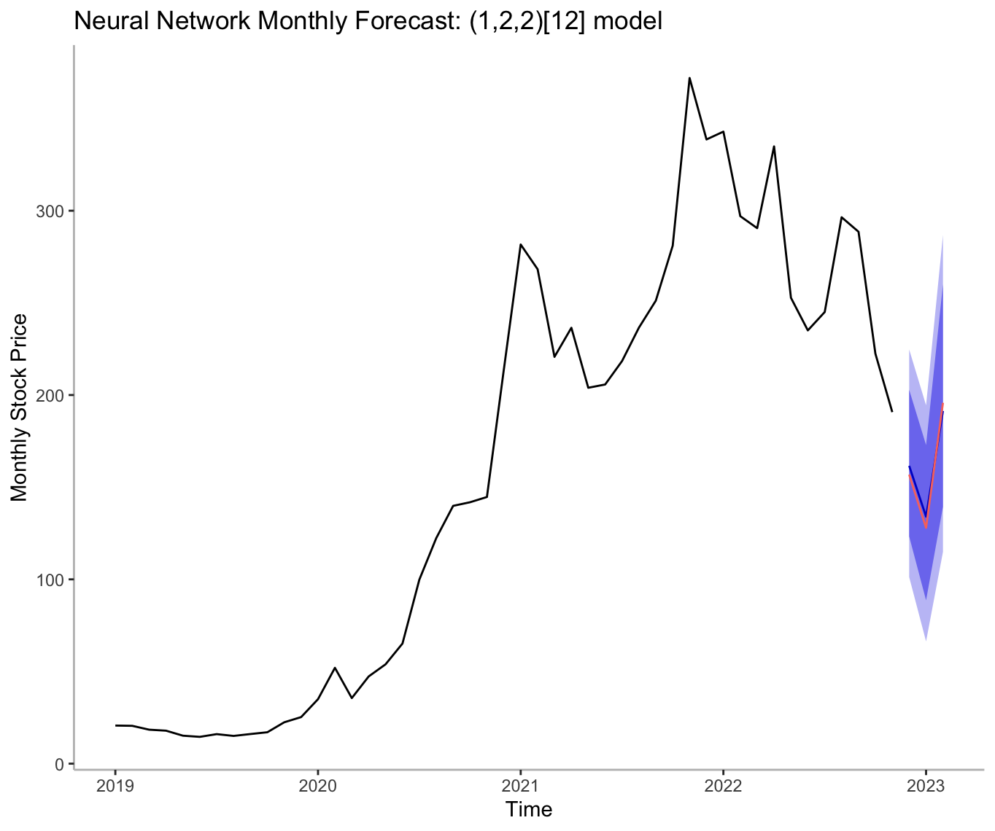

**Figure 17:** Monthly stock price forecast using Neural Networks