**Potential Titles**

Both parental age and helper age impact chick fitness in a cooperatively breeding bird

Intergenerational effects of both parent and helper ages in a cooperatively breeding bird

**Authors** Eve B. Cooper, Timothée Bonnet, Helen Osmond, Andrew Cockburn, Loeske E.B. Kruuk

**Abstract**

Ageing can not only have impacts on the fitness of an individual, but also the fitness of their offspring. However, disentangling how age-related changes in the germline, and age-related changes from the environment cause these intergenerational effects in the wild is poorly understood. In cooperative breeders, not only the ageing of parents, but potentially the ageing of helpers could play an important role. Despite the importance of intergenerational effects of helpers in understanding the evolution of cooperative breeding, no work to date has investigated intergenerational effects of helper ages. Using a wild population of superb fairy-wrens (*Malurus cyaneus*) we investigated the effects of mother, father, as well as helper ages on the nestling weight, juvenile survival, and recruitment of 4547 chicks over 30 cohorts. Exploiting the natural infidelity of fairy-wrens, we were able to observationally measure the isolated effects of father germline and father environment (for chicks sired extra-pair) as well as the combined effect of father germline and environment (for chicks sired within-pair). The fitness of chicks declined with mother age but improved with helper age. Although we found no evidence of isolated effects of father germline or environment, there was a positive effect of father age when germline and environment was combined (chicks sired within-pair). We discuss how sexual selection may explain this unexpected result.

**Introduction**

Identifying how parents influence the fitness of their offspring, both through direct transfer of the germline, as well as through indirect environmental effects, is central to understanding evolution by natural selection. In iteroparous animals, effects of both parental germline and environment can change with the ages of the parents (Priest et al. 2002; Schroeder et al. 2015; Lemaître and Gaillard 2017*a*). The phenomenon of parental age negatively influencing offspring fitness has been recognized in humans for over 100 years (Bell 1918), and is observed to occur broadly across the animal kingdom (Priest et al. 2002; Fox et al. 2003; Bouwhuis et al. 2010; Carnes et al. 2012; Api et al. 2018). These negative parental age effects are typically a consequence of age-related germline changes including de novo mutations and epigenetic changes that occur over time (Soubry et al. 2014; Sharma et al. 2015; Markunas et al. 2016). However, environmental related changes with parental age, which includes both parental care and shared environment, can also influence offspring fitness. Physiological senescence of parents may result in poorer provisioning with increasing age (Moorad and Nussey 2016; Lemaître and Gaillard 2017*b*). Alternatively, improvement of parental care abilities through experience, or accumulation of resources could result in a positive effect of parental age (Forslund and Pärt 1995; Daunt et al. 2007; Froy et al. 2017).

Germline and environmental mechanisms of parental age effects are not mutually exclusive, and may have contrasting influences on offspring fitness. However, the relative importance of these different mechanisms of parental age effects are poorly understood. Most previous research has either isolated only germline effects, or quantified both germline and environmental effects combined (Lemaître and Gaillard 2017*b*). Only one study to date has isolated both germline and environmental parental age effects within the same population. In a wild population of house sparrows (*Passer domesticus*), Schroeder et al. (2015) found negative effects of the genetic parent ages, but no effect of the social parent ages on chick fitness.

This landmark study by Schroeder et al. (2015) was able to isolate germline and environmental effects of parental age by using a cross-fostering study design. However, in a cross-fostering manipulation, any elements of sexual selection are removed from the natural breeding dynamics of the population. Despite the occurrence of male germline ageing, negative intergenerational effects may not be realized in natural conditions if female choice or sperm competition removes senescent males from the pool of successful sires of older ages (Bowers et al. 2015). This may explain the paradox of females demonstrating a preference for older sires, despite the observed negative effects of paternal germline ageing. It is entirely possible to investigate germline and environmental paternal age effects observationally, without impeding any potential role of sexual selection. This can be done by using observational data on a population with biparental care of chicks, but where females are often unfaithful to their social mate. For a population of this nature, the germline and environmental effects of father age can indeed be separated. To our knowledge, no observational study of this nature has yet to be attempted.

In cooperative breeders, it is not only the ages of the parents which may influence offspring fitness. Ages of group members that act as helpers in the rearing of offspring may also potentially be of importance. The presence (Covas et al. 2011; Hammers et al. 2019*b*), number (Sparkman et al. 2011; Brouwer et al. 2012), sex (Stacey and Koenig 1984; Hailman et al. 1994), behavior (Russell et al. 2007*b*; Hammers et al. 2019*a*), and relatedness (Green et al. 2016) of helpers can all impact the fitness of the young. There is also evidence that helpers become more effective in provisioning young with increased experience (Lawton and Guindon 1981; Hunter 1987; Heinsohn and Cockburn 1994; Woxvold et al. 2006; Klauke et al. 2014). Despite the evidence that helpers can have important influence on the fitness of the next generation, we are not aware of any study that has investigated the impact of helper age on the fitness of offspring.

This gap in our understanding of both parental and helper age effects is likely a consequence of the difficulties associated with investigating caregiver age effects on fitness in the wild. Longitudinal tracking of individuals is typically required so that both parents and helpers can be accurately aged. Additionally, models of age-related effects are at risk of being biased by selective disappearance if the lifespan of individuals is correlated with their individual quality (van Noordwijk and De Jong 1986). In order to control for this bias, parents need to be tracked until death so that their lifespan can be included in modelling (van de Pol and Verhulst 2006). Lastly, chicks must also be tracked so that metrics of their fitness can be measured, and genetic testing of both chicks and adult males in the population is necessary to assign extra-group parentage.

The superb fairy-wren (*Malurus cyaneus*; hereafter ‘fairy-wren’) offers an excellent system to investigate both germline and environmental effects of parental age, as well as effects of helper age. Fairy-wrens are a non-obligate cooperative breeding passerine endemic to South Eastern Australia. They occupy year-round territories and groups are composed of a breeding female, a dominant male, and between zero and five sexually mature male helpers (Cockburn et al. 2016). The breeding female and the dominant male are aided in provisioning young by any helpers residing on their territory. Once they reach independence, female chicks disperse from their natal territory to obtain a breeding territory while male chicks will often remain on their natal territory, acting as a helper in the subsequent breeding season (Cockburn et al. 2008*b*, 2016). Despite social monogamy between the dominant female and male on a territory, there are high rates of infidelity and 83% of broods contain at least chick sired by an extra-pair male that almost always resides on a different territory (Hajduk et al. 2018). As a result of this social system, the paternal germline and paternal environment can be measured in isolation in the cases of these chicks sired extra-pair.

In this study, we aimed to quantify the intergenerational effects of maternal, paternal and helper ages on three metrics of chick fitness in a wild population of fairy-wrens: (*i*) weight as a nestling, (*ii*) survival to independence, and (*iii*) recruitment into the breeding population. Using the naturally occurring instances of extra-pair matings we were able to isolate and quantify age-related effects of both paternal germline and paternal environment without impeding any influence sexual selection may have on these paternal age effects in a natural setting.

**Methods**

Study Population

The population of superb fairy-wrens is located in and around the Australian National Botanic Gardens, Canberra, Australia (35°16 S, 149°06 E) and has been intensively monitored since 1988 (Cockburn et al. 2003, 2016). The study site, approximately 60 ha in area, contains 40-90 territories encompassing between 120-230 year-round resident adults. In this study, we used data from the years 1988-2018. Shortly after hatching, individuals are colour-banded, and a blood sample taken to assign parentage using SNP genotyping (Peñalba et al. 2019). The reproduction and survival of adults is feasibly tracked until death because adults rarely disperse further than one territory away from their home territory (Cockburn et al. 2008*b*, 2016).

Territories can accumulate helpers when males remain on their natal territory into adulthood while an older male already occupies the dominant male position on that territory. Helpers queue for the dominant male breeding position based on age. When the dominant male on a territory dies, the eldest of any helpers on that territory will assume his dominant position (Cockburn et al. 2008*b*). Helpers can either be the sons of the dominant female on the territory, or unrelated if they precede the current female on the territory (Cockburn et al. 2008*b*, 2016). The presence of unrelated helpers is indicative of a high quality territory, since that indicates there is higher chick and adult survival on that territory. The presence of related helpers could be indicative of a high quality territory, and additionally could be indicative of a high quality mother who is capable of producing offspring who survive beyond maturity.

Data Selection

Only chicks with a known hatch date, sire identity, mother age, dominant male age, ages of any helpers, age of the extra-pair father (when applicable), and lifespans of all parents were included in this study. Due to age-related queueing for dominance, occasionally the dominant female was socially paired with her son as the dominant male on a territory. Since this results in a social father that is genetically related to the offspring (half or full siblings), we excluded chicks whose social father was the son of the dominant female (141 chicks, 3% of initial sample). We also excluded chicks whose genetic father was a helper on their natal territory since these individuals share both genes and environment with the chicks (165 chicks, 3% of initial sample). The final sample included 4547 chicks from 1691 clutches over 30 cohorts and 532 mothers, 482 social fathers (i.e. the dominant male on the territory), and 562 genetic fathers. The identities of the social father and the genetic father overlap for chicks sired within-pair (55% of the sample). There was an approximately even split between male and female chicks.

Statistical Analysis

We measured intergenerational effects of age using three mixed effects models which each tested the effects of *maternal age*, *cuckolded social father age* (for chicks sired extra-pair), *extra-pair genetic father age, within-pair father age* and *mean helper age* on each fitness-related trait in the chicks (nestling weight, survival to independence, and male recruitment). In order to compare the isolated age effects of paternal germline and paternal environment (using the genetic father and the social father of extra-pair chicks) as well as the combined age effects of paternal germline and environment (fathers of within-pair chicks), we included all three ‘types’ of father ages in each model. An interaction between a dummy variable (0 = within-pair chick, 1 = extra-pair chick) and the *cuckolded social father age* term as well as the *extra-pair genetic father age* term made it so only extra-pair chicks contributed to the estimates of these terms. The term *within-pair father age* was in interaction with the reverse dummy variable (0 = extra-pair chick, 1 = within-pair chick) so that only within-pair chicks contributed to the estimate of this term. The model structure that results from this dummy variable method is described further in box 1.

At least one helper resided on the territory for 60% of chicks, while the remaining 40% had no helpers. In order to include both these groups of chicks within each model, we used an analogous method to that used for the paternal age terms where the term *mean helper age* also interacted with a dummy variable (0 = no helpers, 1 = helper(s) present). *Mean helper age* was calculated as the average age of all the helper(s) residing on a chick’s natal territory at the time of their hatching. In order to separate any effects simply due to helpers presence and not their age, we also included a binary variable denoting the presence of *unrelated helper(s)* (indicative of a higher quality territory) and a binary variable denoting the presence of *related helper(s)* (indicative of a higher quality territory and/or a higher quality mother). Although chicks had up to four unrelated helpers and four related helpers at hatching, we chose to control for unrelated and related helper presence rather than the absolute number since most chicks only had either one or none of each type of helper (95% for unrelated, 92% for related).

We included the lifespans of the mother and fathers in order to control for and quantify potential selective disappearance. Julian *incubation date* was included in order to control for the fact that chicks hatched later in the breeding season are generally of higher fitness than those born earlier in their cohort. Random effects for each parental ID (mother, social father, and genetic father) were included to control for the non-independence of repeated measures from the same parents across chicks. Cohort was included as a random effect to control for any potential heterogeneity between years. All analysis was done in R version 3.5.0 (R Core Team 2018).

Box 1

Each fitness trait was modelled using a random effects regression model, described in part below.

$$r_{i}= β_{0}+ β_{germ\&enviro} x {age}_{Fgen} x WP+ β_{germ} x {age}_{Fgen} x EP+ β_{enviro} x {age}_{Fsoc} x EP+EP…$$

Here, $r$ is the fitness metric of an individual chick (*i*). The term *WP* equates to 1 for a chick sired within-pair and equates to 0 for a chick sired extra-pair. The term *EP* is the inverse of *WP*, where a value of 1 denotes a chick sired extra-pair, and a value of 0 denotes a chick sired within-pair. As a result, the coefficient for within-pair father age ( $β_{germ\&enviro} x {age}_{Fgen})$ is only estimated for within-pair chicks, and the coefficients for extra-pair genetic father age $(β_{germ} x {age}_{Fgen})$ and social father age ( $β_{enviro} x {age}_{Fsoc})$ are only estimated for extra-pair chicks. An analogous dummy variable method is used to estimate the mean helper age coefficient only using chicks for which helper(s) were present at the nest. All additional fixed effects and random effects included in each model are described under *Statistical Analysis*.

The three fitness-related traits measured were nestling weight, survival to independence, and male recruitment. These traits are each described in further detail below.

*- Weight:* Nestling weight was measured in grams when nestlings were briefly removed from their nest to be banded and bleed for SNP genotyping. The majority of weights were measured 7 days after hatching, but sometimes day(s) earlier or later. To control for this, the age of the chick (in days) at weighing was included in this model. A two-level factor ‘*pre-1992*’ indicated whether the cohort was before 1992 or not. This term controlled for a change in protocol in the time of day chicks were weighed from this year forward. We excluded 226 chicks from analysis as weight was not measured during the nestling phase or measurements were deemed unreliable. This resulted in a sample size of 4321 chicks. Weight followed a normal distribution and so a linear model with Gaussian error structure was used.

*- Survival:* Early-life survival was measured from the late nestling stage (approximately 7 days old, when chicks are banded and blood sampled to assign parentage), until 4 weeks after fledging (41 days from hatching) when they reach independence from their parents and may disperse to another territory. Survival probability was modeled using a Bernoulli distribution (fitted with a logit-link function).

*- Recruitment:* Survival from nestling to recruitment (measured as being alive at the start of the next year’s breeding season) was measured in only males. Recruitment into the breeding population could only be assessed in males since for females death cannot be distinguished from emigration from the study area during their first year of life. In contrast, males are highly philopatric and easily tracked during all life stages, as 72% of males remain on their natal territory their entire life, and males that do disperse move to an immediately neighboring territory 95% of the time (Cockburn et al. 2008*b*). After excluding males for which emigration or death was uncertain due to living close to the study area border, 2259 males were used in this analysis. Recruitment probability was modeled using a Bernoulli distribution (fitted with a logit-link function). For this model, social father was not included as a random effect in order to avoid over-parameterization of this model given its relatively smaller sample size. Excluding the random effect of social father did not alter fixed effects estimates, but it allowed for the variances of random effect of genetic father to be estimated, rather than being estimated as 0.

**Results**

We found evidence of intergenerational effects of age on both chick survival and male recruitment (table 2, 3), while there were no effects on nestling weight (table 1). *Mean helper age* was positively associated with higher chick survival and higher male recruitment (table 2, 3; figure 1). Neither the presence of related helpers or unrelated helpers affected chick fitness, except in one case where the presence of unrelated helpers had a marginally significant negative effect on chick survival (table 2).

*Mother age* had a negative effect on both survival and recruitment (table 2, 3; figure 2a,3a), while in contrast, *mother lifespan* had a positive effect (table 2, 3; figure 2b,3b). This indicates that at the individual level, the fitness of offspring declines as a breeding female ages, while at the population level, mothers that live longer are on average having higher quality offspring at any given age. Importantly, the positive effects of maternal lifespan were not driven by the very low survival and recruitment of chicks of mothers that lived only one year (as seen in the raw data, figure 2b,3b). When mothers with a one year lifespan were removed from analysis, the positive effects were still significant (supplementary XX).

Chicks that were sired within-pair had increased survival probability, but not weight or recruitment probability, with increasing age of their father (table 2; figure 4). The father ages of these chicks represent the combined age-related effects of paternal germline and paternal environment. Surprisingly, despite this positive association between survival and within-pair father ages, for extra-pair chicks there was no effect of either their genetic father (representing paternal germline) or their social father (representing paternal environment).

**Table 1** Effects on chick weight as a nestling (approximately 7 days post-hatching) from a linear mixed-model.

|  |  |  |  |
| --- | --- | --- | --- |
| Predictors | Estimates | CI | p |
| Intercept | **0.752** | **0.478 – 1.026** | **<0.001** |
| Age at Weighing | **0.851** | **0.823 – 0.880** | **<0.001** |
| Pre-1992 | **0.412** | **0.079 – 0.745** | **0.017** |
| Clutch Size | -0.017 | -0.050 – 0.015 | 0.292 |
| Incubation Date | **0.319** | **0.185 – 0.453** | **<0.001** |
| Extra-Pair Dummy [yes] | **0.220** | **0.049 – 0.390** | **0.012** |
| 1. *Maternal age effects* |  |  |  |
| Mother Age | -0.006 | -0.030 – 0.017 | 0.600 |
| Mother Lifespan | 0.002 | -0.021 – 0.024 | 0.876 |
| 1. *Paternal age effects* |  |  |  |
| Within-pair Father Age | 0.019 | -0.008 – 0.047 | 0.171 |
| Within-pair Father Lifespan | 0.003 | -0.022 – 0.029 | 0.797 |
| Cuckolded Social Father Age | -0.000 | -0.025 – 0.024 | 0.990 |
| Within-pair Father Lifespan | 0.003 | -0.022 – 0.029 | 0.797 |
| Extra-pair Genetic Father Age | -0.009 | -0.032 – 0.014 | 0.453 |
| Cuckolded Social Father Lifespan | -0.003 | -0.025 – 0.020 | 0.816 |
| 1. *Helper age effects* |  |  |  |
| Related Helper Presence [1] | 0.010 | -0.079 – 0.099 | 0.822 |
| Related Helper Presence [2+] | **0.115** | **0.003 – 0.227** | **0.045** |
| Unrelated Helper Presence [1] | 0.005 | -0.106 – 0.116 | 0.935 |
| Unrelated Helper Presence [2+] | -0.036 | -0.183 – 0.111 | 0.631 |
| Mean Helper Age | 0.038 | -0.006 – 0.081 | 0.090 |

Note: Sample size is 4321 individual chicks. The model includes random effects of mother ID (n = 532, variance = 0.076), social father ID (n = 482, variance = 0.050), genetic father ID (n = 562, variance = 0.034), and cohort (n= 30, variance = 0.018). The residual variance is 0.450. Both chicks sired extra-pair and within-pair are included in the model. Interactions with dummy variables (0 or 1) are employed so that only extra-pair chicks contribute to estimates related to the extra-pair genetic fathers and cuckolded social fathers, while only within-pair chicks contribute to estimates related to within-pair fathers. This dummy variable method is also employed so that only chicks with helpers on the territory contribute to the estimate of mean helper age.

**Table 2.** Effects on chick survival to potential independence (four weeks post-fledging) from a generalized linear mixed-model (Bernoulli distribution, logit-link function).

|  |  |  |  |
| --- | --- | --- | --- |
| Predictors | Log-Odds | CI | p |
| Intercept | **-1.994** | **-2.537 – -1.451** | **<0.001** |
| Incubation Date | **3.280** | **2.809 – 3.751** | **<0.001** |
| Extra-Pair Dummy [yes] | 0.271 | -0.287 – 0.830 | 0.341 |
| 1. *Maternal age effects* |  |  |  |
| Mother Age | **-0.088** | **-0.168 – -0.008** | **0.031** |
| Mother Lifespan | **0.105** | **0.029 – 0.182** | **0.007** |
| 1. *Paternal age effects* |  |  |  |
| Within-pair Father Age | **0.098** | **0.005 – 0.191** | **0.039** |
| Within-pair Father Lifespan | -0.045 | -0.129 – 0.040 | 0.298 |
| Cuckolded Social Father Age | -0.025 | -0.107 – 0.056 | 0.540 |
| Cuckolded Social Father Lifespan | -0.031 | -0.108 – 0.045 | 0.422 |
| Extra-pair Genetic Father Age | -0.050 | -0.128 – 0.028 | 0.210 |
| Extra-pair Genetic Father Lifespan | 0.024 | -0.046 – 0.095 | 0.501 |
| 1. *Helper age effects* |  |  |  |
| Related Helper Presence [1] | -0.112 | -0.409 – 0.185 | 0.459 |
| Related Helper Presence [2+] | -0.193 | -0.566 – 0.179 | 0.309 |
| Unrelated Helper Presence [1] | **-0.374** | **-0.747 – -0.001** | **0.049** |
| Unrelated Helper Presence [2+] | -0.357 | -0.859 – 0.146 | 0.164 |
| Mean Helper Age | **0.213** | **0.064 – 0.361** | **0.005** |

Note: Sample size is 4547 individual chicks. The model includes random effects of mother ID (n = 538, variance = 0.839), social father ID (n = 491, variance = 0.771), genetic father ID (n = 570, variance = 0.143), and cohort (n= 30, variance = 0.095). The residual variance is 3.29. Both chicks sired extra-pair and within-pair are included in the model. Interactions with dummy variables (0 or 1) are employed so that only extra-pair chicks contribute to estimates related to the extra-pair genetic fathers and cuckolded social fathers, while only within-pair chicks contribute to estimates related to within-pair fathers. This dummy variable method is also employed so that only chicks with helpers on the territory contribute to the estimate of mean helper age.

**Table 3.** Effects on male recruitment probability (survival to the breeding season after their hatching) from a generalized linear mixed-model (Bernoulli distribution, logit-link function).

|  |  |  |  |
| --- | --- | --- | --- |
| Predictors | Log-Odds | CI | p |
| Intercept | **-2.647** | **-3.229 – -2.064** | **<0.001** |
| Incubation Date | **1.827** | **1.213 – 2.442** | **<0.001** |
| Extra-Pair Dummy [yes] | **1.101** | **0.385 – 1.818** | **0.003** |
| 1. *Maternal age effects* |  |  |  |
| Mother Age | **-0.114** | **-0.205 – -0.023** | **0.015** |
| Mother Lifespan | **0.103** | **0.035 – 0.171** | **0.003** |
| 1. *Paternal age effects* |  |  |  |
| Within-pair Father Age | 0.058 | -0.053 – 0.169 | 0.304 |
| Within-pair Father Lifespan | 0.028 | -0.064 – 0.119 | 0.556 |
| Cuckolded Social Father Age | -0.049 | -0.146 – 0.048 | 0.324 |
| Cuckolded Social Father Lifespan | -0.034 | -0.109 – 0.041 | 0.375 |
| Extra-pair Genetic Father Age | -0.024 | -0.120 – 0.073 | 0.634 |
| Extra-pair Genetic Father Lifespan | -0.019 | -0.105 – 0.066 | 0.654 |
| 1. *Helper age effects* |  |  |  |
| Related Helper Presence [1] | 0.007 | -0.345 – 0.358 | 0.971 |
| Related Helper Presence [2+] | -0.082 | -0.544 – 0.381 | 0.730 |
| Unrelated Helper Presence [1] | **-0.431** | **-0.854 – -0.007** | **0.046** |
| Unrelated Helper Presence [2+] | -0.131 | -0.680 – 0.418 | 0.640 |
| Mean Helper Age | **0.212** | **0.047 – 0.376** | **0.012** |

Note: Sample size is 2259 individual males. The model includes random effects of mother ID (n = 494, variance = 0.246), genetic father ID (n = 498, variance = 0.082), and cohort (n= 30, variance = 0.020). Social father ID was not included as a random effect as there was inadequate statistical power to estimate this term. The residual variance is 3.30. Both male chicks sired extra-pair and within-pair are included in the model. Interactions with dummy variables (0 or 1) are employed so that only extra-pair chicks contribute to estimates related to the extra-pair genetic fathers and cuckolded social fathers, while only within-pair chicks contribute to estimates related to within-pair fathers. This dummy variable method is also employed so that only chicks with helpers on the territory contribute to the estimate of mean helper age.

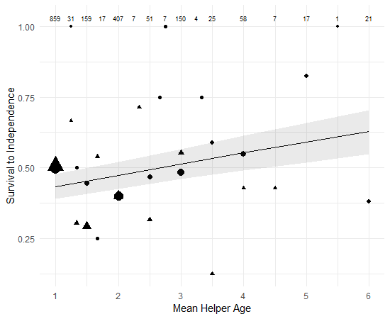 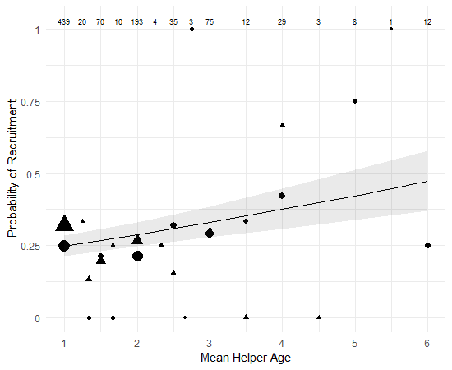

**Figure 1** The effect of the mean age of helper(s) on the probability of (a) chick survival too independence and (b) male recruitment. Lines represent model predictions and the shaded areas are the 95% confidence intervals Points. Triangles represent the raw mean values for chicks that had at least one related helper, and circles represent the raw mean values for chicks where all the helper(s) were unrelated. The size of the points is log proportional to the number of data points for that mean helper age and sample sizes (number of chicks) are included across the top of the graph.

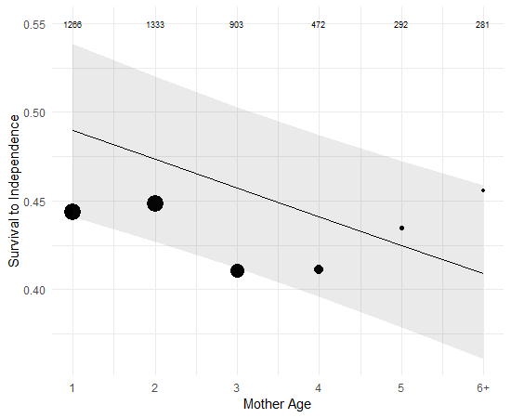 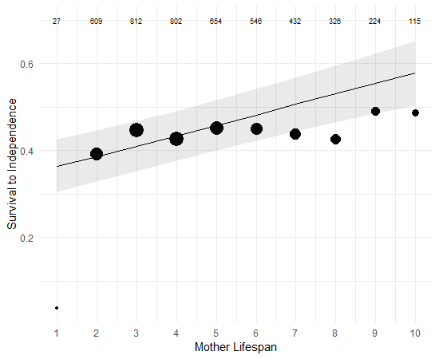

**Figure 2** The effect of (a) mother age and (b) mother lifespan on the probability of chick survival to independence. Lines represent model predictions and the shaded areas are the 95% confidence intervals Points. Dots represent raw mean values. The size of the points is log proportional to the number of data points for that mean helper age and sample sizes (number of chicks) are included across the top of the graph.

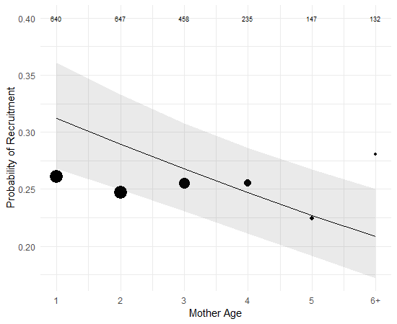 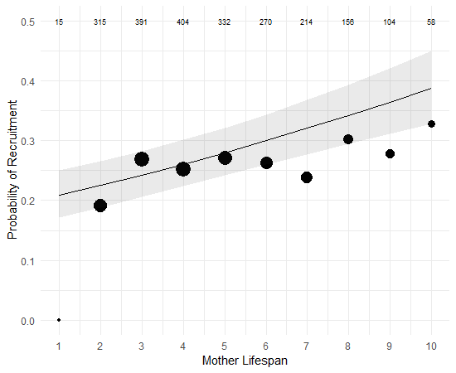

**Figure 3** The effect of (a) mother age and (b) mother lifespan on the probability of male chick recruitment into the breeding population. Lines represent model predictions and the shaded areas are the 95% confidence intervals. Points represent raw mean values. The size of the points is log proportional to the number of data points for that mean helper age and sample sizes (number of chicks) are included across the top of the graph.

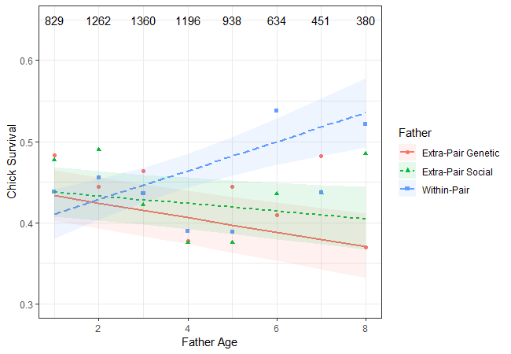

**Figure 4** The effect of extra-pair genetic, extra-pair social, and within-pair father ages on the probability of chick survival to independence. Lines represent model predictions and the shaded areas are the 95% confidence intervals Points. Points represent raw mean values. The sample sizes (number of chicks) for all three father types together are included across the top of the graph.

**Discussion**

In this study, we investigated the intergenerational effects of age in the cooperatively breeding superb fairy-wren by testing how mother, father, and helper ages influenced three different metrics of chick fitness. Survival to independence and male recruitment probability, but not nestling weight, declined with mother age and improved with the mean age of helpers residing on the natal territory. There was evidence of improvement in survival probability with father age, but surprisingly only for within-pair fathers. This study is the first to demonstrate that the ages of cooperatively breeding helpers can have intergenerational effects. The unexpected father age effect could indicate that the complexity of natural and sexual selection pressures in naturally occurring populations impact how intergenerational effects of age are realized in the wild. We discuss each of these results and their potential evolutionary and ecological implications below.

Helper Effects

There are two non-mutually exclusive mechanisms that could be driving the positive effect of mean helper age on offspring fitness. It’s possible that the effect is driven by helper age *per se*, whereby helpers become better at providing care to chicks as they gain experience with age. This is not implausible as tt has been shown in several cooperatively breeding bird species that the age of helpers is associated with their level of contribution towards chick provisioning and predator defense (Lawton and Guindon 1981; Hunter 1987; Heinsohn and Cockburn 1994; Woxvold et al. 2006; Klauke et al. 2014). If helping experience does improve provisioning skills cumulatively, this result offers support for the theory that benefits to helpers in the form of skill acquisition if one factor leading to the evolution or maintenance of cooperative breeding behavior (Korndeur 1996; Cockburn 1998). A non-mutually exclusive but alternative possible cause of the effect of helper age is that there is a correlation between helper survival and territory quality. Helpers may enjoy increased survival until later ages as a consequence of their natal territory having greater food availability or lower predation risk, which may be associated with the fitness of chicks hatched on this same territory.

In contrast helper age, there was no positive effect of the presence of either related or unrelated helpers on any metric of chick fitness. Although helper presence is associated with increased territory productivity in fairy-wrens (Cockburn et al. 2008*c*), this is likely primarily a consequence of ‘load lightening’, where mothers invest less in the quality and size of their eggs when helpers are present (Russell et al. 2007*a*). Our results suggest that any benefits of the presence of helpers are not passed on to the chicks themselves, and so previous findings of increased territory productivity when helpers are present must be driven by females increasing investment in the number, but not the quality, of offspring produced.

Maternal Effects

Chick survival and male recruitment probabilities declined with maternal age. This finding adds to the growing body of evidence of negative fitness consequences to offspring of older mothers in the wild (Descamps et al. 2008; Hoffman et al. 2010; Bouwhuis et al. 2015*a*; Schroeder et al. 2015; Hammers et al. 2019*a*). Maternal lifespan had the opposite effect on chick fitness, with longer living mothers having chicks with higher survival and recruitment. It is important to note that the negative effects of mother age would not have been recognized in this study had maternal age not been included in the models to control for this selective disappearance of lower quality mothers at higher ages (supplementary XX).

In has been previously shown that fairy-wren mothers actually demonstrate increases in the number of independent young produced in the breeding season for the first several years of life (Cooper et al. 2019). Since we found declines in chick survival and recruitment with maternal age, this suggests that despite increased investment in the number of chicks produced, mothers are having less success at raising those chicks to independence and recruitment as they age. This suggests the negative effect of maternal age is more a consequence of physiological senescence of parental care, or an increase in birth defects with maternal age, rather than senescence in fertility.

Paternal Effects

Increasing father age was associated with higher probability of survival, but not higher weight or recruitment, and only for chicks sired within-pair. There was no evidence of additive or divergent effects of paternal germline and paternal environment age effects as there was no effect of the genetic or the social father for chicks sired extra-pair. Thus, the mechanism of the positive effect of father age for within-pair chick survival is not entirely unclear. The within-pair father age effect is unlikely to be a consequence of germline level changes with age. Sperm DNA damage increases with paternal age (Velando et al. 2011; Johnson et al. 2015), and sperm age typically has either negative or null effects on offspring fitness (Johnson and Gemmell 2012; Lemaître and Gaillard 2017*b*). More likely is that the effect of within-pair father age is related to changes in paternal environment that in some way differ from the effects of extra-pair social fathers.

Differences between cuckolded males and successful males may explain these differing paternal age effects . It’s possible that the degree of cuckoldry a male experiences is correlated with his overall quality and the quality of his offspring. Female fairy-wrens typically always mate with their social partner (Cockburn et al. 2016), but the reduced siring success of cuckolded males could result from female choice and/or sperm competition (Pizzari et al. 2008; Fitzpatrick and Lüpold 2014; Vuarin et al. 2019). If only high quality males are capable of achieving within-pair siring success at late ages, the apparent improvement of chick fitness with within-pair sire age could be the result of a selective disappearance of low quality males at these later ages. Since our study is the first to assess age effects of both cuckolded and genetic social fathers on offspring fitness, additional work is needed to observe the robustness of this result.

As there were no effects of extra-pair genetic father age, there was is no evidence of germline deterioration with age. Although sperm typically deteriorates in quality with male age (Johnson et al. 2015; Lemaître and Gaillard 2017*b*), the effects of senescent sperm carrying over to influence offspring fitness are contentious. Although some studies have found evidence of negative effects of male age on some measures of offspring fitness (Ducatez et al. 2012; Bouwhuis et al. 2015*a*; Schroeder et al. 2015; Nybo Andersen and Urhoj 2017), many others have not found any such associations (Fox et al. 2003; Fricke and Maklakov 2007; Avent et al. 2008; Carnes et al. 2012). In natural conditions, if senescence rates vary amongst individuals, females may avoid senescent males or their sperm may lose to less senescent males (Vuarin et al. 2019). This could result in the sample of older males that are successful sires being biased towards only high quality males (Pizzari et al. 2008; Fitzpatrick and Lüpold 2014). It is interesting then to note that the studies which have found negative effects of paternal age on offspring fitness have been either in controlled laboratory experiments or in a cross-fostering experiment where female choice and sperm competition is constrained (Priest et al. 2002; Ducatez et al. 2012; Schroeder et al. 2015), in species with high genetic monogamy where female choice and sperm competition plays little to no role (Bouwhuis et al. 2015*b*), and in modern day humans (Nybo Andersen and Urhoj 2017) where adaptive female choice and sperm competition is likely to be made irrelevant by societal and cultural factors. Female fairy-wrens are highly promiscuous (Cockburn et al. 2008*a*; Hajduk et al. 2018), and female choice and sperm competition may result in a reduction in senescent males being successful sires. Regardless of the mechanism, the lack of any negative effects of father age suggests that female preference for older males is neither adaptive nor maladaptive in the context of offspring early life fitness.

Conclusion

Our study is the first to demonstrate that the age of helpers in cooperatively breeding groups can have an intergenerational impact on fitness, with increasing helper age improving chick early life survival and recruitment probabilities. Not only is this finding important in elucidating intergenerational effects of age more generally, but suggests that the age of helpers may be an important characteristic in the fitness payoffs of helping behavior.

We also found intergenerational effects of parental ages. Maternal age negatively affected chick fitness, an effect that was only apparent after controlling for selective disappearance of lower quality mothers at older ages. In contrast to mothers, the ages of fathers had a positive effect on chick fitness, but only for chicks sired within-pair. The lack of effect of social father and genetic father ages for extra-pair sired chicks highlights that dynamics of sexual selection may play an important role in the evolutionary ecology of intergenerational age effects.

**Acknowledgements**

We are grateful to the Australian National Botanic Garden for permission to work at the study site and for logistical support. We also thank the many field assistants who contributed to data collection over the years. Our research was licensed by the Australian National University Animal Experimentation Ethics Committee. We thank Michael Morrissey for helpful advice on estimating confidence intervals for the graphing of results. We thank the Australian Research Council for long-term funding of the superb fairy-wren project, of which the most recent grant for the data in this study was DP150100298.

**References**

Api, M., P. Biondi, I. Olivotto, E. Terzibasi, A. Cellerino, and O. Carnevali. 2018. Effects of Parental Aging During Embryo Development and Adult Life: The Case of Nothobranchius furzeri. Zebrafish 15:112–123.

Avent, T. D., T. A. R. Price, and N. Wedell. 2008. Age-based female preference in the fruit fly Drosophila pseudoobscura. Animal Behaviour 75:1413–1421.

Bell, A. G. 1918. The Duration of Life and Conditions Associated with Longevity: A Study of the Hyde Genealogy. Genealogical Record Office.

Bouwhuis, S., A. Charmantier, S. Verhulst, and B. C. Sheldon. 2010. Trans-generational effects on ageing in a wild bird population. Journal of Evolutionary Biology 23:636–642.

Bouwhuis, S., O. Vedder, and P. H. Becker. 2015*a*. Sex-specific pathways of parental age effects on offspring lifetime reproductive success in a long-lived seabird. Evolution 69:1–21.

Bowers, E. K., A. M. Forsman, B. S. Masters, B. G. P. Johnson, L. S. Johnson, S. K. Sakaluk, and C. F. Thompson. 2015. Increased extra-pair paternity in broods of aging males and enhanced recruitment of extra-pair young in a migratory bird. Evolution 69:2533–2541.

Brouwer, L., D. S. Richardson, and J. Komdeur. 2012. Helpers at the nest improve late-life offspring performance: Evidence from a long-term study and a cross-foster experiment. PLoS ONE 7:16–20.

Carnes, B. A., R. Riesch, and I. Schlupp. 2012. The delayed impact of parental age on offspring mortality in Mice. Journals of Gerontology - Series A Biological Sciences and Medical Sciences 67 A:351–357.

Cockburn, A. 1998. Evolution of Helping Behavior in Cooperatively Breeding Birds. Annual Review of Ecology & Systematics 29:141–177.

Cockburn, A., L. Brouwer, N. Margraf, H. L. Osmond, and M. Van de Pol. 2016. Superb fairy-wrens: making the worst of a good job. Pages 133–149 *in* W. D. Koenig and J. L. Dickinson, eds. Cooperative breeding in vertebrates: studies of ecology, evolution and behavior. Cambridge University Press.

Cockburn, A., H. L. Osmond, and M. C. Double. 2008*a*. Swingin’ in the rain: condition dependence and sexual selection in a capricious world. Proceedings of the Royal Society B: Biological Sciences 275:605–612.

Cockburn, A., H. L. Osmond, R. A. Mulder, M. C. Double, and D. J. Green. 2008*b*. Demography of male reproductive queues in cooperatively breeding superb fairy-wrens Malurus cyaneus. Journal of Animal Ecology 77:297–304.

Cockburn, A., H. L. Osmond, R. A. Mulder, D. J. Green, and M. C. Double. 2003. Divorce, dispersal and incest avoidance in the cooperatively breeding superb fairy-wren Malurus cyaneus. Journal of Animal Ecology 72:189–202.

Cockburn, A., R. A. Sims, H. L. Osmond, D. J. Green, M. C. Double, and R. A. Mulder. 2008*c*. Can we measure the benefits of help in cooperatively breeding birds: The case of superb fairy-wrens Malurus cyaneus? Journal of Animal Ecology 77:430–438.

Covas, R., A. S. Deville, C. Doutrelant, C. N. Spottiswoode, and A. Grégoire. 2011. The effect of helpers on the postfledging period in a cooperatively breeding bird, the sociable weaver. Animal Behaviour 81:121–126.

Daunt, A. F., S. Wanless, M. Harris, L. Money, P. Monaghan, F. Daunt, S. Wanless, et al. 2007. Older and Wiser : Improvements in Breeding Success are Linked to Better Foraging Performance in European Shags. Functional Ecology 21:561–567.

Descamps, S., S. Boutin, D. Berteaux, and J. M. Gaillard. 2008. Age-specific variation in survival, reproductive success and offspring quality in red squirrels: evidence of senescence. Oikos 117:1406–1416.

Ducatez, S., M. Baguette, V. M. Stevens, D. Legrand, and H. Fr. 2012. Complex Interactions Between Paternal and Maternal Effects : Parental Experience and Age At Reproduction Affect Fecundity and 66:1–12.

Fitzpatrick, J. L., and S. Lüpold. 2014. Sexual selection and the evolution of sperm quality. Molecular Human Reproduction 20:1180–1189.

Forslund, P., and T. Pärt. 1995. Age and reproduction in birds - hypotheses and tests. Trends in Ecology & Evolution 10:374–378.

Fox, C. W., L. Dublin, and S. J. Pollitt. 2003. Gender differences in lifespan and mortality rates in two seed beetle species. Functional Ecology 17:619–626.

Fricke, C., and A. A. Maklakov. 2007. Male age does not affect female fitness in a polyandrous beetle, Callosobruchus maculatus. Animal Behaviour 74:541–548.

Froy, H., S. Lewis, D. H. Nussey, A. G. Wood, and R. A. Phillips. 2017. Contrasting drivers of reproductive ageing in albatrosses. Journal of Animal Ecology 86:1022–1032.

Green, J. P., R. P. Freckleton, and B. J. Hatchwell. 2016. Variation in helper effort among cooperatively breeding bird species is consistent with Hamilton’s Rule. Nature Communications 7:1–7.

Hailman, J. P., K. J. McGowan, and G. E. Woolfenden. 1994. Role of Helpers in the Sentinel Behaviour of the Florida Scrub Jay (Aphelocoma c. coerulescens). Ethology 97:119–140.

Hajduk, G. K., A. Cockburn, N. Margraf, H. L. Osmond, C. A. Walling, and L. E. B. Kruuk. 2018. Inbreeding, inbreeding depression, and infidelity in a cooperatively breeding bird*. Evolution 72:1500–1514.

Hammers, M., S. A. Kingma, L. A. Van Boheemen, A. M. Sparks, H. L. Dugdale, D. S. Richardson, and J. Komdeur. 2019*a*. Helpers compensate for age-related declines in parental care and offspring survival. EcoEvoRxiv August 26:1–17.

Hammers, M., S. A. Kingma, L. G. Spurgin, K. Bebbington, H. L. Dugdale, T. Burke, J. Komdeur, et al. 2019*b*. Breeders that receive help age more slowly in a cooperatively breeding bird. Nature Communications 10:1–10.

Heinsohn, R., and A. Cockburn. 1994. Helping is costly to young birds in cooperatively breeding white-winged choughs. Proceedings of the Royal Society B: Biological Sciences 256:293–298.

Hoffman, C. L., J. P. Higham, A. Mas-Rivera, J. E. Ayala, and D. Maestripieri. 2010. Terminal investment and senescence in rhesus macaques (Macaca mulatta) on Cayo Santiago. Behavioral Ecology 21:972–978.

Hunter, L. A. 1987. Cooperative breeding in purple gallinules: the role of helpers in feeding chicks. Behavioral Ecology and Sociobiology 20:171–177.

Johnson, S. L., J. Dunleavy, N. J. Gemmell, and S. Nakagawa. 2015. Consistent age-dependent declines in human semen quality: A systematic review and meta-analysis. Ageing Research Reviews 19:22–33.

Johnson, S. L., and N. J. Gemmell. 2012. Are old males still good males and can females tell the difference?: Do hidden advantages of mating with old males off-set costs related to fertility, or are we missing something else. BioEssays 34:609–619.

Klauke, N., J. Jansen, J. Kramer, and H. M. Schaefer. 2014. Food allocation rules vary with age and experience in a cooperatively breeding parrot. Behavioral Ecology and Sociobiology 68:1037–1047.

Korndeur, J. 1996. Influence of helping and breeding experience on reproductive performance in the Seychelles warbler: a translocation experiment. Behavioral Ecology 7:326–333.

Lawton, M. F., and C. F. Guindon. 1981. Flock Composition, Breeding Success, and Learning in the Brown Jay. The Condor 83:27.

Lemaître, J.-F., and J.-M. Gaillard. 2017*a*. Reproductive senescence: new perspectives in the wild. Biological Reviews 33.

Markunas, C. A., A. J. Wilcox, Z. Xu, B. R. Joubert, S. Harlid, V. Panduri, S. E. Håberg, et al. 2016. Maternal age at delivery is associated with an epigenetic signature in both newborns and adults. PLoS ONE 11:1–11.

Moorad, J. A., and D. H. Nussey. 2016. Evolution of maternal effect senescence. Proceedings of the National Academy of Sciences 113:362–367.

Nybo Andersen, A. M., and S. K. Urhoj. 2017. Is advanced paternal age a health risk for the offspring? Fertility and Sterility 107:312–318.

Pizzari, T., R. Dean, A. Pacey, H. Moore, and M. B. Bonsall. 2008. The evolutionary ecology of pre- and post-meiotic sperm senescence. Trends in Ecology and Evolution 23:131–140.

Priest, N. K., B. Mackowiak, D. E. L. Promislow, N. K. Priest, B. Mackowiak, and D. E. L. Promislow. 2002. The Role of Parental Age Effects on the Evolution of Aging. Evolution 56:927–935.

R Core Team. 2018. R: A language and environment for statistical computing. R Foundation for Statistical Computing, Vienna, Austria.

Russell, A. F., N. E. Langmore, A. Cockburn, L. B. Astheimer, and R. M. Kilner. 2007*a*. Reduced egg investment can conceal helper effects in cooperatively breeding birds. Science 168:321–325.

Russell, A. F., A. J. Young, G. Spong, N. R. Jordan, and T. H. Clutton-Brock. 2007*b*. Helpers increase the reproductive potential of offspring in cooperative meerkats. Proceedings of the Royal Society B: Biological Sciences 274:513–520.

Schroeder, J., S. Nakagawa, M. Rees, M. Mannarelli, and T. Burke. 2015. Reduced fitness in progeny from old parents in a natural population 1–5.

Sharma, R., A. Agarwal, V. K. Rohra, M. Assidi, M. Abu-Elmagd, and R. F. Turki. 2015. Effects of increased paternal age on sperm quality, reproductive outcome and associated epigenetic risks to offspring. Reproductive Biology and Endocrinology 13:1–20.

Soubry, A., C. Hoyo, R. L. Jirtle, and S. K. Murphy. 2014. A paternal environmental legacy: Evidence for epigenetic inheritance through the male germ line. BioEssays 36:359–371.

Sparkman, A. M., J. Adams, A. Beyer, T. D. Steury, L. Waits, and D. L. Murray. 2011. Helper effects on pup lifetime fitness in the cooperatively breeding red wolf (Canis rufus). Proceedings of the Royal Society B-Biological Sciences 278:1381–1389.

Stacey, P. B., and W. D. Koenig. 1984. Cooperative Breeding in the Acorn Woodpecker. Scientific American 251:114–121.

van de Pol, M., and S. Verhulst. 2006. Age ‐ Dependent Traits : A New Statistical Model to Separate Within ‐ and Between ‐ Individual Effects. The American Naturalist 167:766–773.

van Noordwijk, A. J., and G. De Jong. 1986. Acquisition and Allocation of Resources : Their Influence on Variation in Life History Tactics. The American Naturalist 128:137–142.

Velando, A., J. C. Noguera, H. Drummond, and R. Torres. 2011. Senescent males carry premutagenic lesions in sperm. Journal of Evolutionary Biology 24:693–697.

Vuarin, P., A. Bouchard, L. Lesobre, G. Levêque, T. Chalah, M. Saint Jalme, F. Lacroix, et al. 2019. Post-copulatory sexual selection allows females to alleviate the fitness costs incurred when mating with senescing males. Proceedings of the Royal Society B: Biological Sciences 286.

Woxvold, I. A., R. A. Mulder, and M. J. L. Magrath. 2006. Contributions to care vary with age, sex, breeding status and group size in the cooperatively breeding apostlebird. Animal Behaviour 72:63–73.