**Introduction**

Background

* Deciphering how parents influence the fitness of their offspring is central to understanding evolution by natural selection. Parents can influence their offspring through both germline and environment.
* In iteroparous animals, effects of both parental germline, and environment can change with age. Parental age may act on offspring fitness through several different mechanisms:
  + Epigenetic changes resulting in germline deterioration
  + Physiological senescence resulting in poorer provisioning
  + Improvement of parental care abilities through experience, or accumulation of resources
* These mechanisms are not mutually exclusive and are likely to have contrasting influences on offspring fitness. However, the relative importance of these different mechanisms of parental age effects are poorly understood as most previous research has either isolated only germline effects, or quantified both germline and environmental effects combined. The exception to this is Schroeder et al. 2015, who, through a cross-fostering experiment, found that there was a negative effect of the genetic parent ages, but no effect of social parent ages on chick fitness.
* To date, natural age-related variation in the effects of parental germline, parental care, and parental environment have never been isolated and quantified within a single population. Since parental care cannot be distinguished from parental environment, from herein, ‘parental care’ refers to both parental care and parental environment.
* In cooperative breeders, the conditions of the social environment can also be associated with parental age if older parents are more likely to have more helpers. Central to understanding the evolution of cooperative breeding is understanding the impact of helping behavior on the fitness of the subsequent generation. It has been shown that (Berger et al. 2018; Hammers et al. 2019*b*) the presence of helpers compensate for declines in offspring fitness with parental age, obscuring negative parental age effects.
* Additionally, there is considerable evidence that) the presence, absolute number, sex, and behavior of helpers themselves can impact offspring fitness (see Berger 2018 + Hammers 2019 for long list.
* Research indicates that helpers can improve the effectiveness of their help with age and experience (bird cites). Despite the importance of helpers in influencing offspring fitness, and their potential to improve their helping behavior with age, we are not aware of any study that has investigated the impact of helper age on offspring fitness.
* This is likely due to practical constraints surrounding the difficulty in data collection
  + Knowledge of the ages of the parents and helpers typically requires longitudinal tracking of individuals
  + Parents need to be tracked until death in order to control for selective disappearance
  + Genetic testing is typically necessary to assign sires
  + Chicks must be tracked as well and fitness traits measured

Superb fairy-wrens

* Non-obligate cooperative breeders, helpers help with young provisioning and territory defense
* Year-round territories occupied by breeding female, dominant male, and between zero and five helper males.
* Once they reach independence, female chicks disperse from their natal territory to obtain a breeding territory. Male chicks will typically remain on their natal territory, acting as a helper. Helpers queue for the dominant male breeding position based on age. When the dominant male on a territory dies, the eldest of any helpers on that territory will assume his dominant position.
* Thus, helpers can either be the sons of the dominant female on the territory, or unrelated if they precede the current female on the territory. The presence of unrelated helpers is indicative of a high quality territory, since that indicates there is higher chick and adult survival on that territory. The presence of related helpers could be indicative of a high quality territory, and additionally could be indicative of a high quality mother.
* High rate of infidelity, with females commonly mating with males outside her territory, and so paternal germline and paternal environmental effects can be measured in isolation (for EG chicks), and together (for WP chicks)

Aims

1. Disentangle germline and parental care age-related effects by quantifying:

* Age-related changes in germline (age of genetic father of EG chicks)
* Age-related changes in paternal care (age of social fathers of EG chicks)
* Combined age-related changes of parental care and germline (mother age (of all chicks), and father age of WP chicks)

1. Quantify age-related effects that are not due to age *per se,* but instead are a result of a correlation between lifespan and average offspring fitness by controlling for all parents lifespans.
2. Investigate if there are effects of helper age on offspring fitness while controlling for the presence of unrelated and related helpers, which may influence offspring fitness as well.

**Methods**

Study population

* Long term study in and around ANBG intensively monitored since 1988
* Life-history of each individual is tracked, including hatching date, both chick and adult survival, immigration, emigration, territory composition and borders
* Chicks color-banded and a blood sample taken to assign parentage during the nestling stage approximately 7 days after hatching

Data selection

* used data from the 1988 to the 2018 breeding season (30 cohorts)
* Included only birds hatched within the study area with a known hatch date, and whose parents and helpers were of known age. For chicks sired extra-pair this requires the information for both fathers (genetic and social). Additionally age of death must have been known for all parents in order to control for selective disappearance.
* Due to age-related queueing for dominance, occasionally the dominant female will be socially pair with her son, and will only mate extra-pair. Since this results in a social father that is genetically related to the offspring, we excluded chicks whose social father was the son of the dominant female (141 birds, 3% of initial sample).
* We excluded chicks whose genetic father was a helper on their natal territory since these individuals share both genes and environment with the chicks (165 birds/3% of initial sample)
* Early life trait sample size: 4321 chicks, 1691 nests from 532 mothers, 482 social fathers and 562 genetic fathers, with an approximately equal number of male and female chicks.

Statistical analysis

* Each of the 3 fitness-related traits, nestling weight, survival to independence, and male recruitment were modelled separately using mixed effects models with an appropriate error distribution. Random effects for each parental ID (mother, social father, and genetic father) were included to control for the non-independence of repeated measures from the same parents across chicks. For male recruitment, social father was not included as a random effect order to avoid over-parameterization of this model given its relatively smaller sample size. Excluding the random effect of social father did not alter fixed effects estimates, but it allowed for the variances of random effects to be estimated, rather than being estimated as 0. Cohort was included as a random effect to control for unmeasured heterogeneity in environmental conditions between years in all models.
* To test for sex-specific differences in the parental and helper age effects on weight and survival, we tested for interactions between each age-related variable and chick sex. Since there were no significant interactions, we kept male and female chicks within the same model for these two traits.
* *Weight:* The majority of weights were taken 7 days after hatching, but sometimes day(s) earlier or later and so age in days at weighing was controlled for in this model. At the time of weighing, chicks had not yet fledged from their natal nest and relied completely on others for food. A two-level factor of Pre-1992 or not was also included to control for a change in protocol in the time of day chicks were weighed from this year forward. 226 chicks were excluded from analysis as weight was not measured during the nestling phase or measurements were deemed unreliable. Weight followed a normal distribution and so a linear model with Gaussian error structure was used.
* *Survival:* Early-life survival was measured from the late nestling stage (approximately 7 days old, when chicks are banded and blood sampled), until 4 weeks after fledging when they reach independence from their parents and may then disperse to another territory (fledging occurs at about 13 days, so independence is ~41 days). Survival was modeled using a Bernoulli distribution (fitted with a logit-link function).
* *Recruitment:* Survival from nestling to recruitment (measured as being alive at the start of the next breeding season) was measured in only males. Recruitment into the breeding population could only be assessed in males since for females death cannot be distinguished from emigration from the study area during their first year of life. Males are highly philopatric and easily tracked. After excluding males for which emigration or death was uncertain due to living close to the study area border, 2259 males were used in this analysis. Recruitment probability was modeled using a Bernoulli distribution (fitted with a logit-link function).
* For each trait, the predictor variables of interest were maternal age, and paternal age, and mean helper age (the average age of all helper(s) living on the territory.
* For EG chicks, there are two paternal ages of interest (age of the ‘genetic father’ and of the ‘social father’). In order to estimate both EG and WP paternal age effects within the same model, interactions between a binary dummy variable of being sired extra-pair (0 = within-pair and 1 = extra-pair) and social and genetic father age, as well as an interaction between the opposite binary dummy variable (0 = extra-pair sire, 1 = within-pair sire) and genetic father age were included in each model.
* Since not all territories contained helpers, the mean helper age also exists as an interaction with a dummy variable (0 = no helpers, 1 = helper(s) present)
* Incubation date was controlled for in each model as a covariate, as it can have considerable effects on both early and late life fitness.
* We included the lifespans of the mother and father(s) in all models in order to control for and quantify potential selective disappearance.
* In order to ascertain the beneficial effects of helpers separate from there age, we included a binary variable denoting the presence of unrelated helper(s) (indicative of a higher quality territory) and a binary variable denoting the presence of related helper(s) (indicative of a higher quality territory and/or a higher quality mother)
* All analysis done in R version 3.5.0, LMMs/GLMMs fitted using lme4

**Results**

Weight

**Table 1** Effects on chick weight as a nestling (approximately 7 days post-hatching) from a linear mixed-model.

|  |  |  |  |
| --- | --- | --- | --- |
| Predictors | Estimates | CI | p |
| Intercept | 0.758 | 0.484 – 1.032 | **<0.001** |
| Mother Age | -0.006 | -0.030 – 0.017 | 0.595 |
| Mother Lifespan | 0.002 | -0.021 – 0.024 | 0.871 |
| Extra-pair Genetic Father Age | -0.009 | -0.032 – 0.015 | 0.462 |
| Extra-pair Genetic Father Lifespan | -0.011 | -0.033 – 0.011 | 0.333 |
| Cuckolded Social Father Age | 0.000 | -0.024 – 0.025 | 0.977 |
| Cuckolded Social Father Lifespan | -0.003 | -0.026 – 0.019 | 0.775 |
| Within-pair Father Age | 0.020 | -0.008 – 0.047 | 0.160 |
| Within-pair Father Lifespan | 0.003 | -0.023 – 0.028 | 0.828 |
| Mean Helper Age | 0.036 | -0.007 – 0.080 | 0.102 |
| Related Helper(s) [present] | 0.046 | -0.035 – 0.127 | 0.265 |
| Unrelated Helper(s) [present] | -0.006 | -0.112 – 0.100 | 0.912 |
| Extra-Pair [yes] | 0.220 | 0.050 – 0.390 | 0.011 |
| Incubation Date | 0.318 | 0.184 – 0.452 | **<0.001** |
| Age at Weighing | 0.851 | 0.822 – 0.879 | **<0.001** |
| Pre-1992 | 0.412 | 0.080 – 0.744 | **0.017** |
| Clutch Size | -0.017 | -0.049 – 0.015 | 0.306 |

Note: Sample size is 4321 individual chicks. The model includes random effects of mother ID (n = 532, variance = 0.076), social father ID (n = 482, variance = 0.050), genetic father ID (n = 562, variance = 0.035), and cohort (n= 30, variance = 0.018). The residual variance is 0.450. Both chicks sired extra-pair and within-pair are included in the model. Interactions with dummy variables (0 or 1) are employed so that only extra-pair chicks contribute to estimates related to the extra-pair genetic fathers and cuckolded social fathers, while only within-pair chicks contribute to estimates related to within-pair fathers. This dummy variable method is also employed so that only chicks with helpers on the territory contribute to the estimate of mean helper age.

Survival

**Table 2.** Effects on chick survival to potential independence (four weeks post-fledging) from a generalized linear mixed-model (Bernoulli distribution, logit-link function).

|  |  |  |  |
| --- | --- | --- | --- |
| Predictors | Log-Odds | CI | p |
| Intercept | -1.995 | -2.538 – -1.453 | **<0.001** |
| Mother Age | -0.088 | -0.168 – -0.008 | **0.031** |
| Mother Lifespan | 0.105 | 0.029 – 0.182 | **0.007** |
| Extra-pair Genetic Father Age | -0.050 | -0.128 – 0.028 | 0.208 |
| Extra-pair Genetic Father Lifespan | 0.024 | -0.046 – 0.095 | 0.499 |
| Cuckolded Social Father Age | -0.026 | -0.107 – 0.055 | 0.531 |
| Cuckolded Social Father Lifespan | -0.031 | -0.108 – 0.045 | 0.425 |
| Within-pair Father Age | 0.097 | 0.004 – 0.190 | **0.041** |
| Within-pair Father Lifespan | -0.044 | -0.129 – 0.040 | 0.303 |
| Mean Helper Age | 0.214 | 0.066 – 0.362 | **0.005** |
| Related Helper(s) [present] | -0.139 | -0.410 – 0.131 | 0.312 |
| Unrelated Helper(s) [present] | -0.370 | -0.728 – -0.012 | **0.043** |
| Extra-Pair [yes] | 0.271 | -0.287 – 0.830 | 0.341 |
| Incubation Date | 3.281 | 2.810 – 3.752 | **<0.001** |

Note: Sample size is 4547 individual chicks. The model includes random effects of mother ID (n = 538, variance = 0.839), social father ID (n = 491, variance = 0.771), genetic father ID (n = 570, variance = 0.143), and cohort (n= 30, variance = 0.095). The residual variance is 3.29. Both chicks sired extra-pair and within-pair are included in the model. Interactions with dummy variables (0 or 1) are employed so that only extra-pair chicks contribute to estimates related to the extra-pair genetic fathers and cuckolded social fathers, while only within-pair chicks contribute to estimates related to within-pair fathers. This dummy variable method is also employed so that only chicks with helpers on the territory contribute to the estimate of mean helper age.

Male Recruitment

**Table 3.** Effects on male recruitment probability (survival to the breeding season after their hatching) from a generalized linear mixed-model (Bernoulli distribution, logit-link function).

|  |  |  |  |
| --- | --- | --- | --- |
| Predictors | Log-Odds | CI | p |
| Intercept | -2.645 | -3.228 – -2.062 | **<0.001** |
| Mother Age | -0.116 | -0.207 – -0.024 | **0.013** |
| Mother Lifespan | 0.104 | 0.035 – 0.172 | **0.003** |
| Extra-pair Genetic Father Age | -0.028 | -0.124 – 0.069 | 0.571 |
| Extra-pair Genetic Father Lifespan | -0.018 | -0.102 – 0.067 | 0.686 |
| Cuckolded Social Father Age | -0.049 | -0.146 – 0.048 | 0.325 |
| Cuckolded Social Father Lifespan | -0.029 | -0.104 – 0.045 | 0.439 |
| Within-pair Father Age | 0.057 | -0.054 – 0.167 | 0.315 |
| Within-pair Father Lifespan | 0.027 | -0.064 – 0.119 | 0.559 |
| Mean Helper Age | 0.215 | 0.051 – 0.379 | **0.010** |
| Related Helper(s) [present] | -0.039 | -0.361 – 0.282 | 0.811 |
| Unrelated Helper(s) [present] | -0.355 | -0.758 – 0.048 | 0.084 |
| Extra-Pair [yes] | 1.079 | 0.364 – 1.795 | 0.003 |
| Incubation Date | 1.835 | 1.221 – 2.449 | **<0.001** |

Note: Sample size is 2259 individual males. The model includes random effects of mother ID (n = 494, variance = 0.246), genetic father ID (n = 498, variance = 0.082), and cohort (n= 30, variance = 0.020). Social father ID was not included as a random effect as there was inadequate statistical power to estimate this term. The residual variance is 3.30. Both male chicks sired extra-pair and within-pair are included in the model. Interactions with dummy variables (0 or 1) are employed so that only extra-pair chicks contribute to estimates related to the extra-pair genetic fathers and cuckolded social fathers, while only within-pair chicks contribute to estimates related to within-pair fathers. This dummy variable method is also employed so that only chicks with helpers on the territory contribute to the estimate of mean helper age.

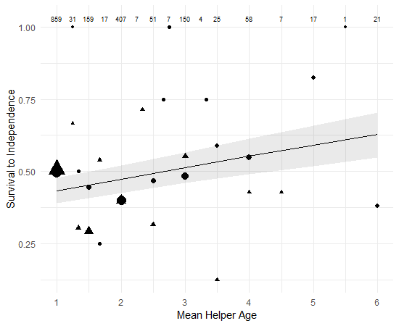 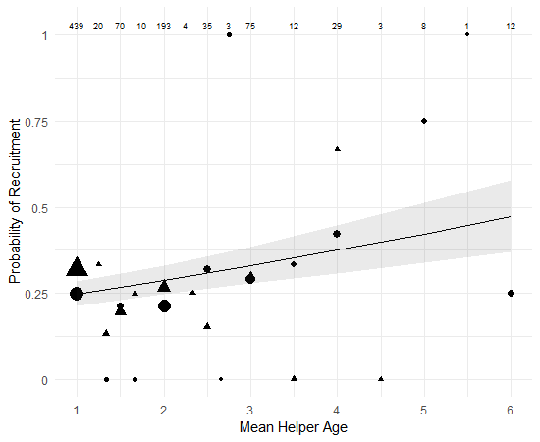

**Figure 1** The effect of the mean age of helper(s) on the probability of (a) chick survival too independence and (b) male recruitment. Lines represent model predictions and the shaded areas are the 95% confidence intervals Points. Triangles represent the raw mean values for chicks that had at least one related helper, and circles represent the raw mean values for chicks where all the helper(s) were unrelated. The size of the points is log proportional to the number of data points for that mean helper age and sample sizes (number of chicks) are included across the top of the graph.

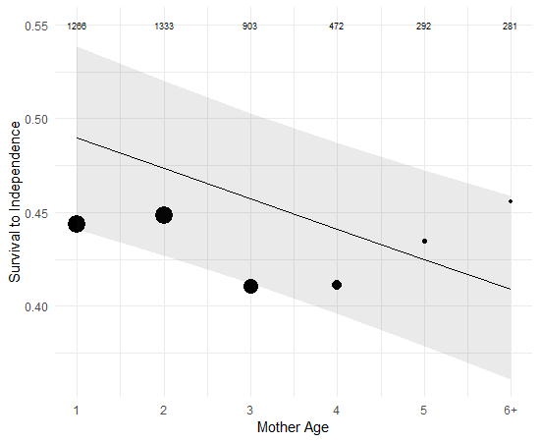 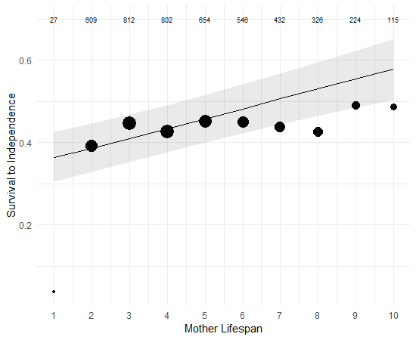

**Figure 2** The effect of (a) mother age and (b) mother lifespan on the probability of chick survival to independence. Lines represent model predictions and the shaded areas are the 95% confidence intervals Points. Dots represent raw mean values. The size of the points is log proportional to the number of data points for that mean helper age and sample sizes (number of chicks) are included across the top of the graph.

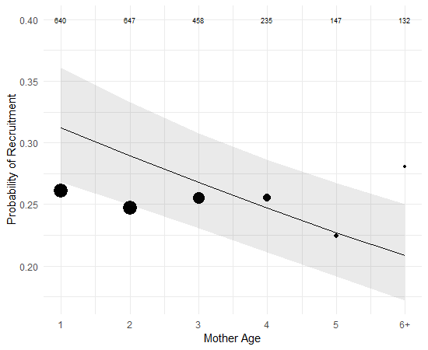 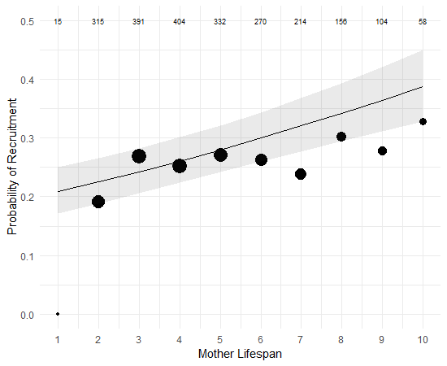

**Figure 3** The effect of (a) mother age and (b) mother lifespan on the probability of male chick recruitment into the breeding population. Lines represent model predictions and the shaded areas are the 95% confidence intervals. Points represent raw mean values. The size of the points is log proportional to the number of data points for that mean helper age and sample sizes (number of chicks) are included across the top of the graph.

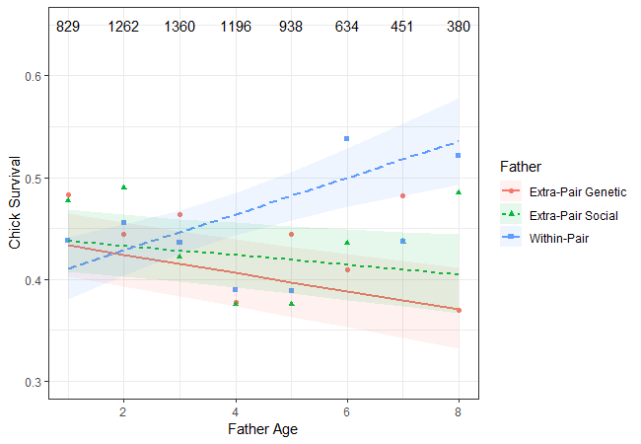

**Figure 4** The effect of extra-pair genetic, extra-pair social, and within-pair father ages on the probability of chick survival to independence. Lines represent model predictions and the shaded areas are the 95% confidence intervals Points. Points represent raw mean values. The sample sizes (number of chicks) for all three father types together are included across the top of the graph.

**Discussion**

In this study, we investigated the transgenerational effects of age in the cooperatively breeding superb fairy-wren by testing how mother, father, and helper ages influenced three different metrics of chick fitness. Nestling weight was not influenced by the ages parents or helpers. Conversely, both survival to independence and male recruitment probability declined with mother age and improved with the mean age of helpers residing on the natal territory. This study is the first to demonstrate helper age can influence chick fitness in cooperative breeders.

Helper effects

There are two non-mutually exclusive mechanisms that could be driving the positive effect of mean helper age on offspring fitness.

* Helper age *per se*: Older helpers helping more/providing better care. In several cooperatively breeding bird species the age of helpers has been associated with their level of contribution towards chick provisioning and predator defense (Lawton and Guindon 1981; Hunter 1987; Heinsohn and Cockburn 1994; Woxvold et al. 2006; Klauke et al. 2014)
* Correlation between helper survival and territory quality
  + - Helpers were raised on the territory. However, if this is true it calls into question why cuckolded social father age does not have a similar association with chick fitness. Within-pair father age does have a positive effect, but only for independence and it is only marginally significant.
* Cockburn 2008 indicates that having at least one helper is associated with an increase in territory productivity. However our results indicate that when the ages of parents and mean helper age is controlled for, there is no effect of related helpers on any metric of fitness, and the only effect of number of unrelated helpers was a marginally significant negative effect. This suggests the positive effect of helpers on territory productivity is a result of load lightening and overall productivity increase of the mother, rather than higher fitness of the chicks.
* Notably, and contrary to model predictions, the raw data suggests that having 1 year old helpers is associated with the highest offspring fitness (figure x). What this may suggest is that successful recent recruitment of helper(s) is a better predictor of territory and/or maternal quality than later recruitment of helpers, while recruitment of helpers more than one year previously is a poorer predictor of territory/mother quality due to stochastic environmental conditions and maternal care senescence (Cooper et al. 2020).

Maternal effects

* Chick survival and male recruitment declines with maternal age when maternal lifespan is controlled for. Maternal age is often negatively associated with offspring quality in a range of animals and this study adds to the growing body of evidence showing fitness consequences to offspring of older mothers in the wild (Descamps et al. 2008; Hoffman et al. 2010; Bouwhuis et al. 2015; Schroeder et al. 2015; Hammers et al. 2019*a*).
* The effect of mother lifespan on chick fitness suggests that mothers that live longer are either inherently higher quality or reside on higher quality territories.
* Fairy-wren mothers actually demonstrate increases in the number of independent young produced in the breeding season for the first several years of life (Cooper et al. 2020). Since we found declines in chick survival and recruitment with maternal age, this suggests that despite increased investment in the number of chicks produced, mothers are having less success at raising those chicks to independence and recruitment as they age. This suggests the negative effect of maternal age is more a consequence of physiological senescence or an increase in birth defects with maternal age, rather than senescence in fertility.

Paternal effects

WP father age positively influences early-life chick fitness as older fathers have nestlings that are more likely to survive to independence.

* The lack of an effect of WP father lifespan suggests this positive effect of WP paternal age is due to improvements with age and not simply that longer-lived individuals are of higher quality (selective appearance) (van de Pol and Verhulst 2006)
* The WP father age effect is unlikely to be a consequence of germline level changes with age. Sperm DNA damage increases with paternal age (Velando et al. 2011; Johnson et al. 2015), and sperm age typically has either negative or null effects on offspring fitness (Johnson and Gemmell 2012; Lemaître and Gaillard 2017).
* More likely is that the effect of WP father age is related to changes in paternal care or environment. The effects of WP father age appear to be isolated to the period where offspring are reliant on parental care, and there is no effect on male recruitment. Thus, improvements in parental care are most likely to be the driver.

Given that the WP father age effect is most likely environmental, it is not clear why EP social father age does not positively influence chick fitness as well.

* Differences between cuckolded males and successful males may explain these divergent patterns.
* It’s possible that males reduce their parental care for clutches that contain more extra-pair chicks through signals of partner infidelity (e.g. Schroeder et al. 2016). If males become better parents with age, but the ability to discern partner fidelity also improves with age, we could expect to see the divergent pattern of father ages on offspring fitness where only the offspring sired WP enjoy the fitness benefit of older social fathers. However, this is unlikely in the fairy-wrens as post-hoc analysis indicated that, at the level of the clutch, dominant male age was not correlated with any measure of increasing within-pair chick fitness relative to extra-pair chick fitness.
* Alternatively, It’s possible that the degree of cuckoldry a male experiences is correlated with his overall quality and quality of his offspring. This reduced siring success of cuckolded males could result from female choice and/or sperm competition (Pizzari et al. 2008; Fitzpatrick and Lüpold 2014; Vuarin et al. 2019).
  + It’s possible, if a difference in male quality exists between within-pair and cuckolded males, that WP successful sires are capable of improving their chick fitness with increased experience, whereas the cuckolded males do not improve with increased experience (because they’re just low quality, they’re already trying their very best).
  + Alternatively, if only high quality males are capable of achieving within-pair siring success at late ages, the apparent improvement of chick fitness with within pair sire age could be resultant of a selective disappearance of low quality males at these later ages, which is unrelated to lifespan.
* Given that the effect of WP father age is only apparent in one metric of chick fitness (survival), and given its marginal significant, it is also entirely possible that this effect is a result of a type I error in the model. Since our study is the first to assess age effects of both cuckolded and genetic social fathers on offspring fitness, additional work is needed to observe the robustness of this result.

As there were no effects of EP father age, there is no evidence of genetic deterioration with age.

* Although sperm typically deteriorates in quality with male age (Johnson et al. 2015; Lemaître and Gaillard 2017), the effects of senescent sperm carrying over to influence offspring fitness are contentious. Although some studies have found evidence of negative effects of male age on some measures of offspring fitness (Ducatez et al. 2012; Bouwhuis et al. 2015; Schroeder et al. 2015), many others have not found any such associations (Fox et al. 2003; Fricke and Maklakov 2007; Avent et al. 2008; Carnes et al. 2012). In natural conditions, if senescence rates vary amongst individuals, females may avoid senescent males or their sperm may lose to less senescent males (Vuarin et al. 2019), and so the sample of older males that are successful sires may be biased towards only high quality males (Pizzari et al. 2008; Fitzpatrick and Lüpold 2014).
* This may be the case in the fairy-wrens as we see no negative male age effects, even when controlling for longevity.
* This suggests that female preference for older males is neither adaptive nor maladaptive in the context of offspring early life fitness.

Conclusion

* Our study is the first to demonstrate in a cooperative breeder that the ages of helpers can influence the fitness of subsequent generations. Central to understanding the evolution of cooperative breeding is an understanding of how helping influences the fitness of the subsequent generation. There has been considerable research effort into quantifying how many characteristics helpers influence chick fitness, especially the number and behaviors of the helpers. Age of helpers has been ignored, despite that parental caregiver ages often dramatically effect chick fitness.
* We did find that parental caregiver ages did influence chick fitness, namely a negative effect of maternal age.
* Our study highlights that separating germline and environmental paternal effects could be important in better understanding the mechanisms of parental age effects. Our results indicate that potential differences between cuckolded and successful males may be a cause for concern in comparing these two groups directly.
* Additional work is needed to better understand the germline and environmental mechanisms that drive parent age effects, and also to understand the role of helper age in the evolution of cooperative breeding.