**S1. Life Tables**

*S1a. Methods*

Using all individuals of known age and known death date, we summarized age-specific measures of survival and reproduction. For each age we tallied the number of males and females in our dataset, and the proportion of these individuals that survived until the next age class. Average lifespan of both females and males that survived until at least adulthood was also calculated. For female reproduction, we tallied the number of individuals we had full breeding records for each age, and calculated the average probability they would produce any independent young, and the average number of independent young they produced and the standard deviation. We summarized male reproduction similarly, except that we used the measure of offspring sired (rather than raised to independence), and we also separated within-group success from extra-group success. We measured number of offspring sired rather than offspring raised to independence because parental care is irrelevant for male extra-group success, and we wanted to make the measures of within-group and extra-group male reproduction comparable. Generation time, measured as the average age of reproduction, was calculated for the female and two male measures of reproduction.

*S1b. Results*

**Table S1** Summary statistics for survival and reproduction. For both female and male fairy-wrens, the number of individuals alive at the beginning of each age (No. Living), the proportion that survived to the subsequent year (Prop. Survived), the number of individuals breeding for each age (No. Reproductive) , and their probability (Prob.) and number (No.) of offspring with the standard deviation (SD). For females, only offspring that survived to independence (approx. 41 days from hatching) are included in reproductive success and for males all offspring that survived to blood sampling age (approx. 7 days from hatching) are included. Male reproductive success is separated into offspring sired by the female within his territory (within-group), and by females outside his territory (extra-group).

|  |  |  |  |  |  |  |  |  |  |  |  |  |  |
| --- | --- | --- | --- | --- | --- | --- | --- | --- | --- | --- | --- | --- | --- |
|  | ***Females*** |  |  |  |  | ***Males*** |  |  |  |  |  |  | |
| ***Age*** | *No. Living* | *Prop. Survived* | *No. Reproductive* | *Prob. Independent Young* | *No. Independent Young (SD)* | *No. Living* | *Prop. Survived* | *No. Reproductive* | *Prob. Within-Group Offspring* | *No. Within-Group Offspring (SD)* | *Prob. Extra-Group Offspring* | *No. Extra-Group Offspring (SD)* | |
| 1 | 749 | 0.66 | 627 | 0.53 | 1.23 (1.39) | 1046 | 0.65 | 898 | 0.07 | 0.14 (0.62) | 0.06 | 0.09 (0.45) | |
| 2 | 497 | 0.57 | 399 | 0.73 | 2.01 (1.80) | 634 | 0.70 | 586 | 0.15 | 0.32 (0.94) | 0.12 | 0.30 (1.03) | |
| 3 | 285 | 0.58 | 225 | 0.73 | 2.08 (1.80) | 437 | 0.70 | 404 | 0.20 | 0.48 (1.24) | 0.2 | 0.54 (1.37) | |
| 4 | 166 | 0.60 | 141 | 0.68 | 2.05 (1.89) | 295 | 0.70 | 271 | 0.20 | 0.56 (1.39) | 0.2 | 0.73 (1.98) | |
| 5 | 100 | 0.54 | 85 | 0.69 | 2.08 (1.95) | 203 | 0.63 | 188 | 0.25 | 0.65 (1.43) | 0.26 | 1.12 (2.40) | |
| 6 | 54 | 0.48 | 43 | 0.70 | 2.14 (2.02) | 126 | 0.61 | 113 | 0.18 | 0.55 (1.40) | 0.31 | 1.10 (2.24) | |
| 7 | 26 | 0.50 | 23 | 0.87 | 3.00 (2.30) | 75 | 0.63 | 69 | 0.29 | 0.65 (1.21) | 0.33 | 1.52 (2.93) | |
| 8 | 13 | 0.38 | 11 | 0.91 | 2.09 (1.04) | 46 | 0.54 | 36 | 0.28 | 0.69 (1.58) | 0.33 | 1.75 (3.21) | |
| 9 | 5 | 0.20 | 4 | 0.75 | 1.75 (1.71) | 22 | 0.36 | 21 | 0.29 | 0.71 (1.38) | 0.29 | 0.81 (1.86) | |
| 10 | 1 | 0 | - | - | - | 8 | 0.38 | 6 | 0.33 | 0.83 (1.33) | 0.17 | 0.17 (0.41) |
| 11 | - | - | - | - | - | 3 | 0.33 | 2 | 0 | 0 (0) | 0 | 0 (0) |
| 12 | - | - | - | - | - | 1 | 0 | 1 | 0 | 0 (-) | 0 | 0 (-) |  | |

Age classes are one year in length and commence September 1st of the calendar year. Number of reproductive individuals is smaller than number of living individuals for each age class because those that died after September 1st but before they could have possibly accumulated any reproductive success (due to dying too early in the breeding season) were included as a living individual but excluded as a reproductive individual.

Age-specific survival probabilities in the fairy-wrens showed only slight differences between the sexes. Maximum lifespans were ten and twelve years for females and males respectively (table 1). However, the smaller sample size of females may have contributed to our lack of observation of females at extreme ages. Mean adult lifespan, measured as age of death among individuals that survived to the age of 1 year, was longer for males: 3.44 years (± 2.22 SD) than females 2.97 years (± 1.73 SD) (Wilcoxon rank sum test p-value < 0.001, n = 751 females, 979 males). In females, survival was highest at age one, stabilized through age four, and then declined from age five onwards (table 1). In males, age one survival was similar to that of females but then improved at age two, remaining stable through age four, after which survival began to similarly decline each year (table 1).

In contrast to survival, female reproduction improved substantially after the first breeding season, and then remained relatively stable up to late ages, where there was another increase at age seven and eight, but with small sample sizes (table 1). Generation time, the average age of reproduction in females (*sensu* Leslie 1966), was 2.59 (n = 6905 offspring from 837 mothers).

For males, within-group reproductive success showed improvements from age one through age five, likely due to a larger proportion of males gaining dominant social status on their territory in these years, as well as a smaller proportion of males living on a territory with their mother, which both improve their siring success within the territory (table 1). Beyond this age, when virtually all males in the sample are dominant, within-group reproductive success stopped improving. Extra-group reproductive success increased with age up through age eight, after which point there was a decline (table 1). Within-group generation time was 3.41 years, and extra-group generation time was 3.69 (n = 6209 offspring from 910 biological fathers).

*S1c. Discussion*

The raw survival data (table S1) indicates that males have higher survival than females from age two to five, and have slightly longer average lifespans. These lifetable results differ from the survival GAMM predictions which indicate comparable levels of survival in both males and females and senescence onset at age one. These differences are likely due to the male survival GAMM controlling for the effect of dominant social status. The GAMM suggests that helpers tend to have higher survival than dominants (table 2, p=0.06), which is why higher male survival is observed at early ages when not taking this variable into account. Further investigation is needed in order to determine how and to what extent dominance status influences male survival, but that is beyond the scope of this paper.

Reproduction results do not differ substantially in the lifetables in comparison to the results of the main text.

**S2. GAMM simulations**

We ran simulations of the zero-inflated GAMM models checked against raw data means and variance for the effect of age. Here we verify that the true values fall within the variability of model predictions, indicating this modeling technique is appropriate for our data distribution.

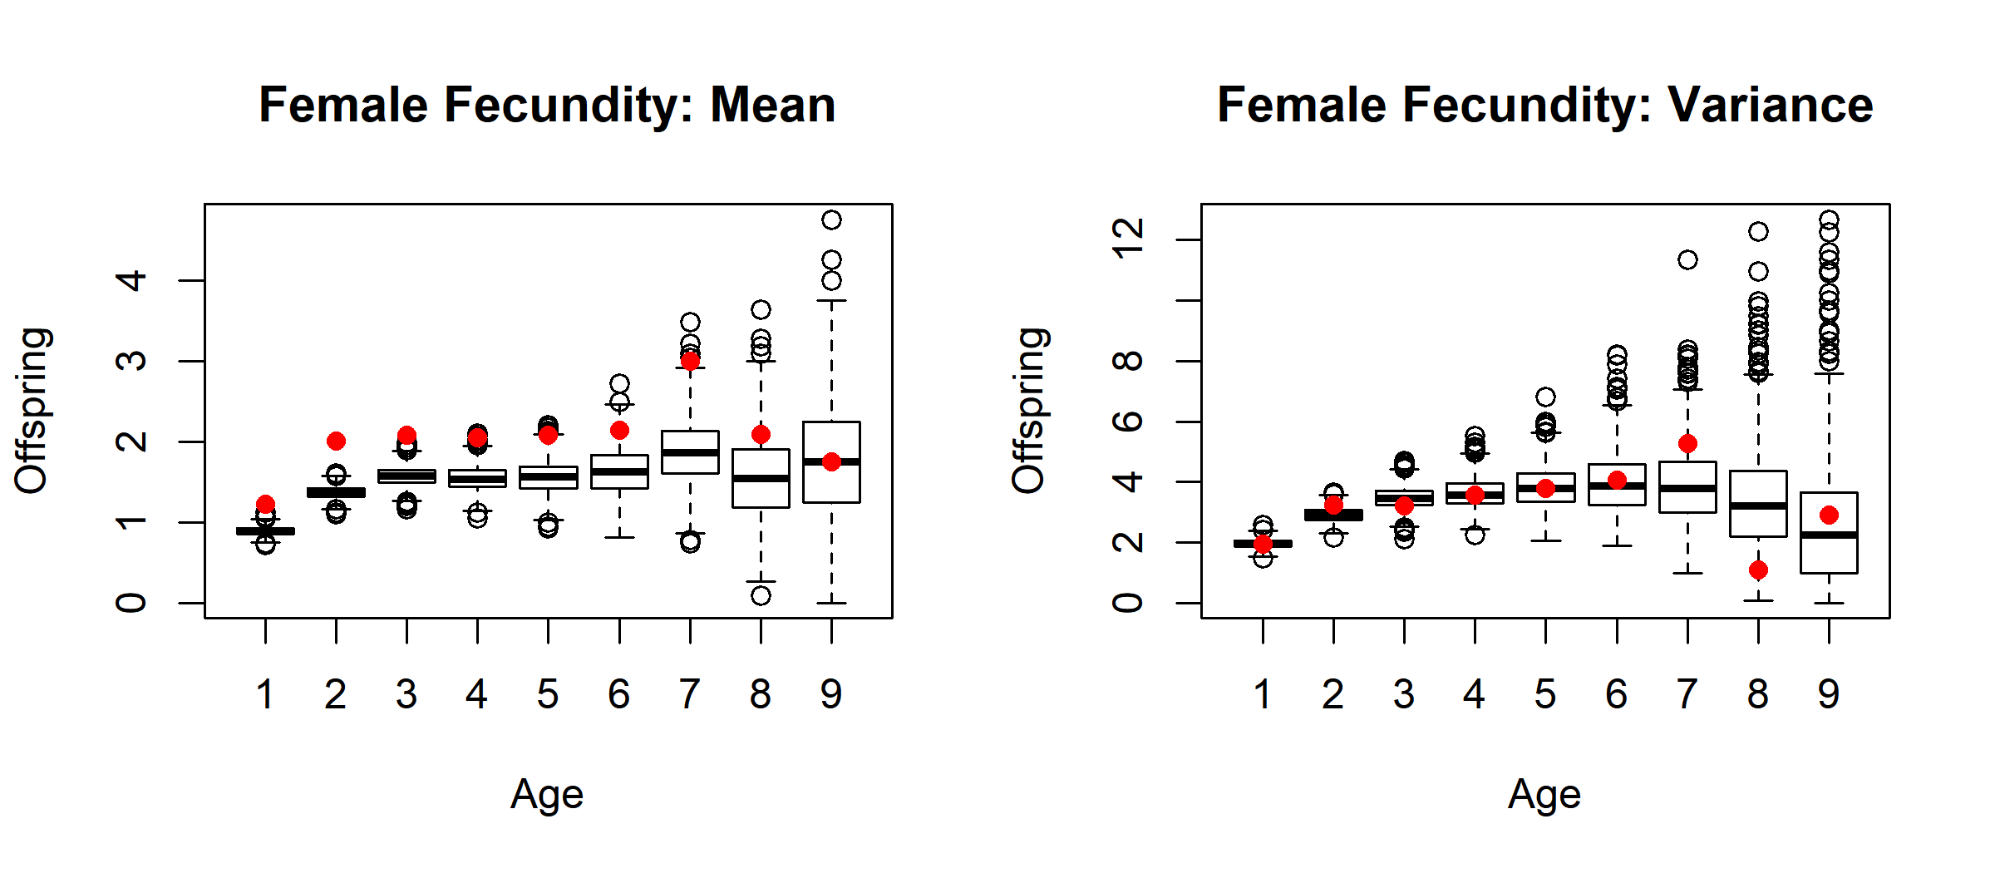

**Figure S1a.** Boxplots of predicted means and variance of female fecundity in 1000 simulations of the GAMM model. Red dots represent the raw means and variance for every age class.

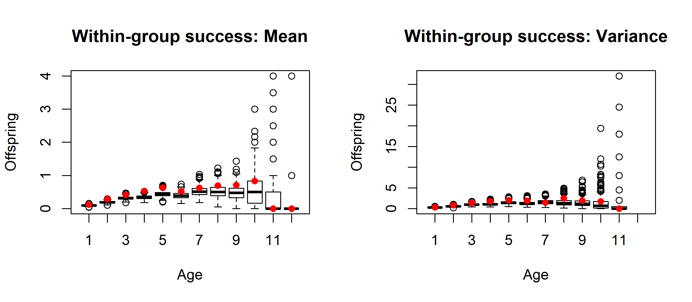

**Figure S1b.** Boxplots of predicted means and variance of extra-group mating success in males in 1000 simulations of the GAMM model. Red dots represent the raw means and variance for every age class.

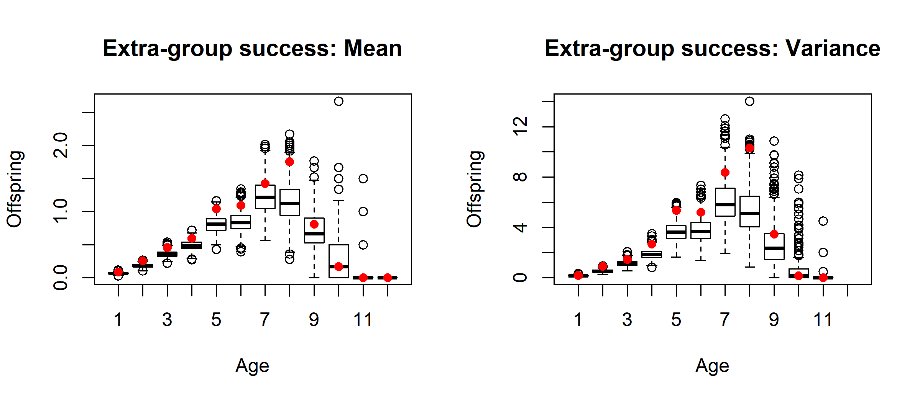

**Figure S1c.** Boxplots of predicted means and variance of extra-group mating success in males in 1000 simulations of the GAMM model. Red dots represent the raw means and variance for every age class.

**S3. Longevity Spline Results**

|  |  |  |  |
| --- | --- | --- | --- |
| Trait | Lifespan Spline EDF | | P-value |
| *Female breeding start date* | 1.015 | 0.43 | |
| *Female clutch size* | 1.000 | 0.19 | |
| Female fecundity |  |  | |
| *Probability* | 2.036 | 0.14 | |
| *Number* | 1.366 | 0.38 | |
| *Male moult date* | 1.011 | 0.40 | |
| Male within-group success |  |  | |
| *Probability* | 2.025 | 0.40 | |
| *Number* | 1.001 | 0.41 | |
| Male extra-group success |  |  | |
| *Probability* | 1.000 | 0.50 | |
| *Number* | 1.003 | 0.25 | |

**Table S2.** Effective degrees of freedom (EDF) and p-value associated with the spline effect of lifespan in the GAMM for each trait. Additional spline and parametric terms in each model are denoted in figures S4-S12 and the estimates and statistics for these covariates are not notably different than those reported there.

**S4. GAMM Detailed Results**

**Table S4** Results from a zero-inflated GAMM predicting annual number of offspring reaching independence for females. EDF is the effective degrees of freedom and Ref. DF is the reference degrees of freedom for the relevant spline term. Terms in the probability portion of the zero-inflated model are denoted by (p) and terms in the numbered count portion are denoted by (n). ‘Death’ is a binomial term denoting if the individual died before the end of the breeding season. This variable is nested within ‘Final breed season’, which denotes whether the individual died at any point in the year before the start of the next breeding season.

|  |  |  |  |  |
| --- | --- | --- | --- | --- |
| **Spline Terms** | **EDF** | **Ref. DF** | **Chi squared** | **P-value** |
| Age (p) | 4.417 | 5.300 | 42.330 | < 0.001 |
| Age (n) | 3.325 | 4.119 | 20.440 | < 0.001 |
| **Parametric Terms** | **Estimate** | **Standard Error** | **Z-value** | **P-value** |
| Intercept (p) | 0.078 | 0.112 | 0.697 | 0.486 |
| Longevity (p) | 0.035 | 0.024 | 1.449 | 0.147 |
| Death [yes] (p) | -0.759 | 0.321 | -2.359 | 0.018 |
| Final breed season (p) | -0.246 | 0.299 | -0.824 | 0.410 |
| Intercept (n) | 0.793 | 0.077 | 10.293 | < 0.001 |
| Longevity (n) | 0.017 | 0.015 | 1.108 | 0.268 |
| Death [yes] (n) | -0.114 | 0.097 | -1.175 | 0.240 |
| Final breed season (n) | -0.006 | 0.184 | -0.033 | 0.974 |

Note: The deviance explained by the model is 15.6%. The sample size is 1558. The model includes random effects of year (n =28, variance (n) = 0.22, variance (p) = 0.26 ), and individual (n = 678, variance (n) = 3.99 x 10-3, variance (p) = 0.29) for both numerical and probability portions.

**Table S5** Results from a zero-inflated GAMM predicting annual number of within-group offspring sired by dominant males. EDF is the effective degrees of freedom and Ref. DF is the reference degrees of freedom for the relevant spline term. Terms in the probability portion of the zero-inflated model are denoted by (p) and terms in the numbered count portion are denoted by (n). ‘Death’ is a binomial term denoting if the individual died before the end of the breeding season. This variable is nested within ‘Final breed season’, which denotes whether the individual died at any point in the year before the start of the next breeding season.

|  |  |  |  |  |
| --- | --- | --- | --- | --- |
| **Spline Terms** | **EDF** | **Ref. DF** | **Chi squared** | **P-value** |
| Age (p) | 1.593 | 1.956 | 0.967 | 0.564 |
| Age (n) | 1.005 | 1.009 | 0.000 | 0.996 |
| **Parametric Terms** | **Estimate** | **Standard Error** | **Z-value** | **P-value** |
| Intercept (p) | -2.772 | 0.693 | -4.003 | < 0.001 |
| Longevity (p) | -0.006 | 0.045 | -0.124 | 0.901 |
| Death [yes] (p) | -0.968 | 0.554 | -1.748 | 0.081 |
| Final breed season (p) | -0.240 | 0.427 | -0.562 | 0.574 |
| Intercept (n) | 0.593 | 0.183 | 3.235 | 0.001 |
| Longevity (n) | 0.020 | 0.035 | 0.582 | 0.560 |
| Death [yes] (n) | 0.328 | 0.581 | 0.564 | 0.573 |
| Final breed season (n) | -0.491 | 0.460 | -1.067 | 0.286 |

Note: The deviance explained by the model is 48.7%. The sample size is 1440. The model includes random effects of year (n =28, variance (n) = 0.037, variance (p) = 3.194), and individual (n = 530, variance (n) = 0.523, variance (p) = 3.194) for both numerical and probability portions.

**Table S6** Results from a zero-inflated GAMM predicting annual number of extra-group offspring sired by males. EDF is the effective degrees of freedom and Ref. DF is the reference degrees of freedom for the relevant spline term. Terms in the probability portion of the zero-inflated model are denoted by (p) and terms in the numbered count portion are denoted by (n). ‘Status’ is a binomial term denoting whether the male was a dominant or helper during that year’s breeding season. ‘Death’ is a binomial term denoting if the individual died before the end of the breeding season. This variable is nested within ‘Final breed season’, which denotes whether the individual died at any point in the year before the start of the next breeding season.

|  |  |  |  |  |
| --- | --- | --- | --- | --- |
| **Spline Terms** | **EDF** | **Ref. DF** | **Chi squared** | **P-value** |
| Age (p) | 3.486 | 4.281 | 40.64 | < 0.001 |
| Age (n) | 4.962 | 5.825 | 50.830 | < 0.001 |
| **Parametric Terms** | **Estimate** | **Standard Error** | **Z-value** | **P-value** |
| Intercept (p) | -4.251 | 0.782 | -5.435 | < 0.001 |
| Longevity (p) | 0.039 | 0.047 | 0.837 | 0.403 |
| Status [dominant] (p) | 0.172 | 0.164 | 1.045 | 0.296 |
| Death [yes] (p) | -1.194 | 0.460 | -2.597 | 0.009 |
| Final breed season (p) | 0.324 | 0.358 | 0.904 | 0.366 |
| Intercept (n) | 1.026 | 0.186 | 5.505 | < 0.001 |
| Longevity (n) | -0.051 | 0.034 | -1.142 | 0.139 |
| Status [dominant] (n) | -0.245 | 0.125 | -1.965 | 0.049 |
| Death [yes] (n) | 0.060 | 0.213 | 0.283 | 0.777 |
| Final breed season (n) | -0.417 | 0.294 | -1.421 | 0.155 |

Note: The deviance explained by the model is 52.6%. The sample size is 2511. The model includes random effects of year (n =28, variance (n) = 0.138, variance (p) = 3.628), and individual (n = 898, variance (n) = 0.442, variance (p) = 0.739) for both numerical and probability portions.

**Table S7** Results from GAMM predicting female clutch size. EDF is the effective degrees of freedom and Ref. DF is the reference degrees of freedom for the relevant spline term.

|  |  |  |  |  |
| --- | --- | --- | --- | --- |
| **Spline Terms** | **EDF** | **Ref. DF** | **F-value** | **P-value** |
| Age | 7.828 | 7.983 | 8.513 | < 0.001 |
| Incubation date | 5.336 | 6.413 | 68.560 | < 0.001 |
| **Parametric Terms** | **Estimate** | **Standard Error** | **t-value** | **P-value** |
| Intercept | 1.148 | 0.014 | 79.470 | < 0.001 |
| Longevity | 0.003 | 0.003 | 1.010 | 0.312 |
| Final breed season | -0.005 | 0.007 | -0.714 | 0.475 |

Note: The model R2 (adjusted) is 0.23 and sample size is 3865. The model includes random effects of year (n =28, variance = 1.24 x 10-6), and individual (n = 979, variance = 5.63 10-2).

**Table S8** Results from GAMM predicting female breeding start date. EDF is the effective degrees of freedom and Ref. DF is the reference degrees of freedom for the relevant spline term.

|  |  |  |  |  |
| --- | --- | --- | --- | --- |
| **Spline Terms** | **EDF** | **Ref. DF** | **F-value** | **P-value** |
| Age | 5.555 | 6.229 | 74.943 | < 0.001 |
| **Parametric Terms** | **Estimate** | **Standard Error** | **t-value** | **P-value** |
| Intercept | 12.152 | 1.414 | 8.596 | < 0.001 |
| Longevity | -0.477 | 0.353 | -1.350 | 0.178 |
| Final breed season | -2.714 | 1.367 | -1.987 | 0.047 |

Note: The model R2 (adjusted) is 0.56 and sample size is 1089. The model includes random effects of year (n =28, variance = 1.87 x 10-4), and individual (n = 678, variance = 9.05).

**Table S9** Results from GAMM predicting male moult date. EDF is the effective degrees of freedom and Ref. DF is the reference degrees of freedom for the relevant spline term.

|  |  |  |  |  |
| --- | --- | --- | --- | --- |
| **Spline Terms** | **EDF** | **Ref. DF** | **F-value** | **P-value** |
| Age | 5.709 | 6.683 | 171.140 | < 0.001 |
| **Parametric Terms** | **Estimate** | **Standard Error** | **t-value** | **P-value** |
| Intercept | -42.588 | 3.222 | -13.217 | < 0.001 |
| Longevity | 0.777 | 0.569 | 1.366 | 0.172 |
| Status [dominant] | -4.193 | 1.588 | -2.640 | 0.008 |
| Final breed season | -0.856 | 1.934 | -0.442 | 0.658 |

Note: The model R2 (adjusted) is 0.59 and sample size is 2116. The model includes random effects of year (n =28, variance = 3.23 x 10-4), and individual (n = 1024, variance = 14.31).

**Table S10** Results from GAMM predicting annual female survival probability. EDF is the effective degrees of freedom and Ref. DF is the reference degrees of freedom for the relevant spline term.

|  |  |  |  |  |
| --- | --- | --- | --- | --- |
| **Spline Terms** | **EDF** | **Ref. DF** | **Chi squared** | **P-value** |
| Age | 1.000 | 1.000 | 15.969 | < 0.001 |
| **Parametric Terms** | **Estimate** | **Standard Error** | **Z-value** | **P-value** |
| Intercept | 59.870 | 12.960 | 4.620 | < 0.001 |

Note: The model R2 (adjusted) is 0.05 and sample size is 1896. The model includes random effects of year (n =29, variance = 0.22 ), and individual (n = 979, variance = 1 x 10-7).

**Table S11** Results from GAMM predicting annual male survival probability. EDF is the effective degrees of freedom and Ref. DF is the reference degrees of freedom for the relevant spline term.

|  |  |  |  |  |
| --- | --- | --- | --- | --- |
| **Spline Terms** | **EDF** | **Ref. DF** | **Chi squared** | **P-value** |
| Age | 1.001 | 1.002 | 29.15 | < 0.001 |
| **Parametric Terms** | **Estimate** | **Standard Error** | **Z-value** | **P-value** |
| Intercept | 45.983 | 12.419 | 3.703 | < 0.001 |
| Status [dominant] | -0.191 | 0.103 | -1.853 | 0.064 |

Note: The model R2 (adjusted) is 0.056 and sample size is 2747. The model includes random effects of year (n =29, variance = 0.21 ), and individual (n = 979, variance = 3.01 x 10-4).

**S5. Comparison of annual survival probability between the sexes**

**Table S12** Results from GLMM of the effect of sex on annual survival probability.

|  |  |  |  |
| --- | --- | --- | --- |
| Predictors | Odds Ratios | CI | P-value |
| M | 1.10 | 0.94 – 1.29 | 0.234 |

Note: The model R2 (conditional) is 0.37. Sample size is 7866 individual years. The model includes random effects of year (n = 30 , variance = 1.00 ), and individual (n = 1730, variance = 0.91).

**S6. The effect of molt on male extra-group success**

In order to test if the early-life improvement of male extra-group siring success is driven by the improvement in their molt (a secondary sexual trait), we re-ran the GAMM and subsequent broken stick models for extra-group success, controlling for molt date as an additional explanatory variable in the GAMM. As expected, molt date had a highly significant effect on extra-group success in the GAMM (coefficient of -5.9 x 10-3 ± 1.6 x 10-3 for probability, coefficient of -3.1 x 10-3 ± 0.9 x 10-3 for number).

The subsequent broken stick models had the same breakpoints as the models not controlling for molt (figure S2). Early-life rates of improvement remained significant in these models, but the slopes and total overall improvement the trait with age was reduced (figure S2; coefficient of 0.24± 0.03 for probability, coefficient of 0.56 ± 0.07 for number). These results indicate that molt date is partially responsible for driving early-life improvements in extra-group success. However, since there still remains some significant improvement after controlling for molt date, this suggests that some other characteristics associated with male age play a role in the early-life rate of improvement.

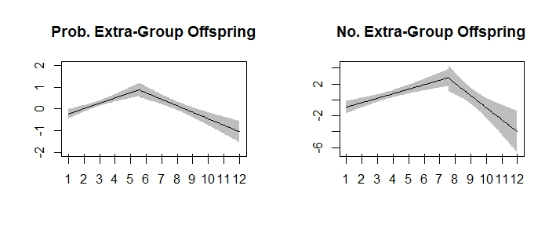

**Figure S2** Broken-stick model results for the effect of age on the probability (Prob.) and number (No.) of extra-group offspring produced by males.