The Clique Problem:
One of the quintessential NP-Complete problems is that of finding cliques in a graph. A clique is a subset of vertices in a graph, which maintains the property that vertex in the clique has a direct edge (or adjacent in the literature) with every other vertex in the clique. A nice example is shown below, where the red vertices make up a clique in the graph. We can frame finding cliques in a graph as a decision problem called k-clique which asks if there exists k or more cliques in the graph? Alternatively, we can view clique as a optimization problem of finding the largest clique (most vertices) or maximum number of cliques in a graph. As Karp states, the clique decision problem is NP-Complete, although their explanation is quite brief:
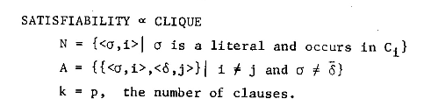
Here, C₁ refers to a clause in the SAT problem, N is the set of vertices in the clique, A is the set of edges in the clique and α is a literal. An explanation of this reduction is nicely shown in this video. We start by constructing clusters of vertices for each clause in the SAT equation. We then draw an edge between each vertex and all the other vertices outside of its cluster unless the two vertices are compliments of each other. We can then find a solution to the SAT problem by
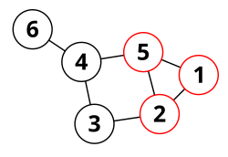
Citations:
[1] https://en.wikipedia.org/wiki/Clique_problem#Surveys_and_textbooks
[2]https://link.springer.com/chapter/10.1007/978-1-4684-2001-2_9
[3]https://www.youtube.com/watch?v=a_1sFUH7UsY

