## 1b. English-language explanation (10 pts)
The function fastest_tour_nn(start_light, L) defines an algorithm to find a tour through an array of lighthouses L starting from a lighthouse start_light using a nearest neighbor approximation. An external function, *get_travel_time(x,y)* is used to lookup the travel time between two lighthouses. *fastest_tour_nn()* begins by initializing an array *tour* to hold the order of lighthouses visited by the algorithm. *tour* is initialized with the first lighthouse *start_light* as the first element in the array. A variable *tour_time* is used to keep track of the total travel time between the lighthouses in the tour and is initialized to zero. The variable *all_steps*, which is initialized to zero, counts the number of “computational steps” made by the program, as a way of estimating the Big-O runtime of the algorithm. Next, the starting lighthouse is removed from L using an externally defined function *list_minus()*. We now enter the core of the algorithm which aims to tour the lighthouses by choosing the closest lighthouse from the current lighthouse. We start by initializing the *current_light* variable to the starting lighthouse. We then enter a while loop and iterate until all lighthouses in L have been toured. Inside the while loop we find the nearest neighbor, update the tour, remove the visited lighthouse from L and then update the current lighthouse variable. We start by initializing *next_time* to infinity, this variable will allow us to find the neighboring lighthouse with the shortest travel time, we also iniatilze a temparay variable *next_light* to store the current closest lighthouse. To find the nearest lighthouse we iterate through the lighthouses in L, calculate the travel time from *second_light* to the current lighthouse, and if it is smaller than *next_time*, assign it to *next_time* and assign *next_light* to *second_light*. We then increment all_steps to account for the loop iteration. After the for-loop we are sure that *next_light* holds the closest neighbor and *next_time* holds the travel time from *current_light* to *next_light*. We then update the total tour time by *next_time* and append *next_light* to the tour list. Next, to ensure the while loop continues, *next_light* is removed from *L* and *current_light* is set to *next_light*. After all lighthouses have been visited the while loop exits and the algorithm returns the order of lighthouses toured, the travel time of the tour, and the total computational steps taken by the algorithm.

## 2a. Asymptotic bounds (10 pts)
Using the techniques that you learned in Modules 1 and 2, provide an analytic estimate of the asymptotic bounds (Big-O, Big-Theta, etc.) for your algorithm.

The *fastest_tour_nn* function begins by performing five constant time operations, initializing the *tour*, *tour_time*, *all_steps* and *current_light* variables and then the constant time external set operation *list_minus*. In total this contributes a factor of O(1) to the function’s runtime. The while loop iterates once per lighthouse. Within the while-loop, an O(n) linear search is performed over the lighthouse to determine the nearest lighthouse. In the for-loop, the distance between *second_light* and *start_light* is calculated using a constant time lookup (external function *get_travel_time()*). A constant time comparison is performed to determine if *second_light* is the nearest neighbor, as well as constant time assignment operations to set *next_light* and *next_time* if it is. Outside of the for-loop, the rest of the while-loop is a series of constant time operations including addition, appending to a list, set modification and assignment operations. Each iteration of the while loop removes a lighthouse from *L*, so we can express the runtime as: T(N) = T(N-1) + N => n + (n-1) + (n-2) … + 1 => Θ(n(n+1)/2) => O(n^2).

## 2b. Error bounds (10 pts)

What theoretical bound can you place on the best and worst case error that the nearest neighbor algorithm will have?
*Hint: the best-case scenario should be pretty obvious. For the worst case, you will need to consider what geometric layout and choice of start point will cause the worst possible outcome. Remember that you are working on a 2D Euclidean plane here, so the Triangle Inequality will likely come into play.*

To quantify the difference between the cost approximation and exact algorithms using an approxamation ratio: Max(C/C*,C*/C) <= p(n). Where C is the cost of the approximate algorithm and C* is the cost of the optimal algorithm. In this scenario we can use the tour time as a proxy for the cost of the functions.
The best-case for the *fastest_tour_nn(start_light, L)* would be a case where the error between the best tour and the approximate tour is zero. This would occur if the best tour through *L* starting at *start_light* is the tour that travels to the next closest lighthouse. An example of this would be if each lighthouse was on a line, and the starting lighthouse was at one end of the line. In this way the brute force approach and the nearest neighbor approach would both have the same tour and the same tour time (cost), so there would be no error. We can express this in terms of a best-case approximation ratio as : Max(C/C*, C*/C) = Max(C/C, C*/C*) = Max(1,1) = 1 <= p(n).
The triangle inequality states that the shortest distance between two points is the straight path between the points. Stated mathematically: for all triples of vertices (u,v,w): d(u,w) <= d(u,v) + d(v,w). As the course content point out, the Euclidian distance (travel time) maintains the triangle inequality. If there is a one or two lighthouses then it is obvious that the optimal and nearest neighbor approach would produce the same tour and the same tour time, with no error. If there are three lighthouses (or for any triplet of lighthouses if n>3), the worst-case scenario can be evaluated using the triangle inequality. Let’s label the three lighthouses (a,b,c) the three edges between them AB, BC, and AC. Since they satisfy the triangle inequality we can state: d(AB) + d(BC) >= d(AC).
Let’s assume the starting lighthouse is *a*. The nearest neighbor algorithm must traverse the shortest path *AB*, while the optimal algorithms could take *AC* or *AB*, note that both algorithms would have to use the edge *BC*. This difference between the *AC* and *AB* is maximized when *a* is in the middle of *b* and *c*. More generally, the nearest neighbor algorithms error is maximized when, for any two points *x* and *y*, we consider a third point *z*, that lies on the line formed by *x* and *y*, but *d(x,y)* distance from *x* in the opposite direction as *y*. In this worst-case the optimal solution would be to traverse (z,x,y) = 2d(x,y), while the nearest neighbor solution would traverse (x,y,z) = d(x,y) + d(y,z) = d(x,y) + d(y,x) + d(x,z) = 3d(x,y). This shows for an optimal travel time of *T*, the worst-case travel time for nearest neighbor would *3T/2*. Expressed as a worst-case approximation ratio we can state: Max(C/C*, C*/C) = Max(T/(3T/2), (3T/2)/T) = Max(2/3,3/2) = 3/2 <= p(n).
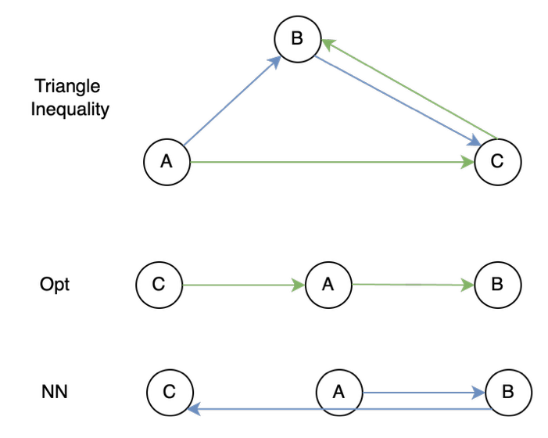

# PART 3 RETROSPECTION
## Retrospection (10 pts)
Figure 1 shows the bounds of the *fastest_tour_nn()* function. The asymptotic bounds analysis claimed that the runtime of the algorithm would be Θ((n(n+1))/2), which confirmed by the overlapping dotted (benchmark) and solid (function steps) red lines. The black dotted line represents the loose upper bounds of O(n^2) and the dotted green line shows how these runtimes relate to a linear algorithm O(n). Note that the plotting code accounts for *n* being one less than the total number of lighthouses since the initial *start_light* is removed from *L* before entering the while-loop.
The second figure compares the runtimes of the three lighthouse tour functions from the programming assignments. The blue line shows the factorial runtime of the brute force algorithm, the green line shows the improvement made using memoization, bringing the runtime to O(n^2*2^n), and the red line shows O(n^2) runtime of the nearest neighbor approach. This figure demonstrates the drastic difference in runtime achieved by the nearest neighbor approximation algorithm. This highlights the power of approximation algorithms to perform efficiently on large datasets.
The third figure aims quantify the error between the tour time computed by the nearest neighbor approximation algorithm and the exact algorithm. The *fastest_tour_memo()* function was used to compute the exact tour time. Each algorithm was run eleven times on a randomly generated list of lighthouses ranging in size from 3 to 14. For each run a random lighthouse was chosen to be the *start_light* for *fastest_tour_nn()*. This experiment was then repeated 25 times to account for variation in the input. For each run percent error was calculated by: ((a-e)/e)*100, where *a* is the approximate tour time from *fastest_tour_nn()* and *e* was the excepted best tour time computed by *fastest_tour_memo()*. Percent error was used to account for the difference in size of *L* at each run. The histogram in figure 3 shows the frequency of percent error over all the runs in the experiments, as well as the mean, median and +/- standard deviation from the mean. During my experiment the maximum error was 19.8% and the best error was 0.0%. The mean and median error were 5.4% and 5.03%, respectively, with a standard deviation of 3.9%. Most of the error was accumulated in the 0-10% range. Figure 4 shows a box-and-whisker plot that stratifies the percent error by number of lighthouses in the input.
This plot shows that as the input increases the mean and median percent error converges on ~5% error. The shrinking of the IQR range also shows the convergence of error into a smaller range as the input size increases.
We can use the results of these experiments to help guide the decision to use an exact or approximate algorithm. The exact algorithm will always return the best tour but at the cost of increased runtime. In scenarios where the absolute best tour is required, then an exact algorithm would be required. Although, even at moderate sized inputs (n >15), the exact algorithms (brute force or memo) become inefficient. This can be quantified by the super-polynomial (brute force) and exponential (memo) runtime of the exact algorithms, as shown in the previous programming assignments. We can overcome this inefficacy by leveraging approximation to produce a polynomial runtime algorithm. This comes at the cost of introducing error into the calculation of the fastest tour. As the experiments show, for the nearest neighbor approximation the mean and median percent error converges to ~5% and in the worst case ~20%. This is much better than the theoretical 50% worst case error described above. A hybrid approach, which uses an exact algorithm for small inputs and an approximation algorithm for large inputs, can be used to minimize error. The decision to use an exact or approximate algorithm will depend on the requirements of the situation, but this experiment quantifies the trade-offs between the two options.
Several code improvements were made, such as type hints, docstrings, error handling, and wrapper functions. A naive (linear) nearest neighbor search was implemented for simplicity.

