Evan Edelstein
EN.605.645.82.SP26
Module 7 – self check
Pseudocode
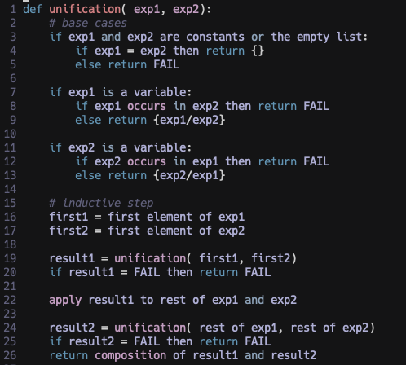

  - Unify(Fred, Barney): We can see from line 3-5 in the pseudocode that if both inputs are constants and not equal, unify returns FAIL
  - Unify(Pebbles, Pebbles): We can see from line 3-5 in the pseudocode that if both inputs are constants and are equal, unify returns an empty substitution list.
  - Unify((quarry_worker Fred), (quarry_worker, ?x) ): Since both arguments are expressions we hit the inductive step, and extract quarry_worker from both arguments. The recursive unification returns an empty substitution list since the inputs are equal constants. Since it is empty, there is nothing to apply and we call unify again with Fred and ?x. Since the second input is a variable and does not occur in the first ,we return a substation list containing {?x/Fred}.
  - Unify((son Barney ?x) (son ?y Bam_Bam)). Following the pseudocode we extract son and son and return an empty substitution list. Next, we extract Barney and ?y and return a substitution list of {?y/Barney}. Lastly, we recursivley call unify(?x, Bam_Bam) and return {?x/Bam_Bam}. Combining the two substitution lists we get {?y/Barney, ?x/Bam_Bam}.
  - Unify((married ?x ?y), (married Barney Wilma)). Trivially we can see that we can assign each constant in the second argument to the two variables in the first, returning {?x/Barney, ?y/Wilma}
  - [also 2] Unify((son Barney ?x), (son ?y (son Barney) )). Following the pseudocode we pop son and son off the inputs and recursively return an empty substitution list. Recursively, we then pop off Barney and ?y and get the substitution list {?y/Barney}. Next, we recursively call unify(?x, (son Barney)). Since the first input is a variable and it does not occur in the second input, by line 9, we add {?x/(son Barney)} to the substitution list. This results in the solution {?y/Barney, {?x/(son Barney)).
  - Unify((son Barney ?x), (son ?y (son ?y) )). We follow the same logic as (f), but at the application step we change (son ?y) to (son Barney) this then returns the same solution {?y/Barney, {?x/(son Barney)).
  - Unify((son Barney Bam_Bam), (son ?y (son Barney) )). Following the above steps we get the substation list {?y/Barney}. Next, we recursively call unif(Bam_Bam, (son Barny)). Since we cannot assign a constant function to a constant we return Fail as the final solution.
  - Unify((loves Fred Fred), (loves ?x ?x)): trivially we have the substitution list {?x/Fred}
  - Unify((loves Geroge Fred), (loves ?y ?y)): Trivially we cannot assign the same variable to two different constants, so this returns FAIL,

