Evan Edelstein
EN.605.645.82.SP26
Module 13 – self check

1)

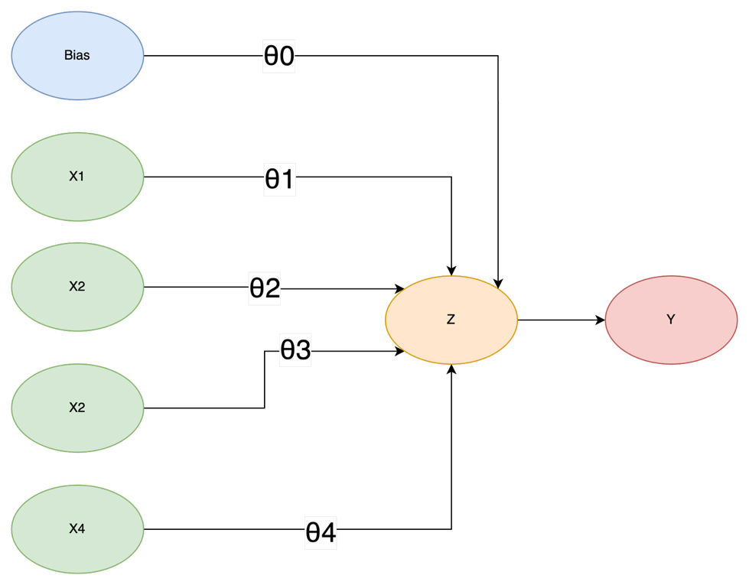

2) The difference between linear and logistic regression is the added step of applying the sigmoid function $f\left(z\right)=\frac{1}{1+e^{-z}}$to z, the weighted sum of theta and x
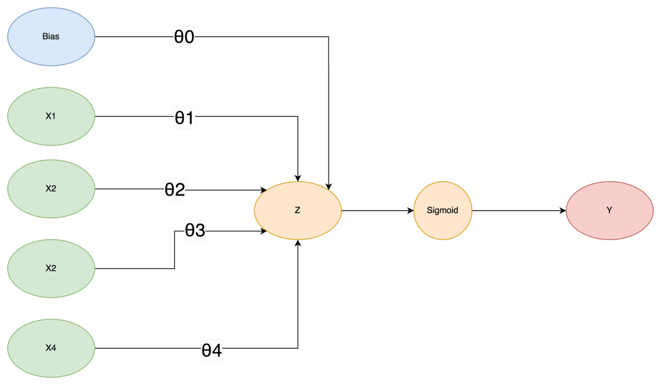

3)
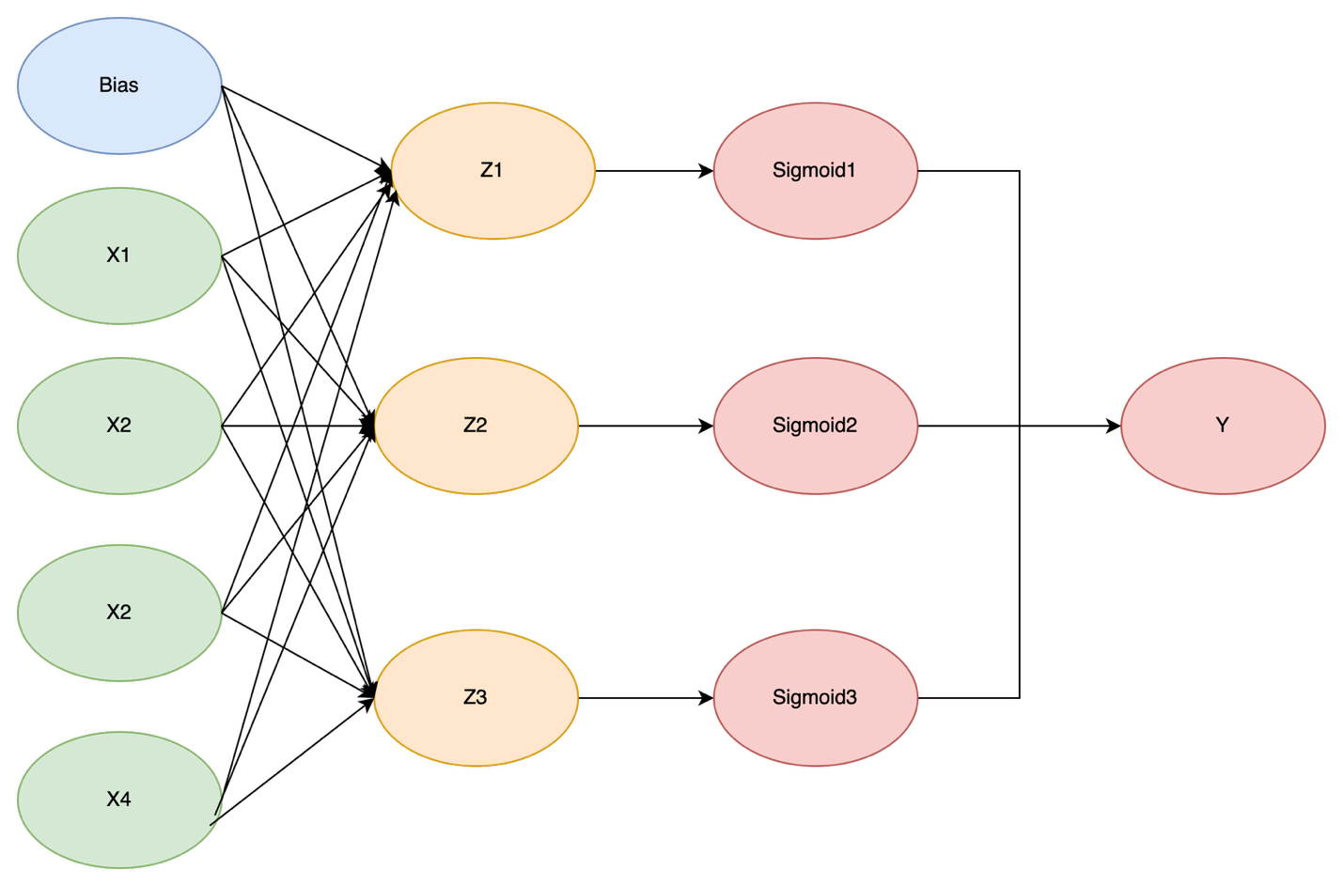

4)

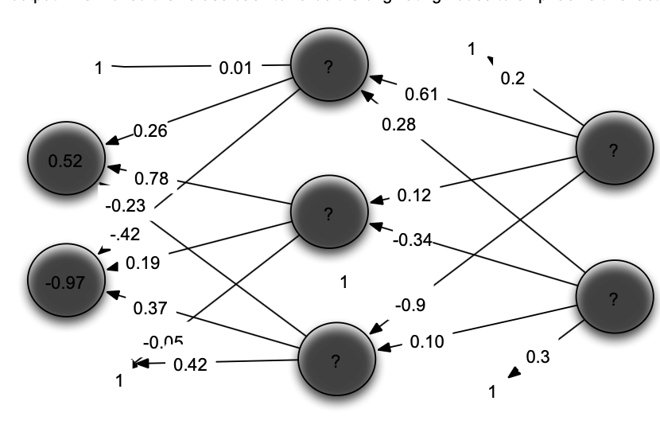

Feed Forward:
Input: [0.52, -0.97]
Z =bias + w1 * x1 + w2 * x2
Sigmoid = 1/(1+e^-z)
Delta:
Output: $δ=\hat{y} (1-\hat{y} )(y-\hat{y})$
Hidden: $δ=\hat{y} (1-\hat{y} )\sum{θ_{i,o}δ_{i,0}}$

Node | Bias | Weight1 | Weight2 | Weight3 | Z | Sigmoid ($\hat{y}$) | Delta
1 | 0.01 | 0.26 | -0.42 |  | 0.01+0.26*0.52 +-0.42*-0.97 = 0.553 | 1/(1+e^-0.553) = 0.634 | 0.634 * (1-0.634) * ( 0.61*0.108 +0.28 * -0.142) = 0.006
2 | -0.05 | 0.78 | 0.19 |  | -0.05+0.78*0.52+0.19*-0.97 = 0.1713 | 1/(1+e^-0.171) = 0.542 | 0.542 * (1-0.545) * (0.12*0.108 + -0.34*-0.142) = 0.015
3 | 0.42 | -0.23 | 0.37 |  | 0.42+-0.23*0.52+0.37*-0.97 = -0.059 | 1/(1+e^0.059) = 0.485 | 0.485 * (1 – 0.485) * (-0.9*0.108 + 0.1*-0.142) = -0.028
4 | 0.2 | 0.61 | 0.12 | -0.9 | 0.2 + 0.61*0.634 + 0.12*0.542-0.9*0.485 = 0.215 | 1/(1+e^-0.215) = 0.554 | 0.544 * (1 -0.554) * (1-0.554) = 0.108
5 | 0.3 | 0.28 | -0.34 | 0.10 | 0.3+ 0.28*0.634-0.34*0.542+0.1*0.485 = 0.342 | 1/(1+e^-0. 342) = 0.585 | 0.585 * (1 – 0.585) * (0 – 0.585) = -0.142

$$w+=a*δ*x$$

13
16
17
15
14
12
11
10
9
8
7
6
5
4
3
2
1

Weight | Old | Update
1 | 0.01 | 0.01+0.01*0.006 *1 = 0.01
2 | 0.26 | 0.26+0.01* 0.006*0.52=0.260
3 | 0.78 | 0.78+0.01*0.015*0.52 = 0.780
4 | -0.23 | -0.23+0.01*-0.028*-0.52 = -0.230
5 | -0.42 | -0.42+0.01*0.006*-0.97 = -0.420
6 | 0.19 | 0.19+0.01*0.015*-0.97 = 0.190
7 | 0.37 | 0.37+0.01*-0.028*-0.97 = 0.37
8 | -0.05 | -0.05+0.01*0.015*1 = -0.0498
9 | 0.42 | 0.42+0.01*-0.028*1 =0.4197
10 | 0.2 | 0.2+0.01*0.006+1=0.2006
11 | 0.61 | 0.61+0.01*0.108*0.634 = 0.6106
12 | 0.28 | 0.28+0.01*0.634*-0.142 = 0.279
13 | 0.12 | 0.12+0.01*0.108  * 0.542=0.1206
14 | -0.34 | -0.34+0.01*0.542*-0.142=-0.34077
15 | -0.9 | -0.9+0.01*0.485*0.108 = -0.899
16 | 0.10 | 0.1+0.01*0.485*-0.142=0.0993
17 | 0.3 | 0.3+0.01*-0.142*1= = 0.298

