Evan Edelstein
EN.605.645.82.SP26
module 3 – self check
Linear Regression:
- We can draw the line $y = 1.3 + 2.9x$ as follows:
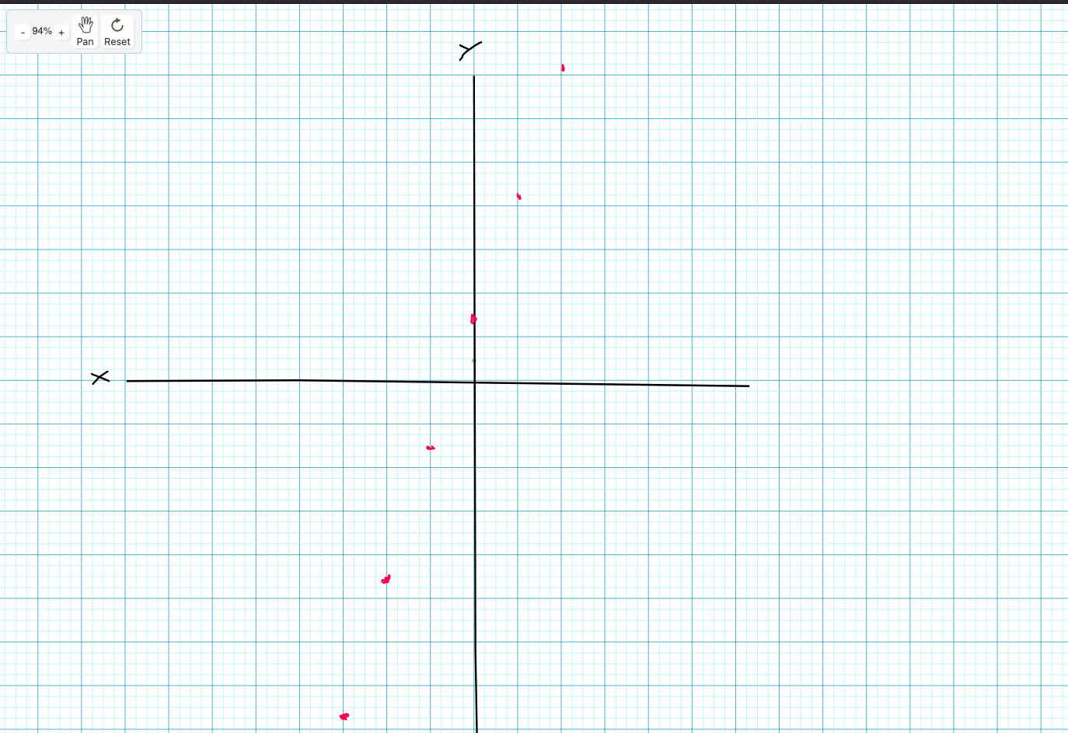

- The data points in this problem are [1.0, 2.0] and [3.0, 1.0] which means the data points are expressed as:
$P1: xs = [1.0, 1.0] , y = 2.0$
$$P2: xs = [1.0, 3.0], y = 1.0$$
The formula for y-hat is y-hat = Θx, where Θ is the vector [1.3, 2.9]. Therefore:
$$P1: \hat{y}1 = 1.3*1.0 + 2.9*1.0 = 4.2$$
$$P2: \hat{y}1 = 1.3*1.0 + 2.9*3.0 = 10.0$$
- *switching to graphing calculator
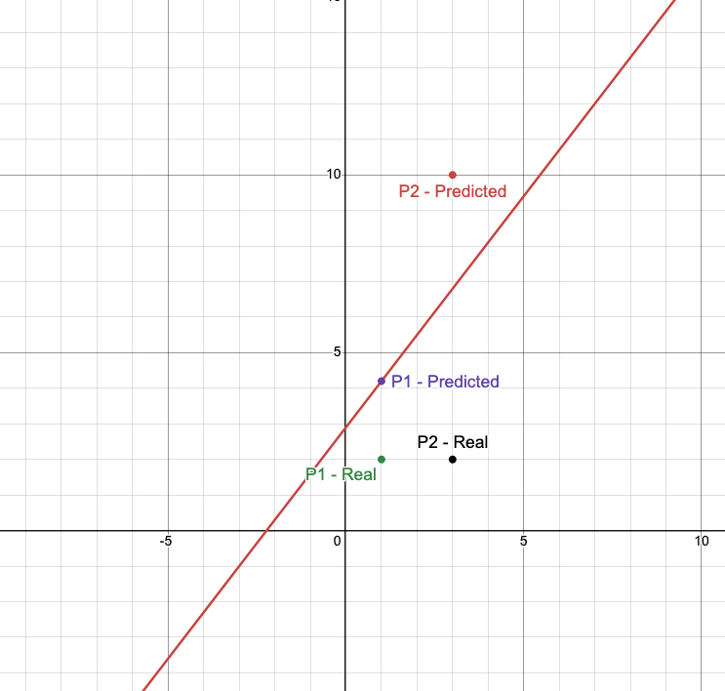

- Mean Squared Error is defined as: $J\left(Θ\right)=\frac{1}{2n}{\sum{\hat{{(y}_{i}}-y_{i})}}^{2}$
$$P1: error = ( 4.2 - 2 )^2 = 2.2^2 = 4.84$$
$$P2: error = (10 - 1) = 9^2 = 81$$
$$MSE = 1/4 * (4.84 + 81) = 21.46$$
- The update for thetas is: $new Θ\left(j\right)= Θ\left(j\right)- α \left(\frac{dj}{dΘ\left(j\right)}\right)= Θ\left(j\right)- α*\frac{1}{n}* {\sum{\hat{{((y}_{i}}-y_{i}) x_{ij})}}^{}$
$$j1: 1.3- 0.1 *\frac{1}{2}*\left(2.2*1\right)+\left(9*1\right)=1.3-0.1*5.6 =1.3- 0.55=0.74$$
$$j2: 2.9 -0.1*\frac{1}{2}*(2.2 * 1) + (9 * 3) = 2.9 - 0.1 * 14.6 = 2.9 - 1.46 = 1.44$$
- The blue line indicates the newline produces using the updates thetas of [0.74, 1.44]
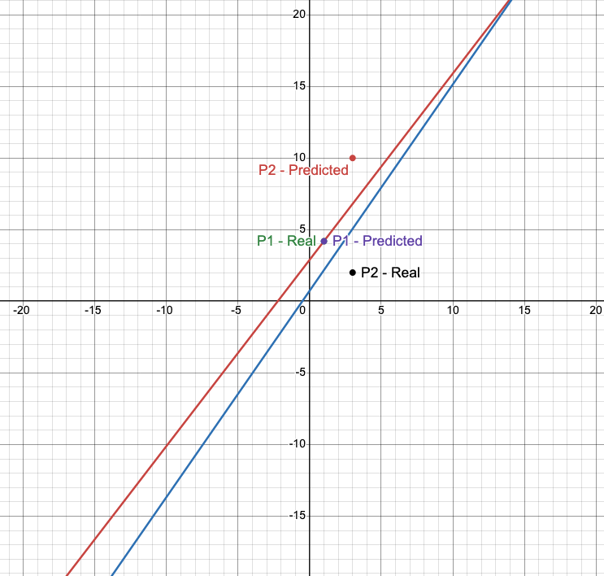
- The new estimates can be generated using y-hat = $Θx$ (with $Θ_{0} being the y-intercept and x_{0} being 1$
$$P1: \hat{y} = 0.74 * 1 + 1.44 * 1 = 2.18$$
$$P2: \hat{y} = 0.74 * 1 + 1.44 * 3 = 5.06$$

Logistic Regression:
$$Θ=\left[0.8, 1.1\right], P1=\left[1.0, 1.1\right], P2=\left[1.0, 2.7\right], Y=\left[0,1\right]$$
- We can use the formula $\hat{y} = 1/(1+e^-(Θx) )$to compute the estimates:
X | Z | Y
$$-3$$ | $$0.8 + 1.1* -3 = -2.5$$ | $$1/(1+e^{2.5}) = 0.076$$
$$-2$$ | $$0.8 + 1.1* -2= -1.4$$ | $$1/1+e^{1.4} =0.198$$
$$-1$$ | $$0.8 + 1.1* -1 = -0.3$$ | $$1/1+e^{0.3} =0.425$$
$$0$$ | $$0.8 + 1.1* 0 = 0.8$$ | $$1/1+e^{-0.8} =0.689$$
$$1$$ | $$0.8 + 1.1* 1 = 1.9$$ | $$1/1+e^{-1.9} =0.870$$
$$2$$ | $$0.8 + 1.1* 2 = 3$$ | $$1/1+e^{-3} =0.953$$
$$3$$ | $$0.8 + 1.1* 3 = 4.1$$ | $$1/ 1+e^{-4.1} =0.984$$
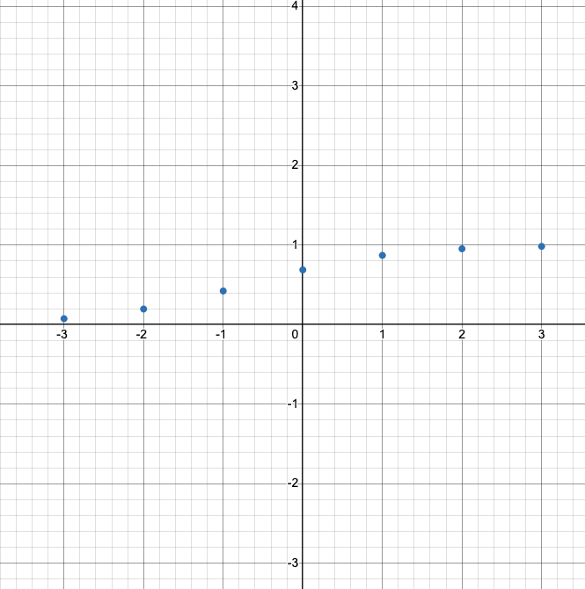
- The error for these points:

$$P1: z = Θx = 0.8 (1.0) + 1.1(1.1) = 2.01$$
$$\hat{y} = 1/(1+e^-z) = 1/(1+e^-2.01) = 0.882$$
$$error = ylog\left(\hat{y}\right)+\left(1-y\right)\log\left(1 - \hat{y}\right)= 0 *\log\left(0.882\right)+ \left(1-0\right)*\log\left(1- 0.882\right)=\log\left(0.118\right)= -0.928$$

$$P2: z = Θx = 0.8 (1.0) + 1.1(2.7) = 3.77$$
$$\hat{y} = 1/(1+e^-z) = 1/(1+e^-3.77) = 0.977$$
$$error = ylog\left(\hat{y}\right)+ \left(1-y\right)log\left(1 - \hat{y}\right)= 1 * log\left(0.977\right)+ \left(1 - 1\right)* log\left(1- 0.977\right)= log\left(0.977\right)= -0.010$$
$Log loss= -\frac{1}{n}\sum{ ylog\left(\hat{y}\right)+ \left(1-y\right)log\left(1 - \hat{y}\right)}= -\frac{1}{2}*\left(-0.977+ -0.010 \right)= 0.469$

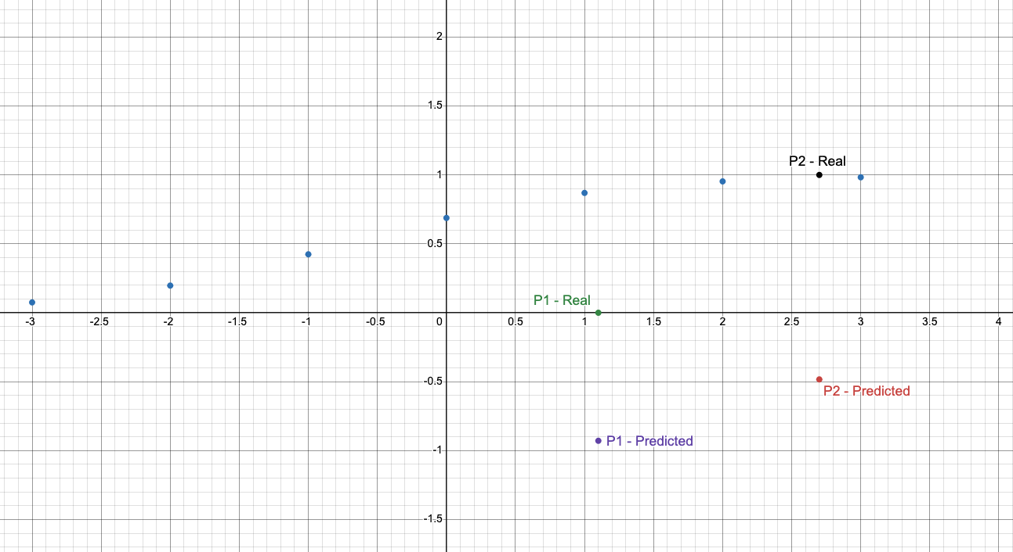
- $new Θ\left(j\right)= Θ\left(j\right)- α \left(\frac{dj}{dΘ\left(j\right)}\right)= Θ\left(j\right)- α*\frac{1}{n}* {\sum{\hat{{((y}_{i}}-y_{i}) x_{ij})}}^{}$
$$P1:new Θ\left(j\right)= 0.8-0.1*\frac{1}{2}* \left( 0.882-0\right)*1+\left(0.977-1\right)*1= 0.757$$
$$P2:new Θ\left(j\right)= 1.1-0.1*\frac{1}{2}* \left( 0.882-0\right)*1.1+\left(0.977-1\right)*2.7=1.055$$

X | Z | Y
$$-3$$ | $$0.757+ 1.055* -3 = -2.408$$ | $$1/(1+e^{2.408}) = 0.0826$$
$$-2$$ | $$0.757+ 1.055* -2=-1.353$$ | $$1/1+e^{1.353} =0.205$$
$$-1$$ | $$0.757 + 1.055* -1 =-0.298$$ | $$1/1+e^{0.298} =0.426$$
$$0$$ | $$0.757 + 1.055* 0 =0.757$$ | $$1/1+e^{-0.757} =1$$
$$1$$ | $$0.757 + 1.055* 1 =1.812$$ | $$1/1+e^{-1.812} =0.860$$
$$2$$ | $$0.757 + 1.055* 2 =2.867$$ | $$1/1+e^{-2.867}=0.946$$
$$3$$ | $$0.757 + 1.055* 3 =3.922$$ | $$1/ 1+e^{-3.922} =0.980$$

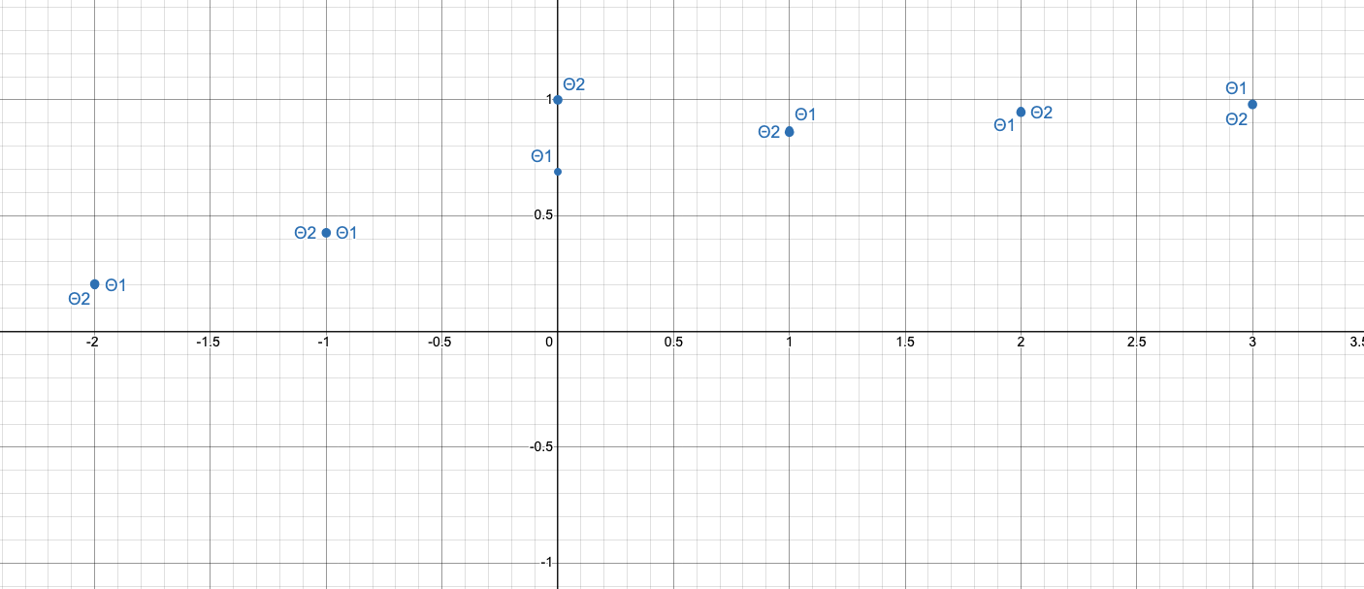

- Updated yhats
$$P1: z = Θx = 0.757 (1.0) + 1.055(1.1) = 1.9175$$
$$\hat{y} = 1/(1+e^-z) = 1/(1+e^-1.9175 ) = 0.872$$

$$P2: z = Θx = 0.757 (1.0) + 1.055(2.7) =3.606$$
$$\hat{ y }=\frac{1}{1+e^{-z}}= \frac{1}{1+e^{-3.606}}=0.974$$

