Consolidated G-Methods & Causal Triangulation Report
This analysis starts follow-up at the beginning of treatment (Time 0).

Strategy 1: Full Treatment Cohort (Time 0)
Time | Month | CI_Non_LTFU | CI_LTFU | Risk_Diff | Risk_Ratio
1 Year | 12.0000 | 0.0592 | 0.0173 | -0.0419 | 0.2924
5 Years | 60.0000 | 0.0670 | 0.0537 | -0.0134 | 0.8007
10 Years | 120.0000 | 0.0815 | 0.0718 | -0.0096 | 0.8817
12 Years | 144.0000 | 0.0819 | 0.0776 | -0.0043 | 0.9474

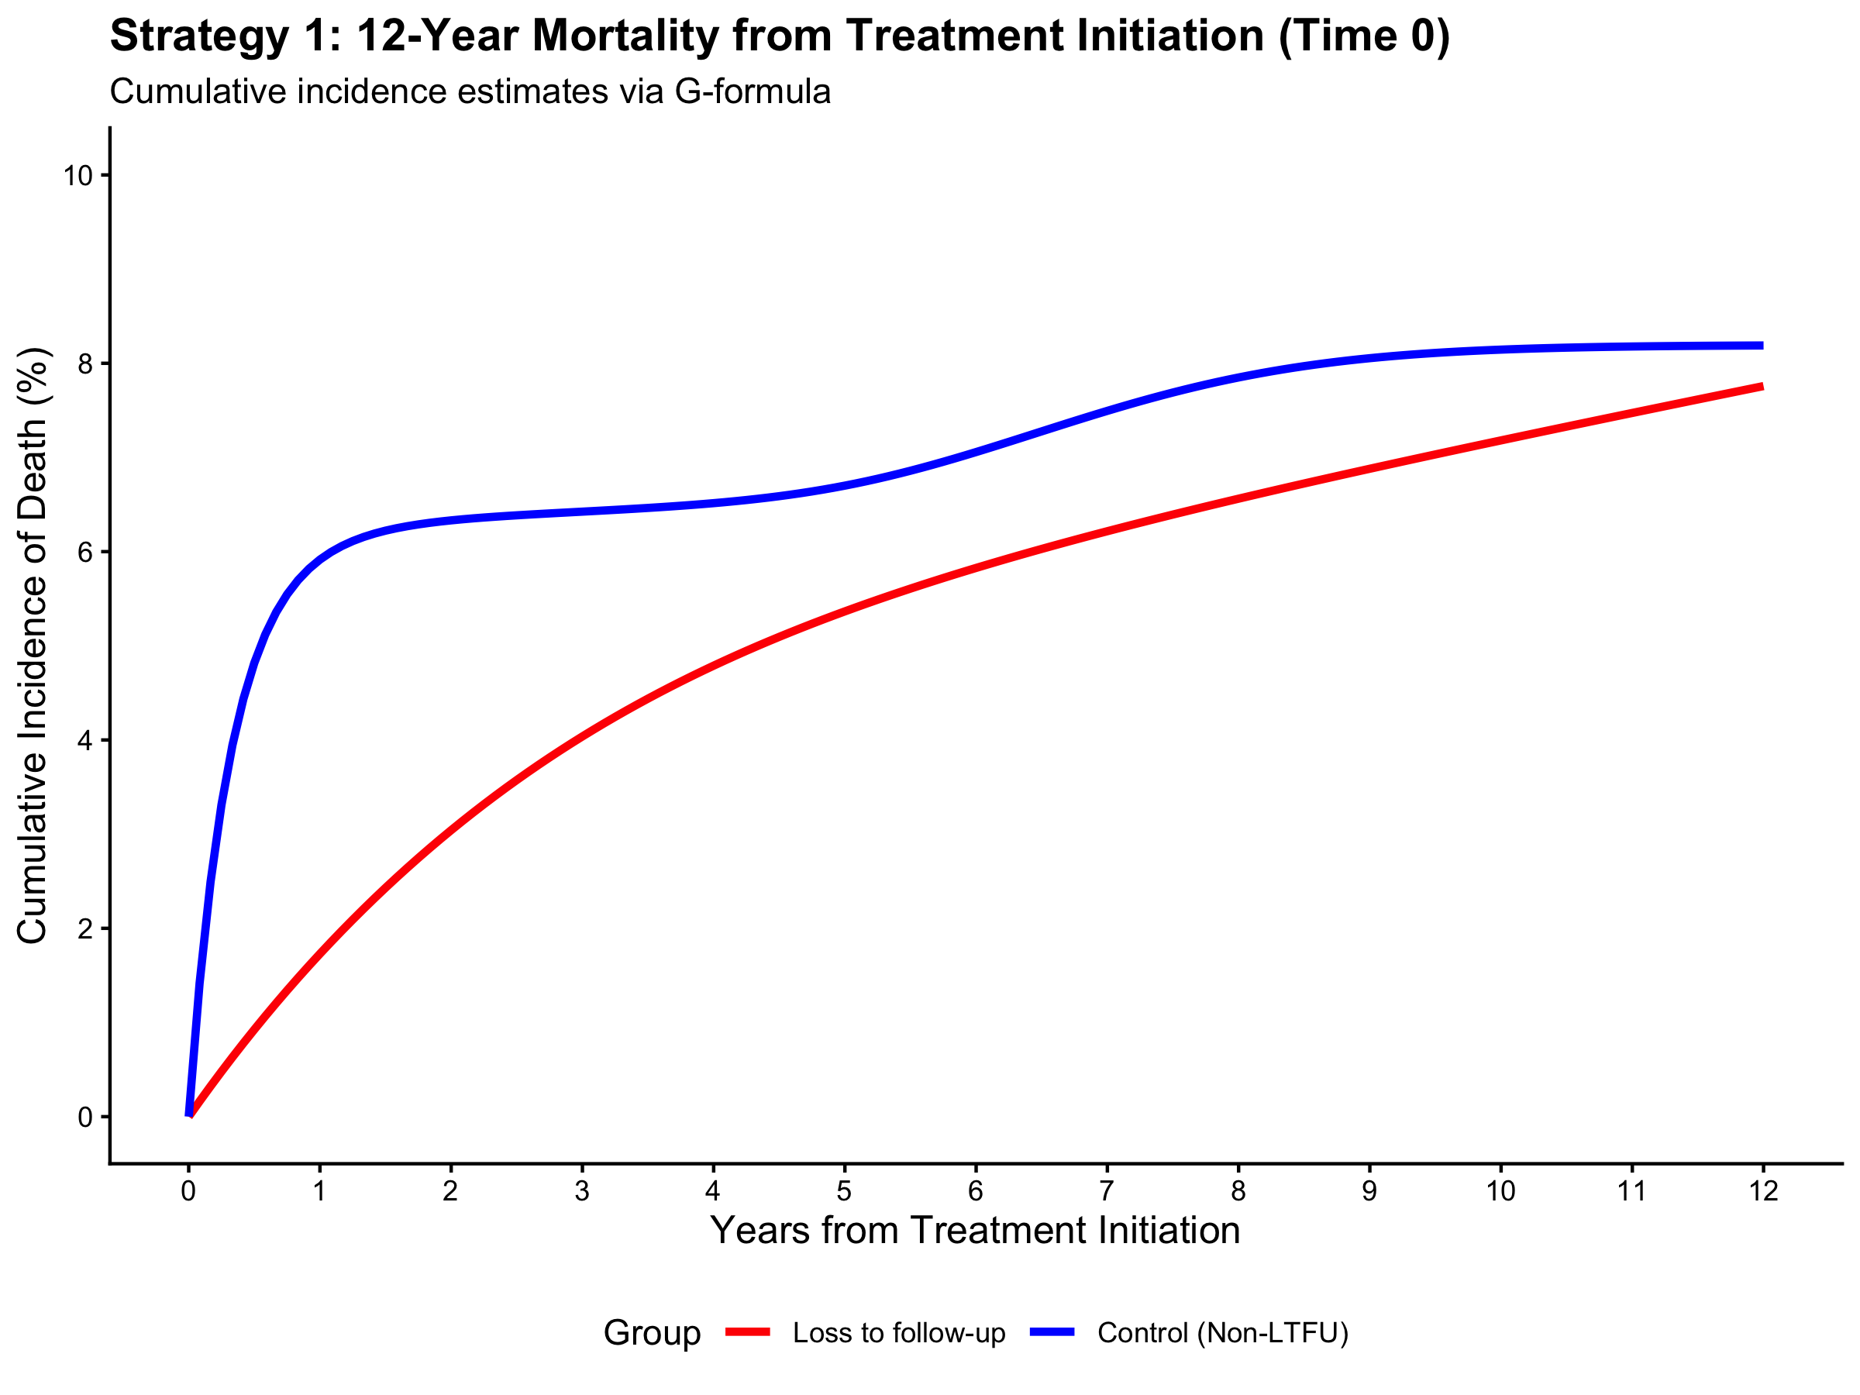

This analysis starts follow-up after 180 days of treatment to isolate long-term effects.

Strategy 2: 180-Day Landmark (Intensive Phase Survivors)
Time | Month | CI_Non_LTFU | CI_LTFU | Risk_Diff | Risk_Ratio
1 Year | 12.0000 | 0.0064 | 0.0210 | 0.0146 | 3.2852
5 Years | 60.0000 | 0.0201 | 0.0520 | 0.0319 | 2.5905
10 Years | 120.0000 | 0.0325 | 0.0706 | 0.0381 | 2.1745
12 Years | 144.0000 | 0.0349 | 0.0751 | 0.0402 | 2.1510

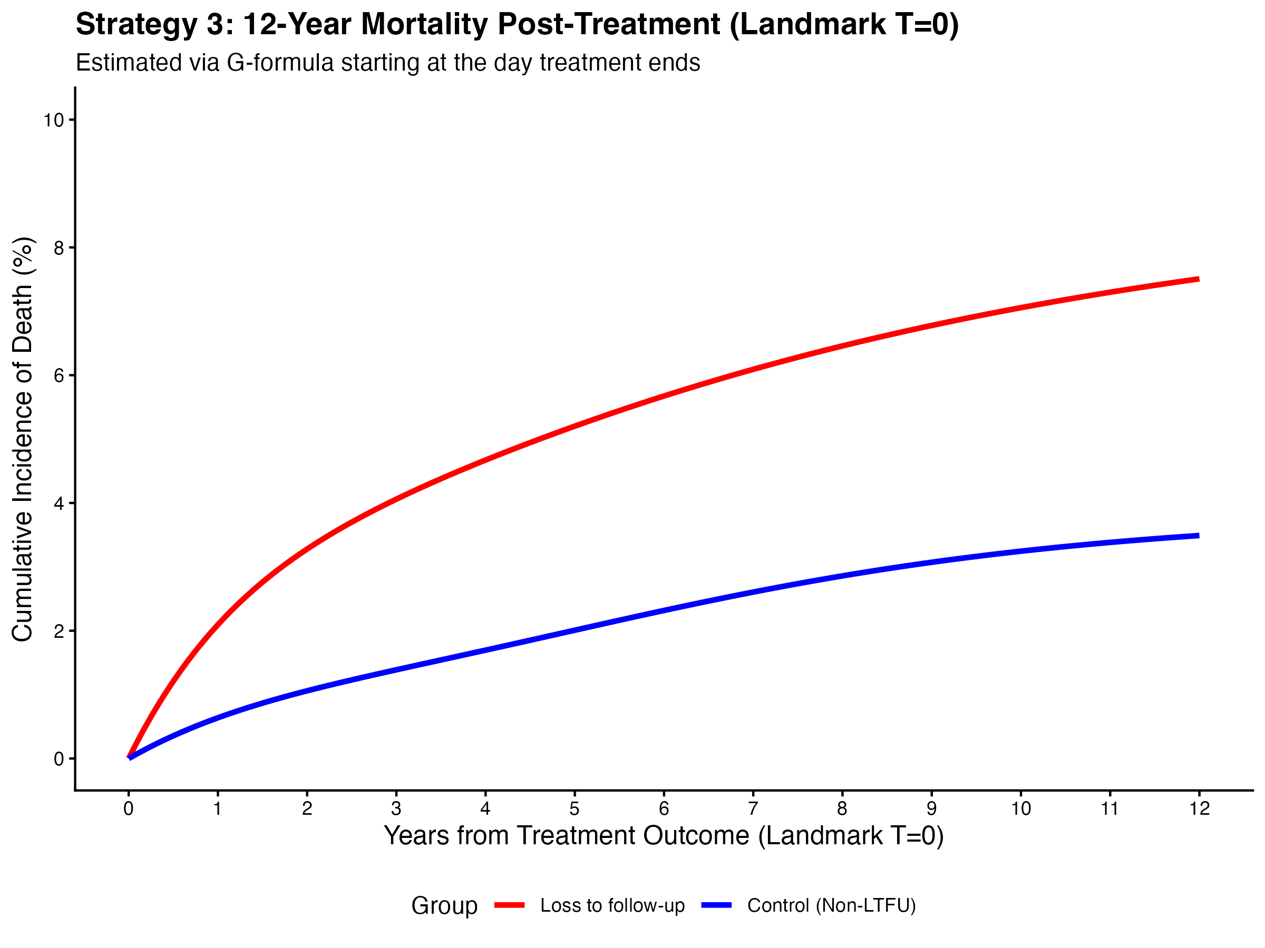

This analysis starts follow-up exactly at the day treatment ends (abandonment or completion).

Strategy 3: Landmark at End of Treatment / Outcome Day
Year_Post_Start | Month_Post_Landmark | Risk_Non_LTFU | Risk_LTFU | RD | RR
1.0000 | 6.0000 | 0.0039 | 0.0111 | 0.0072 | 2.8217
5.0000 | 54.0000 | 0.0192 | 0.0462 | 0.0270 | 2.4039
10.0000 | 114.0000 | 0.0324 | 0.0667 | 0.0343 | 2.0565

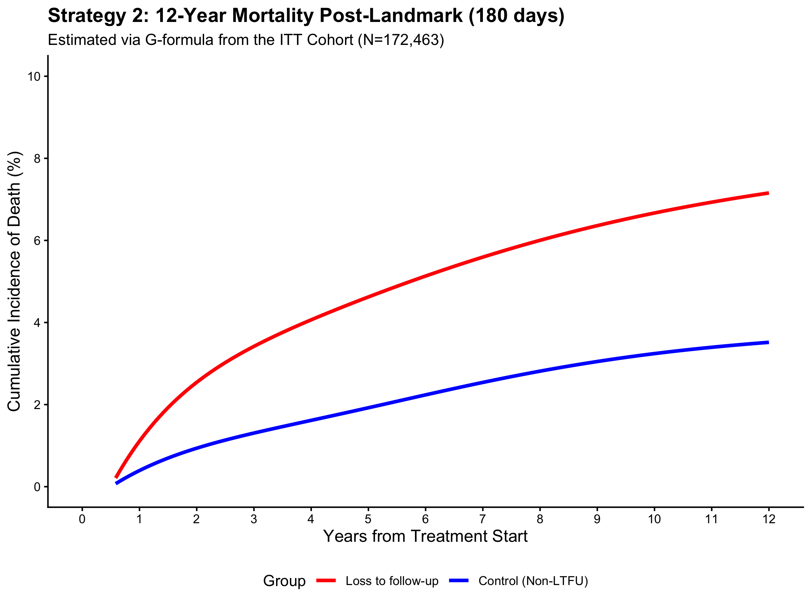

Evidence-Based Triangulation: QBA & E-Value
This section addresses the 'Two-Way Bias' (Sick-to-Stay vs Healthy-to-Quit) to reconcile the differences between Time 0 and Landmark results.

1. Quantitative Bias Analysis (QBA) - Correcting Time 0
To correct the 'Sick-to-Stay' bias at Time 0 (where the observed RR was 0.947), we adjusted for an unmeasured severity factor (U) with the following priors:
RR_UY (Effect of U on Death) | 4.50
P(U|A=1) (Prevalence in Abandoners) | 5.0%
P(U|A=0) (Prevalence in Completers) | 30.0%
Adjusted Risk Ratio (Corrected Effect) | 1.65
Result: The 'protective' effect at Time 0 disappears, revealing a 65% increased risk.

2. E-Value - Robustness of 180-day Landmark
For our primary causal estimate (180-day Landmark, RR=2.15), we calculated the E-value:
E-Value: 3.72 (Lower Bound: 3.31)
This indicates a high degree of robustness to unmeasured confounding.

