Stratified Mortality Analysis: LTFU Group by HIV Status
This report presents the cumulative metadata for long-term mortality specifically among individuals who experienced Loss to Follow-up (LTFU). The results are stratified by HIV status (Positive vs. Negative).

1. Cumulative Mortality Incidence (%)
HIV Status | Follow-up Year | Cumulative Mortality (%)
Negative | 1 | 1.9%
Negative | 5 | 6.1%
Negative | 10 | 8.7%
Negative | 12 (End of study) | 9.7%
Positive | 1 | 7.1%
Positive | 5 | 19.2%
Positive | 10 | 25.1%
Positive | 12 (End of study) | 25.3%
Log-rank test: p < 0.001

2. Survival Visualization
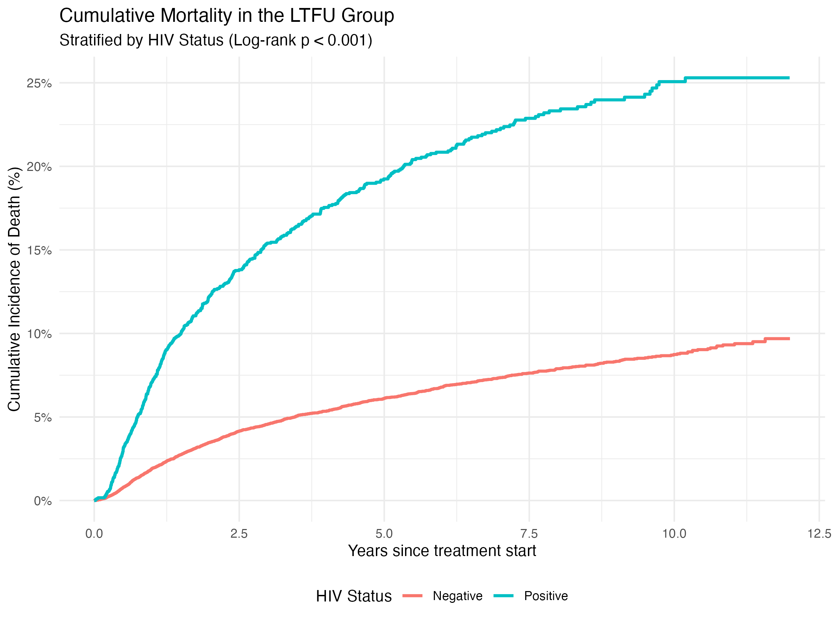
Figure 1: Cumulative mortality incidence in the LTFU group stratified by HIV status.

