Stratified Mortality Analysis: LTFU Group by Homelessness
This report presents the cumulative mortality for long-term survival specifically among individuals who experienced Loss to Follow-up (LTFU). The results are stratified by Homelessness status (Yes vs. No).

1. Cumulative Mortality Incidence (%)
Homelessness | Follow-up Year | Cumulative Mortality (%)
No | 1 | 2.2%
No | 5 | 6.9%
No | 10 | 9.6%
No | 12 (End of study) | 10.4%
Yes | 1 | 5.0%
Yes | 5 | 14.3%
Yes | 10 | 20.0%
Yes | 12 (End of study) | 21.6%
Log-rank test: p < 0.001

2. Survival Visualization
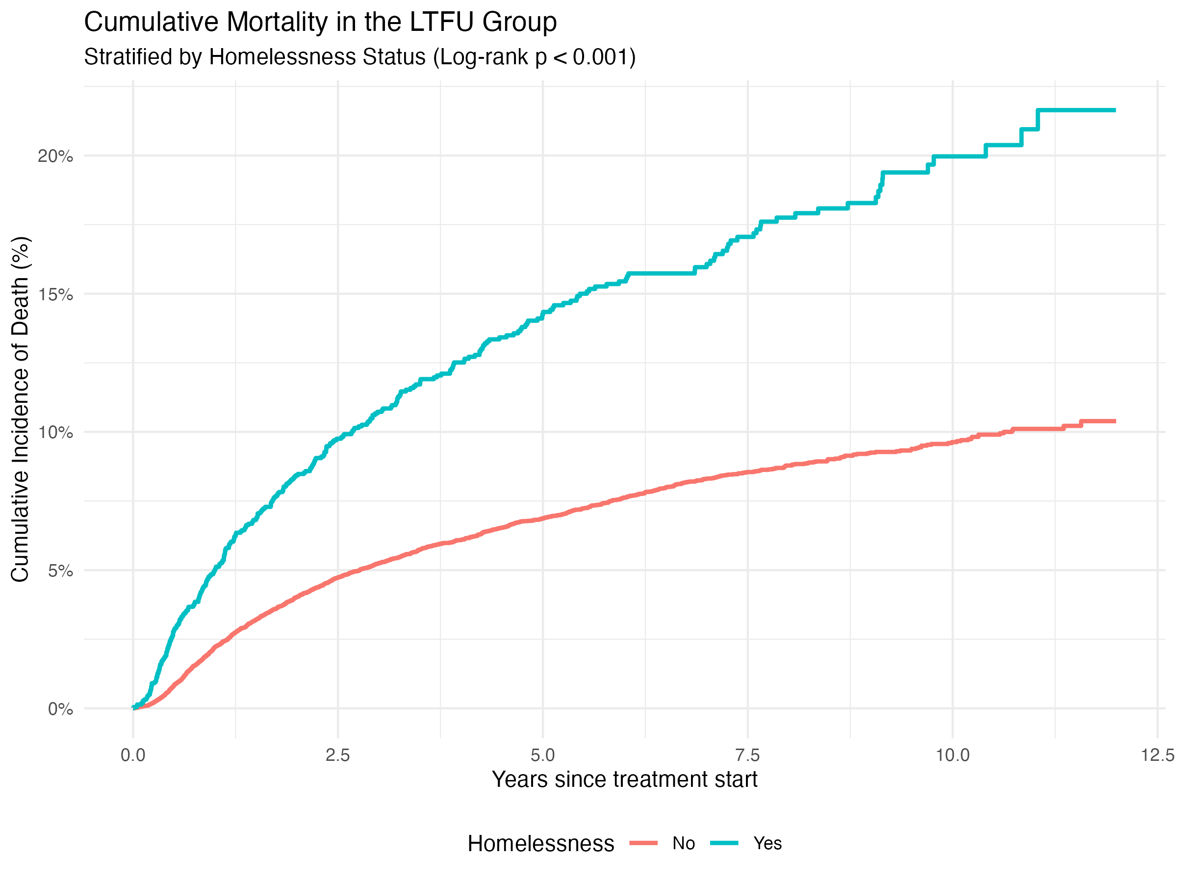
Figure 1: Cumulative mortality incidence in the LTFU group stratified by homelessness status.

