Stratified Retreatment Analysis (Cumulative Incidence)

1. Stratified by HIV Status
Group | 1 Years | 2 Years | 5 Years | 10 Years | 11.9 Years
Negative | 32.77% | 37.49% | 42.28% | 45.86% | 46.16%
Positive | 46.85% | 51.89% | 58.57% | 62.26% | 63.25%

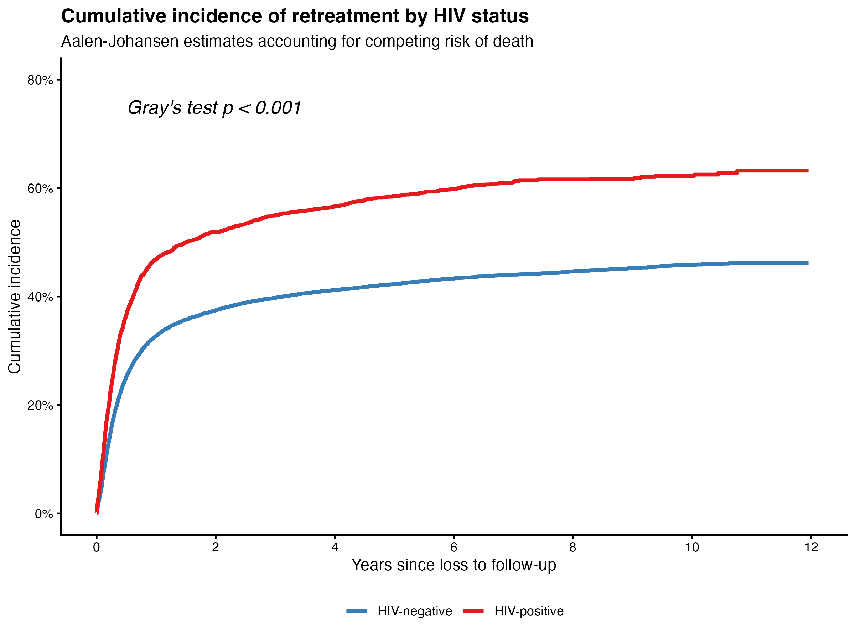

2. Stratified by Homelessness
Group | 1 Years | 2 Years | 5 Years | 10 Years | 11.9 Years
No | 33.81% | 38.56% | 43.64% | 47.25% | 47.71%
Yes | 38.25% | 43.07% | 47.85% | 51.36% | 51.36%

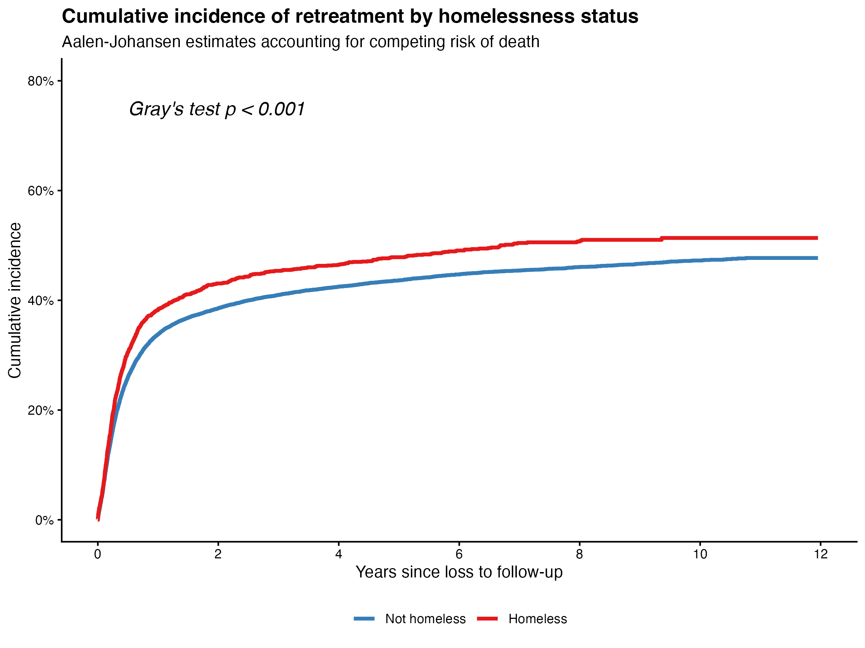

3. Stratified by Timing of Loss to Follow-up
Group | 1 Years | 2 Years | 5 Years | 10 Years | 11.9 Years
1 to <2 months | 51.43% | 58.91% | 62.90% | 65.84% | 65.84%
≥ 4 months | 23.56% | 27.18% | 32.42% | 36.47% | 37.12%
< 1 month | 39.19% | 43.00% | 46.04% | 48.63% | 48.63%
2 to <4 months | 42.87% | 48.49% | 54.11% | 57.48% | 57.91%

