Evelyn Zepeda

2/3/24

Exercise 4.3 MongoDB Shell

Display all documents:

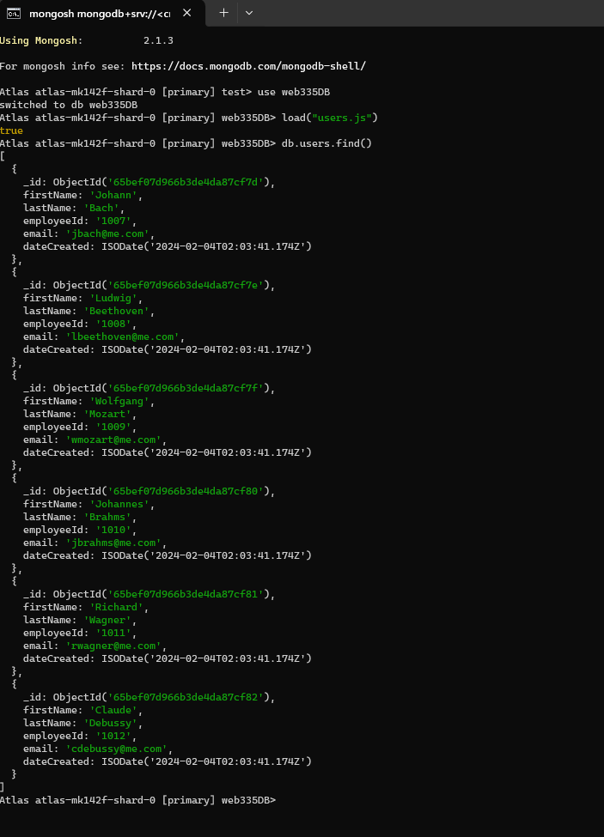

Queries:

