Evelyn Zepeda

2/11/24

Assignment 5.2 - Projections

insertOne

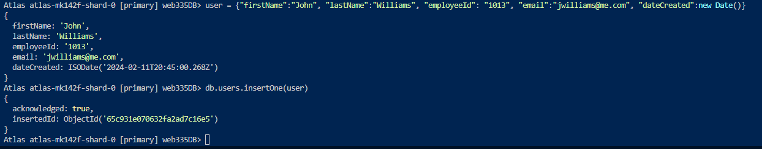

updateOne

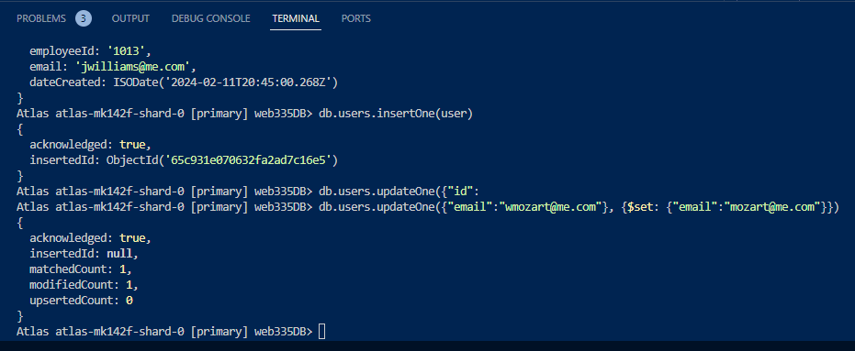

projections

